MINISTRY OF EDUCATION AND TRAINING

FPT UNIVERSITY
Capstone Project Document
PickleVerse – Multiplayer Pickleball Skill-Training and Match Game with AI Coaching

GFA26SE111
Group Members | Huỳnh Trung Kiên – SE184454 (Leader)  Nguyễn Văn Thành Đạt – SE184450  Nguyễn Gia Huy – SE184439  Trần Nguyễn Hiếu Thuận – SE184471
Supervisor | Mr. Lại Đức Hùng
Ext Supervisor | None
Capstone Project code | PKV

– Ho Chi Minh City, November 2026 –
Table of Contents

Acknowledgement 4
Definition and Acronyms 4
I. Project Introduction 7
1. Overview 7
2. Product Background 8
3. Existing Systems 8
4. Business Opportunity 9
5. Software Product Vision 10
6. Project Scope & Limitations 10
7. References 12
II. Project Management Plan 13
1. Overview 13
2. Management Approach 16
3. Project Deliverables 19
4. Responsibility Assignments 20
5. Project Communications 21
6. Configuration Management 21
III. Software Requirement Specification 23
1. Product Overview 23
2. User Requirements 24
3. Functional Requirements 37
4. Non-Functional Requirements 81
5. Requirement Appendix 83
IV. Software Design Description 90
1. System Design 90
2. Database Design 97
3. Detailed Design 111
4. Workflows and State Changes 146
V. Software Testing Documentation 167
1. Scope of Testing 167
2. Test Strategy 168
3. Test Plan 169
4. Test Cases 170
5. Test Reports 171
VI. Release Package & User Guides 174
1. Deliverable Package 174
2. Installation Guides 174
3. User Manual 177

Acknowledgement
We would like to express our sincere gratitude to our supervisor, Mr. Lại Đức Hùng, for his guidance throughout the capstone project. His questions about scope, requirements and evidence shaped the way we planned the work, designed the system and reported our results.
We thank FPT University and the lecturers of the Software Engineering programme for the knowledge and the learning environment that made this project possible, and the members of the review committees for their comments at each review, which helped us improve both the product and the documents.
We also acknowledge the open-source communities and tool vendors whose work we built on, in particular Unity, Photon, the .NET, PostgreSQL, Redis, FastAPI and React communities, and the authors of PlantUML and draw.io used for our diagrams.
Finally, we thank our families and friends for their patience and support during the many evenings of development and testing.

Definition and Acronyms
The definitions and acronyms used in this document are listed below. Pickleball terms and product-specific terms are also explained in Part III, §5.4.
Acronym | Definition
AI | Artificial Intelligence
API | Application Programming Interface
BR | Business Rule
CI/CD | Continuous Integration / Continuous Delivery
CMS | Content Management System (lesson, item and mission management in the admin web)
DAU | Daily Active Users
Dedicated server | Headless Unity server that runs an online match with authority over the result
Drill | Practice exercise with a fixed number of shots and a target
Elo | Rating system used for ranked matches (K-factor 32, floor 100)
ERD | Entity Relationship Diagram
EV | Evidence item of a test run (Report 5, §5.1)
FE | Major feature (FE-01 to FE-10)
FR | Functional Requirement (FR-01 to FR-33)
Fusion | Photon Fusion 2, the real-time networking library and cloud
GUI | Graphical User Interface
HMAC | Hash-based Message Authentication Code
HUD | Head-Up Display (in-match information)
JWT | JSON Web Token
Kitchen / NVZ | Non-volley zone, the area within 2.13 m of the net where volleys are not allowed
LI | Limitation or exclusion (Report 1, §6.2)
NFR | Non-Functional Requirement (NFR-01 to NFR-12)
OTP | One-Time Password
PB | Product backlog item
RACI | Responsibility matrix: Do, Review, Support, Inform
RTT | Round-Trip Time
S3 | Amazon Simple Storage Service API, used for replay storage
SDD | Software Design Description
SPMP | Software Project Management Plan
SRS | Software Requirement Specification
TC | Test Case
Tokenpad | In-game currency earned by playing
UAT | User Acceptance Test
UC | Use Case (UC-01 to UC-68)
UI | User Interface
W01–W04 | End-to-end review workflows committed in the Review 2 form BM04
WBS | Work Breakdown Structure
XP | Experience points
About this document. This final report consolidates the six capstone reports of the project in their latest versions: Part I – Project Introduction (Report 1), Part II – Project Management Plan (Report 2), Part III – Software Requirement Specification (Report 3), Part IV – Software Design Description (Report 4), Part V – Software Testing Documentation (Report 5) and Part VI – Release Package & User Guides (Report 6). A reference of the form "Report n" points to Part n of this document. Figures and tables are numbered separately within each part. The test workbooks, the project tracking workbook and the schedule are delivered as separate files (Part VI, §1).

I. Project Introduction

1. Overview

1.1 Project Information
Table 1. Project information
Item | Value
Project name (English) | PickleVerse – Multiplayer Pickleball Skill-Training and Match Game with AI Coaching
Project name (Vietnamese) | PickleVerse – Game Huấn Luyện Kỹ Thuật và Thi Đấu Pickleball Nhiều Người Chơi Tích Hợp AI
Project code | PKV
Group name | GFA26SE111
Software type | 3D multiplayer sports game for Windows desktop and Android, supported by a web API, a real-time dedicated game server, an AI coaching service and an administration web application
Duration | 14 weeks of development, from 07/09/2026 (Week 1) to 13/12/2026 (Week 14); final defense in Week 15 (14–20/12/2026)
Source repository | https://github.com/Tad-Min/PickleVerse (private; access is granted to the supervisor and the review committee on request)
Staging environment | Admin web: http://tad-min.io.vn – Web API: http://tad-min.io.vn:8080 – Dedicated game server: tad-min.io.vn, UDP 3669

1.2 Project Team
The team consists of four software engineering students supervised by one lecturer. Every member owns one end-to-end review workflow, as committed in the Review 2 form BM04 of 07/11/2026, and one or more technical areas; the leader additionally coordinates planning, meetings and submissions. Workflow ownership is separate from implementation effort: according to the repository history, Nguyễn Gia Huy and Nguyễn Văn Thành Đạt implemented the largest share of the code (Report 2, §4).
Table 2. Project team
Full Name | Student ID | Role | Main responsibility | Email | Mobile
Lại Đức Hùng | – | Supervisor | Supervises scope, schedule and report quality | Hungld5@fe.edu.vn | –
Huỳnh Trung Kiên | SE184454 | Leader | Planning and tracking; admin web application; music and sound effects; owner of workflow W04 (moderation and content) | kienht7704@gmail.com | –
Nguyễn Văn Thành Đạt | SE184450 | Member | Web API and database; online multiplayer and dedicated server; AI coaching service; CI/CD; owner of workflow W03 (find and play an online match); support for W02 | nguyenvanthanhdat44@gmail.com | –
Nguyễn Gia Huy | SE184439 | Member | Unity gameplay, ball physics and rules; training and tutorial; bot behaviour; 3D characters, animation, courts and in-game UI; owner of workflow W02 (play a bot match and get a tip); support for W01 and W03 | huyngse184439@fpt.edu.vn | –
Trần Nguyễn Hiếu Thuận | SE184471 | Member | Unity user interface (login, loading, settings); audience and character assets; test lead; owner of workflow W01 (learn and sync a drill); support for W04 | hieuthuan833@gmail.com | –

2. Product Background
Pickleball has become one of the fastest-growing recreational sports in Vietnam. Local press reported that the number of regular players nearly doubled during 2024 to about 30,000 [1], that more than 200 new courts opened in Hanoi alone in the first seven months of 2024 [2], and that Vietnam was listed among the ten fastest-growing pickleball nations by registered-player growth on the DUPR rating platform [3]. The sport attracts office workers, university students and older adults because the court is small and the basic strokes are easy to start with.
The growth, however, is not matched by structured learning. Most newcomers learn by imitating other players on the court and receive no feedback on their technique. Qualified coaches are scarce and private lessons are expensive, so beginners often reinforce incorrect fundamentals – an overhand or late serve, dinks that float too high, volleys taken inside the non-volley zone (the "kitchen") – which are difficult to correct later. Casual players also find it hard to meet partners of a similar level, and they cannot practise when a court is unavailable because of weather, cost or schedule. Recent reports that some courts in central Hanoi are now under-used [4] suggest that players who do not progress tend to drop the sport.
The project idea was proposed by the team members, who are themselves beginner and casual players, and was registered as a student-initiated capstone topic under the supervision of Mr. Lại Đức Hùng. The proposal identifies Vietnamese beginners and casual players as the primary users and pickleball clubs, academies and community sport centres as potential organisational customers. PickleVerse addresses the problems above with a 3D game in which a player learns the rules and controls, repeats short graded drills, receives technique feedback computed from in-game telemetry, and applies the skills in matches against bots or other players.

3. Existing Systems
The team studied three products that either simulate pickleball or help players improve their technique. They were selected because together they cover the three ideas that PickleVerse combines: an accessible pickleball game, a realistic training simulator, and AI-based technique analysis.

3.1 Pickleball Smash
Link: https://www.xbox.com/games/store/pickleball-smash/9N4DL8WL5DV2 [5]
Overview: An arcade pickleball game developed by 1PXL Games and published by GameMill Entertainment on 24 October 2023 for Nintendo Switch, PlayStation 4/5, Xbox One/Series X|S and PC (Steam) [5], [6].
Actors: Player (single player against the computer, or up to four players sharing one console).
Main features: Singles and doubles matches against computer opponents; local multiplayer; mini-games that each practise one shot; several playable characters and courts.
Pros: Simple controls and short sessions; mini-games show that a single activity can teach a single skill; available on many platforms.
Cons: Arcade physics rather than real pickleball technique; no lesson structure, scoring of technique or feedback; local multiplayer requires all players on the same console; no Vietnamese interface; no mobile version.

3.2 Eleven Pickleball
Link: https://www.meta.com/experiences/eleven-pickleball [7]
Overview: A virtual-reality pickleball simulator by For Fun Labs, the studio behind Eleven Table Tennis, released for Meta Quest headsets [7].
Actors: Player (single player against AI, or online against other players).
Main features: Physics-based paddle control with motion controllers; a programmable ball machine whose speed, spin and placement can be set for each shot; matches against AI bots; online 1v1 and 2v2 matches.
Pros: Realistic ball physics and paddle motion; the ball machine supports deliberate repetition of one shot; real online play.
Cons: Requires a VR headset, which few Vietnamese beginners own; no guided curriculum or star scoring; no technique diagnosis or recommendation; English interface.

3.3 PB Vision
Link: https://apps.apple.com/us/app/pb-vision/id6467020610 [8]
Overview: A mobile and web service that analyses videos of real pickleball games with computer vision and machine learning [8], [9].
Actors: Player (uploads a recorded game and reviews the analysis); club (records courts with an installed camera).
Main features: Shot speed, placement and error statistics; rally and shot breakdowns; heat maps and highlights; skill ratings.
Pros: Feedback is based on the player's real games; detailed statistics; integrates with club court cameras.
Cons: A full game must be filmed from a fixed angle with all four court corners visible; feedback arrives after the game, not during practice; no practice content when no court is available; advanced analysis is a paid service.

3.4 Comparison
Table 3 compares the three products with PickleVerse against the criteria that matter to the target users.
Table 3. Comparison of existing systems with PickleVerse
Criterion | Pickleball Smash | Eleven Pickleball | PB Vision | PickleVerse
Device needed | Console or PC | VR headset | Phone and camera, real court | Windows PC or Android phone
Structured lessons with graded drills | No (mini-games only) | No (free ball machine) | No | Yes – tutorial and 15 lessons scored 0–3 stars
Technique feedback | No | No | Yes, after a filmed game | Yes, after each drill and match, from in-game telemetry
Practice without a court or partner | Yes | Yes | No | Yes, including offline training
Online play and rating | No online play | Yes | Rating only | Yes – ranked singles with Elo, custom singles and doubles rooms
Vietnamese interface | No | No | No | Yes
Administration tools for an organisation | No | No | Club integration | Yes – user, content, match, moderation and analytics tools

4. Business Opportunity
The comparison shows a gap between entertainment games, which are accessible but do not teach technique, and analysis tools, which give useful feedback but require a real court, a recorded game and in many cases payment. A Vietnamese beginner who wants to learn the fundamentals at home, at low cost and in Vietnamese currently has no suitable product.
PickleVerse targets this gap. It runs on hardware the users already own (a Windows PC or an Android phone), teaches the official rules through a tutorial and graded drills, and turns each drill and match into feedback without any camera. Because the feedback is computed from the game's own telemetry, the cost of a coaching session is close to zero, which makes the product attractive to price-sensitive students and young workers. Online ranked matches with an Elo rating and a leaderboard keep players engaged after the learning phase and help them find opponents of a similar level, which is a common complaint in local player communities.
For organisations, the administration web application lets a club or academy manage accounts, publish its own lessons and technique references, monitor matches and handle player reports. This creates a business-to-business direction described in the proposal: clubs could use PickleVerse as an inexpensive digital training and community tool for new members. Cosmetic items are already bought with an in-game currency; real-money payment through local wallets such as MoMo or VNPay is a post-capstone option and is excluded from this project (LI-02).

5. Software Product Vision
For Vietnamese pickleball beginners and casual players who want to learn the rules and fundamental strokes without a coach, a partner or a court, PickleVerse is a 3D pickleball game for Windows and Android that teaches the rules through an interactive tutorial, trains each core technique with graded drills, gives technique feedback computed from gameplay telemetry, and lets players apply their skills in matches against adaptive bots and other players online. Unlike arcade pickleball games, which do not teach technique, and video-analysis services, which need a filmed game on a real court, our product combines practice, feedback and competition in one Vietnamese-language application that runs on devices the players already own, and gives clubs a web dashboard to manage their members and training content.

6. Project Scope & Limitations

6.1 Major Features
The ten major features below define the scope of version 1.0. Report 3 refines each feature into use cases and functional requirements (FR-01 to FR-33), and the Review 2 commitment features F01–F18 are traced to them in Report 3, Appendix A.
Table 4. Major features of PickleVerse 1.0
ID | Feature | Description
FE-01 | Account and onboarding | Register with an email address, verify it with a six-digit one-time password (OTP), sign in and out, recover a forgotten password, edit the display name, choose a male or female character and choose a starting level (beginner or experienced) once. Configure audio, graphics, key bindings and the touch layout.
FE-02 | Tutorial and technique training | A 17-step interactive tutorial on the court, the rules and the controls. Fifteen lessons in four groups (basic, control, advanced and doubles) train twelve techniques: serve, drive, dink, volley, power and cross-court modifiers, third-shot drop, reset, smash, footwork, approach, and doubles coverage and transition. Each drill is scored with 0–3 stars. Training also works offline after the first sign-in, and results are synchronised once when the game is online again.
FE-03 | Bot practice | Singles matches against a computer opponent at three fixed levels (Easy, Medium, Hard) or in an adaptive mode whose behaviour-tree bot scales its shot choice, aggression and error rate to the player's Elo tier. The player chooses a professional or outdoor court and day or night lighting.
FE-04 | Online matches | Ranked singles quick match that pairs players of similar Elo, with a 10-second ready check and a bot opponent after 180 seconds without a human match; quick doubles; private singles and doubles rooms joined by room code or friend invitation. Matches run on an authoritative dedicated game server and support reconnection.
FE-05 | AI coaching | After a drill or match, the AI coaching service analyses the shot telemetry and returns a summary, detected errors (for example a late serve or a dink that is too high) and at most three recommended drills.
FE-06 | Progress, rewards and shop | Experience points and levels, lesson stars and technique mastery, daily and weekly missions, achievements, and the Tokenpad currency. Players buy and equip cosmetic paddles in the shop and view owned items in the collection.
FE-07 | Social, history and ranking | Send, accept and decline friend requests; remove and block players; view match history and replays (pause, seek, 0.5×–2× speed); view the Elo leaderboard.
FE-08 | Reports, restrictions and appeals | Report another player after a match. A restricted (suspended or banned) player can see the sanction decision and submit one appeal.
FE-09 | Administration web application | Administrators manage accounts, roles and sanctions, reset player progress by group, manage lessons, technique references, cosmetics and missions, monitor and stop live matches, review player reports and appeals, and view analytics (active users, retention, popular lessons, technique errors and matchmaking health).
FE-10 | Expert review of AI results | Administrators acting as pickleball experts label recorded shots and export a labelled dataset. This tool is used to evaluate the AI coaching quality (Report 3, NFR-06) and is an addition to the proposal.

6.2 Limitations & Exclusions
The following items are deliberately excluded from version 1.0, or deviate from the registered proposal. Each deviation is recorded with its reason so that requirement changes can be evaluated against it.
Table 5. Limitations and exclusions
ID | Limitation or exclusion
LI-01 | Coaching uses in-game telemetry only. Analysis of real swing video, augmented reality and a separate coach portal are excluded.
LI-02 | Ranked seasons, tournaments, spectator mode, club management, voice or text chat and real-money payments are excluded. The Tokenpad currency is earned only by playing. The Elite Token currency exists in the data model but has no earning source in version 1.0, so items priced only in Elite Token cannot be bought.
LI-03 | Only Ranked Singles and Ranked Bot matches change the Elo rating (K-factor 32, floor 100). Doubles and private rooms are unrated. The proposal described an Elo update after every match; rating only one-to-one ranked results keeps the rating meaningful.
LI-04 | Offline mode covers training only, after at least one online sign-in on the device. Bot matches, online matches, the shop and the administration tools need a connection.
LI-05 | The proposal's "self-assessment with a starting-tier classifier" is implemented as a one-time choice between Beginner and Experienced. The trained tier model in the AI service is gated: its estimate is shown only when the model passes the accuracy target in NFR-06; otherwise the rule-based result is used.
LI-06 | Release platforms are Windows 10 or later and Android 8.0 (API 26) or later on ARM64. An iOS build is outside the delivered scope because the team has no Apple build machine and developer account; the project settings keep iOS 15.0 as the minimum for future work (the proposal named iOS 14).
LI-07 | The staging deployment runs one dedicated game-server container, so one server-authoritative match can run at a time; when the slot is busy players are told that the server is busy. The proposal target of 500 concurrent matches requires a server pool and is treated as a scalability goal, verified by load testing of the API (Report 3, NFR-04).
LI-08 | Technology deviations from the proposal: the web API uses ASP.NET Core (.NET 10) instead of Spring Boot or FastAPI because the team shares C# with Unity; real-time networking uses Photon Fusion 2 (shared lobby plus a dedicated server) instead of Netcode for GameObjects, after Netcode with Relay showed unstable connections during the October prototype; the game interface uses uGUI instead of UI Toolkit; ball flight uses a custom fixed-step simulation instead of PhysX for deterministic replay and server authority. The reasons are detailed in Report 4, §1.4.
LI-09 | The game interface is in Vietnamese only. The administration web application is in Vietnamese, and project documents are in English.

7. References
[1] Tuoi Tre News, "Rapid rise of pickleball in Vietnam marked by growing pains in organization," 15 Mar. 2025. https://tuoitrenews.vn/news/sports/20250315/rapid-rise-of-pickleball-in-vietnam-marked-by-growing-pains-in-organization/85232.html (accessed 11 Nov. 2026).
[2] VnExpress International, "Vietnam catches pickleball fever," 2024. https://e.vnexpress.net/news/life/trend/vietnam-catches-pickleball-fever-4771953.html (accessed 11 Nov. 2026).
[3] Voice of Vietnam, "Vietnam among world's top 10 fastest-growing pickleball nations." https://english.vov.vn/en/sports/vietnam-among-worlds-top-10-fastest-growing-pickleball-nations-post1340523.vov (accessed 11 Nov. 2026).
[4] Dan Tri International, report on court usage in inner Hanoi, 8 Apr. 2026. https://dtinews.dantri.com.vn/print/20260408102840844.htm (accessed 11 Nov. 2026).
[5] Microsoft Store, "Pickleball Smash." https://www.xbox.com/games/store/pickleball-smash/9N4DL8WL5DV2 (accessed 11 Nov. 2026).
[6] Gematsu, "Pickleball Smash – release dates." https://www.gematsu.com/games/pickleball-smash (accessed 11 Nov. 2026).
[7] Meta Quest Store, "Eleven Pickleball," For Fun Labs. https://www.meta.com/experiences/eleven-pickleball (accessed 11 Nov. 2026).
[8] Apple App Store, "PB Vision," Pickleball Vision AI Inc. https://apps.apple.com/us/app/pb-vision/id6467020610 (accessed 11 Nov. 2026).
[9] Ministry of Sport, "AI now assisting pickleball players improve their game with the launch of PB Vision." https://ministryofsport.com/ai-now-assisting-pickleball-players-improve-their-game-with-the-launch-of-pb-vision/ (accessed 11 Nov. 2026).
[10] GFA26SE111, "PickleVerse – Capstone Project Register (proposal)," FPT University, 2026.

II. Project Management Plan

1. Overview

1.1 Scope & Estimation
The scope of version 1.0 is the ten major features FE-01 to FE-10 defined in Report 1, plus the technical work that the features depend on: the gameplay core, the networking layer, art and audio assets, deployment and testing. Table 1 decomposes this scope into a two-level work breakdown structure (WBS). Each function is classified as Simple, Medium or Complex and estimated in man-days, where one man-day is eight hours of work by one member.
Table 1. Work breakdown structure and effort estimation
# | WBS Item | Complexity | Est. Effort (man-days) | Owner
1 | Project management and documentation |  | 28
1.1 | Planning, scheduling and weekly tracking | Medium | 5 | Kiên
1.2 | Report 1 and Report 2 | Simple | 3 | Huy, Kiên
1.3 | Report 3 – Software Requirement Specification | Complex | 8 | Huy
1.4 | Report 4 – Software Design Document | Complex | 7 | Đạt
1.5 | Reports 5–7, user guides and defense slides | Medium | 5 | Huy, Thuận
2 | Foundation and architecture |  | 20
2.1 | Unity project, scenes and assembly structure | Simple | 3 | Huy
2.2 | Layered Web API, EF Core model and database schema (51 tables) | Complex | 9 | Đạt
2.3 | Docker Compose environment with PostgreSQL, Redis and S3 storage | Medium | 4 | Đạt
2.4 | CI/CD pipeline (GitHub Actions, Docker Hub, SSH deployment) | Medium | 4 | Đạt
3 | Gameplay core |  | 30
3.1 | Ball flight and bounce simulation at 120 Hz | Complex | 8 | Huy
3.2 | Paddle contact, shot input and seven shot kinds | Complex | 7 | Huy
3.3 | Singles rules engine (scoring, serve, faults, non-volley zone) | Complex | 7 | Huy
3.4 | Character movement and animation controller | Medium | 5 | Huy
3.5 | Match flow, HUD, intro cinematic and result screen | Simple | 3 | Thuận
4 | FE-01 Account and onboarding |  | 16
4.1 | Registration and OTP email verification | Medium | 4 | Đạt
4.2 | Sign in, sign out, JWT access and refresh tokens | Medium | 4 | Đạt
4.3 | Password recovery | Simple | 2 | Thuận
4.4 | Profile, character and onboarding level | Simple | 2 | Thuận
4.5 | Settings: audio, graphics, key binding, touch layout | Medium | 4 | Thuận
5 | FE-02 Tutorial and technique training |  | 23
5.1 | Interactive tutorial (17 steps) | Medium | 5 | Huy
5.2 | Lesson and drill framework with star scoring | Complex | 7 | Huy
5.3 | Content of 15 lessons and 12 techniques | Medium | 5 | Huy
5.4 | Offline training and one-time synchronisation | Complex | 6 | Đạt
6 | FE-03 Bot practice |  | 15
6.1 | Fixed-level bot (Easy, Medium, Hard) | Medium | 5 | Huy
6.2 | Adaptive behaviour-tree bot with Elo tiers | Complex | 7 | Đạt
6.3 | Bot match setup, court and lighting options, rewards | Simple | 3 | Thuận
7 | FE-04 Online matches |  | 36
7.1 | Photon Fusion session, lobby and room codes | Complex | 7 | Đạt
7.2 | Ranked matchmaking, ready check and bot fallback | Complex | 7 | Đạt
7.3 | Dedicated server build, signed tickets, lease and result | Complex | 9 | Đạt
7.4 | State synchronisation, input prediction and reconnection | Complex | 9 | Đạt
7.5 | Elo rating and match result persistence | Medium | 4 | Đạt
8 | FE-05 AI coaching |  | 18
8.1 | Telemetry capture, local spool and upload | Medium | 5 | Đạt
8.2 | FastAPI rule engine and gated tier model | Complex | 7 | Đạt
8.3 | Hybrid analysis worker, analysis jobs and coaching panel | Medium | 6 | Huy
9 | FE-06 Progress, rewards and shop |  | 15
9.1 | XP, levels, technique mastery and progress dashboard | Medium | 5 | Huy
9.2 | Daily and weekly missions, achievements, streak rewards | Medium | 5 | Đạt
9.3 | Currencies, shop and collection | Medium | 5 | Huy
10 | FE-07 Social, history and ranking |  | 12
10.1 | Friends, blocking and room invitations | Medium | 4 | Đạt
10.2 | Match history, replay recording and replay viewer | Complex | 6 | Đạt
10.3 | Elo leaderboard with cache | Simple | 2 | Kiên
11 | FE-08 Reports, restrictions and appeals |  | 6
11.1 | Player report after a match | Simple | 2 | Kiên
11.2 | Restricted access, decision view and appeal | Medium | 4 | Kiên
12 | FE-09 Administration web application |  | 24
12.1 | Admin authentication, layout and protected routing | Simple | 2 | Kiên
12.2 | User management, sanctions and progress reset | Complex | 6 | Kiên
12.3 | Content management: lessons, references, cosmetics, missions | Medium | 6 | Kiên
12.4 | Live match monitoring and stopping | Medium | 4 | Đạt
12.5 | Moderation of player reports and appeals | Medium | 3 | Kiên
12.6 | Analytics dashboard | Medium | 3 | Kiên
13 | FE-10 Expert review |  | 4
13.1 | Shot labelling and dataset export | Medium | 4 | Đạt
14 | Art, audio and interface assets |  | 15
14.1 | Characters, 20 animation clips, courts and stadium | Complex | 8 | Huy
14.2 | Music and sound effects | Simple | 2 | Kiên
14.3 | Front-end screens, loading artwork and Vietnamese fonts | Medium | 5 | Thuận
15 | Testing and release |  | 18
15.1 | Unit tests (Unity EditMode, Python) and coverage | Medium | 5 | Thuận
15.2 | Integration and system testing on staging | Medium | 5 | Thuận
15.3 | Acceptance tests, playtests and defect fixing | Medium | 6 | All
15.4 | Staging deployment and release package | Simple | 2 | Đạt
 | Total Estimated Effort (man-days) |  | 280

The estimate covers 56 functions (11 Simple, 28 Medium and 17 Complex) and totals 280 man-days. The available capacity is four members × 14 weeks × 5 working days = 280 man-days, so the plan uses the whole capacity and has no reserve. The team accepts this because Complex networking items were estimated from the actual effort of the October prototypes, and AI coding assistants are used for boilerplate code and first drafts of documents; every generated output is reviewed by the member who owns the item. If an iteration overruns, the first items to be deferred are FE-10 (expert review) and quick doubles matching, which are not part of the core workflows.

1.2 Project Objectives
The overall objective is to deliver, by Week 14 (13/12/2026), a deployed and tested version of PickleVerse in which a beginner can learn the rules, train the core techniques with graded drills and feedback, and play bot and online matches, while administrators manage accounts, content, matches and moderation from the web application. The quality, time and cost objectives are measurable as follows.
Quality. Table 2 states the planned test coverage and the expected number of defects at each testing stage. The defect estimate (about 120 defects in total) is based on the defects already found in the October prototypes and the 10/11/2026 playtest; it is used to judge whether a stage is finding fewer defects than expected, which usually means that testing is too shallow.
Table 2. Quality objectives by testing stage
# | Testing Stage | Test Coverage | No. of Defects | % of Defect | Notes
1 | Reviewing | 100% of reports, diagrams and database changes are reviewed by at least one other member | 20 | 17% | Document and design review before each submission
2 | Unit Test | 100% of public methods in the rule, scoring, Elo, input and economy classes; ≥70% line coverage of core gameplay assemblies | 30 | 25% | Unity EditMode and Python pytest; run before every merge
3 | Integration Test | All 122 API endpoints exercised at least once; all database write paths | 25 | 21% | IntegrationChecks harness and API contract checks in CI
4 | System Test | 100% of the 117 test cases in Report 5 executed on staging | 35 | 29% | Includes network, device and AI quality tests
5 | Acceptance Test | 8 demo scenarios covering workflows W01–W04 | 10 | 8% | Executed with the supervisor before the final review
 | Total |  | 120 | 100%

In addition, the release criteria for version 1.0 are: at least 90% of system test cases passed, no open Critical or High defect, at least 50% of test cases executed automatically, and every functional requirement covered by at least one passed test case.
Milestone timeliness. Up to 11/11/2026, six milestones (M01–M06) were due and one of them (M06) was delivered on time, a timeliness of 17%. Reports 1–4 were first submitted on 06/11/2026 because the team prioritised the playable prototype in Weeks 5–8 (§2.1). The target for the remaining milestones M07–M10 is 100% on time, and the corrective actions are: one document owner per report, a weekly tracking meeting with the leader, and submission one day before each deadline.
Cost (allocated effort). The 280 man-days are distributed over the project activities as shown in Table 3. Feature and technical items include their own design (15%), coding (70%) and unit testing (15%); documentation items are counted under requirements, design or project management.
Table 3. Allocated effort by activity
Activity | Source in the WBS | Effort (man-days) | Share
Requirements | 1.2, 1.3 | 11 | 3.9%
Design | 1.4 + 15% of items 2–14 | 42 | 15.0%
Coding | 70% of items 2–14 | 164 | 58.6%
Testing | 15% of items 2–14 + item 15 | 53 | 18.9%
Project management and documentation | 1.1, 1.5 | 10 | 3.6%
Total |  | 280 | 100%

1.3 Project Risks
Risks are reviewed in the weekly tracking meeting. A risk that occurs is closed in this table and recorded as an issue in the Issues sheet of the project tracking workbook.
Table 4. Project risks
# | Risk Description | Impact | Possibility | Trigger | Response Plans | Owner
1 | Key-person dependency: most of the networking, backend and AI code has been written by one member, so the online features stall if that member is unavailable. | High | Medium | Owner unavailable for more than 3 days, or one member has more than 60% of the commits in an iteration | Each member owns and demonstrates one workflow; pair-programming sessions on Fusion and the API; handover notes in Doc/; code walkthrough at the end of each iteration | Kiên
2 | Leaked credentials: the SMTP password and JWT signing key were committed in appsettings.json and could be misused. | High | High | Secret found in a tracked file (occurred; see issue I-03) | Move secrets to environment variables and the server .env file; rotate the leaked values; add a secret scan to CI | Đạt
3 | One dedicated game-server slot limits concurrent online matches and the scalability target. | High | High | "Server busy" responses during tests with more than two players | Bot fallback and a clear busy message; load-test the API separately; document a server pool as future work | Đạt
4 | The Photon free plan limits concurrent users, which can block group playtests or the demo. | Medium | Medium | Connection refused when more than 20 clients connect | Use the dedicated server path for matches; schedule playtests; upgrade the plan before the defense if needed | Đạt
5 | Unity tests are not yet run in GitHub Actions, so automation evidence depends on manual Unity CLI runs. The pipeline already builds the dedicated server with GameCI and a Unity licence; only a test step is missing. | Medium | High | CI shows no Unity test step | Add a GameCI unity-test-runner EditMode step that reuses the licence secrets of the server build; until then attach Unity CLI result files with the commit hash | Thuận
6 | Resetting the development database deletes test accounts and data. | Medium | Medium | Schema change that requires a reset | Keep seed accounts and content in Database.sql; back up with pg_dump before a reset; re-run seed checks | Đạt
7 | Documents or code produced with AI assistants contain statements that do not match the implementation. | High | Medium | A reviewer finds a claim without evidence in code or tests | The owner of each section verifies it against code and test results; cross-document consistency check before submission | Huy
8 | Too little real player data to validate the AI tier model. | Medium | High | Fewer than 200 labelled sessions by Week 12 | Keep the tier model gated; use rule-based findings; collect labels with the expert review tool during playtests | Đạt
9 | High latency or packet loss between Vietnamese players and the single staging host degrades matches. | Medium | Medium | Round-trip time above 100 ms or rubber-banding reported in playtests | Measure RTT in each playtest; tune interpolation; reconnection within 30 seconds | Đạt
10 | Schedule slip and scope creep (milestones M01–M05 were late). | High | High | A milestone is not ready two days before its date | Freeze scope after Review 3; weekly tracking; defer FE-10 and quick doubles first | Kiên
11 | The staging host fails and data is lost (single server, no replica). | High | Low | Host unreachable or disk failure | Daily database backup; redeploy from Docker Hub images with deploy.sh; keep a local Docker environment as fallback | Đạt
12 | The game does not reach the frame-rate target on mid-range Android phones. | Medium | Medium | Average below 30 FPS on the test phone | Profile with the Unity Profiler; quality presets; reduce stadium detail and shadows on mobile | Huy

2. Management Approach

2.1 Project Process
The team follows an iterative and incremental process with two-week iterations, adapted from Scrum for a student team. The leader acts as Scrum Master and product owner on behalf of the supervisor; each member owns a technical area and one end-to-end workflow. Every iteration starts with planning from the product backlog in the tracking workbook and ends with a demonstration to the team and, at review weeks, to the supervisor. Figure 1 shows the cycle.
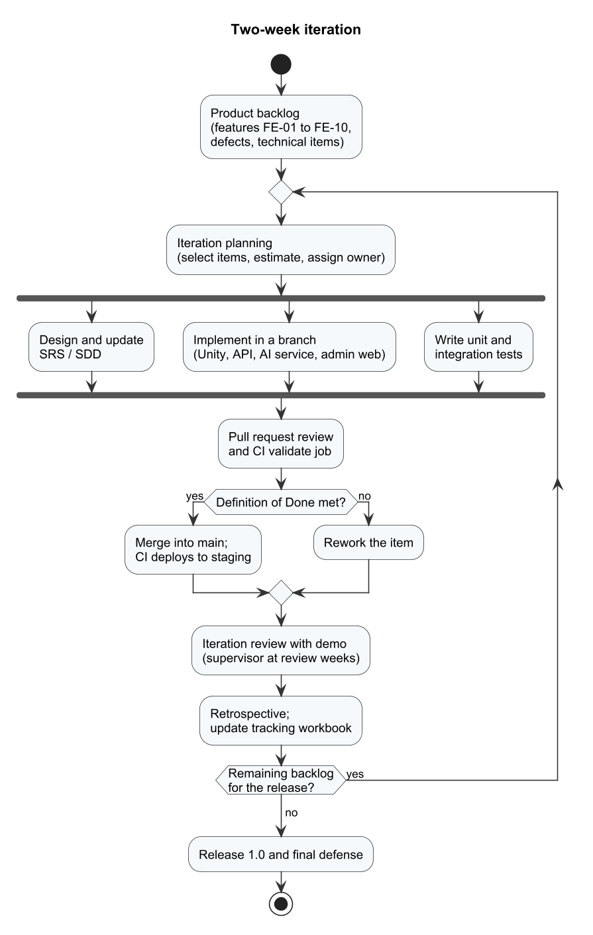
Figure 1. Iterative development process used by the team
Definition of Done. A backlog item is done when (1) the code is merged into the main branch, (2) its unit tests pass and the existing EditMode and Python suites still pass, (3) the related API, database and UI changes are consistent with Database.sql and the API client, (4) it works on the staging server, and (5) the SRS, SDD and test cases are updated.
The actual iterations, reconstructed from the repository history, are listed in Table 5. The architecture changed three times, which explains why the early milestones were late: the online layer moved from a Netcode for GameObjects prototype to Photon Fusion in shared mode and then to an authoritative dedicated server, and player data moved from local JSON files to the Web API and PostgreSQL.
Table 5. Iterations and actual progress
Iteration | Weeks and dates | Main results | Status
It-0 Inception | W1–W2, 07/09–20/09 | Proposal and team set-up; repository created (first commit 23/08); Unity project initialised (17/09) | Done
It-1 Prototype | W3–W4, 21/09–04/10 | Unity project structure and camera; 3D character models generated and rigged (03/10) | Done
It-2 Single-player core | W5–W6, 05/10–18/10 | 20 animation clips; BotMatch singles with rules (07/10); mode selection; music and SFX (09/10); shop and collection (10/10); tutorial (11/10); training mode (12/10); history, missions, Elo and ranks (11/10); friends and leaderboard (12/10); replay and streaks (13/10); Netcode for GameObjects prototype (07/10–21/10) | Done
It-3 Online and backend | W7–W8, 19/10–01/11 | Loading scene and touch controls; Web API and database (20/10); move to Photon Fusion (20/10); Unity–API integration (21–23/10); admin web (22–24/10); OTP email (24/10); doubles and custom rooms (25/10); Review 2 package (27/10); AI service and Unity Behavior bot (27/10); normalised schema and ApiResponse refactor (31/10); login scene (01/11) | Done
It-4 Dedicated server and coaching | W9–W10, 02/11–15/11 | Dedicated server, accounts and coaching (03/11); Docker deployment (04/11); CI/CD to Docker Hub and staging (05–06/11); admin tools and response training (06/11); reports v0.2 (06/11); reconnect and offline fixes (10/11); playtest (10/11); 515 EditMode tests passed (11/11); reports v1.0 (11/11) | In progress
It-5 Stabilisation | W11–W12, 16/11–29/11 | Fix the 18 open defects of test Round 1 (Report 5); secrets out of the repository; pull-request workflow; system and load tests; Report 5 results; Review 3 | Planned
It-6 Release | W13–W14, 30/11–13/12 | Acceptance tests and demo scenarios; release package; final updates of Reports 6 and 7 (v1.0 written on 11/11/2026); defense slides and rehearsal (W15) | Planned

2.2 Quality Management
Defect prevention: Coding rules are written in AGENTS.md and enforced in review: the layered backend architecture (API → Services → Repositories → Entities), access to data only through the unit of work, ApiResponse<T> envelopes, a single schema source (src/Database.sql) and no secrets in source files. Gameplay rules are implemented in engine-independent C# classes so that they can be unit-tested.
Reviewing: Every report section is written by its owner and reviewed by one other member against the code and test results before submission (Table 8). Until 10/11/2026 code was committed directly to the main branch without pull requests; from Iteration 5 every change is merged through a pull request that needs one reviewer and a passing CI run (§6.2).
Unit testing: Unity EditMode tests (515 tests in 10 assemblies, all passed on 11/11/2026) cover the rules, scoring, Elo, input, economy, replay and multiplayer protocol classes; pytest covers the AI service. Tests run before each merge and the results are stored with the commit hash.
Integration testing: The IntegrationChecks console program and the API contract checks run in the CI validate job against a PostgreSQL and Redis instance; they verify the API, the database writes and the dedicated-server ticket flow.
System testing: The 117 test cases in Report 5 are executed on the staging server for each package milestone; defects are logged in the tracking workbook with severity and retested before closing.
Acceptance testing: The eight demo scenarios of the Review 2 commitment are run with the supervisor, and the results are recorded in Report 5.

2.3 Training Plan
Table 6. Training plan
Training Area | Participants | When, Duration | Waiver Criteria
Git and GitHub flow (branches, pull requests, reviews) | All members | W1, 2 hours; refresher W11, 1 hour | Mandatory
Unity 6, C# gameplay scripting, Input System | Thuận, Kiên | W2–W3, 12 hours | Has completed a Unity game project before
Photon Fusion 2 and dedicated server builds | Huy, Thuận | W8–W9, 8 hours (taught by Đạt) | Has run and debugged a networked match on the staging server
ASP.NET Core Web API, EF Core and PostgreSQL | Kiên, Huy | W6–W7, 8 hours (taught by Đạt) | Has implemented an API endpoint with a repository and an EF Core query
React 18, TypeScript and React Query | Kiên, Thuận | W7, 6 hours | Has built a React application with TypeScript
Python FastAPI and scikit-learn | Đạt, Huy | W8, 4 hours | Has deployed a FastAPI service
Docker, Docker Compose and GitHub Actions | All members | W9, 4 hours | Can start the local stack and read container logs
Blender and character animation import | Huy, Thuận | W4, 6 hours | Has rigged and imported a character into Unity
UML modelling with PlantUML and draw.io | All members | W3, 3 hours | Mandatory

3. Project Deliverables
Week 1 starts on Monday 07/09/2026; each milestone is due on the Sunday of its week. Actual dates are taken from the repository history and submission records.
Table 7. Project deliverables and milestones
# | Deliverable | Due Date | Actual Date | Status | Notes
M01 | Report 1 – Project Introduction | 13/09/2026 | 06/11/2026 | Done, late | Proposal registered before Week 1; v1.0 on 11/11/2026
M02 | Report 2 – Project Management Plan, schedule, tracking workbook | 20/09/2026 | 06/11/2026 | Done, late | v1.0 on 11/11/2026
M03 | Report 3 – Software Requirement Specification | 27/09/2026 | 06/11/2026 | Done, late | v1.0 on 11/11/2026
M04 | Report 4 – Software Design Document; Report 5 test plan | 11/10/2026 | 06/11/2026 | Done, late | v1.0 on 11/11/2026
M05 | Software Package 1 – single-player core, training, first online build (Review 2) | 25/10/2026 | 27/10/2026 | Done, 2 days late | Review 2 forms BM01–BM04
M06 | Software Package 2 – Web API, admin web, AI service, dedicated server, CI/CD | 08/11/2026 | 06/11/2026 | Done, on time | Staging deployment on tad-min.io.vn
M07 | Software Package 3 – defect fixes, system and load tests (Review 3) | 22/11/2026 | – | In progress | Report 5 results due with this package
M08 | Full software package with test results and open defects | 06/12/2026 | – | Planned
M09 | Report 6 – Software User Guides | 13/12/2026 | 11/11/2026 | Done (v1.0) | Installation, player and administrator guides; updated with the release build
M10 | Report 7 – Final Project Report, release package and defense | 20/12/2026 | – | In progress | Report 7 v1.0 on 11/11/2026; slides and defense in Week 15

Figure 2 places the iterations and milestones on the calendar; the red line marks the date of this version (11/11/2026).
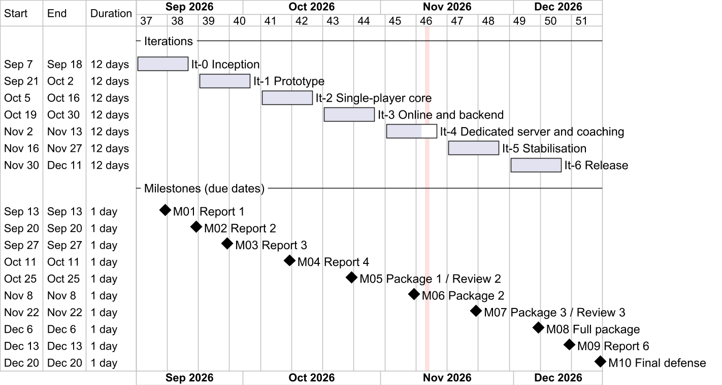
Figure 2. Master schedule: iterations and milestones

4. Responsibility Assignments
D~Do; R~Review; S~Support; I~Informed; <blank>~Omitted. Every row has exactly one D. Each member owns one end-to-end workflow, which that member demonstrates at the reviews; the workflow owners and supporting members follow the Review 2 commitment form BM04 (07/11/2026). Workflow ownership is an accountability for acceptance, not a measure of implementation effort: the technical rows show who built each part, and the repository history shows that Nguyễn Gia Huy and Nguyễn Văn Thành Đạt carried the largest share of the code.
Table 8. Responsibility assignment matrix (RACI)
Responsibility | KienHT SE184454 | DatNVT SE184450 | HuyNG SE184439 | ThuanTNH SE184471
Project planning and tracking | D | R | S | S
Report 1 – Project Introduction | R | S | D | I
Report 2 – Project Management Plan | D | S | R | I
Report 3 – SRS: overview, use cases, screens | R | S | D | S
Report 3 – SRS: functional and non-functional requirements | S | R | D | S
Report 4 – SDD: architecture, database, API, security | I | D | R | S
Report 4 – SDD: gameplay, bot and client design | I | R | D | S
Report 5 – Test plan, test cases and test report | R | S | S | D
Report 6 – User guides | R | S | D | S
Report 7 – Final report | R | R | D | S
Defense slides and presentation | D | S | S | S
Gameplay core, training and tutorial | I | R | D | S
Online matches, dedicated server and netcode | I | D | R | S
Web API, database and AI coaching service | S | D | R | I
Admin web application | D | R | I | S
Unity user interface, settings and loading | S | I | R | D
3D art, animation and courts | I | I | D | S
Music and sound effects | D | I | R | I
CI/CD and staging deployment | I | D | S | R
Workflow W01 – Learn and sync a drill (F01–F04, F13, F14) | R | I | S | D
Workflow W02 – Play a bot and get a tip (F05, F06, F11) | R | S | D | I
Workflow W03 – Find and play an online match (F07–F10, F12) | R | D | S | I
Workflow W04 – Moderation and content (F15–F18) | D | R | I | S

5. Project Communications
Table 9. Project communications
Communication Item | Who/ Target | Purpose | When, Frequency | Type, Tool, Method(s)
Supervisor meeting | Team and Mr. Lại Đức Hùng | Demonstrate progress, agree on scope changes, record decisions and answers | Weekly, 60 minutes; extra meeting before each review | Online or on-campus meeting; minutes and decisions in the Q&A sheet
Iteration planning | All members | Select backlog items, estimate and assign owners | First day of each two-week iteration | Meeting; Iteration backlog in the tracking workbook
Progress check | All members | Report done work, next work and blockers | Twice a week (Tuesday and Friday evening) | Group chat and short call
Iteration review and retrospective | All members, supervisor at review weeks | Demonstrate the increment; decide improvements | Last day of each iteration | Meeting; notes in the tracking workbook
Code review | Author and one reviewer | Check correctness, tests and architecture rules | Each pull request (from Iteration 5) | GitHub pull request with CI result
Defect and issue updates | Owner of the defect or issue | Keep status, severity and owner current | When status changes; reviewed weekly | Tracking workbook (Defects and Issues sheets)
Report submission | Leader | Submit reports and packages | One day before each deadline | FPT University LMS

6. Configuration Management

6.1 Document Management
• All project documents are stored in the Git repository under Doc/: the proposal in Doc/Proposal, review forms in Doc/Project_report/Review*, and Reports 1–7 with the tracking workbook and schedule in Doc/Project_report/Report.
• File names follow the course template: Report<n>_<Title>.docx, PickleVerse_Project_Tracking.xlsx and PickleVerse_Project_Schedule.xml.
• Each document records its versions in the Record of Changes table: v0.x for drafts and v1.0, v1.1 and so on for reviewed versions submitted to the supervisor.
• Diagrams are written as PlantUML sources in Doc/Project_report/Report/diagrams/src and rendered to PNG, so every figure can be regenerated and reviewed as text; the use case and conceptual ERD drawings are also kept as draw.io files.
• A document is submitted only after it has been reviewed by the member marked R in Table 8 and the leader; the PDF exported from the reviewed version is uploaded to the LMS.

6.2 Source Code Management
• Repository: GitHub Tad-Min/PickleVerse, one repository for the Unity client (My project/), the backend and admin web (src/), deployment files (deploy/, Docker Compose files) and documents.
• Practice until 10/11/2026: members committed directly to main and merged local work with merge commits; the coaching work used the branch realtime-AI-response. No pull requests or release tags were used, so reviews were informal.
• Practice from Iteration 5 (16/11/2026): every change is made on a branch named feature/<item-id>-<short-name> or fix/<defect-id>, merged into main through a pull request with one reviewer and a passing CI validate job. Review packages are tagged review-3 and v1.0; the Review 2 package is tagged retrospectively at the commit of 27/10/2026.
• Commit messages follow the Conventional Commits style (feat:, fix:, chore:, docs:) and reference the backlog item or defect ID.
• Large binary sources (Blender work files, local Unity work folders) are excluded by .gitignore; only exported models, textures and animation clips are committed.
• Secrets are not stored in source files: connection strings, the JWT signing key, the SMTP password, Photon keys and the dedicated-server service key are supplied through environment variables and the server .env file.
• Each push to main runs the GitHub Actions workflow dockerhub.yml, which validates the backend, AI service and web build, publishes images to Docker Hub (tadminm/pickelverse) and deploys them to the staging host by image digest.

6.3 Tools & Infrastructures
Table 10. Tools and infrastructure
Category | Tools / Infrastructure
Technology | Unity 6000.6.2f1 with C# (game client and dedicated server); Photon Fusion 2.1.3; Unity Behavior 1.0.16; ASP.NET Core on .NET 10 (Web API); Python 3.12 with FastAPI and scikit-learn (AI service); React 18, TypeScript 5, Vite 5 and React Query (admin web)
Database | PostgreSQL 16 (Npgsql Entity Framework Core); Redis 7.4 (matchmaking queue, leases, presence, cache); S3-compatible object storage (replays)
IDEs/Editors | Unity Editor and Unity CLI, Visual Studio Code, Visual Studio, pgAdmin 4, Docker Desktop, Photon Dashboard
Art and audio | Blender (rigging and animation), Meshy AI (base character meshes), Figma (interface mock-ups)
Diagramming | PlantUML with Graphviz, draw.io
Documentation | Microsoft Office (Word, Excel, Project-compatible XML), Markdown
Version Control | Git and GitHub (source code and documents)
CI/CD and deployment | GitHub Actions, Docker and Docker Compose, Docker Hub; staging host tad-min.io.vn (Ubuntu 24.04, nginx)
Testing | Unity Test Framework (EditMode), Unity CLI, pytest, IntegrationChecks console harness, Swagger UI; k6 is planned for the API load test (NFR-04)
Project management | Tracking workbook (backlog, WBS, issues, defects, Q&A) and the MS Project XML schedule; GitHub for code and pull requests
AI assistants | OpenAI Codex and Anthropic Claude for code suggestions and first drafts of documents; every output is reviewed by the item owner

III. Software Requirement Specification

1. Product Overview
PickleVerse is a new 3D pickleball game that teaches beginners the rules and core techniques of pickleball and lets them practise against bots and other players online. Release 1.0 consists of five deployable parts that together form the system under specification: the Unity game client for Windows and Android, the Unity dedicated game server that runs online matches with server authority, the ASP.NET Core Web API with its PostgreSQL database and Redis cache, the Python AI coaching service, and the React administration web application. The Web API hosts the background workers for matchmaking, dedicated-server leases, AI analysis and moderation expiry.
Figure 1 shows the context of release 1.0. The system exchanges data with two human actors and three external systems. Photon Cloud provides the real-time session and relay service used by the game client and the dedicated server; Gmail SMTP delivers one-time passwords; S3-compatible object storage keeps match replays. Real-money payment, social login and push notifications are outside the boundary of this release.
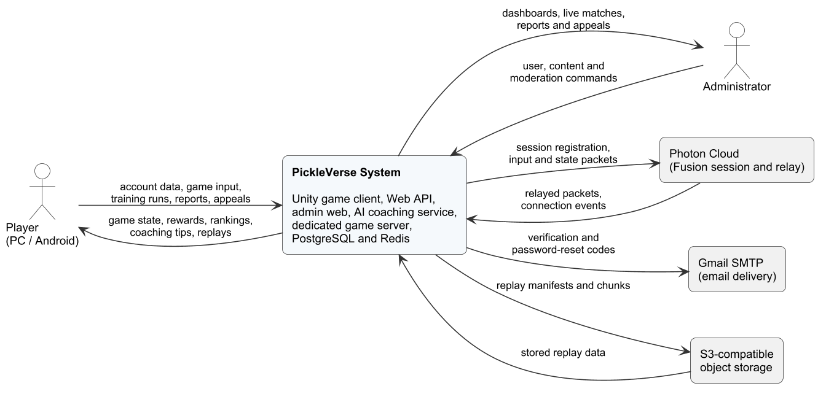
Figure 1. Context diagram of PickleVerse release 1.0
Table 1. External entities of the context diagram
External entity | Type | Data exchanged with PickleVerse
Player | Human (Windows PC or Android phone) | Sends account data, game input, training attempts, reports and appeals; receives game state, rewards, rankings, coaching tips and replays
Administrator | Human (web browser) | Sends user, content, match and moderation commands; receives dashboards, live match status, reports, appeals and analytics
Photon Cloud | External real-time service | Receives session registration and input/state packets from the client and the dedicated server; returns relayed packets and connection events
Gmail SMTP | External e-mail service | Receives verification and password-reset messages to deliver to the player's mailbox
S3-compatible object storage | Storage service | Stores replay manifests and compressed replay chunks; returns them for the replay viewer and moderation

2. User Requirements

2.1 Actors
Table 2. Actors
# | Actor | Description
1 | Visitor | A person who uses the game client without being signed in. A visitor can register, verify an e-mail address, sign in, reset a forgotten password and, on a device that has a cached profile, start offline training.
2 | Player | A signed-in user with the Player role and an active account. A player inherits every use case of a visitor and can learn, train, play bot and online matches, view progress, use the shop and the social features, and report other players.
3 | Restricted Player | A player whose account is suspended or banned. After signing in, a restricted player is limited to viewing the sanction decision and submitting one appeal for it.
4 | Administrator | A user with the Admin role who signs in to the administration web application to manage accounts, content, matches, moderation and analytics, and to label coaching sessions as an expert reviewer.
5 | Email Service | Secondary actor (Gmail SMTP) that delivers verification and password-reset codes.
6 | Photon Cloud | Secondary actor that hosts the real-time sessions through which the game client, other players and the dedicated server exchange match packets.

2.2 Use Cases

2.2.1 Diagram(s)
The 68 use cases are grouped into eight packages. Figure 2 gives the package overview; Figures 3 to 11 show each package with its actors and the «include» and «extend» relationships (package P4 is drawn in two parts for readability). Player and Restricted Player are specialisations of Visitor, so they inherit the visitor use cases.
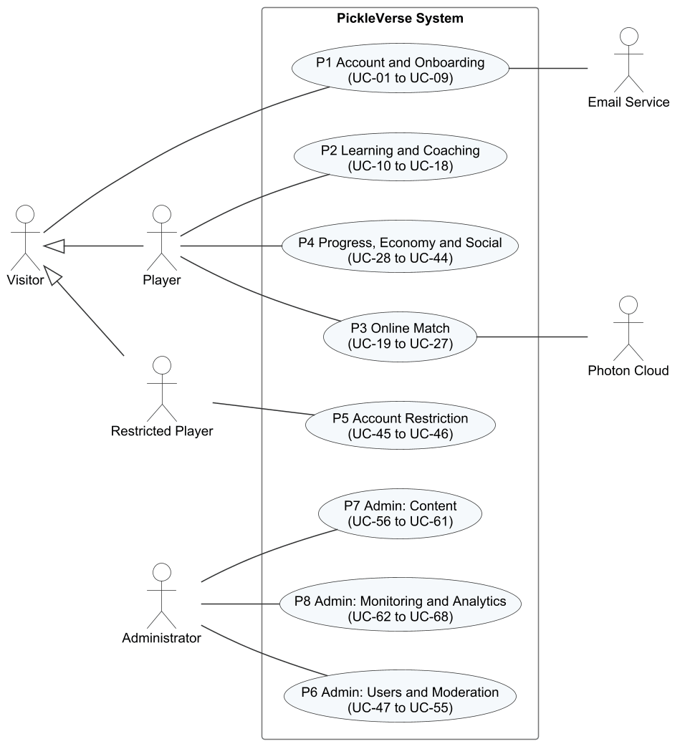
Figure 2. Use case overview by package
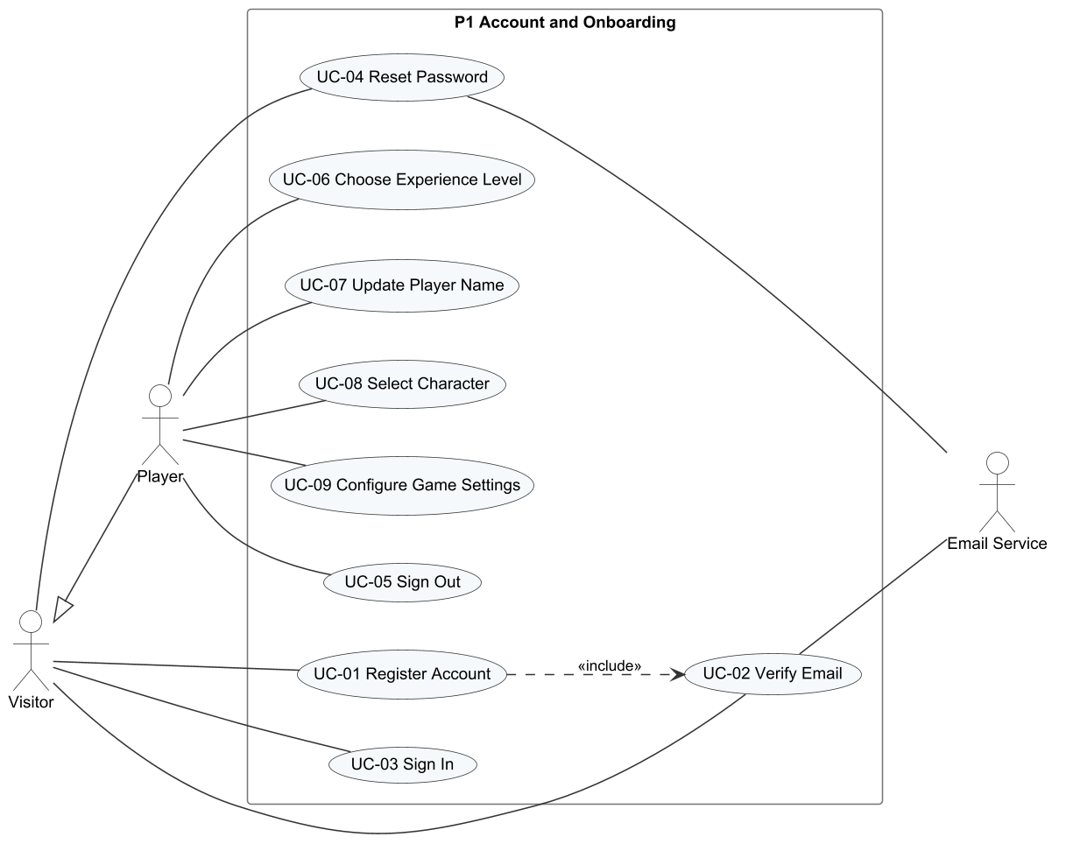
Figure 3. Use case diagram P1 – Account and Onboarding
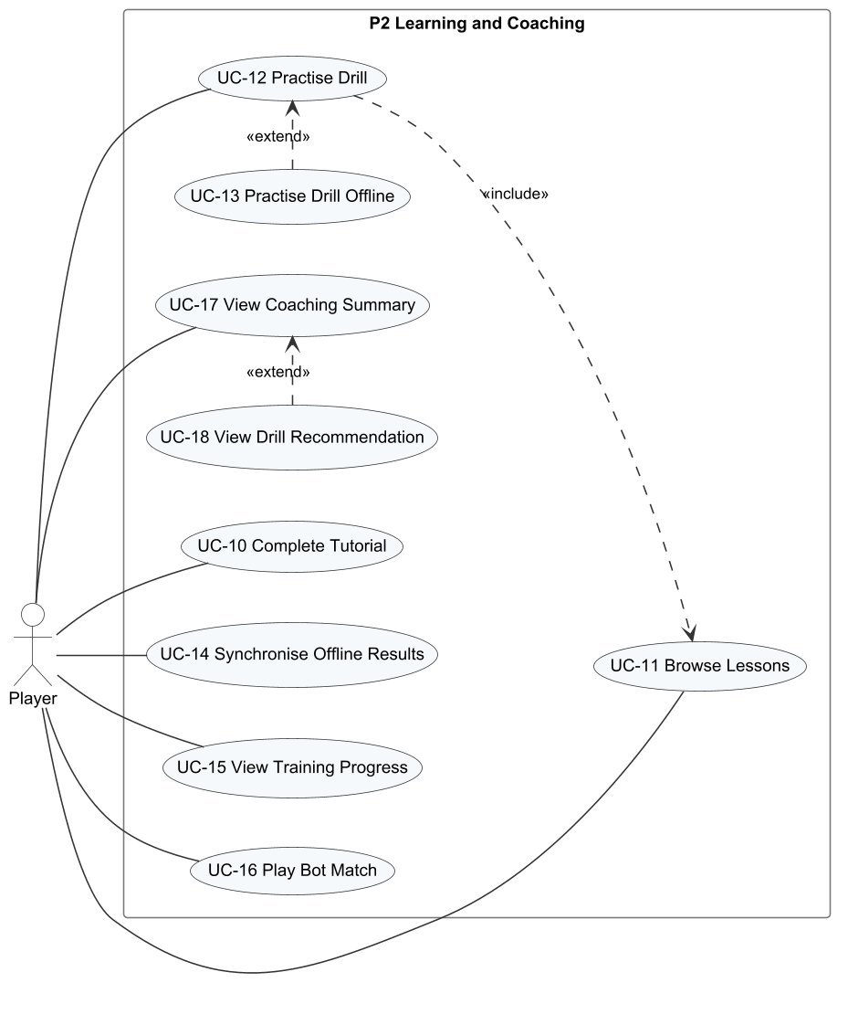
Figure 4. Use case diagram P2 – Learning and Coaching
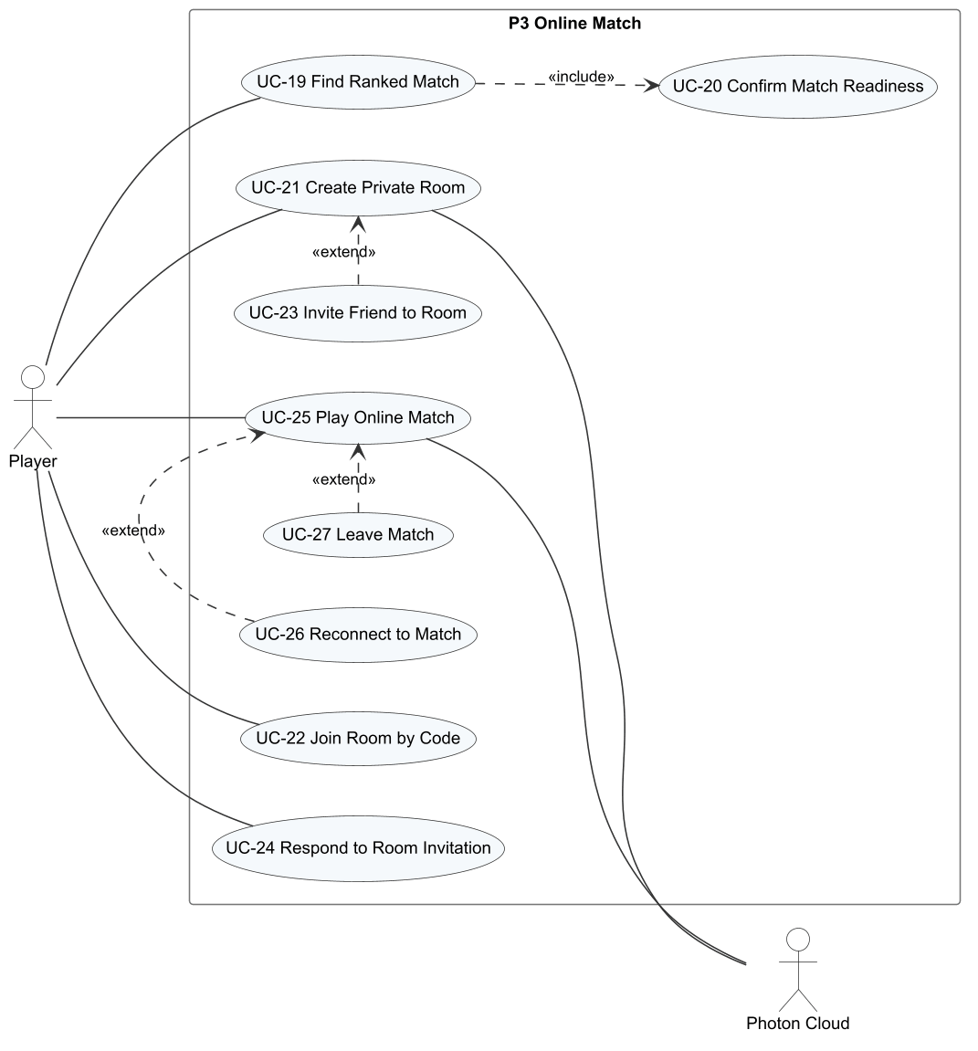
Figure 5. Use case diagram P3 – Online Match
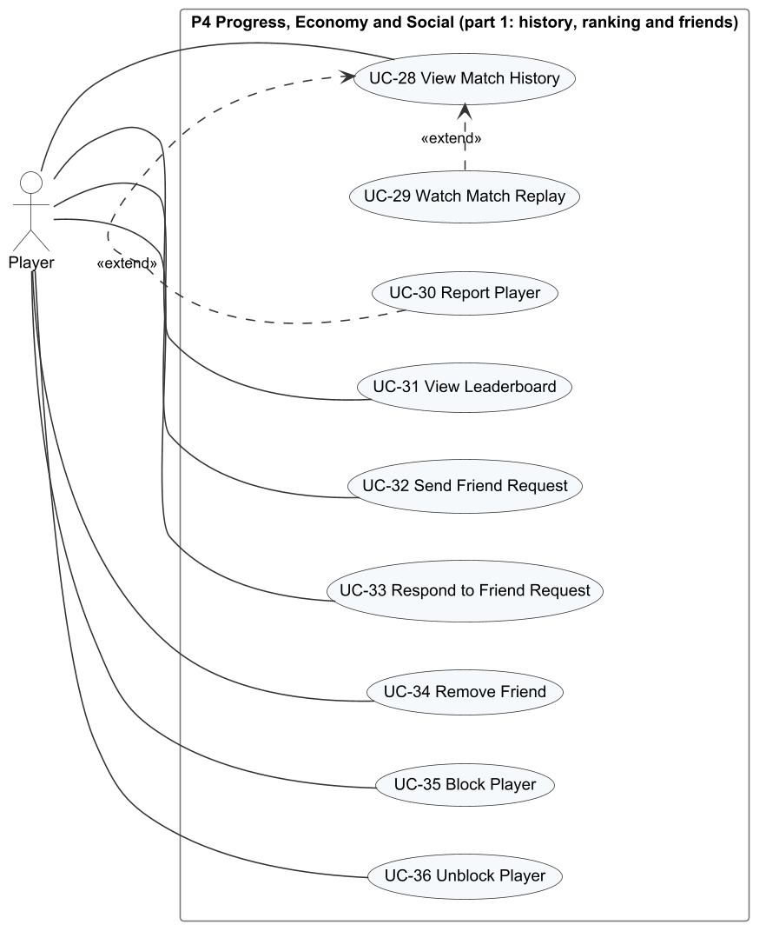
Figure 6. Use case diagram P4 (part 1) – History, Ranking and Friends
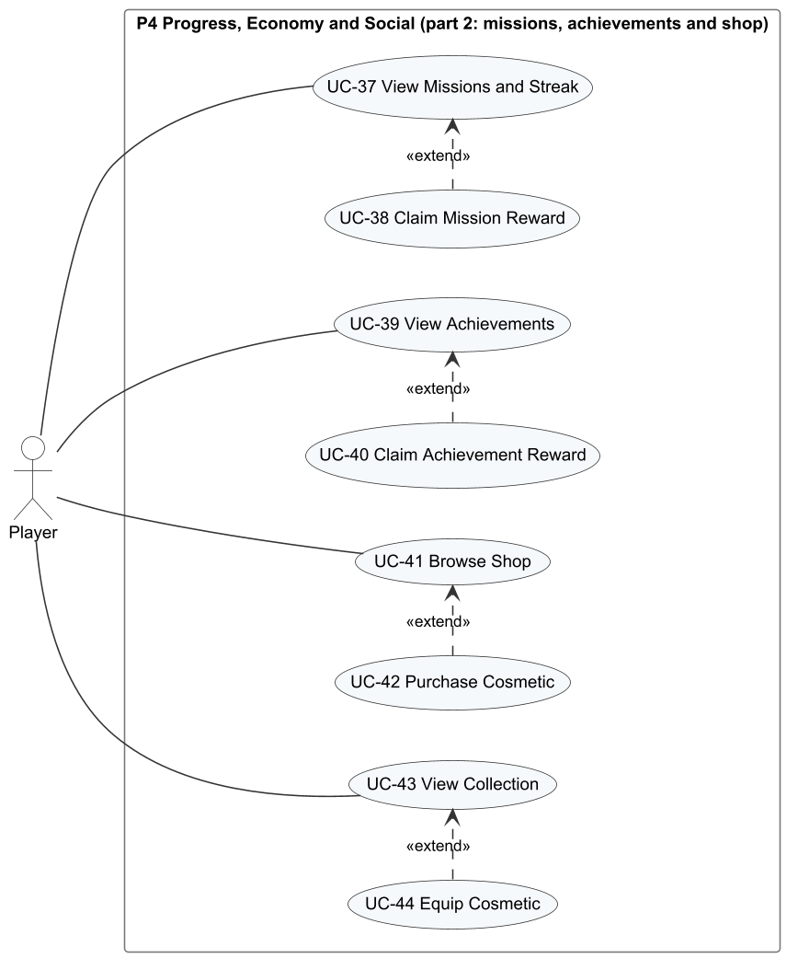
Figure 7. Use case diagram P4 (part 2) – Missions, Achievements and Shop
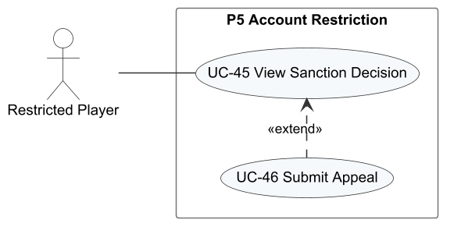
Figure 8. Use case diagram P5 – Account Restriction
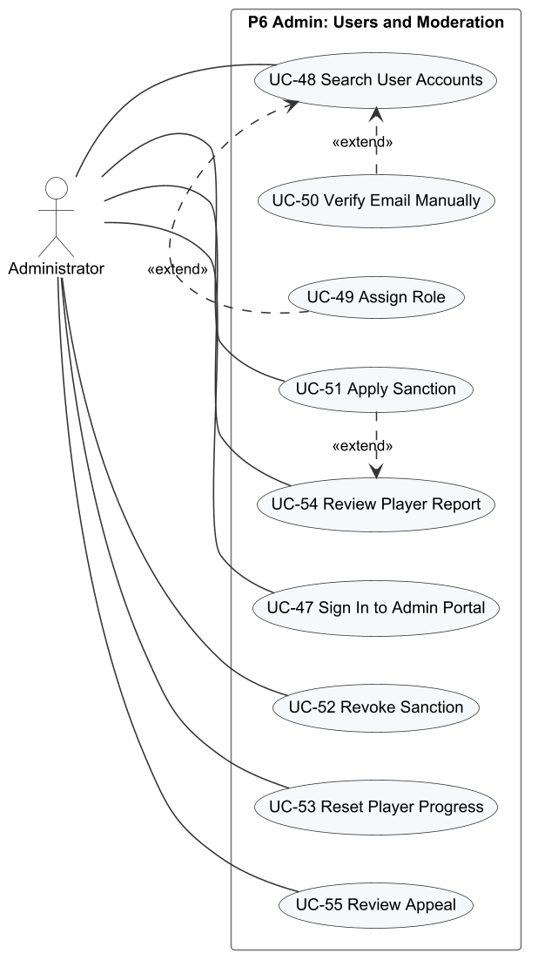
Figure 9. Use case diagram P6 – Admin: Users and Moderation
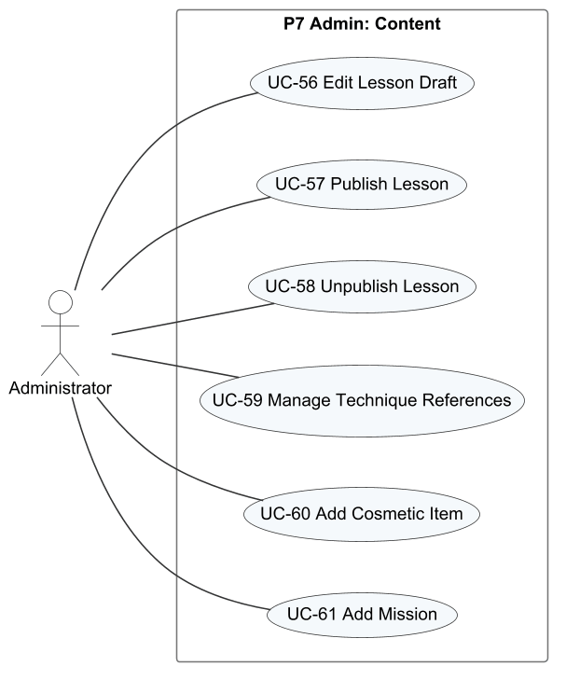
Figure 10. Use case diagram P7 – Admin: Content
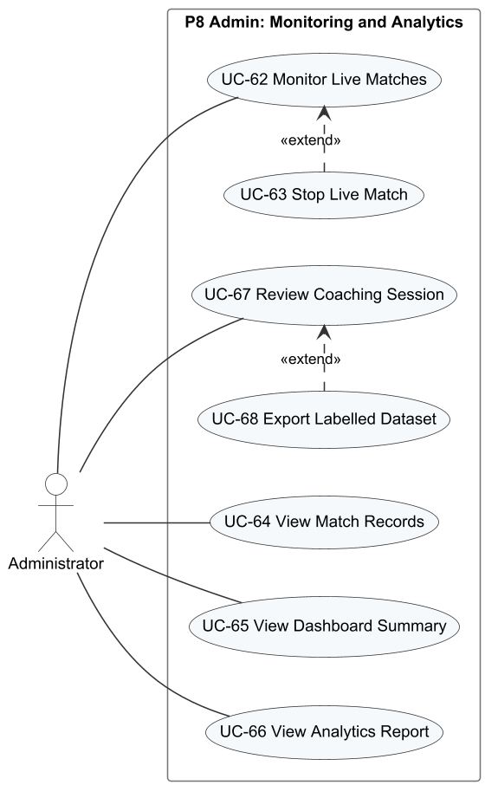
Figure 11. Use case diagram P8 – Admin: Monitoring and Analytics

2.2.2 Descriptions
Table 3. Use case descriptions
ID | Use Case | Actors | Use Case Description | FR
UC-01 | Register Account | Visitor | The visitor creates an account with an e-mail address and a password; the system sends a six-digit code to that address. | FR-01
UC-02 | Verify Email | Visitor, Email Service | The visitor enters the code received by e-mail to activate the account, or asks for a new code. | FR-01
UC-03 | Sign In | Visitor | The visitor signs in with e-mail and password and is taken to the menu with the saved profile. | FR-02
UC-04 | Reset Password | Visitor, Email Service | The visitor receives a reset code by e-mail and sets a new password; all existing sessions are revoked. | FR-03
UC-05 | Sign Out | Player | The player ends the session on the device. | FR-02
UC-06 | Choose Experience Level | Player | At the first sign-in the player states whether they are new to pickleball, which decides whether the tutorial starts. | FR-04
UC-07 | Update Player Name | Player | The player changes the display name shown to other players. | FR-04
UC-08 | Select Character | Player | The player chooses the male or female character used in matches. | FR-04
UC-09 | Configure Game Settings | Player | The player adjusts audio, graphics, key bindings and the touch layout. | FR-05
UC-10 | Complete Tutorial | Player | The player follows the 17-step tutorial on the court, rules and controls. | FR-06
UC-11 | Browse Lessons | Player | The player views the lesson catalogue by group, with stars and lock status. | FR-07
UC-12 | Practise Drill | Player | The player plays the drill of an unlocked lesson and receives a score of 0 to 3 stars. | FR-08
UC-13 | Practise Drill Offline | Player | Without a connection, the player practises a cached drill; the result is stored for later synchronisation. | FR-09
UC-14 | Synchronise Offline Results | Player | When online again, the stored offline results are sent and applied exactly once. | FR-09
UC-15 | View Training Progress | Player | The player reviews passed lessons, practice time, common errors and post-session feedback. | FR-10
UC-16 | Play Bot Match | Player | The player configures and plays a singles match against a computer opponent. | FR-11, FR-12, FR-13
UC-17 | View Coaching Summary | Player | After a drill or match the player reads the analysis of their shots and the main errors. | FR-19
UC-18 | View Drill Recommendation | Player | The player opens a recommended drill that targets a detected weakness. | FR-19
UC-19 | Find Ranked Match | Player | The player joins the ranked singles queue and is paired with an opponent of similar Elo, or with a bot after 180 seconds. | FR-14
UC-20 | Confirm Match Readiness | Player | Each paired player accepts the match within 10 seconds before it starts. | FR-14
UC-21 | Create Private Room | Player, Photon Cloud | The player creates a singles or doubles room identified by a room code. | FR-15
UC-22 | Join Room by Code | Player | The player joins a friend's room by typing its code. | FR-15
UC-23 | Invite Friend to Room | Player | The host invites an online friend into the room. | FR-15
UC-24 | Respond to Room Invitation | Player | The invited player accepts or declines the invitation. | FR-15
UC-25 | Play Online Match | Player, Photon Cloud | The players play a match whose rules and score are decided by the dedicated server. | FR-16
UC-26 | Reconnect to Match | Player | After a disconnection the player rejoins the same match within the reconnection window. | FR-17
UC-27 | Leave Match | Player | The player leaves a match before it ends and accepts the consequences. | FR-17
UC-28 | View Match History | Player | The player views the last 20 matches with result, score and Elo change. | FR-24
UC-29 | Watch Match Replay | Player | The player watches the replay of one of their own matches with pause, seek and speed control. | FR-24
UC-30 | Report Player | Player | The player reports an opponent from a finished match with a reason. | FR-27
UC-31 | View Leaderboard | Player | The player views players ordered by Elo and their own position. | FR-26
UC-32 | Send Friend Request | Player | The player searches by name or ID and sends a friend request. | FR-25
UC-33 | Respond to Friend Request | Player | The player accepts or declines a received request. | FR-25
UC-34 | Remove Friend | Player | The player removes a friend from the friend list. | FR-25
UC-35 | Block Player | Player | The player blocks another player, which removes friendship and prevents requests and invitations. | FR-25
UC-36 | Unblock Player | Player | The player removes a block. | FR-25
UC-37 | View Missions and Streak | Player | The player views daily and weekly missions, their progress and the daily streak. | FR-21
UC-38 | Claim Mission Reward | Player | The player claims the reward of a completed mission or mission set once. | FR-21
UC-39 | View Achievements | Player | The player views achievement progress. | FR-21
UC-40 | Claim Achievement Reward | Player | The player claims the reward of a completed achievement once. | FR-21
UC-41 | Browse Shop | Player | The player views cosmetic items with their prices and currencies. | FR-22
UC-42 | Purchase Cosmetic | Player | The player buys an item with in-game currency. | FR-22
UC-43 | View Collection | Player | The player views owned cosmetic items. | FR-23
UC-44 | Equip Cosmetic | Player | The player equips an owned paddle, which is then shown in matches. | FR-23
UC-45 | View Sanction Decision | Restricted Player | The restricted player reads the restriction type, reason and expiry. | FR-28
UC-46 | Submit Appeal | Restricted Player | The restricted player submits one written appeal against a sanction. | FR-28
UC-47 | Sign In to Admin Portal | Administrator | The administrator signs in to the web application; only the Admin role is accepted. | FR-29
UC-48 | Search User Accounts | Administrator | The administrator searches and filters accounts by text and status. | FR-29
UC-49 | Assign Role | Administrator | The administrator changes the role of an account between Player and Admin. | FR-29
UC-50 | Verify Email Manually | Administrator | The administrator activates an account whose verification e-mail could not be delivered. | FR-29
UC-51 | Apply Sanction | Administrator | The administrator suspends or bans an account with a reason, optionally from a report. | FR-29, FR-30
UC-52 | Revoke Sanction | Administrator | The administrator lifts an active sanction with a reason. | FR-29
UC-53 | Reset Player Progress | Administrator | The administrator previews and resets selected progress groups of a player. | FR-29
UC-54 | Review Player Report | Administrator | The administrator examines a report with match evidence and accepts or declines it. | FR-30
UC-55 | Review Appeal | Administrator | The administrator accepts or declines an appeal; acceptance revokes the related sanction. | FR-30
UC-56 | Edit Lesson Draft | Administrator | The administrator creates or edits a lesson and saves it as a draft. | FR-31
UC-57 | Publish Lesson | Administrator | The administrator publishes the saved draft so that new attempts use it. | FR-31
UC-58 | Unpublish Lesson | Administrator | The administrator hides a published lesson from players. | FR-31
UC-59 | Manage Technique References | Administrator | The administrator maintains the reference values used to judge each technique. | FR-31
UC-60 | Add Cosmetic Item | Administrator | The administrator adds an item to the shop with type, price and currency. | FR-31
UC-61 | Add Mission | Administrator | The administrator creates a daily or weekly mission with target and reward. | FR-31
UC-62 | Monitor Live Matches | Administrator | The administrator watches active matches with score and connection status refreshed every 5 seconds. | FR-32
UC-63 | Stop Live Match | Administrator | The administrator stops a dedicated-server match with a reason. | FR-32
UC-64 | View Match Records | Administrator | The administrator browses finished and interrupted matches. | FR-32
UC-65 | View Dashboard Summary | Administrator | The administrator sees today's key figures and items that need action. | FR-32
UC-66 | View Analytics Report | Administrator | The administrator views active users, retention, lesson pass rates, technique errors and matchmaking health for a date range. | FR-32
UC-67 | Review Coaching Session | Administrator | Acting as expert, the administrator inspects shot evidence of a training session and labels the player level and errors. | FR-33
UC-68 | Export Labelled Dataset | Administrator | The administrator exports the labelled sessions used to evaluate the AI coaching quality. | FR-33

3. Functional Requirements

3.1 System Functional Overview

3.1.1 Screens Flow
Figure 12 shows the screens of the game client and how a player moves between them; Figure 13 shows the administration web application. Rounded white boxes marked [popup], [dialog], [drawer] or [overlay] are windows opened above another screen; the other boxes are full scenes or pages.
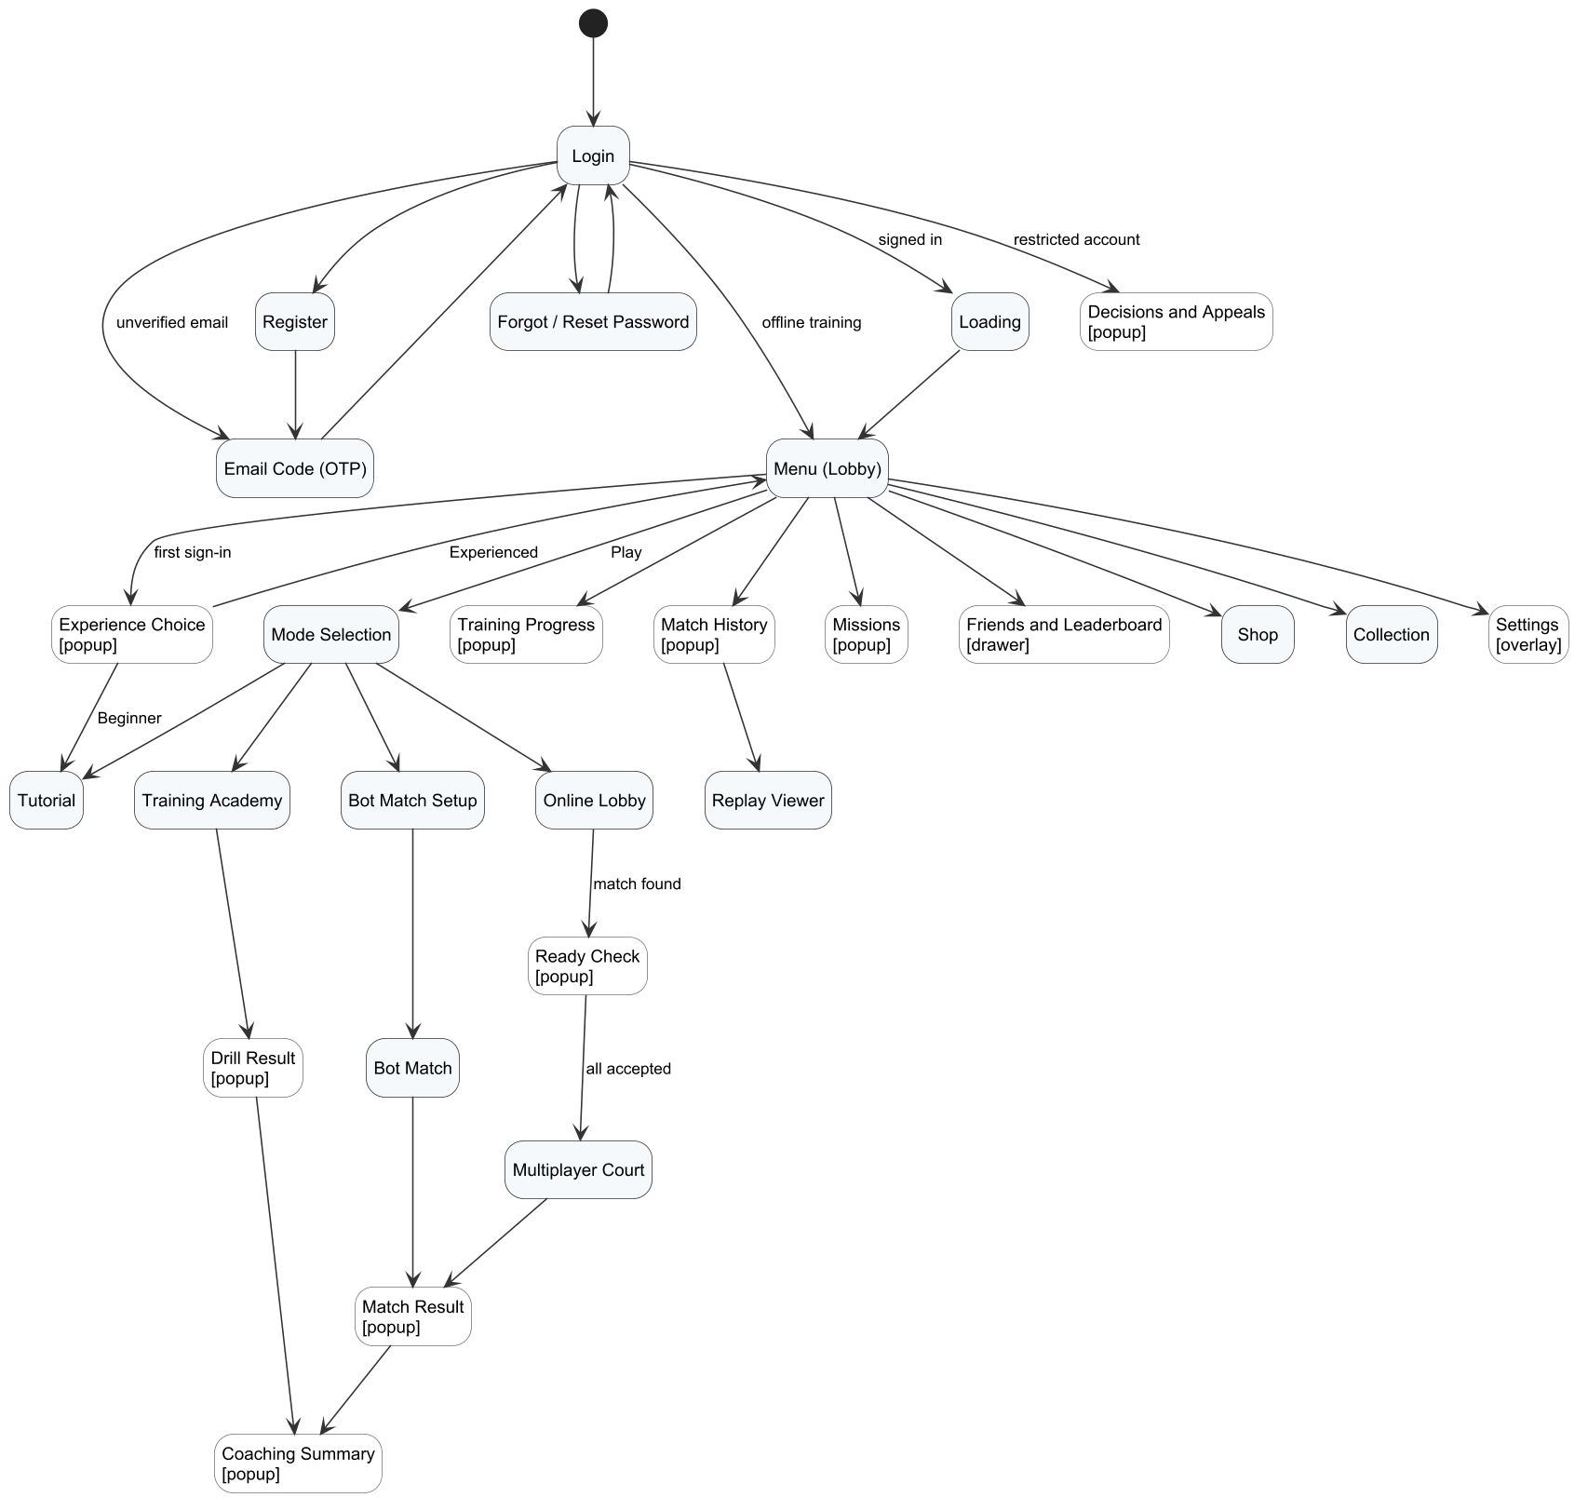
Figure 12. Screen flow of the game client
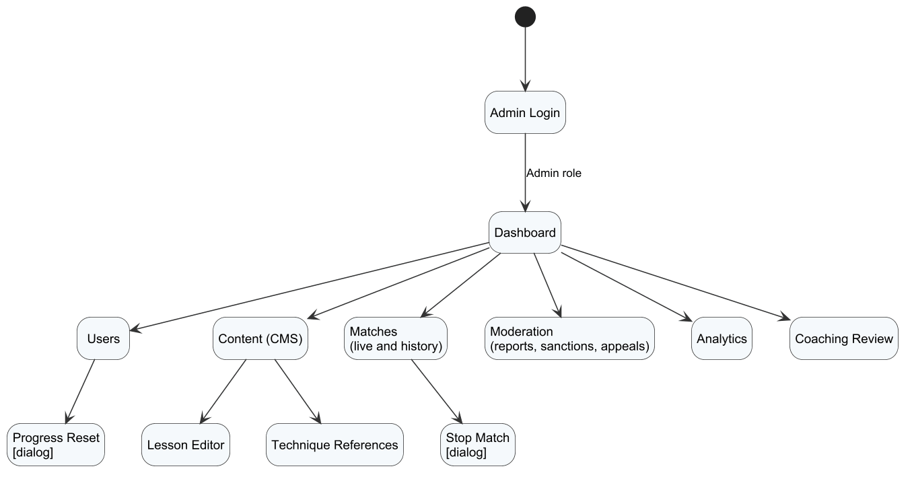
Figure 13. Screen flow of the administration web application

3.1.2 Screen Descriptions
Table 4. Screen descriptions
# | Feature | Screen | Description
1 | FE-01 | Login | E-mail and password fields with a show/hide control, the Sign in button, links to e-mail verification, password recovery and registration, and an Offline training button when a profile is cached on the device.
2 | FE-01 | Register | E-mail, password and password confirmation fields with inline validation and the Create account button.
3 | FE-01 | Email Verification (OTP) | Six-digit code field, Verify and Resend code buttons, and a link back to sign-in.
4 | FE-01 | Forgot / Reset Password | Step 1 asks for the e-mail address; step 2 asks for the reset code, the new password and its confirmation.
5 | FE-01 | Loading | Animated artwork while the profile, wallet, content catalogue and settings are loaded.
6 | FE-01 | Experience Choice [popup] | Asked once at the first sign-in: "Bạn đã quen với pickleball chưa?" with Beginner and Experienced options.
7 | FE-01 | Menu (Lobby) | 3D court with the player's character; name tag with level, rank and Elo; Tokenpad and Elite Token balances; male/female selector; music player; Play button; buttons for Progress, History, Missions, Collection, Shop and Settings; friend drawer; Decisions and Appeals button.
8 | FE-01 | Settings [overlay] | Tabs Overview (with Sign out), Audio, Graphics and Controls (key binding and touch layout); Restore defaults, Undo and Apply and save buttons.
9 | FE-02 | Tutorial | Seventeen steps on the court; each step has a title, an explanation and a demonstration, with Continue, Replay and Later buttons.
10 | FE-02 | Mode Selection | Four cards – Bot match, Online match, Training and Create room – and a Tutorial strip.
11 | FE-02 | Training Academy | Lesson catalogue with group tabs (All, Basic, Control, Advanced, Doubles); lesson briefing with target, reward and star rules; practice HUD with shot counter, timing feedback and key hints.
12 | FE-02 | Drill Result [popup] | Stars, accuracy (hits in target / shots), mean timing error, practice time, most frequent error with a tip, and Retry, Next lesson and Lesson list buttons.
13 | FE-02 | Training Progress [popup] | Passed lessons out of 15, next lesson, post-session feedback, practice time, most frequent error, and per-lesson best result with a Retry button.
14 | FE-03 | Bot Match Setup | Difficulty (Easy, Medium, Hard, Adaptive), time of day (day, night) and court (professional, outdoor), with a summary line and the Enter court button.
15 | FE-03 | Bot Match | Court with both players, score and serving side, serve timer, fault banners, time-out control, key hints and the pause/settings overlay.
16 | FE-03 | Match Result [popup] | Winner, game scores, Tokenpad and XP earned, Elo change for ranked matches, and Play again, Mode selection and View analysis buttons.
17 | FE-05 | Coaching Summary [popup] | Counts of shots, contacts and serves; main errors with their frequency; up to three recommended drills with a Practise now link.
18 | FE-04 | Online Lobby | Room code field, Join by code button, Singles 1v1 and Doubles 2v2 buttons, roster slots, friend invitation list and the Find match / Cancel button with an elapsed-time counter.
19 | FE-04 | Ready Check [popup] | Match found message with Accept and Decline buttons and a 10-second countdown.
20 | FE-04 | Multiplayer Court | Online match on the dedicated server with score, connection state, reconnecting overlay and leave control.
21 | FE-07 | Match History [popup] | Level card and the last 20 matches with opponent, mode, Vietnam time, result, game score, Elo change, and Report and Replay buttons.
22 | FE-07 | Replay Viewer | Playback of a recorded match with play/pause, a seek bar and speeds from 0.5× to 2×.
23 | FE-06 | Missions [popup] | Daily and weekly tabs, mission list with progress and reward, set bonus, daily streak, reset countdown, and Claim buttons.
24 | FE-07 | Friends and Leaderboard [drawer] | Friends tab with search by name or ID and sub-tabs Friends, Find friends and Blocked; Leaderboard tab with own position.
25 | FE-06 | Shop | Featured and all items, item preview, price in Tokenpad and/or Elite Token, wallet balances and the Buy button.
26 | FE-06 | Collection | Owned paddles with preview and the Equip button.
27 | FE-08 | Decisions and Appeals [popup] | List of sanctions on the account with type, reason and expiry; appeal form and appeal status.
28 | FE-08 | Report Player [dialog] | Opened from a history entry: reported player, match, reason field and Send button.
29 | FE-09 | Admin Login | Account or e-mail and password fields and the Authenticate button; only Admin accounts are accepted.
30 | FE-09 | Dashboard | Total users, daily active users, matches played, online time, pending reports, technique-error heat map and quick links.
31 | FE-09 | Users | Search and status filter; table of player and e-mail, role, status, Elo, play time and creation date; actions to assign a role, sanction, verify e-mail and reset progress.
32 | FE-09 | Progress Reset [dialog] | Selection of LEARNING, RANKING, MISSIONS and ECONOMY groups, an impact preview and the Reset button.
33 | FE-09 | Content (CMS) | Lesson manager (draft, publish, unpublish), drill form, shop item form, mission form and technique references.
34 | FE-09 | Matches | Live matches refreshed every 5 seconds with score and connection state, match history, and a Stop match dialog that requires a reason.
35 | FE-09 | Moderation | Reports, sanctions and appeals with match evidence and replay download, decision form and decision reason.
36 | FE-09 | Analytics | Date range in Vietnam time; daily active players, retention cohorts, popular lessons with pass rate, technique-error heat map and matchmaking health.
37 | FE-10 | Expert Review | Training sessions with shot-by-shot evidence, level and error labels, data group (training, calibration, holdout) and export.

3.1.3 Screen Authorization
X means that the role may open the screen or perform the activity. Visitor is a user who has not signed in; Restricted Player is a signed-in player with a suspended or banned account. The Web API enforces the same rules: a missing or expired token returns HTTP 401, and a valid token without the required role or scope returns HTTP 403.
Table 5. Screen authorization
Screen / Activity | Visitor | Player | Restricted Player | Administrator
Login, Register, Email Verification, Forgot Password | X
Start offline training from a cached profile | X | X
Menu, Settings, Mode Selection, Tutorial |  | X
Update name, select character, sign out |  | X
Training Academy, Drill Result, Training Progress |  | X
Bot Match Setup, Bot Match, Match Result, Coaching Summary |  | X
Online Lobby, Ready Check, Multiplayer Court |  | X
Create room, invite friend, start a custom match (host only) |  | X
Match History, Replay Viewer |  | X
Query own matches and replays only |  | X
Report a player of an own finished match |  | X
Missions, Shop, Collection |  | X
Claim rewards, purchase and equip own items |  | X
Friends and Leaderboard |  | X
Decisions and Appeals |  | X | X
Submit an appeal for an own sanction |  |  | X
Admin Login |  |  |  | X
Dashboard, Analytics |  |  |  | X
Users |  |  |  | X
Query all accounts |  |  |  | X
Assign role, verify e-mail, apply and revoke sanctions (not own account) |  |  |  | X
Preview and reset player progress |  |  |  | X
Content (CMS) |  |  |  | X
Add and update lessons, references, items and missions; publish and unpublish |  |  |  | X
Matches |  |  |  | X
Stop a live dedicated-server match |  |  |  | X
Moderation |  |  |  | X
Decide reports and appeals |  |  |  | X
Expert Review |  |  |  | X
Save expert labels and export the dataset |  |  |  | X

3.1.4 Non-Screen Functions
Table 6. Non-screen functions
# | Feature | System Function | Description
1 | FE-01 | Send verification and reset e-mails | Generates a six-digit code, stores only its HMAC, and sends the message through Gmail SMTP (STARTTLS) from a background mail queue.
2 | FE-01 | Refresh access token | Exchanges a valid refresh token for a new access token (2 hours) and a rotated refresh token (14 days); revoked or reused tokens are rejected.
3 | FE-01 | Record activity days | Records each player's login day and active day (Vietnam time) and online presence in Redis for analytics and streaks.
4 | FE-02 | Apply training results | Validates each training attempt from its telemetry, applies stars and first-pass rewards, and returns a receipt APPLIED, DUPLICATE or REJECTED for each request ID.
5 | FE-04 | Ranked matchmaking | Keeps search tickets in a Redis queue, pairs tickets within the Elo window, creates the ready check, and assigns a ranked bot after 180 seconds.
6 | FE-04 | Dedicated server allocation | Issues HMAC-signed match tickets, leases the dedicated server slot, receives heartbeats every 8 seconds and releases expired leases (DedicatedLeaseMonitor).
7 | FE-04 | Settle match result | Saves the game scores once, applies Elo for ranked matches, grants rewards and updates missions and achievements in one transaction.
8 | FE-04 | Store replay | Uploads the replay manifest and compressed chunks to object storage and links them to the match.
9 | FE-05 | Ingest telemetry | Receives shot telemetry parts from the client (or the dedicated server for online matches), stores them and creates an analysis job.
10 | FE-05 | Hybrid AI worker | Sends pending analysis jobs to the AI coaching service, stores the coaching result and retries failed jobs (HybridAiWorker).
11 | FE-05 | AI coaching service | POST /v1/analyze-session: rule-based findings, summary, at most three drill recommendations and, when the gated model is approved, a tier estimate.
12 | FE-06 | Mission cycle | Opens new daily missions at 07:00 Vietnam time each day and new weekly missions each week, and updates the daily streak.
13 | FE-07 | Leaderboard cache | Caches the Elo leaderboard in Redis for 15 seconds.
14 | FE-08 | Sanction expiry | Restores suspended accounts whose sanction has expired (ModerationExpiryWorker).
15 | FE-09 | Analytics projection | Aggregates daily active players, retention cohorts, lesson statistics and matchmaking events (AnalyticsProjectionWorker).
16 | FE-09 | Admin audit | Writes an audit record for every administrative change with actor, action, target and time.

3.1.5 Entity Relationship Diagram
The conceptual ERD is drawn in Chen notation and split into six subject areas so that every diagram stays readable. Entities are business concepts rather than database tables: junction tables appear as relationships with their own attributes (for example PARTICIPATES carries Team and Outcome), and purely technical tables such as refresh tokens and telemetry parts are omitted. The logical design of all 51 tables is given in Report 4, §2.
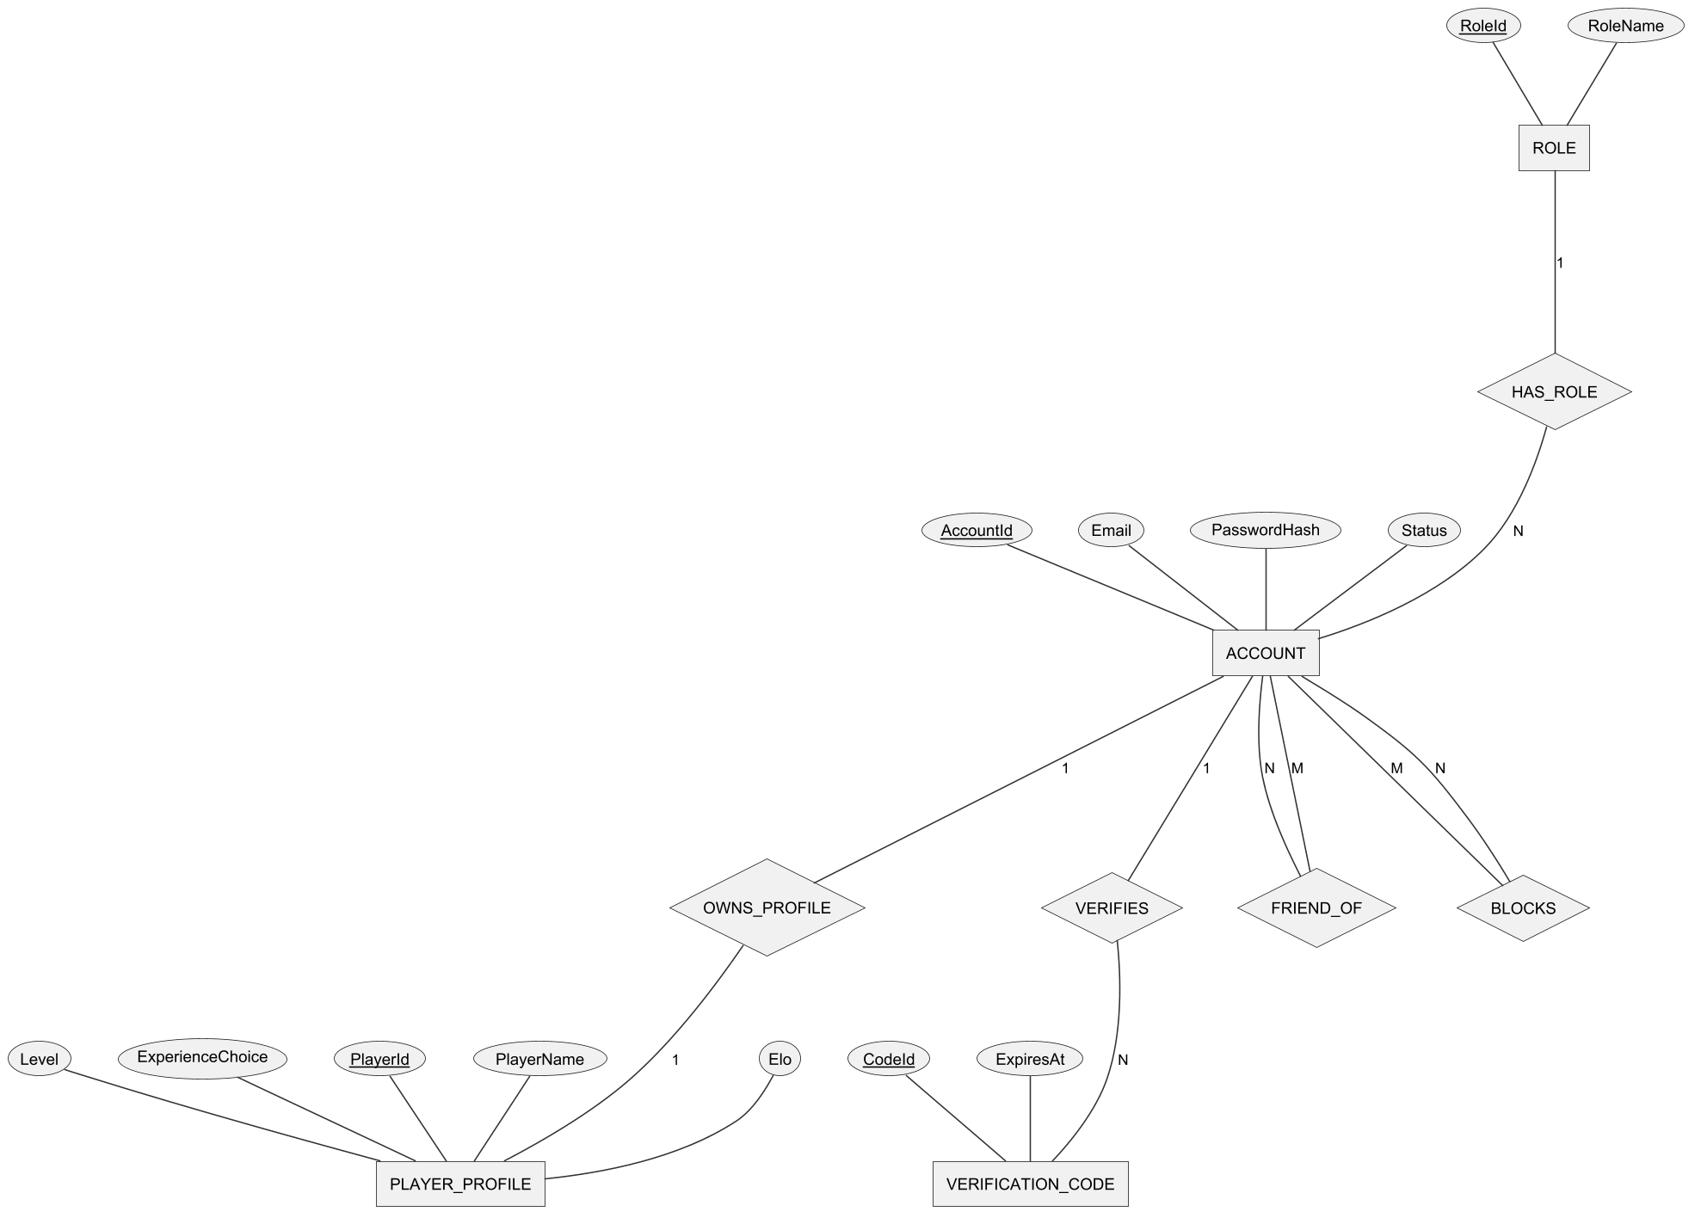
Figure 14. Conceptual ERD – accounts, profiles and social relations
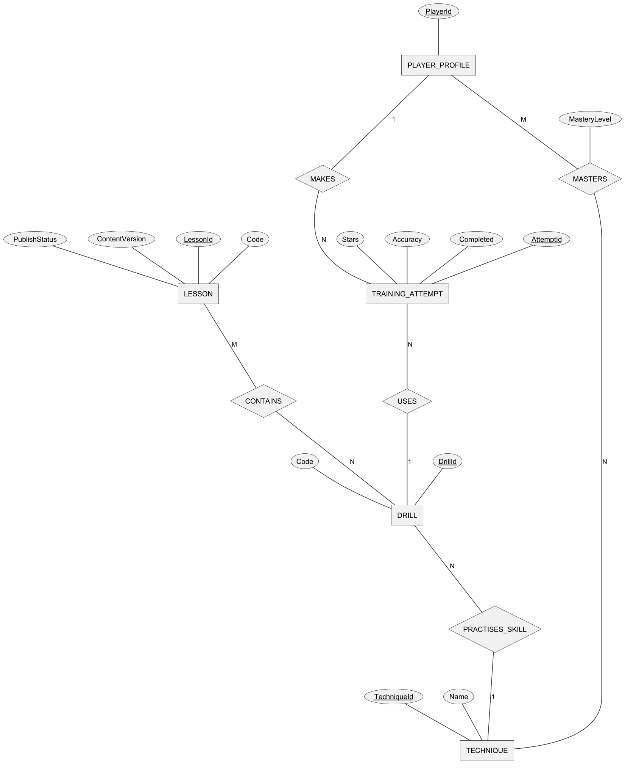
Figure 15. Conceptual ERD – techniques, lessons and training
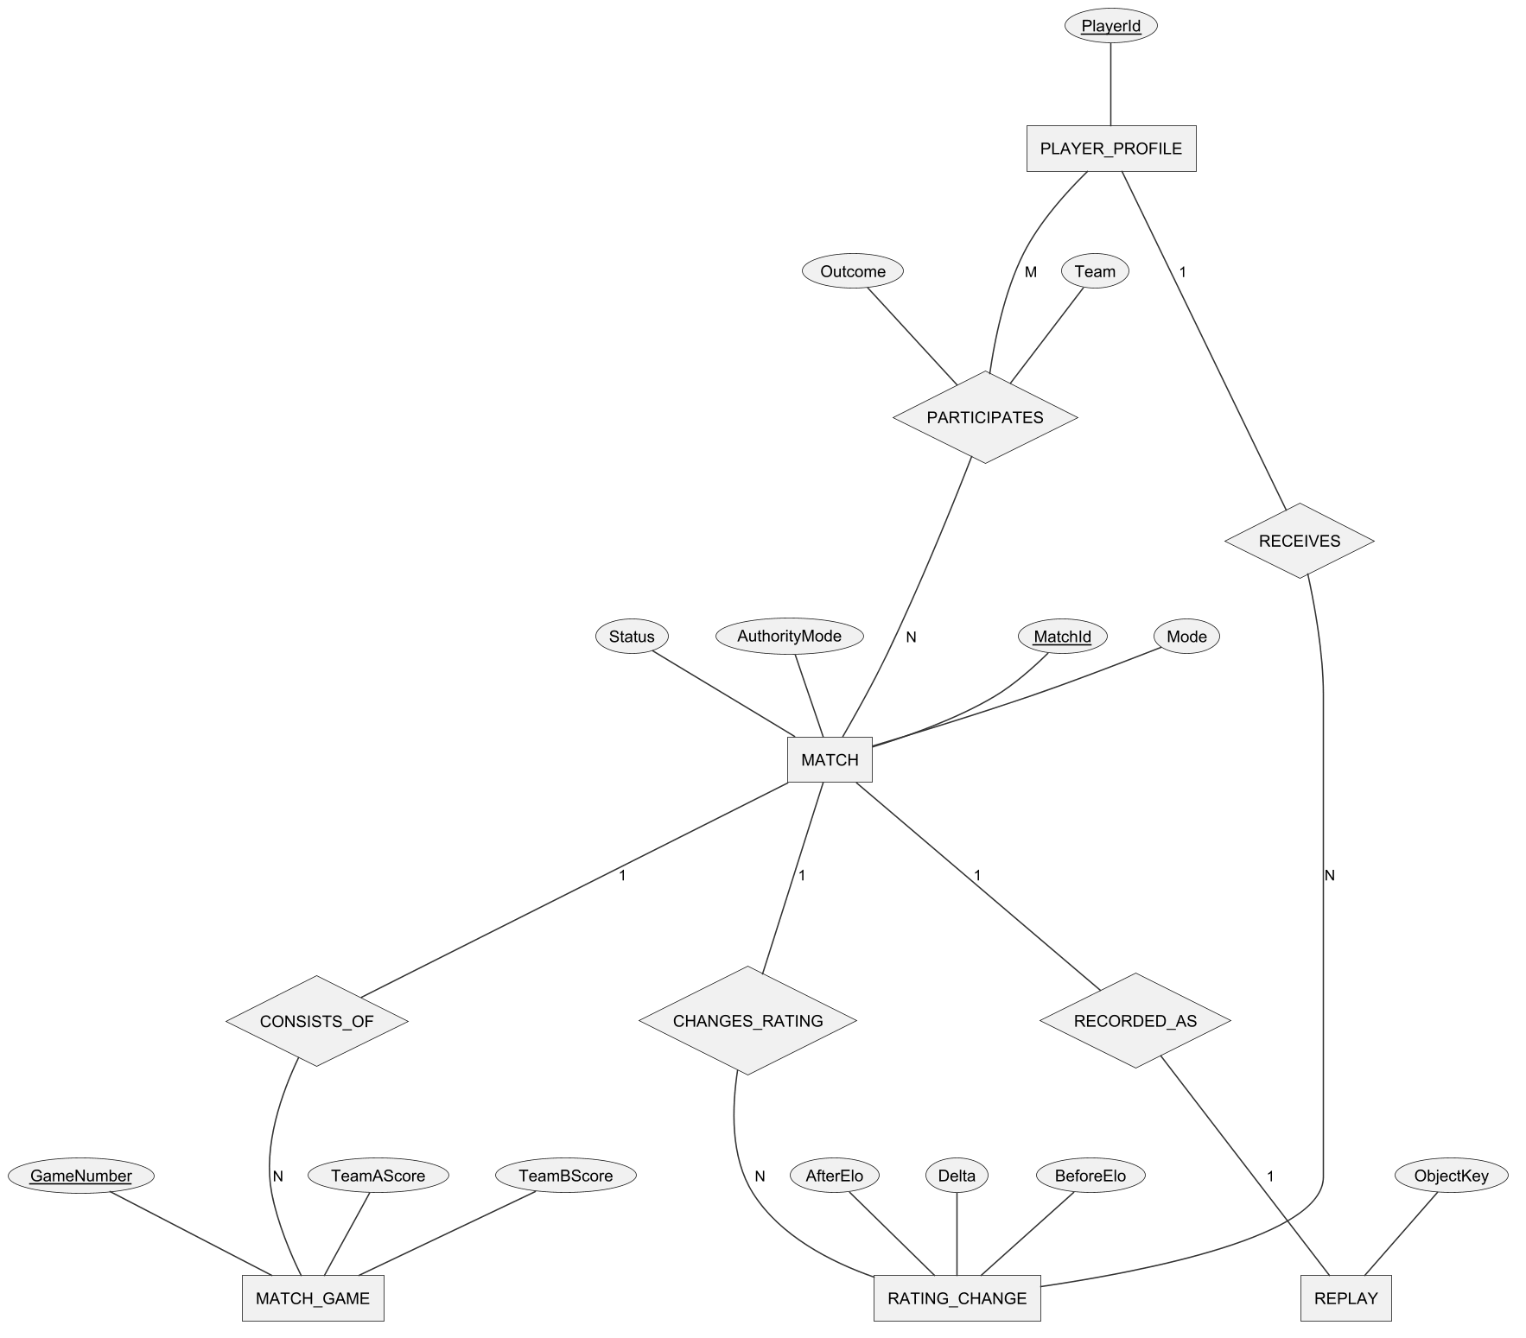
Figure 16. Conceptual ERD – matches, ratings and replays
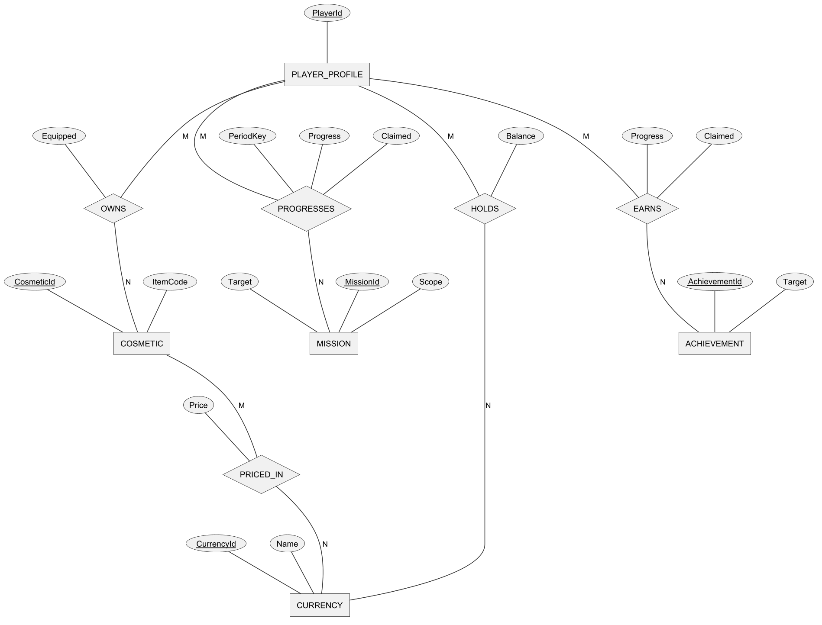
Figure 17. Conceptual ERD – currencies, cosmetics, missions and achievements
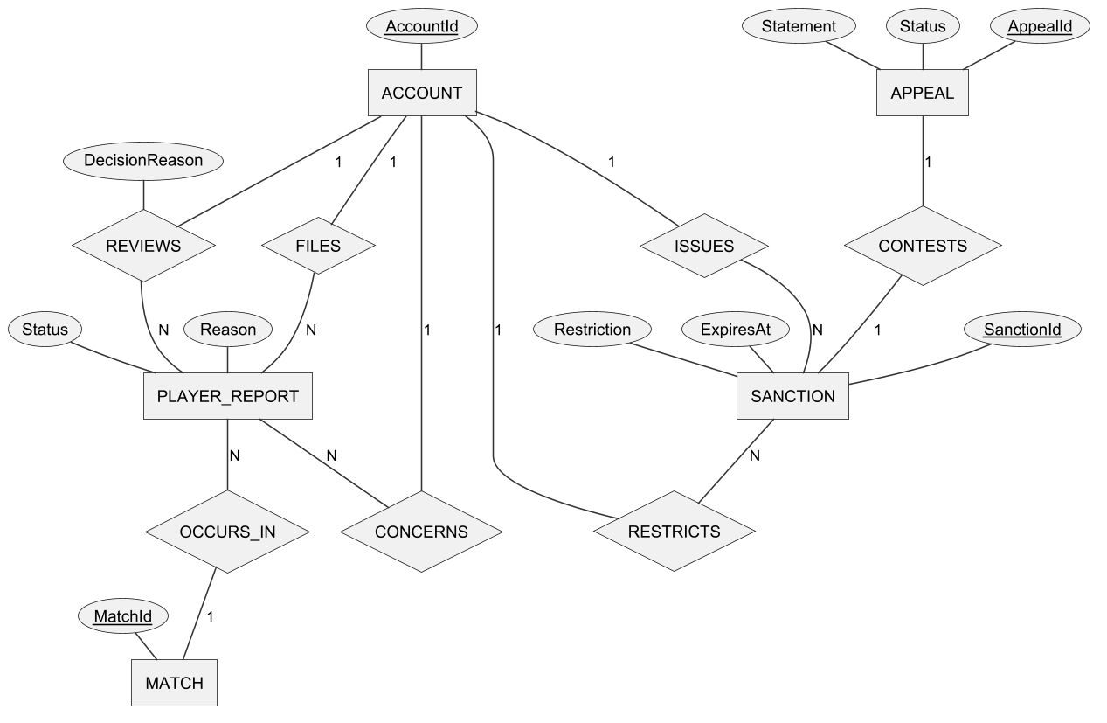
Figure 18. Conceptual ERD – reports, sanctions and appeals
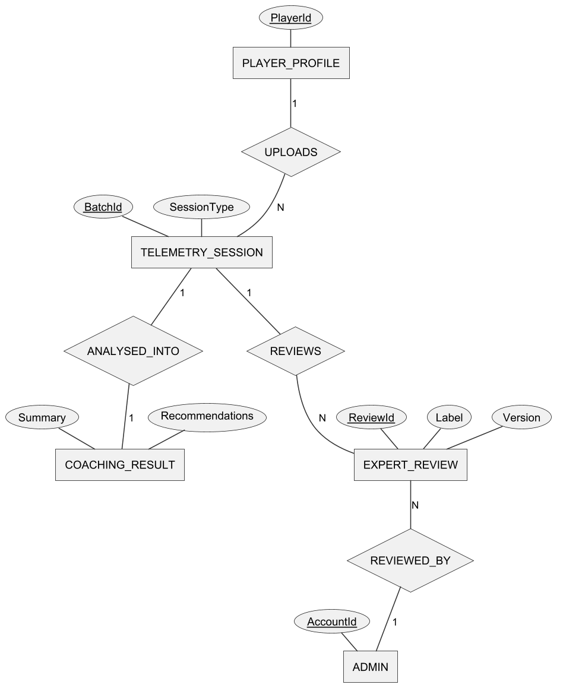
Figure 19. Conceptual ERD – telemetry, coaching and expert review
Entities Description
Table 7. Entities description
# | Entity | Description
1 | ACCOUNT | A registered user identified by e-mail; holds the password hash, status (ACTIVE, SUSPENDED, BANNED) and verification state.
2 | ROLE | Player or Admin; each account has exactly one role.
3 | VERIFICATION_CODE | A one-time code for e-mail verification or password reset, with expiry and remaining attempts.
4 | PLAYER_PROFILE | Game identity of an account: display name, character, level, XP, Elo, onboarding choice and statistics.
5 | TECHNIQUE | A pickleball technique to be learnt (serve, drive, dink, volley, drop, reset, smash, footwork, approach, doubles coverage and transition, modifiers).
6 | LESSON | A unit of the curriculum with code, group, order, target, reward, prerequisite and publication status.
7 | DRILL | An exercise that practises one technique; a lesson contains one or more drills.
8 | TRAINING_ATTEMPT | One run of a drill by a player, with shots, hits, timing, stars and synchronisation receipt.
9 | MATCH | A bot, ranked, matched doubles or custom match with mode, kind, authority mode and status.
10 | MATCH_GAME | One game (1 to 3) of a match with the score of each team; a weak entity identified by match and game number.
11 | RATING_CHANGE | The Elo before, change and after of one player caused by one ranked match.
12 | REPLAY | The stored recording of a match (object key of its manifest).
13 | PLAYER_REPORT | A complaint by one player about another player in a given match, with reason, status and decision.
14 | SANCTION | A suspension (with expiry) or ban applied to an account, with reason, actor and revocation data.
15 | APPEAL | A restricted player's written objection to one sanction, with status and decision.
16 | CURRENCY | In-game currency: Tokenpad (earned by playing) and Elite Token.
17 | COSMETIC | A purchasable or granted item (paddle, outfit, hat) with price and currency.
18 | MISSION | A daily or weekly goal with target and reward.
19 | ACHIEVEMENT | A long-term goal (wins, matches, points, streaks) with a one-time reward.
20 | TELEMETRY_SESSION | The shot-level data captured during a drill or match and uploaded for analysis.
21 | COACHING_RESULT | The AI analysis of a telemetry session: findings, summary, recommendations and optional tier.
22 | EXPERT_REVIEW | An expert's labels for a telemetry session (level, errors, data group) used to evaluate the AI.
23 | ADMIN | An account with the Admin role, shown as a separate box in the coaching diagram for readability.

3.2 Account and Onboarding (FE-01)

FR-01 Register Account and Verify Email
Related use cases: UC-01 Register Account, UC-02 Verify Email
Function trigger: Login screen → link "Đăng ký" (Register). The verification page also opens after a successful registration, or from the link "Bạn cần xác thực email?".
Function description: A visitor creates an account with an e-mail address and a password. The client validates the form, the Web API creates the account in the unverified state, stores a hash of a six-digit one-time password (OTP) and queues an e-mail through Gmail SMTP. The visitor enters the OTP to activate the account; after activation the account can sign in.
Screen layout
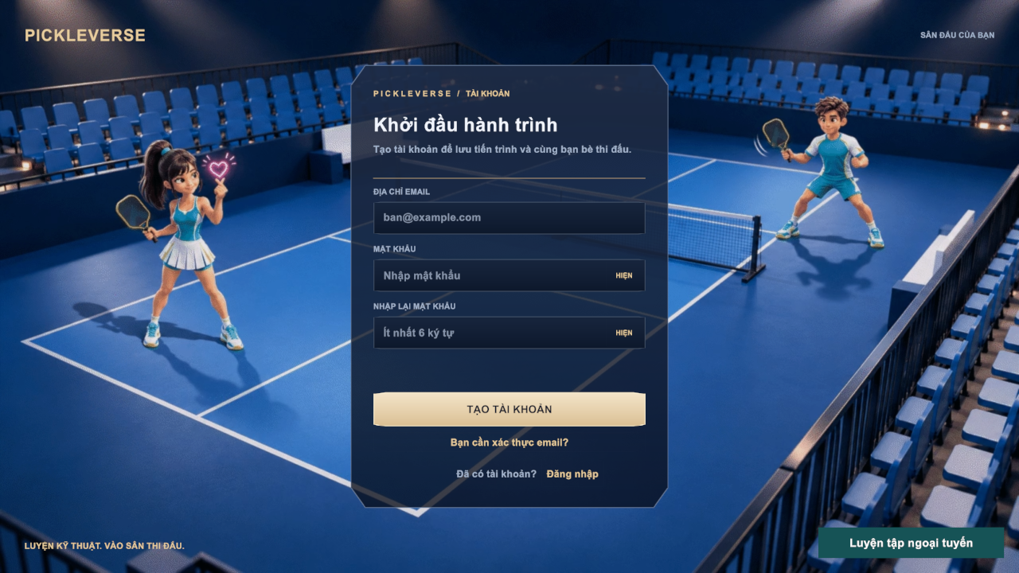
Figure 20. Register screen
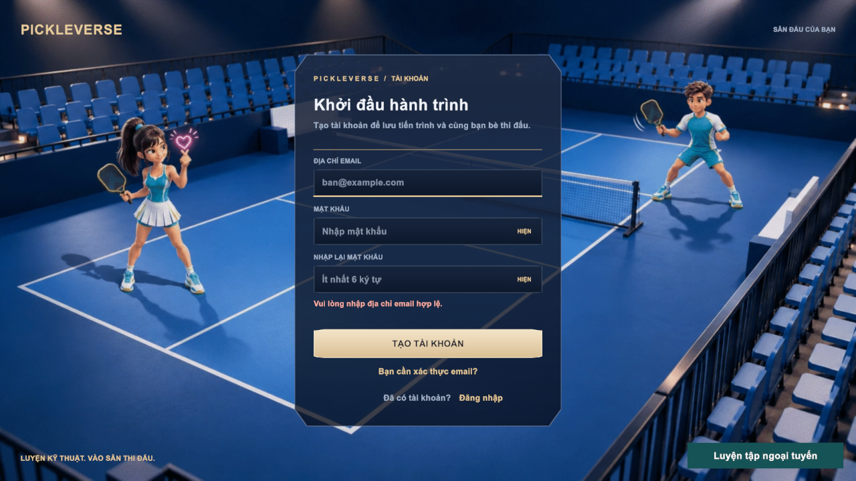
Figure 21. Register screen with an inline validation message
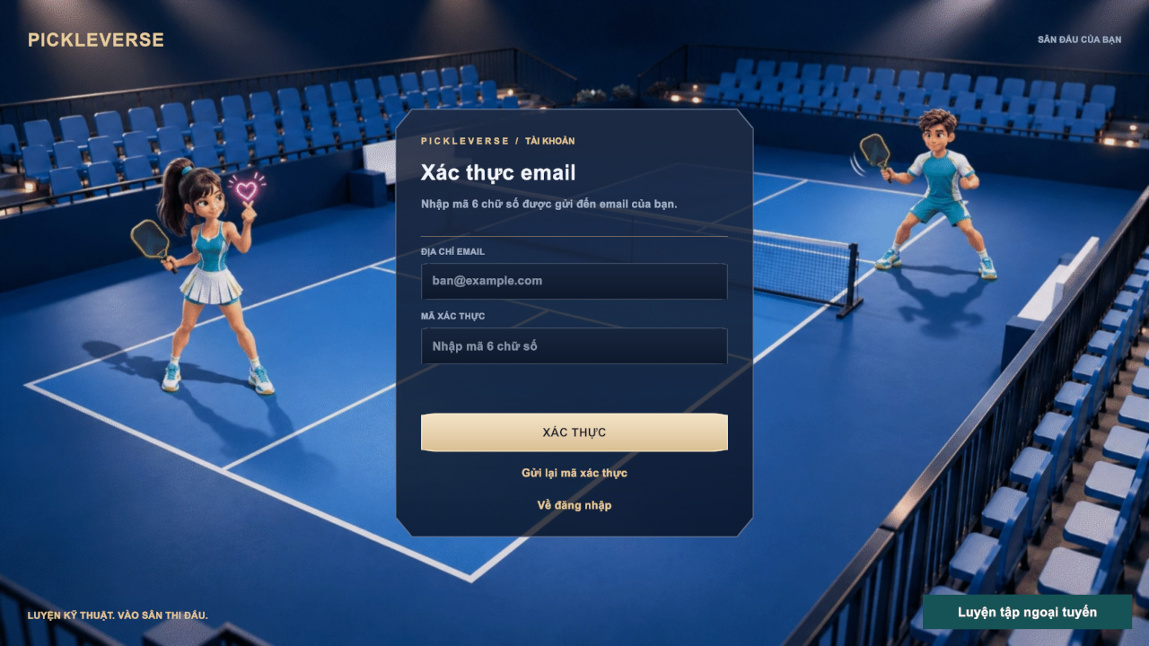
Figure 22. E-mail verification screen
Function details
Table 8. FR-01 data fields
Field | Type | Required | Validation and constraints
Email | Text (≤254) | Yes | Valid e-mail format (MSG01, MSG02); not already registered (MSG06)
Password | Password | Yes | 6–128 characters (MSG03, MSG04, MSG17); show/hide toggle
Confirm password | Password | Yes | Must equal Password (MSG05)
Verification code | Text (6 digits) | Yes | Exactly six digits (MSG08); valid for 10 minutes; at most 5 wrong attempts

Business rules: BR-01, BR-02, BR-03, BR-04.
Normal flow:
1. The visitor enters e-mail, password and confirmation and selects Tạo tài khoản.
2. The client validates the fields; the API creates an ACTIVE but unverified account with the Player role and a player profile.
3. The API sends the OTP e-mail and the client shows MSG07 and the verification page.
4. The visitor enters the six-digit code and selects Xác thực.
5. The API checks the code, marks the e-mail as verified and the client returns to sign-in.
Alternative and exception flows:
• E1 – The e-mail is already registered: MSG06; an unverified owner can use Gửi lại mã xác thực.
• E2 – Resend is requested within 60 seconds of the previous code: HTTP 429 and MSG10.
• E3 – Wrong or expired code: the attempt is counted; after 5 wrong attempts the code is invalid and a new code must be requested.
• E4 – The e-mail cannot be delivered (SMTP not available): MSG22; an administrator can verify the account manually (FR-29).
• E5 – The e-mail is already verified: the client asks the visitor to sign in.

FR-02 Sign In and Sign Out
Related use cases: UC-03 Sign In, UC-05 Sign Out
Function trigger: Login screen → Đăng nhập; Settings → Overview → Đăng xuất. Token refresh runs automatically before the access token expires.
Function description: A visitor signs in with e-mail and password. The API verifies the BCrypt hash, issues a JWT access token (2 hours) and a refresh token (14 days, stored as a SHA-256 hash) and returns the profile summary. The client loads the profile, wallet, catalogue and settings on the Loading screen and opens the Menu. A restricted account receives a token limited to the appeal scope and is taken to Decisions and Appeals. Signing out revokes the refresh token on the server and clears the session on the device.
Screen layout
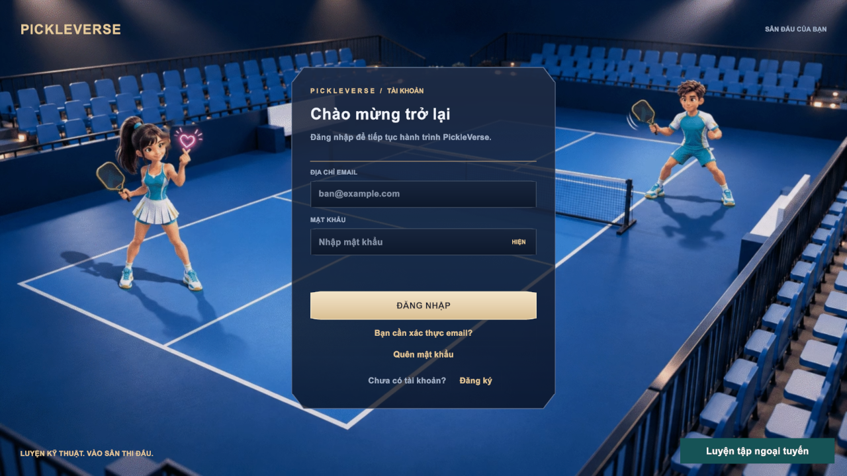
Figure 23. Login screen of the game client
Function details
Table 9. FR-02 data fields
Field | Type | Required | Validation and constraints
Email | Text | Yes | Not empty (MSG01), valid format (MSG02)
Password | Password | Yes | Not empty (MSG03)

Business rules: BR-04, BR-05.
Normal flow:
1. The visitor enters e-mail and password and selects Đăng nhập.
2. The API validates the credentials and returns tokens and the profile; the client shows MSG13 and the Loading screen.
3. On the first sign-in the client asks for the experience level (FR-04); otherwise it opens the Menu.
4. To sign out, the player opens Settings → Overview and selects Đăng xuất; the client returns to the Login screen.
Alternative and exception flows:
• E1 – Wrong e-mail or password: MSG12 (the message does not reveal which field is wrong).
• E2 – The e-mail is not verified: MSG11 and a link to the verification page.
• E3 – The account is suspended or banned: MSG14 and the Decisions and Appeals popup (FR-28).
• E4 – A system bot account tries to sign in: MSG65.
• E5 – The refresh token is expired or revoked: MSG18 and the Login screen.
• A1 – No network and a cached profile exists: the visitor can select Luyện tập ngoại tuyến (FR-09).

FR-03 Reset Password
Related use cases: UC-04 Reset Password
Function trigger: Login screen → Quên mật khẩu.
Function description: A visitor who has forgotten the password requests a reset code. To prevent account enumeration the API always answers with the same neutral message; a code is sent only when the address belongs to a verified account. The visitor enters the code and a new password; the API stores the new hash and revokes every refresh token of the account.
Screen layout
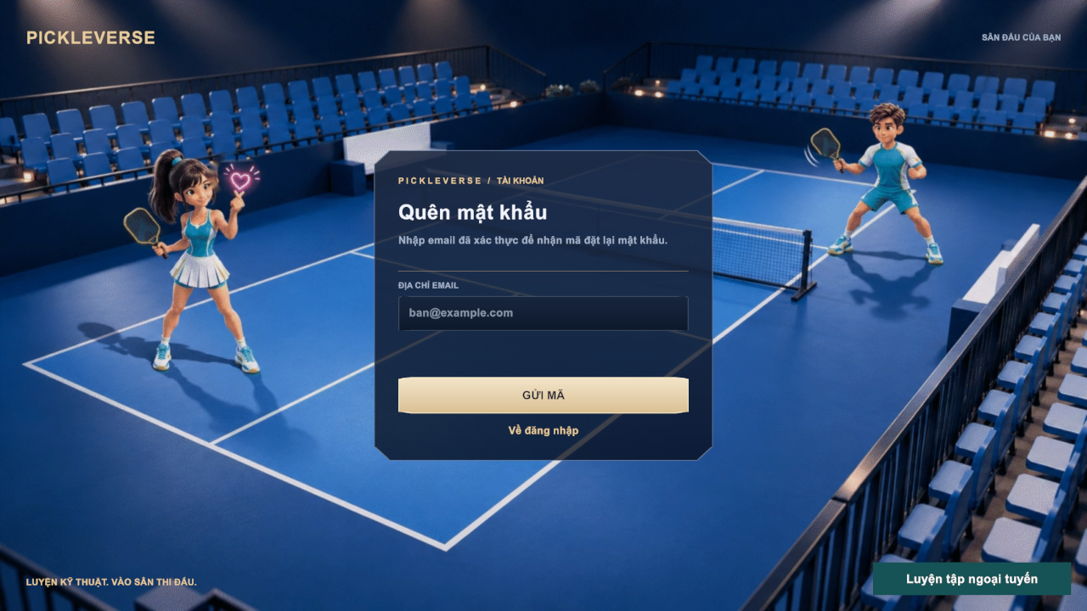
Figure 24. Forgot password screen
Function details
Table 10. FR-03 data fields
Field | Type | Required | Validation and constraints
Email | Text | Yes | Valid format (MSG02)
Reset code | Text (6 digits) | Yes | Valid for 10 minutes; at most 5 attempts (MSG16)
New password / confirmation | Password | Yes | 6–128 characters; equal (MSG04, MSG05, MSG17)

Business rules: BR-02, BR-03, BR-05.
Normal flow:
1. The visitor enters the e-mail address and selects Gửi mã; the client shows MSG15.
2. The visitor enters the code, the new password and its confirmation.
3. The API changes the password, revokes all sessions and the client returns to sign-in.
Alternative and exception flows:
• E1 – Wrong or expired code: MSG16.
• E2 – Resend within 60 seconds: MSG10.

FR-04 Onboarding and Player Profile
Related use cases: UC-06 Choose Experience Level, UC-07 Update Player Name, UC-08 Select Character
Function trigger: First sign-in (experience popup); Menu → name tag or profile card edit icon (name); Menu → Nam / Nữ selector (character).
Function description: At the first sign-in the player answers MSG21. Người mới (Beginner) opens the tutorial; Đã thành thạo (Experienced) goes to the Menu. The answer is saved once. The player can later change the display name and choose the male or female character; the character is used in the menu, training and matches.
Screen layout
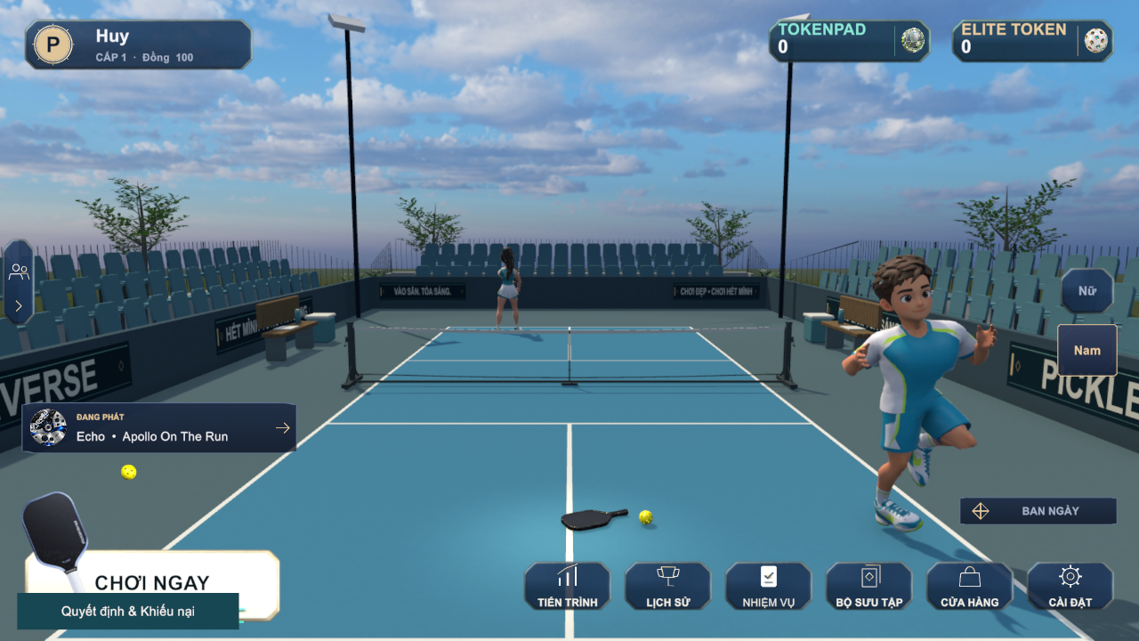
Figure 25. Menu (lobby) of a signed-in player
Function details
Table 11. FR-04 data fields
Field | Type | Required | Validation and constraints
Experience level | Choice | Yes (once) | Beginner or Experienced; cannot be changed afterwards
Display name | Text | Yes | 3–18 characters, no control characters, unique (MSG19, MSG20)
Character | Choice | Yes | Male or Female; default Male

Business rules: BR-06, BR-07, BR-08.
Normal flow:
1. The player answers the experience question; the choice is saved.
2. The player edits the name and confirms; the API checks length and uniqueness and saves it.
3. The player selects Nam or Nữ; the menu character changes immediately and the choice is saved.
Alternative and exception flows:
• E1 – Name outside 3–18 characters: MSG19.
• E2 – Name already used: MSG20.
• E3 – The player is in a room, searching or in a match: profile changes are disabled until the activity ends.

FR-05 Configure Game Settings
Related use cases: UC-09 Configure Game Settings
Function trigger: Menu → Cài đặt, or Esc during a match or drill.
Function description: The player adjusts audio (music and effects volume), graphics (the quality options of the Graphics tab) and controls (keyboard bindings for PC and the touch layout for phones). Changes are previewed and stored on the device when the player selects Áp dụng và lưu.
Screen layout
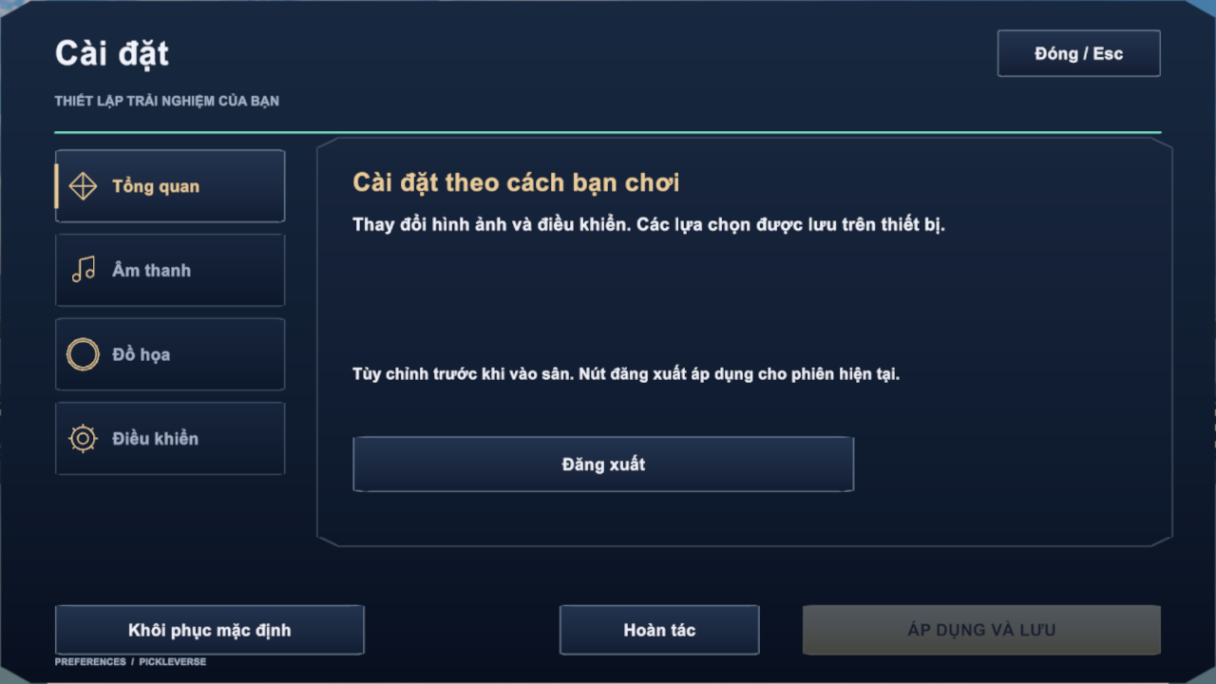
Figure 26. Settings – Overview tab
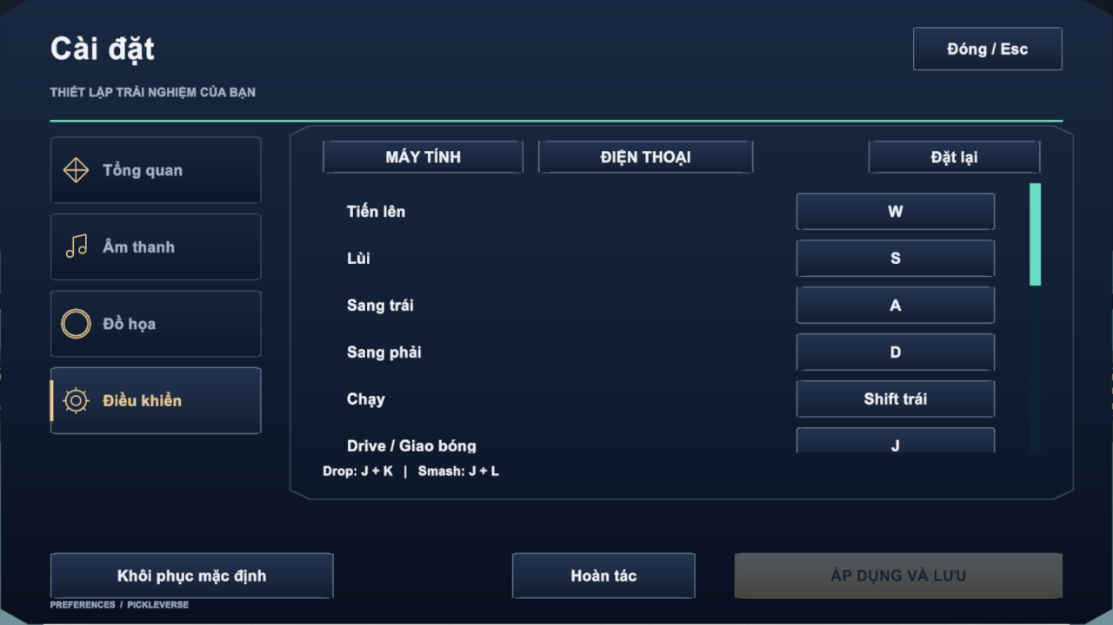
Figure 27. Settings – Controls tab with key bindings
Function details
Table 12. FR-05 data fields
Field | Type | Required | Validation and constraints
Music / effects volume | Slider 0–100 | No | Default from the build
Graphics options | Choice | No | Applied after Apply and save
Key binding | Key | No | One key per action; Restore defaults resets all (defaults: W/A/S/D move, Left Shift run, J drive and serve, K dink, L volley, U power, I cross)

Business rules: BR-17.
Normal flow:
1. The player changes values; Áp dụng và lưu becomes active.
2. The player saves; settings apply immediately and persist on the device.
Alternative and exception flows:
• A1 – Hoàn tác restores the last saved values; Khôi phục mặc định restores factory values.

3.3 Tutorial and Technique Training (FE-02)

FR-06 Complete Tutorial
Related use cases: UC-10 Complete Tutorial
Function trigger: Automatically after choosing Beginner (FR-04); Mode Selection → Tutorial / Hướng dẫn cơ bản.
Function description: The tutorial teaches the court, the rules and the controls in 17 short steps (about 2–3 minutes). Each step shows a title, an explanation and a demonstration on the court, for example the court dimensions, a ball that does not cross the net, the two-bounce rule and the non-volley zone. Completion is saved to the profile.
Screen layout
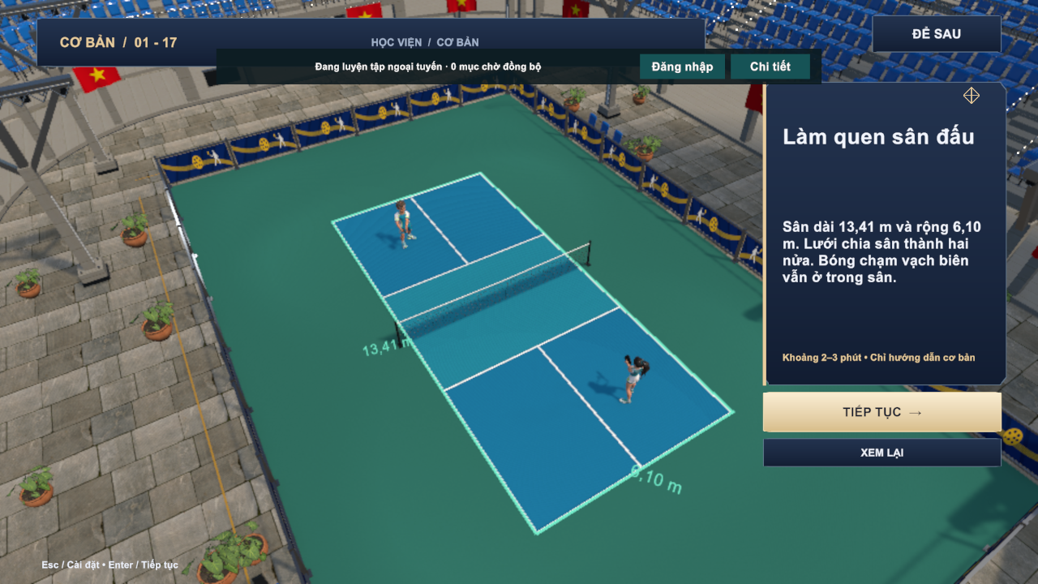
Figure 28. Tutorial step 1 – getting to know the court
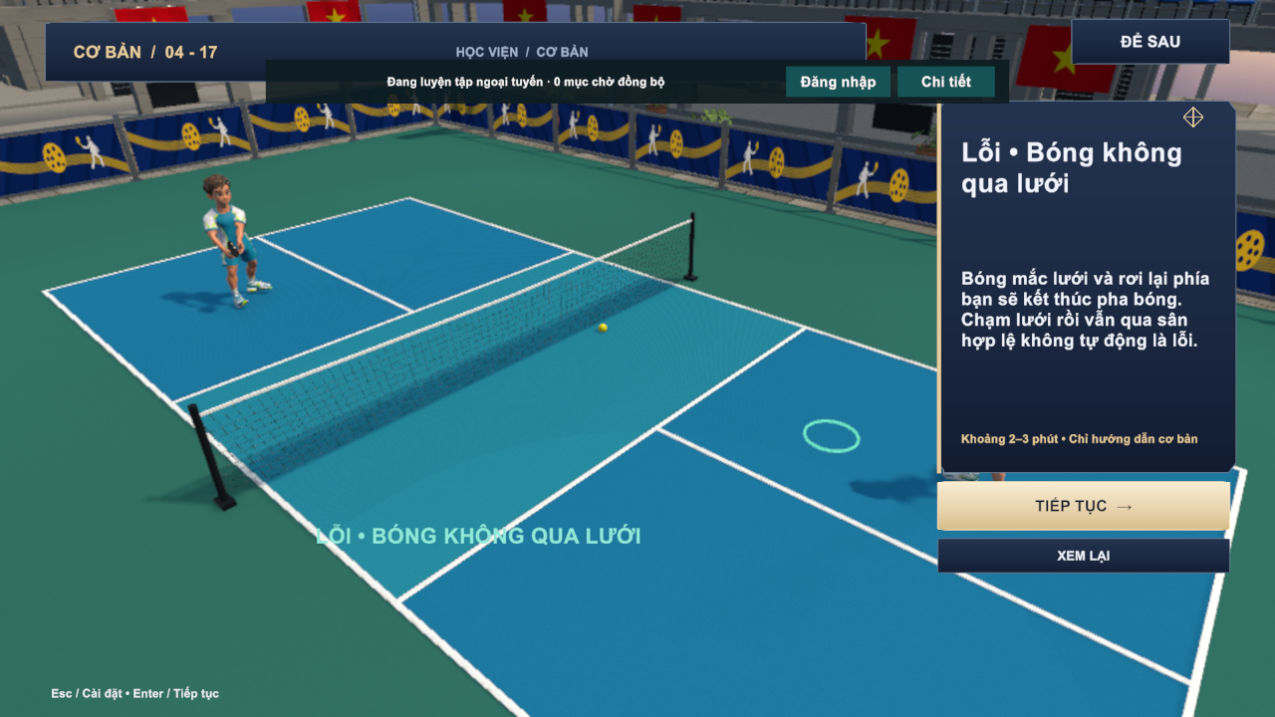
Figure 29. Tutorial step 4 – fault: the ball does not cross the net
Function details
Business rules: BR-09 to BR-14.
Normal flow:
1. The tutorial opens at step 1.
2. The player reads each step and selects Tiếp tục (Enter) to continue or Xem lại to replay the demonstration.
3. After step 17 the completion is saved and the Menu opens.
Alternative and exception flows:
• A1 – Để sau leaves the tutorial; it can be reopened from Mode Selection.

FR-07 Browse Lessons
Related use cases: UC-11 Browse Lessons
Function trigger: Mode Selection → Luyện tập; Training Progress → Tiếp tục luyện.
Function description: The academy lists the 15 published lessons grouped as Basic, Control, Advanced and Doubles. Each row shows the group, the first-pass reward, the best stars and whether the lesson is unlocked. Selecting a lesson opens its briefing: coach explanation, target, reward and the star rules.
Screen layout
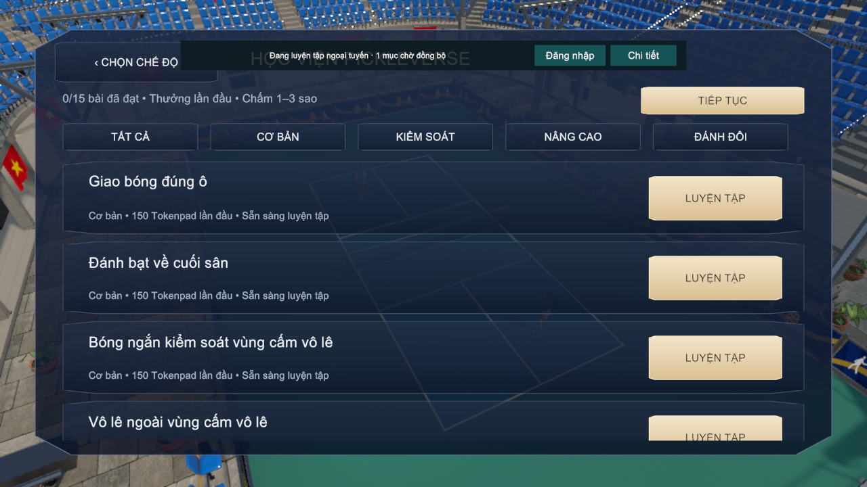
Figure 30. Lesson catalogue with group tabs
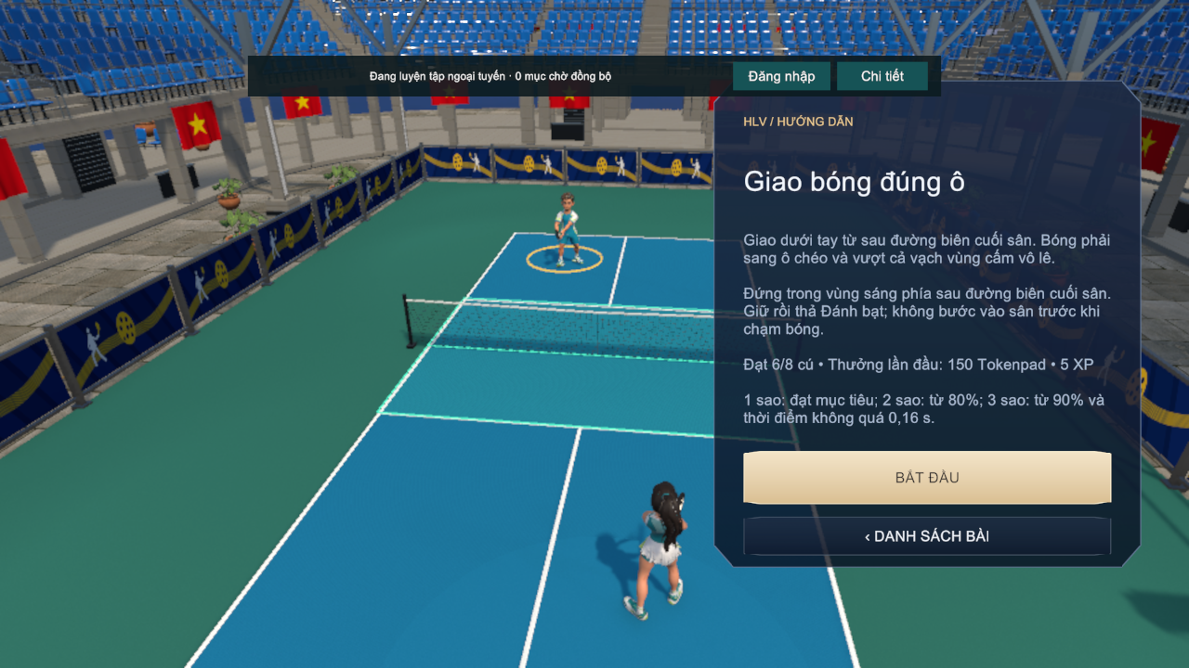
Figure 31. Lesson briefing for "Giao bóng đúng ô" (serve)
Function details
Business rules: BR-18, BR-19, BR-20.
Normal flow:
1. The player opens the academy; the catalogue loads from the server (or the cached catalogue when offline).
2. The player filters by group and selects Luyện tập on a lesson.
3. The briefing opens; Bắt đầu starts the drill (FR-08).
Alternative and exception flows:
• E1 – The lesson is locked: the start button is disabled and MSG23 is shown.

FR-08 Practise Drill
Related use cases: UC-12 Practise Drill
Function trigger: Lesson briefing → Bắt đầu; Drill Result → Luyện lại.
Function description: The player performs the drill on the training court, for example eight serves into the highlighted service court. For each shot the game measures whether the ball lands in the target area and the timing error between the key release and the ideal contact. In-drill feedback tells the player whether the release was early or late. At the end the client sends the attempt and its telemetry to the API, which validates it, applies the stars and the first-pass reward and returns a receipt.
Screen layout
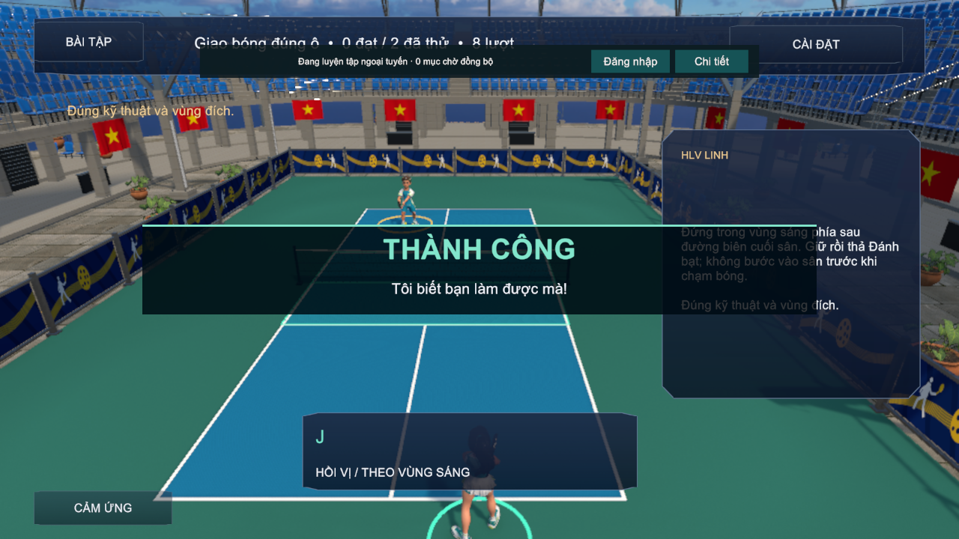
Figure 32. Practice HUD with coach panel and success feedback
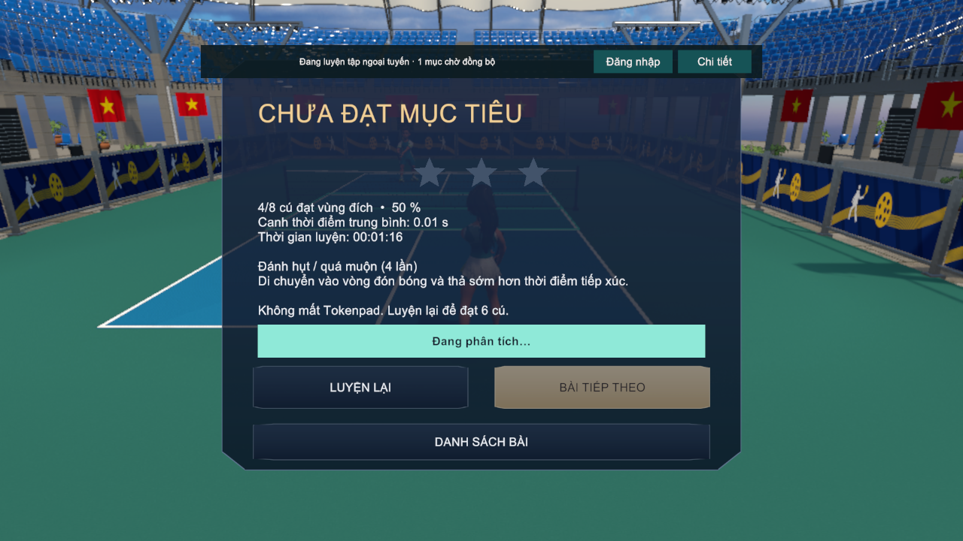
Figure 33. Drill result – target not reached
Function details
Table 13. FR-08 data fields
Field | Type | Required | Validation and constraints
Shots / target | Integer | System | Fixed per lesson (for example 6 of 8 for the serve lesson)
Hits in target | Integer | System | Counted by the rules engine
Mean timing error | Seconds | System | Absolute difference between release and ideal contact
Stars | 0–3 | System | Computed by BR-18; the best result is kept

Business rules: BR-16, BR-17, BR-18, BR-20.
Normal flow:
1. The drill starts and the HUD shows lesson, shot counter and key hints.
2. The player hits the required shots; feedback (MSG26, MSG27) appears after each shot.
3. After the last shot the Drill Result popup shows stars, accuracy, mean timing, time, the most frequent error and a tip.
4. The API stores the attempt; on the first pass it grants the lesson reward and unlocks the next lesson.
5. The coaching analysis appears when ready (FR-19).
Alternative and exception flows:
• A1 – Target not reached: MSG24 and MSG25; no currency is lost and Bài tiếp theo stays disabled.
• A2 – The device is offline: the attempt is queued for synchronisation (FR-09).
• E1 – The attempt is rejected by the server (for example inconsistent telemetry): receipt REJECTED and no reward.

FR-09 Offline Training and Synchronisation
Related use cases: UC-13 Practise Drill Offline, UC-14 Synchronise Offline Results
Function trigger: Login → Luyện tập ngoại tuyến when a profile is cached; automatic synchronisation when the connection returns, or banner → Đăng nhập.
Function description: A player who has signed in on the device at least once can train without a connection. The client uses the cached catalogue and profile, stores every finished attempt with a unique request ID in a local queue and shows the offline banner MSG28. When the player is online again, the queue is sent; the API applies each request at most once and answers APPLIED, DUPLICATE or REJECTED. Online-only features (bot and online matches, shop) are disabled offline.
Screen layout
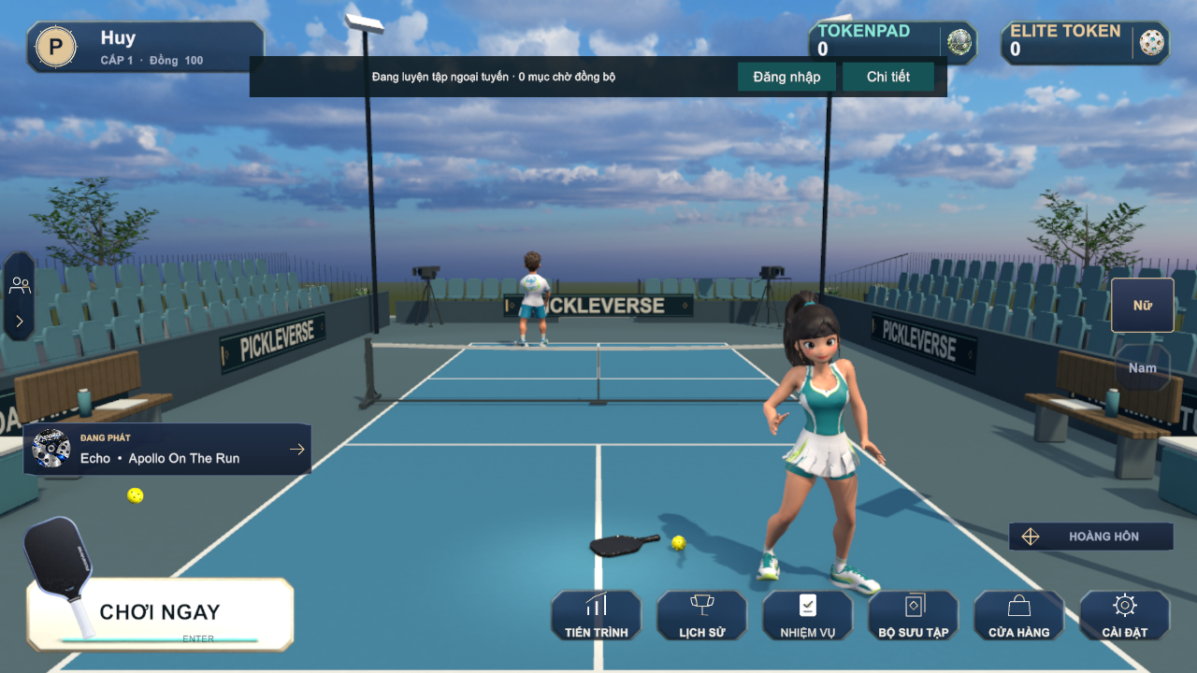
Figure 34. Menu in offline training mode with the offline banner
Function details
Business rules: BR-21.
Normal flow:
1. The player starts offline training from the Login screen.
2. Drills work as in FR-08; each result is added to the queue and the banner shows the pending count.
3. When connected, the client sends the queue; applied items are removed and rewards are added to the profile.
Alternative and exception flows:
• A1 – The same request is sent twice: receipt DUPLICATE; no second reward.
• E1 – No cached profile on the device: the offline button is not shown.
• E2 – A queued item is invalid: receipt REJECTED; the item is removed and the player is informed through Chi tiết.

FR-10 View Training Progress
Related use cases: UC-15 View Training Progress
Function trigger: Menu → Tiến trình.
Function description: The progress popup summarises the player's learning: passed lessons out of 15, the next lesson, the latest post-session feedback, total practice time, the most frequent error and the most retried lesson, and the best result of every lesson with a Retry shortcut. Tabs give access to daily and weekly missions (FR-21).
Screen layout
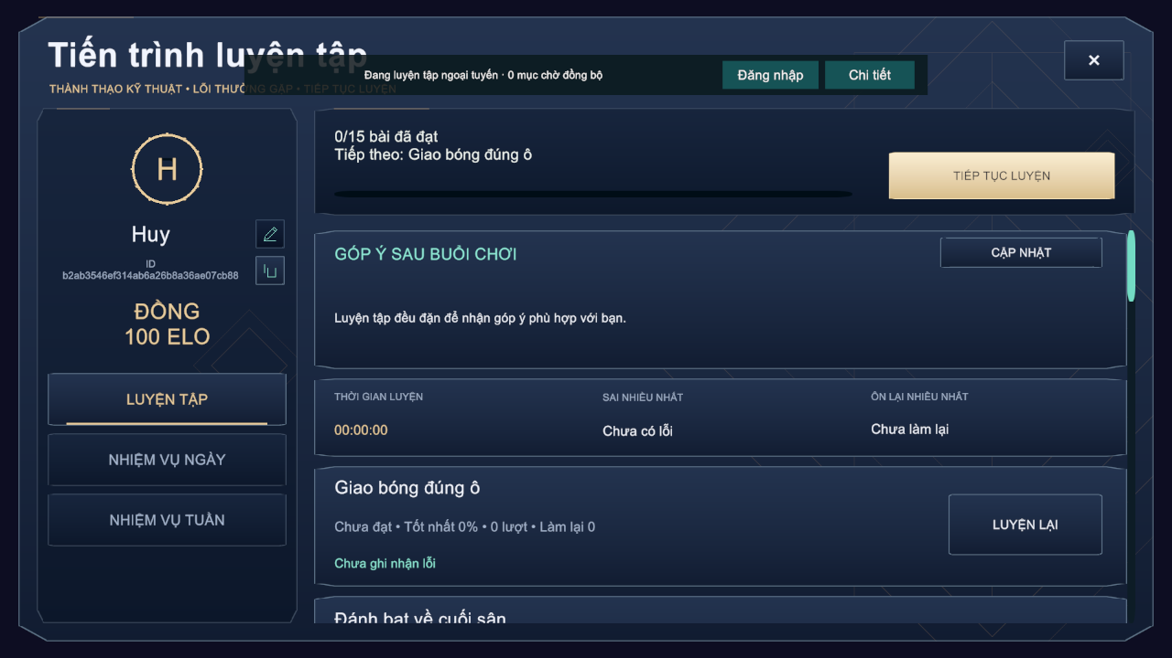
Figure 35. Training progress popup
Function details
Business rules: BR-18.
Normal flow:
1. The player opens Progress; the data is loaded from the profile.
2. The player selects Luyện lại on a lesson to open its briefing.

3.4 Core Gameplay and Bot Practice (FE-03)

FR-11 Control the Player and Hit Shots
Related use cases: UC-12, UC-16, UC-25
Function trigger: Any rally in a drill, bot match or online match.
Function description: The player moves with W/A/S/D (or the virtual joystick on phones), runs with Left Shift and hits by holding and releasing shot keys. One of seven shot kinds is chosen from the key combination when the first key is released; U adds power and I aims cross-court. The paddle contact is accepted only inside the timing window, and the quality of the contact (Perfect, Good, early or late) affects the ball speed and accuracy. The ball flight, bounce and net contact are simulated at 120 Hz.
Screen layout
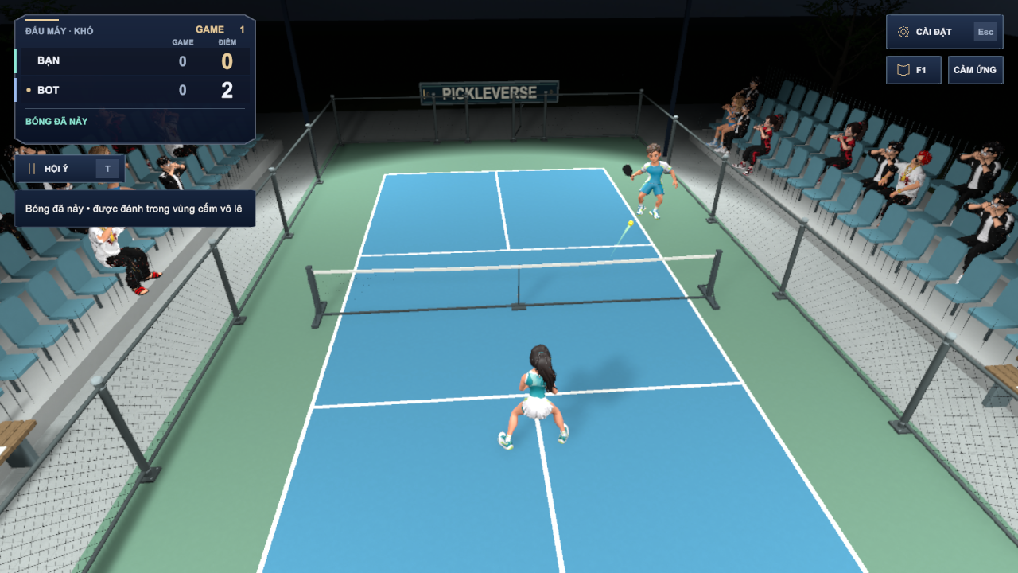
Figure 36. Rally in a bot match with score panel and rule feedback
Table 14. FR-11 screen layout
Area | Elements and behaviour
Score panel (top left) | Mode and difficulty, game number, games and points of each side, serving side, rule hint
Controls (top right) | Settings (Esc), help (F1), touch layout toggle
Court | Player character, opponent, ball, landing marker and fault banner

Function details
Business rules: BR-16, BR-17.
Normal flow:
1. The player moves to the ball and holds a shot key (J, K or L, alone or combined).
2. The player releases the key close to the contact moment; the game selects the shot kind and checks the timing.
3. The ball is hit towards the target computed from the shot kind and modifiers.
Alternative and exception flows:
• A1 – Release outside ±65 ms of the ideal contact: no contact (miss) and feedback MSG26 or MSG27.
• A2 – Invalid key combination: the input is ignored until all keys are released.

FR-12 Apply Singles Match Rules
Related use cases: UC-16, UC-25
Function trigger: Every rally of a bot or online match.
Function description: The rules engine decides legal serves, faults, points, games and the match winner according to the official singles rules simplified for the game. In online matches the same engine runs on the dedicated server, which is the only authority for the score.
Screen layout
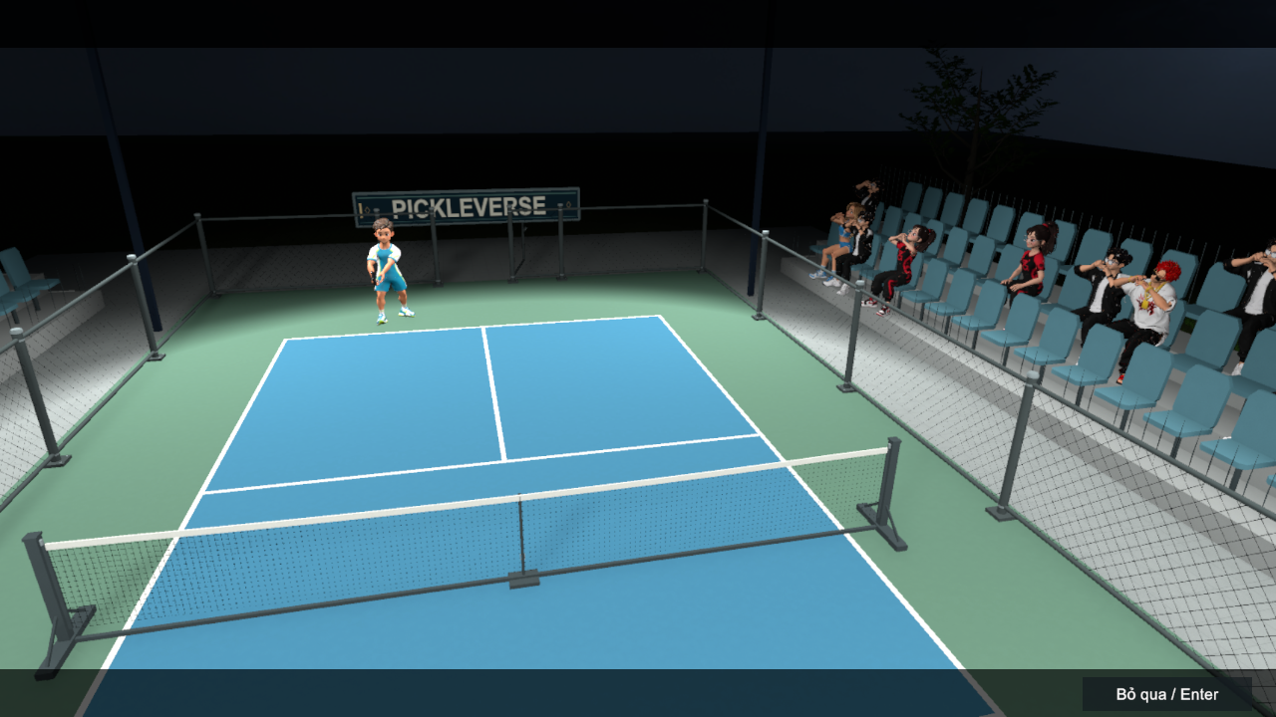
Figure 37. Bot match introduction
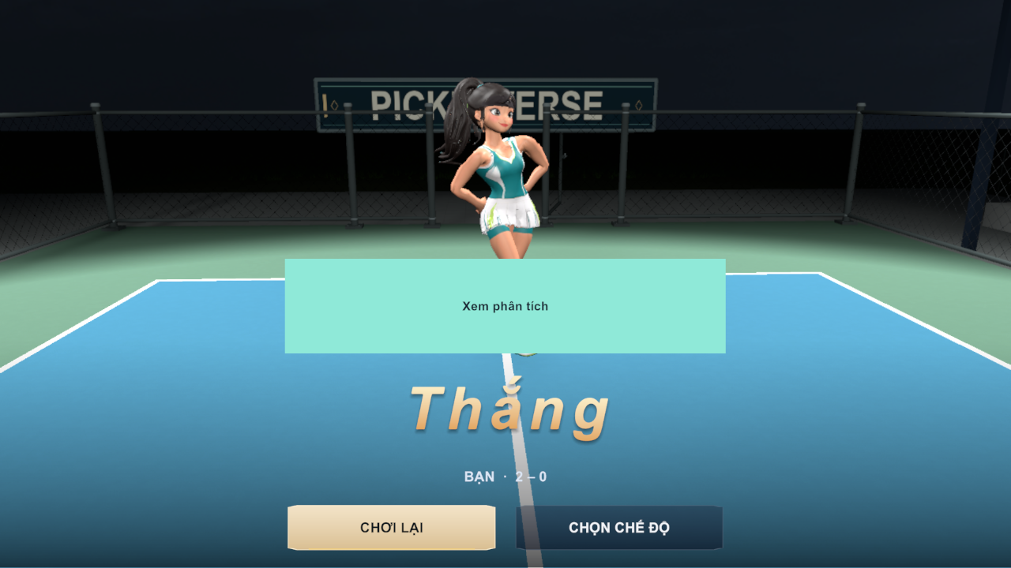
Figure 38. Match result – victory 2–0
Function details
Business rules: BR-09 to BR-15.
Normal flow:
1. The server of the rally serves underhand from behind the baseline into the diagonal service court within 10 seconds.
2. The return and the third shot must bounce; afterwards volleys are allowed outside the non-volley zone.
3. When a fault occurs, the rally ends, a fault banner (MSG30) is shown and the point or side-out is applied.
4. A game ends at 11 points with a 2-point lead; the first side to win two games wins the match (MSG31).
Alternative and exception flows:
• A1 – A side calls a time-out (at most two per game): the match pauses.
• A2 – In the third game the players change ends when a side reaches 6 points.
• E1 – The serve timer expires: fault ServeTimeout and MSG29.

FR-13 Set Up and Play a Bot Match
Related use cases: UC-16 Play Bot Match
Function trigger: Menu → Chơi ngay → Mode Selection → Đấu với bot → Bot Match Setup → Vào sân.
Function description: The player chooses the difficulty, the time of day and the court, then plays a singles match against the computer. Easy, Medium and Hard use fixed reaction and accuracy settings; the adaptive option uses a behaviour-tree bot whose tier follows the player's Elo. After the match the result popup shows the winner, scores and rewards, and the coaching analysis can be opened.
Screen layout
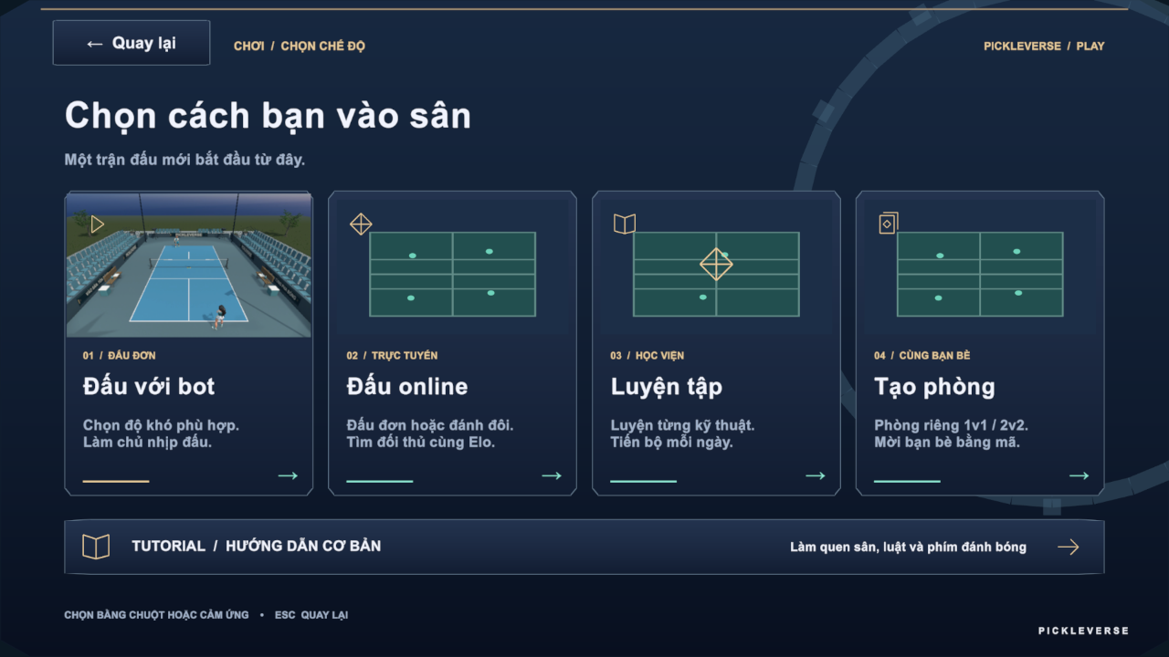
Figure 39. Mode selection
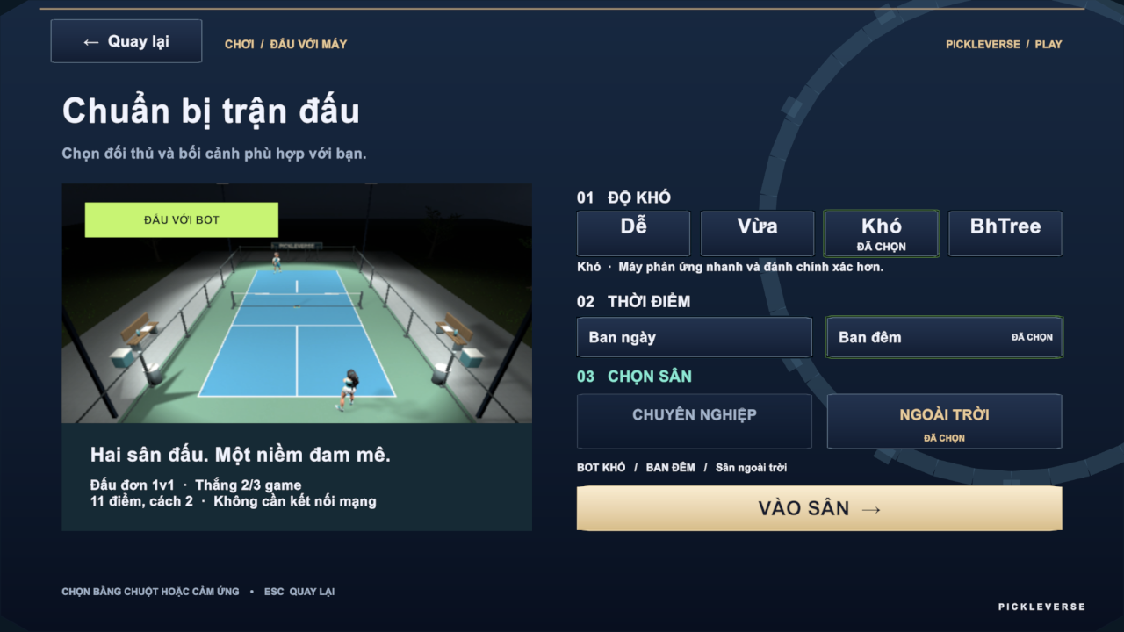
Figure 40. Bot match setup
The layout is also shown in Figure 38.
Function details
Table 15. FR-13 data fields
Field | Type | Required | Validation and constraints
Difficulty | Choice | Yes | Easy, Medium, Hard or Adaptive
Time of day | Choice | Yes | Day or night
Court | Choice | Yes | Professional or outdoor

Business rules: BR-10 to BR-16, BR-22, BR-31, BR-32.
Normal flow:
1. The player selects the options and Vào sân; the intro cinematic plays.
2. The match is played with FR-11 and FR-12.
3. At the end the API settles the result: rewards and XP are added; Elo does not change in a practice bot match.
4. The player selects Chơi lại, Chọn chế độ or Xem phân tích.
Alternative and exception flows:
• A1 – Ranked Bot match assigned by matchmaking (FR-14): Elo changes according to BR-23.
• E1 – The device is offline: the bot match card is disabled.

3.5 Online Matches (FE-04)

FR-14 Find a Ranked Match
Related use cases: UC-19 Find Ranked Match, UC-20 Confirm Match Readiness
Function trigger: Mode Selection → Đấu online → Online Lobby → Đấu đơn 1v1 → Tìm trận.
Function description: The player joins the ranked singles queue. The matchmaking worker pairs two searching players whose Elo is within the pairing window; both must accept within 10 seconds. If no human opponent is found within 180 seconds, a ranked bot opponent is assigned. When all players accept, the API allocates the dedicated server and issues signed tickets, and the clients load the multiplayer court.
Screen layout
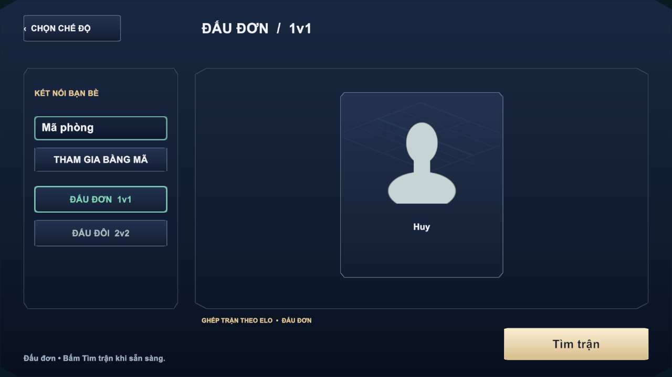
Figure 41. Online lobby – singles
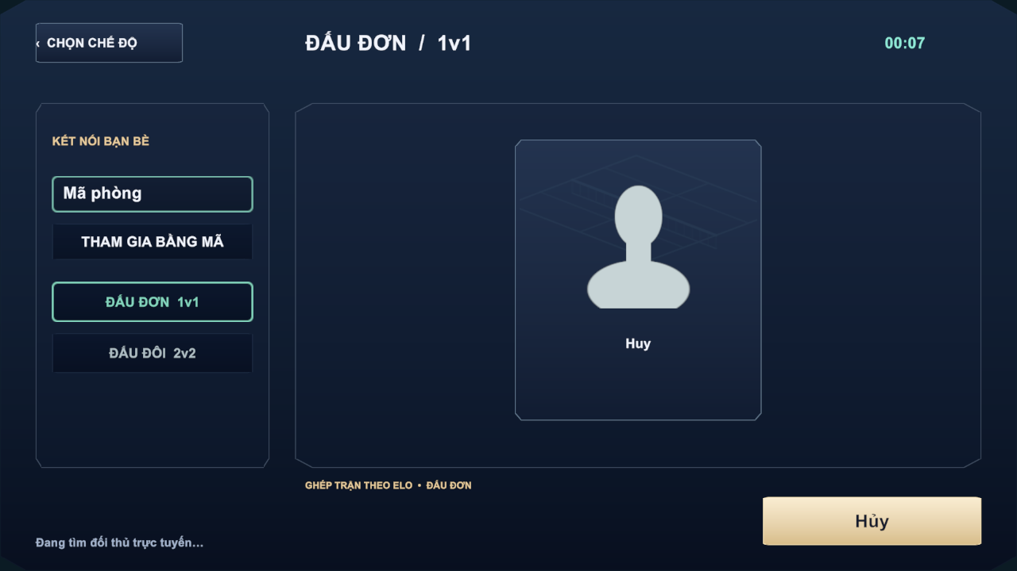
Figure 42. Searching for an opponent with elapsed time
Function details
Business rules: BR-22 to BR-27.
Normal flow:
1. The player selects Tìm trận; MSG32 and a timer are shown.
2. A pair is found; the Ready Check shows MSG33 with a 10-second countdown.
3. Both players accept; the server allocates the match and the court loads (FR-16).
Alternative and exception flows:
• A1 – No opponent within 180 seconds: a ranked bot is assigned and the match starts on the dedicated server.
• A2 – The player selects Hủy while searching: the ticket is cancelled.
• E1 – A player declines or the countdown ends: the offer closes; the decliner sees MSG35 and the other player returns to the queue.
• E2 – The dedicated server is busy: MSG36 and the request waits for the slot.
• E3 – The player already has a search or an unfinished match: MSG41.
• E4 – Search expired: MSG34.

FR-15 Private Rooms and Invitations
Related use cases: UC-21 Create Private Room, UC-22 Join Room by Code, UC-23 Invite Friend to Room, UC-24 Respond to Room Invitation
Function trigger: Mode Selection → Tạo phòng; Online Lobby → Mã phòng + Tham gia bằng mã; friend list → invite.
Function description: A player creates a singles (2 players) or doubles (up to 4 players) room. Other players join with the room code or accept an invitation sent to an online friend. The host can change teams, remove a guest and start the match. Custom matches are unrated and give no Elo.
Screen layout
The layout is also shown in Figure 41.
Function details
Table 16. FR-15 data fields
Field | Type | Required | Validation and constraints
Room code | Text | Yes (to join) | Code of an open room on Photon; wrong code → MSG39
Mode | Choice | Yes | Singles 1v1 or Doubles 2v2

Business rules: BR-22, BR-30, BR-38.
Normal flow:
1. The host creates the room; the lobby shows the room code and roster slots.
2. Guests join by code or by accepting an invitation.
3. The host starts the match; the dedicated server is allocated as in FR-14.
Alternative and exception flows:
• E1 – Room full: MSG37.
• E2 – Room closed or the player was removed: MSG38.
• E3 – Invited player is busy or offline: MSG40.
• E4 – Blocked players cannot invite each other (BR-38).

FR-16 Play an Online Match
Related use cases: UC-25 Play Online Match
Function trigger: Automatically after the ready check (FR-14) or when the host starts a room (FR-15).
Function description: Each client connects to the dedicated server with its signed ticket through Photon Fusion. The server simulates the ball and applies the rules (FR-12); clients send only input and render server state with interpolation. The server sends heartbeats to the API every 8 seconds, records telemetry and the replay, and reports the final result.
Screen layout
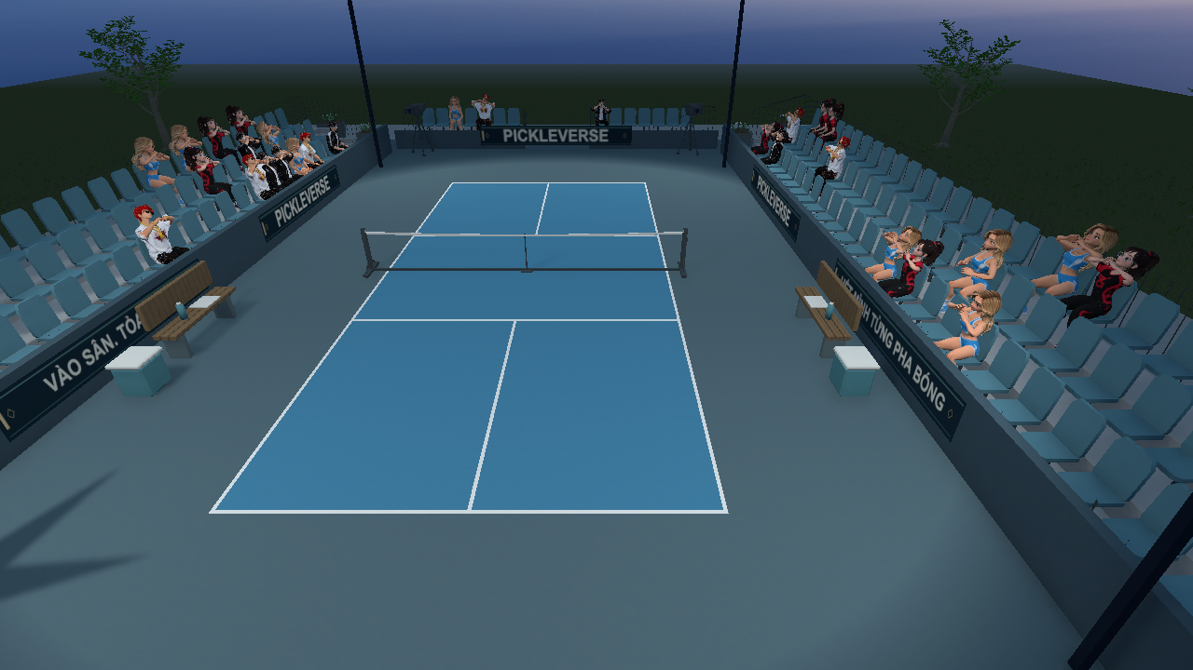
Figure 43. Multiplayer court scene
Function details
Business rules: BR-12 to BR-17, BR-28, BR-29.
Normal flow:
1. The court loads and the server starts the match after all players are connected.
2. Players play rallies; scores are shown from the server state.
3. The server ends the match and the result popup appears (FR-18).
Alternative and exception flows:
• E1 – Photon cannot be reached: MSG45.
• E2 – The connection to the match server is lost: MSG42 and FR-17 starts.

FR-17 Reconnect to or Leave a Match
Related use cases: UC-26 Reconnect to Match, UC-27 Leave Match
Function trigger: Connection loss during an online match; pause menu → leave.
Function description: If a player's connection drops, the client shows a reconnecting overlay and retries for up to 30 seconds with the same identity. The server keeps the player's slot for 35 seconds after the last heartbeat. A player who reconnects in time continues with the server score. A player who leaves, or who does not return in time, causes the match to end as interrupted; interrupted matches change no Elo and give no reward.
Screen layout
Table 17. FR-17 screen layout
Area | Elements and behaviour
Reconnecting overlay | Status text and countdown; the court stays visible in the background
Leave dialog | Warning about the consequence and Confirm / Cancel buttons

Function details
Business rules: BR-28, BR-29.
Normal flow:
1. The client detects the loss and starts reconnecting.
2. The player rejoins with the same ticket identity and control is restored.
Alternative and exception flows:
• E1 – Reconnection fails within 30 seconds: MSG43; the result is shown when the server finishes processing.
• A1 – The player confirms leaving: MSG44 and the Menu opens.

FR-18 Record the Match Result and Update Elo
Related use cases: UC-16, UC-25 (non-screen settlement)
Function trigger: End of a bot match (reported by the client) or of an online match (reported by the dedicated server).
Function description: The API settles each match exactly once in a single transaction: it stores the game scores, marks the match FINISHED, applies Elo for ranked matches, grants Tokenpad and XP, and updates missions, achievements and streaks. The result popup and the history (FR-24) show the outcome.
Screen layout
The layout is also shown in Figure 38.
Function details
Business rules: BR-22, BR-23, BR-29, BR-32 to BR-35.
Normal flow:
1. The API receives the result with the match identifier.
2. It validates that the match is still PLAYING and that the reporter is allowed to report it.
3. It saves scores, Elo, rewards and progress, then returns the summary to the clients.
Alternative and exception flows:
• A1 – The result is sent again: the stored result is returned and nothing is applied twice.
• E1 – The match was stopped by an administrator before the result: no Elo or reward (BR-48).

3.6 AI Coaching (FE-05)

FR-19 View Coaching Summary and Drill Recommendations
Related use cases: UC-17 View Coaching Summary, UC-18 View Drill Recommendation
Function trigger: Drill Result → analysis panel; Match Result → Xem phân tích.
Function description: The client uploads the shot telemetry of the drill or match (for online matches the dedicated server uploads it). The hybrid AI worker sends the session to the AI coaching service, which detects common errors with rules (for example late contact, dink too high, entering the non-volley zone after a volley), writes a short summary and recommends at most three drills. When the gated tier model is approved, it also estimates the player's tier. The coaching popup shows the counts of shots, contacts and serves, the main errors with their frequency, and the recommended drills.
Screen layout
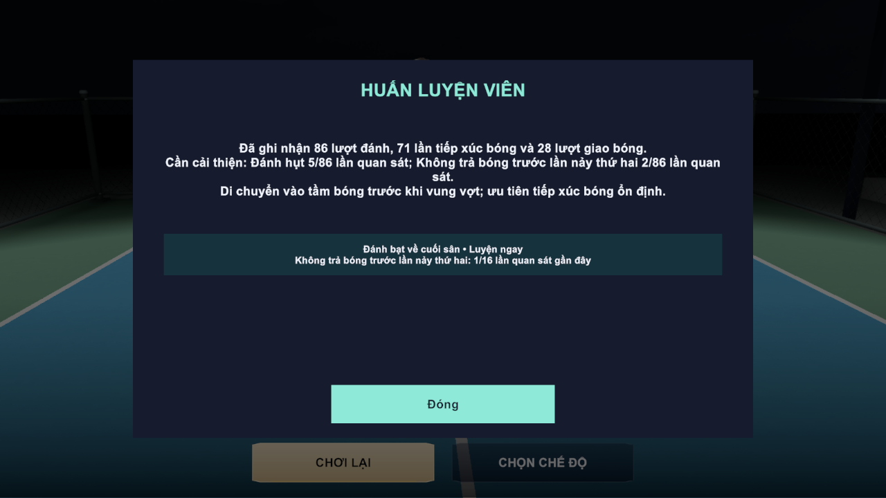
Figure 44. Coaching summary after a bot match
Function details
Business rules: BR-50, BR-51.
Normal flow:
1. The player opens the analysis; the client polls the analysis job.
2. The summary and recommendations appear when the job is completed.
3. Luyện ngay opens the recommended lesson briefing.
Alternative and exception flows:
• A1 – The analysis is still running: the panel shows "Đang phân tích…".
• E1 – Too few shot opportunities: no finding is reported for that error.
• E2 – AI service unavailable: the job is retried by the worker; the player can open the analysis later.

3.7 Progress, Rewards and Shop (FE-06)

FR-20 Earn Experience, Levels and Progression Rewards
Related use cases: UC-15, UC-16 (non-screen progression)
Function trigger: Settlement of a drill (FR-08) or match (FR-18); claiming mission rewards (FR-21).
Function description: Players earn XP from matches, lessons and missions. Reaching the XP threshold raises the level, which is shown in the name tag and history card. Two items are granted automatically once: the THOT paddle after 10 passed lessons and the GEMSTONE paddle at level 25.
Screen layout
The layout is also shown in Figure 25.
Function details
Business rules: BR-20, BR-32, BR-33, BR-37.
Normal flow:
1. XP is added by the settlement.
2. If XP reaches level × 200, the level increases and the remaining XP carries over.
3. Progression grants are checked and recorded in the reward log so that each is given once.

FR-21 Missions, Streak and Achievements
Related use cases: UC-37 to UC-40
Function trigger: Menu → Nhiệm vụ; Progress → Nhiệm vụ ngày / tuần.
Function description: Seven daily and ten weekly missions track matches, wins, points, valid returns and serves, bot matches and human matches. Completing all daily or weekly missions unlocks a set bonus. The daily streak counts consecutive days with at least one match. Ten achievements reward long-term goals such as 5, 25 and 100 wins.
Screen layout
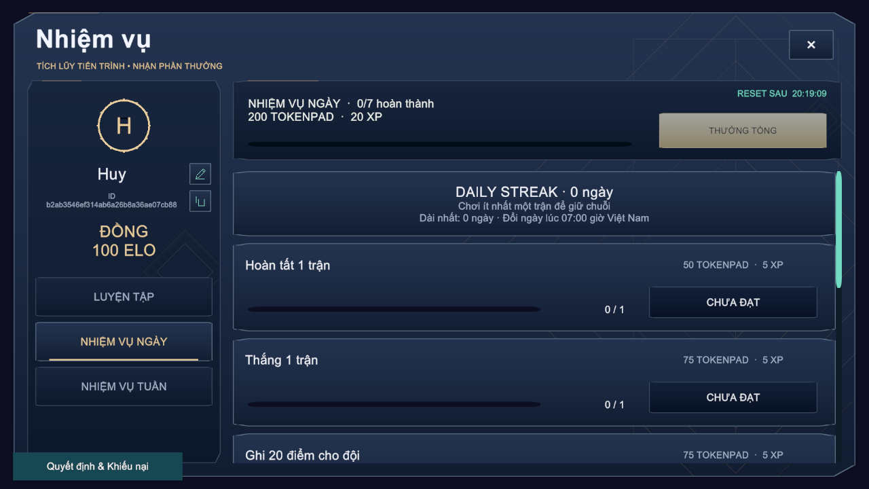
Figure 45. Missions popup with daily streak and reset countdown
Function details
Business rules: BR-34, BR-35.
Normal flow:
1. The player opens Missions; progress and the reset countdown are shown.
2. A completed mission shows NHẬN THƯỞNG (or NHẬN THƯỞNG TỔNG for the set bonus); the player claims it and the reward is added.
3. Achievement rewards are claimed in the same way (MSG49).
Alternative and exception flows:
• A1 – A reward is claimed twice: the second claim adds nothing.
• A2 – Missions renew at 07:00 Vietnam time; unclaimed progress of the old cycle is closed.

FR-22 Browse Shop and Purchase Cosmetic
Related use cases: UC-41 Browse Shop, UC-42 Purchase Cosmetic
Function trigger: Menu → Cửa hàng.
Function description: The shop lists cosmetic paddles with preview, description and price. An item can have a Tokenpad price, an Elite Token price or both. The purchase debits the wallet and adds the item to the collection in one transaction.
Screen layout
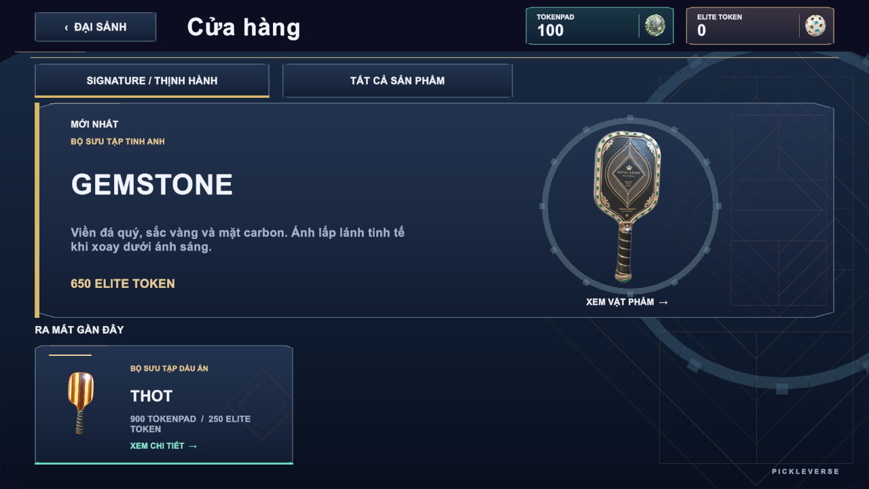
Figure 46. Shop with featured GEMSTONE and THOT paddles
Function details
Business rules: BR-36.
Normal flow:
1. The player selects an item and its currency and confirms the purchase.
2. The API checks ownership and balance, debits the price and grants the item.
3. The wallet and the collection are refreshed.
Alternative and exception flows:
• E1 – Not enough balance: MSG46.
• E2 – Item already owned: MSG47.
• E3 – Transaction failure: no balance is changed.

FR-23 View Collection and Equip Cosmetic
Related use cases: UC-43 View Collection, UC-44 Equip Cosmetic
Function trigger: Menu → Bộ sưu tập.
Function description: The collection shows all paddles with their status: in use, owned or not owned (preview only). The player equips an owned paddle, which is then used in matches and replays.
Screen layout
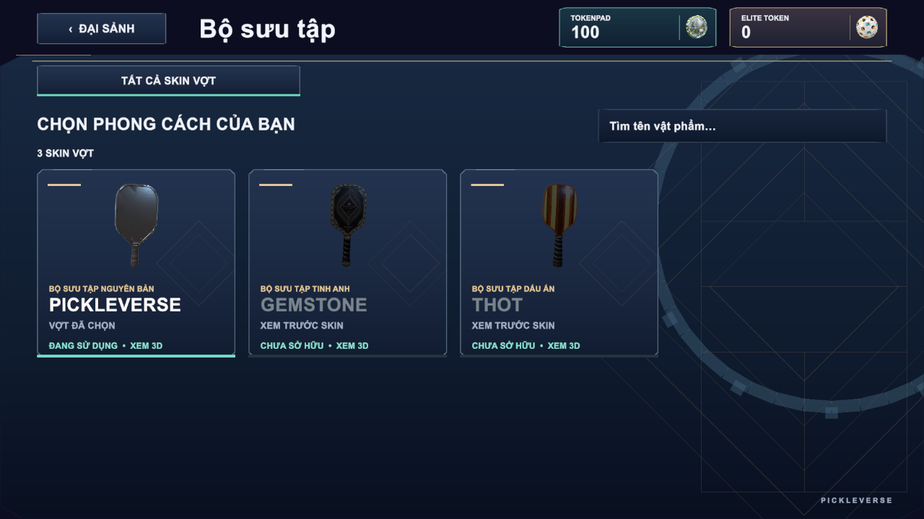
Figure 47. Collection of paddle skins
Function details
Business rules: BR-36.
Normal flow:
1. The player selects an owned paddle and TRANG BỊ.
2. The API marks it as the only equipped item; the menu character shows it.
Alternative and exception flows:
• E1 – The item is not owned: MSG48.

3.8 Social, History and Ranking (FE-07)

FR-24 View Match History and Watch Replay
Related use cases: UC-28 View Match History, UC-29 Watch Match Replay
Function trigger: Menu → Lịch sử; history entry → replay button.
Function description: The history popup lists the player's last 20 matches in Vietnam time with opponent, mode, result (win, loss or interrupted), game score and Elo change, plus the level card. A match with a stored replay can be watched in the Replay Viewer with pause, seek and speeds from 0.5× to 2×. Only participants can open a replay.
Screen layout
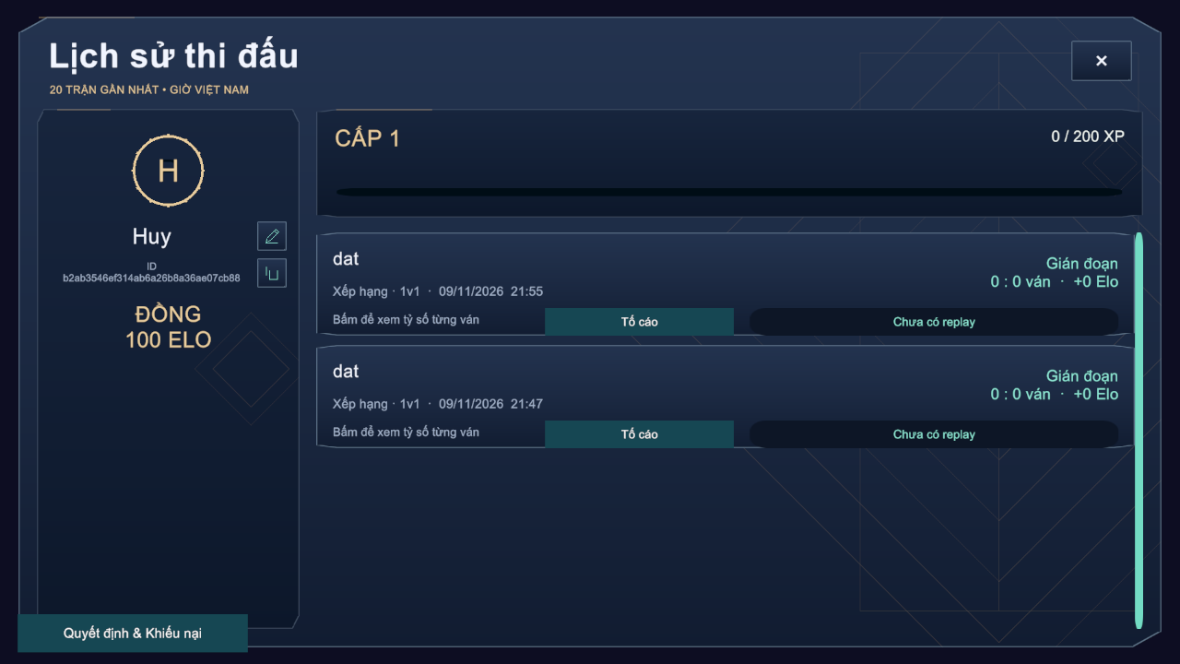
Figure 48. Match history with interrupted ranked matches
Function details
Business rules: BR-29, BR-40.
Normal flow:
1. The player opens History; the list loads from the API.
2. The player selects a replay; the manifest and chunks are downloaded and played.
Alternative and exception flows:
• A1 – No replay stored: the entry shows "Chưa có replay".
• E1 – A player who did not take part requests the replay: HTTP 403.

FR-25 Manage Friends and Blocked Players
Related use cases: UC-32 to UC-36
Function trigger: Menu → friend drawer → Bạn bè.
Function description: The player searches other players by name or ID, sends friend requests, accepts or declines received requests, removes friends and blocks or unblocks players. Online friends can be invited to a room (FR-15).
Screen layout
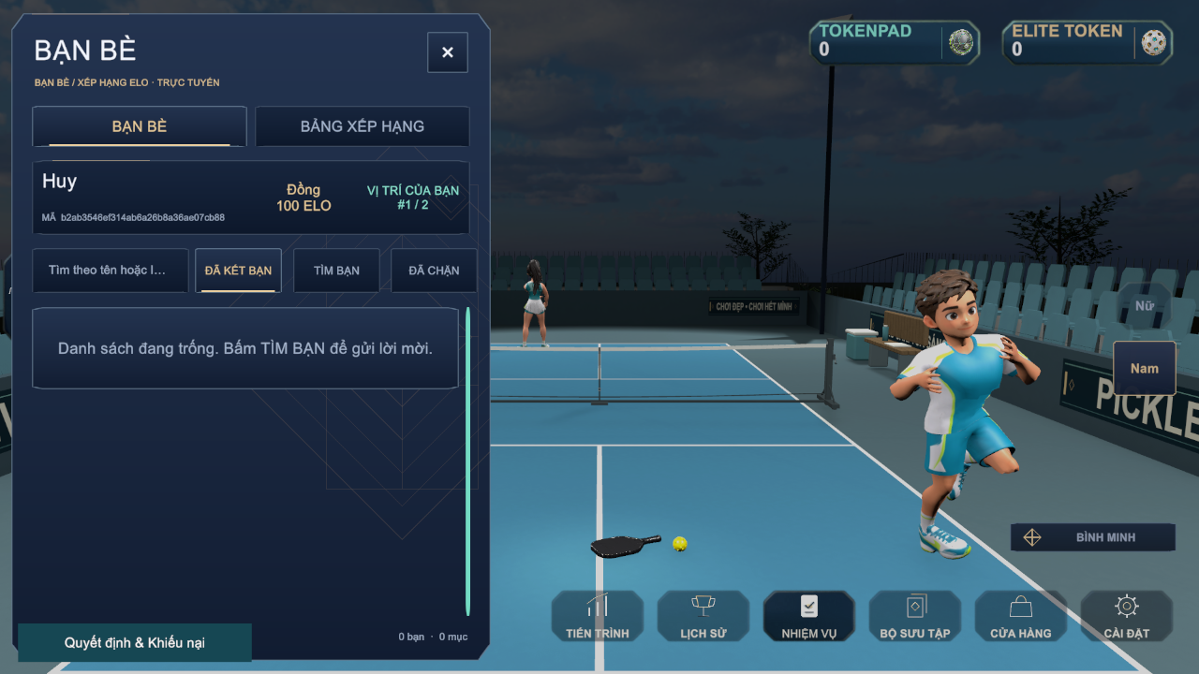
Figure 49. Friends drawer
Function details
Business rules: BR-38.
Normal flow:
1. The player searches by name or ID and sends a request.
2. The receiver accepts or declines it under the requests list.
3. The player can remove a friend or block a player from the list.
Alternative and exception flows:
• E1 – No match for the search: MSG51.
• E2 – The other player has already sent a request: MSG50.
• E3 – A request to oneself or to a blocked player is rejected.

FR-26 View Leaderboard
Related use cases: UC-31 View Leaderboard
Function trigger: Menu → friend drawer → Bảng xếp hạng.
Function description: The leaderboard lists players by Elo in descending order with rank tier, and highlights the player's own position, which can be located with Vị trí của tôi.
Screen layout
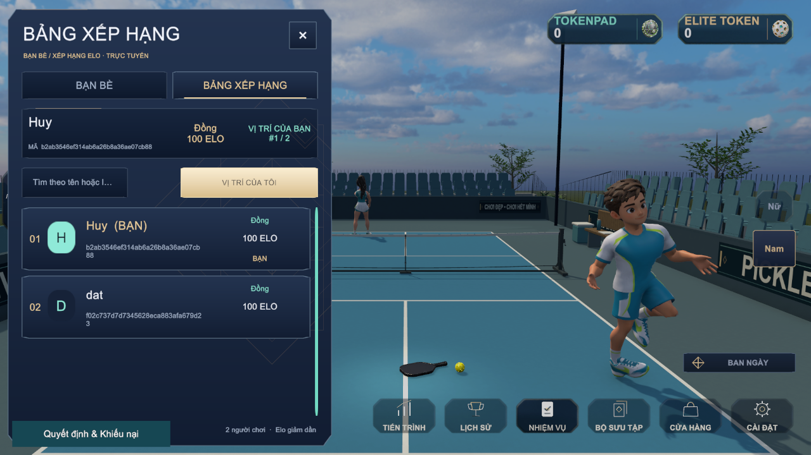
Figure 50. Elo leaderboard
Function details
Business rules: BR-27, BR-39.
Normal flow:
1. The player opens the leaderboard; the cached list is loaded.
2. The player searches by name or jumps to the own position.

3.9 Reports, Restrictions and Appeals (FE-08)

FR-27 Report a Player
Related use cases: UC-30 Report Player
Function trigger: Match History → Tố cáo on a finished match.
Function description: A player reports an opponent from one of their own matches with a reason. The report is stored as PENDING for administrators (FR-30).
Screen layout
The layout is also shown in Figure 48.
Function details
Table 18. FR-27 data fields
Field | Type | Required | Validation and constraints
Reported player | Choice | Yes | A participant of the match other than the reporter (MSG52)
Reason | Text (≤254) | Yes | Not empty

Business rules: BR-41, BR-44.
Normal flow:
1. The player selects Tố cáo, the opponent and enters the reason.
2. The API stores the report; the button changes to the reported state.
Alternative and exception flows:
• E1 – The player has already reported this player in this match: the duplicate is rejected.
• E2 – No eligible player: MSG52.

FR-28 View Sanction Decision and Submit Appeal
Related use cases: UC-45 View Sanction Decision, UC-46 Submit Appeal
Function trigger: Sign-in of a restricted account (automatic); Menu → Quyết định & Khiếu nại.
Function description: A restricted player sees each sanction with its type (suspended or banned), reason and expiry, and can submit one appeal per sanction. The appeal status (PENDING, CHECKING, ACCEPTED, DECLINED) and the administrator's decision reason are shown when available.
Screen layout
Table 19. FR-28 screen layout
Area | Elements and behaviour
Decision list | Restriction type, reason, start and expiry ("Không thời hạn" for an indefinite ban)
Appeal form | Statement field (10–4000 characters) and Send button; hidden when an appeal already exists
Appeal status | Status badge and decision reason

Function details
Table 20. FR-28 data fields
Field | Type | Required | Validation and constraints
Statement | Text | Yes | 10–4000 characters (MSG53)

Business rules: BR-42, BR-43, BR-44.
Normal flow:
1. The restricted player opens the popup and reads the decision.
2. The player writes the statement and sends it; the status becomes PENDING.
Alternative and exception flows:
• E1 – Statement shorter than 10 characters: MSG53.
• E2 – No sanction to appeal: MSG54.
• E3 – An appeal already exists for the sanction: the form is not shown.

3.10 Administration Web Application (FE-09)

FR-29 Admin Sign-in and User Management
Related use cases: UC-47 to UC-53
Function trigger: Browser → admin web URL → Login; sidebar → Quản lý người dùng (/users).
Function description: An administrator signs in with an Admin account; other roles are rejected. On the Users page the administrator searches and filters accounts, assigns the Player or Admin role, verifies an e-mail manually when delivery failed, applies or revokes a sanction with a reason, and resets selected progress groups of a player after previewing the impact. Every change is written to the audit log.
Screen layout
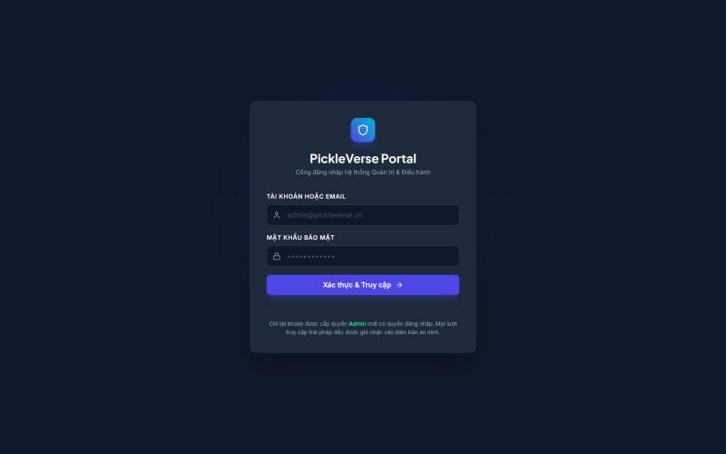
Figure 51. Admin web login page
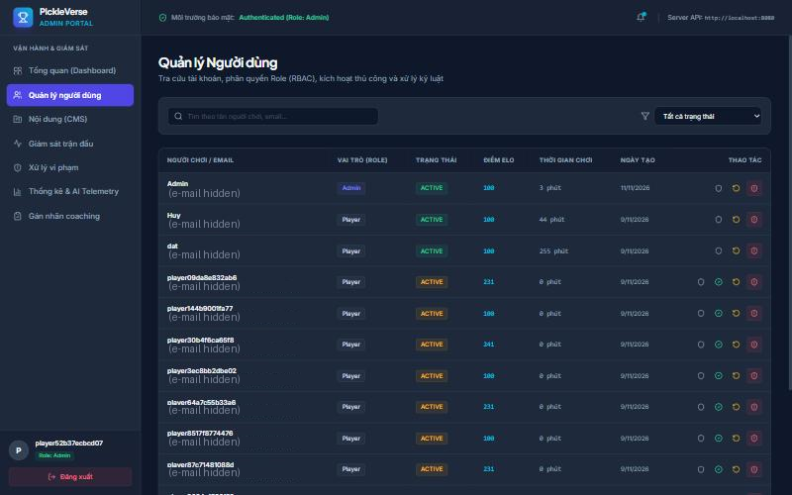
Figure 52. Users page of the admin web application
Function details
Table 21. FR-29 data fields
Field | Type | Required | Validation and constraints
Search text | Text | No | Matches name, e-mail or ID
Restriction | Choice | Yes (sanction) | SUSPENDED or BANNED
Expiry | Date-time (UTC) | Suspend: yes | Must be in the future (MSG56)
Reason | Text | Yes | 3–2000 characters (MSG55)
Reset groups | Multi-choice | Yes (reset) | At least one of LEARNING, RANKING, MISSIONS, ECONOMY

Business rules: BR-42, BR-45, BR-46.
Normal flow:
1. The administrator signs in and opens Users.
2. The administrator searches, selects an account and an action.
3. The administrator confirms; the API applies the change, writes the audit record and the table refreshes.
Alternative and exception flows:
• E1 – Non-admin account at login or on any admin API: HTTP 403.
• E2 – Sanction on the own account or a system account: MSG57.
• E3 – Reset while the player is searching or in a match: MSG58.
• E4 – Invalid reason or expiry: MSG55, MSG56.

FR-30 Review Player Reports and Appeals
Related use cases: UC-54 Review Player Report, UC-55 Review Appeal, UC-51 Apply Sanction
Function trigger: Sidebar → Xử lý vi phạm (/moderation).
Function description: The administrator opens a pending report, marks it CHECKING, examines the match evidence and replay, and accepts or declines it with a reason; accepting may apply a sanction to the reported player. Appeals are handled in the same way; accepting an appeal revokes only the sanction it concerns.
Screen layout
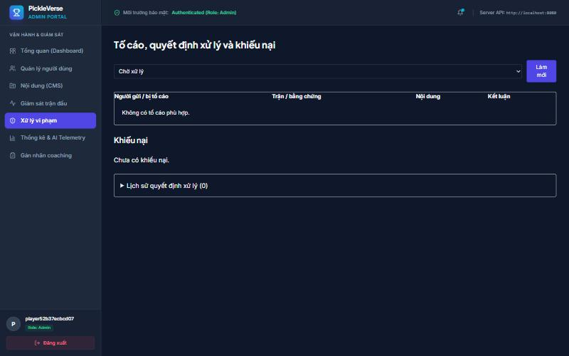
Figure 53. Moderation page
Function details
Table 22. FR-30 data fields
Field | Type | Required | Validation and constraints
Decision | Choice | Yes | ACCEPTED or DECLINED
Decision reason | Text | Yes | 3–2000 characters (MSG55)

Business rules: BR-42, BR-43, BR-44, BR-45.
Normal flow:
1. The administrator selects a report and reviews evidence.
2. The administrator enters the decision and reason and saves.
3. The report status changes; a sanction, if chosen, is applied and the player is restricted.
Alternative and exception flows:
• E1 – The report or appeal was changed by another administrator: the latest version is reloaded.
• E2 – A non-admin token: MSG63 (HTTP 403).

FR-31 Manage Training Content, Items and Missions
Related use cases: UC-56 to UC-61
Function trigger: Sidebar → Nội dung (CMS) (/cms).
Function description: The administrator creates and edits lessons as drafts, publishes a saved draft so that new attempts use it, and unpublishes a lesson to hide it from players; attempts already in progress keep their version. The administrator also maintains technique reference values, adds shop items and creates missions.
Screen layout
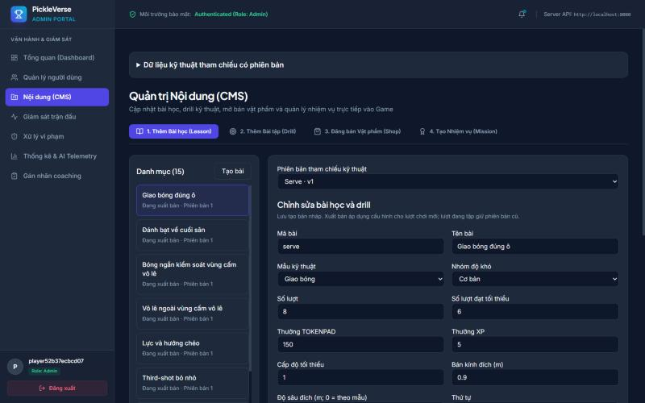
Figure 54. Content management page
Function details
Table 23. FR-31 data fields
Field | Type | Required | Validation and constraints
Lesson code | Text | Yes | Unique (MSG59)
Target | Integer | Yes | 1 ≤ target ≤ number of shots
Prerequisite | Lesson | No | Must not create an unlock cycle
Price | Integer | Yes (item) | ≥ 0, with a currency

Business rules: BR-19, BR-45, BR-47.
Normal flow:
1. The administrator edits a lesson and selects Lưu bản nháp.
2. The administrator selects Xuất bản bản đã lưu; the lesson becomes PUBLISHED.
3. Gỡ xuất bản sets it to UNPUBLISHED.
Alternative and exception flows:
• E1 – Duplicate lesson code: MSG59.
• E2 – The content changed since it was loaded: MSG60.
• E3 – The prerequisite creates a cycle: the save is rejected.

FR-32 Monitor Matches and View Analytics
Related use cases: UC-62 to UC-66
Function trigger: Sidebar → Tổng quan (Dashboard), Giám sát trận đấu (/matches), Thống kê & AI Telemetry (/analytics).
Function description: The dashboard summarises today's activity and pending work. The Matches page shows live matches with the score and connection state reported by the dedicated server and lets the administrator stop a live match with a reason. The Analytics page reports daily active players, retention cohorts, popular lessons with pass rate (passes divided by started attempts), the technique-error heat map and matchmaking health for a chosen date range.
Screen layout
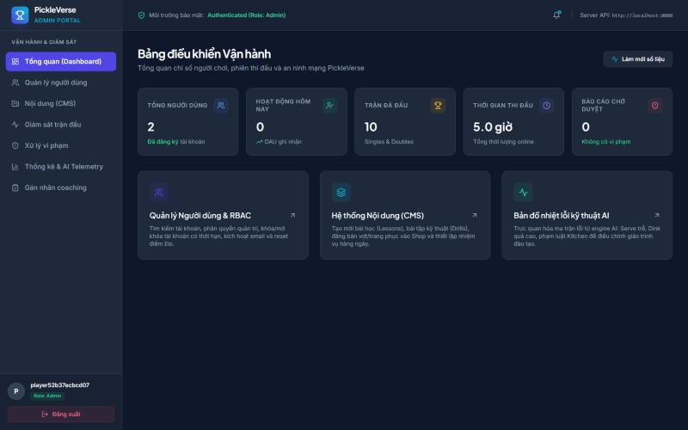
Figure 55. Admin dashboard
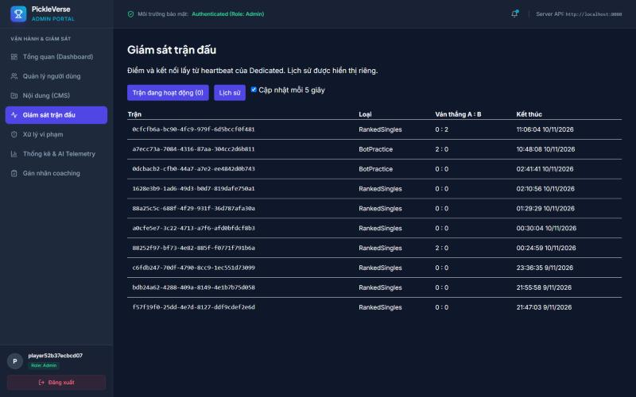
Figure 56. Live matches page
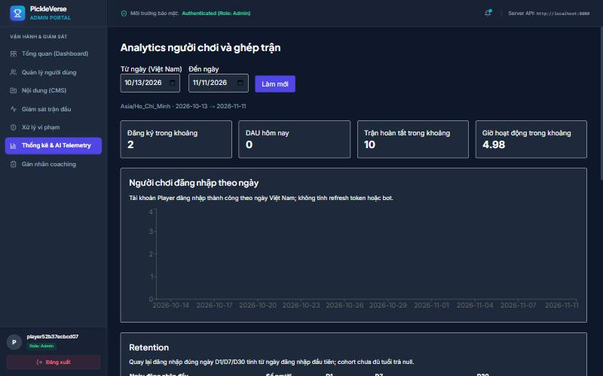
Figure 57. Analytics page
Function details
Table 24. FR-32 data fields
Field | Type | Required | Validation and constraints
Stop reason | Text | Yes | 3–2000 characters
From / To date | Date | Yes | From ≤ To; at most 366 days (MSG62)

Business rules: BR-45, BR-48, BR-49.
Normal flow:
1. The administrator opens Matches; the list refreshes every 5 seconds.
2. To stop a match the administrator enters a reason and confirms MSG61; the server ends the match as interrupted.
3. The administrator opens Analytics, sets the dates and reads the reports.
Alternative and exception flows:
• E1 – The match already finished: the stop is ignored and the final result is kept.
• E2 – Invalid date range: MSG62.

3.11 Expert Review (FE-10)

FR-33 Review Coaching Sessions and Export Dataset
Related use cases: UC-67 Review Coaching Session, UC-68 Export Labelled Dataset
Function trigger: Sidebar → Gán nhãn coaching (/coaching).
Function description: An administrator acting as a pickleball expert inspects the shot-level evidence of a real training session, assigns the player level and confirms or rejects each error, and assigns the data group. All sessions of one player must use the same data group. The labelled sessions are exported to calibrate the rule thresholds and to evaluate the tier model against NFR-06.
Screen layout
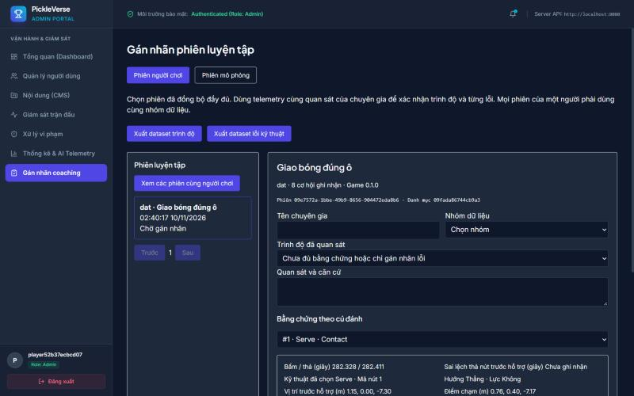
Figure 58. Expert review page
Function details
Table 25. FR-33 data fields
Field | Type | Required | Validation and constraints
Level | Choice | Yes | Beginner, intermediate or advanced
Error labels | Per error code | At least one | Present or absent with evidence (MSG64)
Data group | Choice | Yes | Training, calibration or holdout; consistent for a player

Business rules: BR-45, BR-50.
Normal flow:
1. The administrator selects a session and reviews the evidence.
2. The administrator sets the labels and saves the review.
3. The administrator exports the labelled dataset.
Alternative and exception flows:
• E1 – Missing confirmation, evidence or labels: MSG64.
• E2 – The session already has a newer review: the evidence must be reloaded.
• E3 – The player's sessions are in different data groups: HTTP 409.

4. Non-Functional Requirements

4.1 External Interfaces

4.1.1 User Interfaces
• The game interface is in Vietnamese with the project's Vietnamese fonts; it scales for 16:9 (1920×1080, 1280×720) and 20:9 phone screens; every screen can be operated with mouse and keyboard on PC and with touch on Android; Esc closes overlays and opens Settings, and Enter confirms.
• In-match information (score, serving side, timers, fault banners) is placed at the screen edges so that it does not cover the court.
• The administration web application is a responsive single-page application for desktop browsers with a fixed sidebar, tables with paging and confirmation dialogs for every destructive action.

4.1.2 Hardware Interfaces
• PC: keyboard and mouse; game controller input is not supported in release 1.0.
• Android: multi-touch screen for the virtual joystick and shot buttons.
• Server: Linux host with Docker; the dedicated game-server container is limited to 2 CPUs and 2 GB RAM by default.

4.1.3 Software Interfaces
Table 26. Software interfaces
Interface | Description
Web API (REST/JSON) | 122 endpoints under /api, JSON bodies wrapped in the ApiResponse<T> envelope {success, message, data}; error responses carry {success, message, code, errors}; JWT bearer authentication; Swagger/OpenAPI documentation
AI coaching service | Internal HTTP API POST /v1/analyze-session protected by the X-AI-Key header; called only by the Web API worker
Dedicated server ↔ Web API | HTTP calls for lease, heartbeat, telemetry, replay and result, authenticated with a service key; match tickets signed with HMAC-SHA256
Photon Fusion 2.1.3 | Real-time session service (protocol version 18) used by clients and the dedicated server
PostgreSQL 16 / Redis 7.4 | Persistent storage through Npgsql Entity Framework Core; Redis for matchmaking queue, leases, presence and caches
S3-compatible storage | Replay manifests and chunks through the S3 API

4.1.4 Communication Interfaces
• Client and admin web to Web API: HTTP/1.1 with JSON over TLS in production (port 443); the staging environment exposes HTTP on port 8080.
• Game traffic: UDP through Photon Cloud and to the dedicated server on UDP port 3669.
• E-mail: SMTP with STARTTLS on port 587 to Gmail.
• All timestamps are exchanged in UTC (ISO 8601) and displayed in Vietnam time (UTC+7).

4.2 Quality Attributes
Each quality attribute below is measurable and is verified by the test case named in the last column (Report 5).

4.2.1 Usability
Table 27. Usability requirements
ID | Requirement | Measure and acceptance criterion | Verification
NFR-01 | A new player can learn the game without outside help. | At least 8 of 10 first-time testers complete the 17-step tutorial in 5 minutes or less and then pass the first lesson (serve) within three attempts, without help from the team. | Moderated usability test with 10 students who have not played PickleVerse (Report 5, TC-N01)

4.2.2 Reliability
Table 28. Reliability requirements
ID | Requirement | Measure and acceptance criterion | Verification
NFR-07 | Online services are available when players want to play. | The API health endpoint /health/ready is available ≥ 99.5% of the time measured every 5 minutes by an external probe over the 14 days before the final defense (at most 100 minutes of downtime). | Uptime probe report (TC-N07)
NFR-08 | No result or reward is lost or duplicated. | Every match result, training receipt and purchase is applied exactly once under retries; after a container failure the service is restored from Docker Hub images within 1 hour (MTTR) with at most 24 hours of data loss from the daily database backup. No open Critical defect is allowed at release (Critical = loss of player data or inability to sign in or play). | Retry tests on settlement and sync APIs; restore drill (TC-N08)
NFR-11 | Training is possible without a connection. | After one online sign-in, all published lessons can be practised offline, and 100% of offline attempts are synchronised exactly once (no duplicate reward) when the device reconnects. | Offline–online test with 20 queued attempts (TC-N11)

4.2.3 Performance
Table 29. Performance requirements
ID | Requirement | Measure and acceptance criterion | Verification
NFR-02 | Online play is responsive for players in Vietnam. | Round-trip time between the client and the staging game server is at most 100 ms at the 95th percentile over 10 online matches on home broadband in Ho Chi Minh City. | Fusion RTT statistics logged by the client (TC-N02)
NFR-03 | Matches are smooth on mid-range devices. | Average frame rate ≥ 60 FPS (1% low ≥ 45 FPS) during a bot match on a reference PC (Intel Core i5 10th generation, GTX 1650, 16 GB RAM, 1920×1080, default quality); average ≥ 30 FPS on a reference Android phone (Snapdragon 7-series, 6 GB RAM). | Unity Profiler capture of a full bot match on each device (TC-N03)
NFR-04 | The Web API supports the target player population. | With 2,000 concurrent virtual users performing a read-mostly mix (profile, missions, leaderboard, history, catalogue) the API keeps the 95th-percentile response time ≤ 500 ms and the error rate < 1% for 10 minutes. The release capacity of online matches equals the number of dedicated server slots (one in the staging deployment, LI-07 in Report 1). | k6 load test against staging (TC-N04)
NFR-05 | Coaching feedback arrives quickly. | The AI coaching service returns the analysis of one drill or match in ≤ 1 second at the 95th percentile once the telemetry has been received; the coaching popup shows the result within 5 seconds of the end of the drill when online. | Timing of 50 analysis requests from the worker log (TC-N05)

4.2.4 Accuracy of AI Coaching
Table 30. Accuracy of AI Coaching requirements
ID | Requirement | Measure and acceptance criterion | Verification
NFR-06 | Coaching findings are trustworthy. | Each rule-based finding reaches precision ≥ 0.80 and recall ≥ 0.70 on the expert-labelled holdout sessions. The tier model is shown to players only when it is approved: real expert data, at least 10 holdout players per tier, macro-F1 ≥ 0.70 and at least 0.05 above the majority baseline, prediction confidence ≥ 0.65 and at least 20 shot opportunities. | Calibration and training reports of the AI service (TC-N06)

4.2.5 Security
Table 31. Security requirements
ID | Requirement | Measure and acceptance criterion | Verification
NFR-09 | Accounts and match results are protected. | Passwords are stored with BCrypt; access tokens are signed JWTs valid for 2 hours and refresh tokens are stored as SHA-256 hashes; OTPs and dedicated-server tickets are protected with HMAC; authentication endpoints are rate-limited; every admin endpoint requires the Admin role; secrets are supplied by environment variables and never committed; production traffic uses HTTPS (TLS 1.2+); match outcomes are decided only by the dedicated server. | Security checklist, API negative tests and secret scan (TC-N09)

4.2.6 Compatibility
Table 32. Compatibility requirements
ID | Requirement | Measure and acceptance criterion | Verification
NFR-10 | The game runs on the target platforms. | The client runs on Windows 10/11 64-bit and on Android 8.0 (API 26) or later on ARM64, at 16:9 and 20:9 aspect ratios with keyboard or touch input; the admin web supports the latest Chrome and Edge at 1366×768 or larger. | Installation and smoke test on each platform (TC-N10)

4.2.7 Maintainability and Privacy
Table 33. Maintainability and Privacy requirements
ID | Requirement | Measure and acceptance criterion | Verification
NFR-12 | The system can be changed safely and protects personal data. | The backend keeps the layered dependency rule (API → Services → Repositories → Entities) with no reverse reference; core rule classes are covered by automated unit tests that run before release; other players can see only the display name, player ID, rank and Elo, never the e-mail address, which is visible only to administrators. | Architecture check of project references, test run report and API response review (TC-N12)

5. Requirement Appendix

5.1 Business Rules
Table 34. Business rules
ID | Group | Rule Definition
BR-01 | Account | An e-mail address can be used by only one account.
BR-02 | Account | A password has 6 to 128 characters and is stored only as a BCrypt hash.
BR-03 | Account | A verification or reset code has six digits, is valid for 10 minutes, can be re-sent only after 60 seconds and allows at most 5 wrong attempts.
BR-04 | Account | Only an account with a verified e-mail can sign in. System bot accounts can never sign in. A suspended or banned account can sign in only with the appeal scope.
BR-05 | Account | An access token is valid for 2 hours and a refresh token for 14 days; a refresh token is replaced each time it is used. Resetting the password or signing out revokes the refresh tokens concerned.
BR-06 | Account | A display name has 3 to 18 characters, contains no control characters and is unique among players.
BR-07 | Account | The experience level (Beginner or Experienced) is chosen once, at the first sign-in.
BR-08 | Account | The display name and character cannot be changed while the player is in a room, searching for a match or playing a match.
BR-09 | Gameplay | The court is 13.41 m × 6.10 m; the non-volley zone extends 2.13 m from the net on each side. A ball touching a line is in.
BR-10 | Gameplay | A singles match is the best of three games. A game is won by the first side to reach 11 points with a lead of at least 2. Only the serving side scores a point; a fault by the server gives the serve to the opponent (side-out).
BR-11 | Gameplay | The serve is hit underhand, with both feet behind the baseline, into the diagonal service court and beyond the non-volley zone, within 10 seconds after the server is ready. The server serves from the right court when the server's score is even and from the left when it is odd.
BR-12 | Gameplay | Two-bounce rule: the return of serve and the third shot must bounce once before they are hit.
BR-13 | Gameplay | A volley may not be hit while standing in the non-volley zone, and the player's momentum after a volley may not carry them into the zone.
BR-14 | Gameplay | The rally ends with a fault of one of 17 types: serve foot, serve motion, serve timeout, short serve, serve to the wrong court, missed serve, out, ball into own court, two-bounce rule, double bounce, double hit, kitchen volley, kitchen momentum, net touch, body hit, net plane and permanent object.
BR-15 | Gameplay | Each side has two time-outs per game. In the third game the players change ends when a side first reaches 6 points.
BR-16 | Gameplay | A paddle contact is accepted only when the key is released within ±65 ms of the ideal contact time. A contact is Perfect when the contact error is ≤ 0.145 m and the timing error is within ±30 ms.
BR-17 | Gameplay | Shot keys: J drive (and serve), K dink, L volley, J+K drop, J+L smash, K+L reset; U adds power and I aims cross-court. The shot is decided once, when the first base key is released.
BR-18 | Training | Drill score: 0 stars below the target; 1 star when the target is reached; 2 stars at ≥ 80% hits; 3 stars at ≥ 90% hits with a mean timing error ≤ 0.16 s. The best result of each lesson is kept.
BR-19 | Training | A lesson is unlocked when its prerequisite lesson has been passed; a locked lesson cannot be started. Prerequisites cannot form a cycle.
BR-20 | Training | The first pass of a lesson grants 150, 225, 300 or 450 Tokenpad and 5, 7, 10 or 15 XP according to the lesson group; later passes and failed attempts grant no currency and cost nothing.
BR-21 | Training | Offline training is allowed only for a profile cached by a previous online sign-in. Each attempt carries a unique request ID and is applied at most once (receipt APPLIED, DUPLICATE or REJECTED).
BR-22 | Match | Match kinds are Bot Practice, Ranked Bot, Ranked Singles, Matched Doubles and Custom. Only Ranked Singles and Ranked Bot change Elo.
BR-23 | Match | A new player starts at 100 Elo, which is also the minimum. After a ranked match Elo changes by round(32 × (S − E)), where S is 1 for a win and 0 for a loss and E = 1 / (1 + 10^((R_opponent − R_own)/400)); the result is never below 100.
BR-24 | Match | Ranked pairing uses a window of 120 Elo. During the first 30 seconds the window extends only upward (only downward for a player with 5 or more losses); after 30 seconds it extends 120 in both directions.
BR-25 | Match | When a match is found, every player must accept within 10 seconds; a decline or a timeout cancels the offer.
BR-26 | Match | If no human opponent is found within 180 seconds, a ranked bot is assigned with Elo = own + 120 (own − 100 for a player with 5 or more losses).
BR-27 | Match | Rank tiers by Elo: Đồng < 500, Bạc < 1000, Vàng < 2000, Bạch Kim < 3500, Kim Cương < 5000, Cao Thủ < 7000, Huyền Thoại ≥ 7000.
BR-28 | Match | A disconnected client tries to reconnect for 30 seconds. The dedicated server sends a heartbeat every 8 seconds and the API keeps the player's slot for 35 seconds after the last heartbeat; after that the match is interrupted.
BR-29 | Match | A match result is saved exactly once. An interrupted or stopped match gives no Elo and no reward.
BR-30 | Match | A singles room holds 2 players and a doubles room up to 4. The host starts a custom match and may start a doubles room before all four slots are filled; custom matches are unrated.
BR-31 | Match | Bot levels Easy, Medium and Hard use fixed reaction, accuracy and error settings. The adaptive bot selects its tier from the player's Elo: below 500 beginner, below 2000 intermediate, otherwise advanced.
BR-32 | Economy | Match rewards: bot match win 100 / loss 50 Tokenpad; online match win 150 / loss 75 Tokenpad; every finished match gives 10 XP for a win and 5 XP for a loss.
BR-33 | Economy | Reaching level n+1 requires n × 200 XP at level n; surplus XP carries over.
BR-34 | Economy | There are 7 daily and 10 weekly missions. Daily missions renew at 07:00 Vietnam time (UTC+7) and weekly missions at the start of each mission week. Completing all daily missions gives 200 Tokenpad + 20 XP and all weekly missions 1,000 Tokenpad + 50 XP. The daily streak grows by one for each day with at least one finished match.
BR-35 | Economy | Each mission, mission set and achievement reward can be claimed only once.
BR-36 | Economy | A purchase requires enough balance in the chosen currency and is refused if the item is already owned; the debit and the grant are one transaction. Exactly one paddle is equipped at a time. Elite Token has no earning source in release 1.0.
BR-37 | Economy | The THOT paddle is granted once after 10 passed lessons and the GEMSTONE paddle once at level 25, unless already owned.
BR-38 | Social | A player cannot send a friend request to themself, send a duplicate request, or send one to a player who has already sent them a request. Blocking removes the friendship and prevents friend requests and room invitations in both directions.
BR-39 | Social | The leaderboard is ordered by Elo descending and is cached for 15 seconds.
BR-40 | Social | A match history and its replay can be read only by the players who took part and by administrators.
BR-41 | Moderation | A player can report another participant of their own finished match once per match; self-reporting is not allowed; the reason has at most 254 characters.
BR-42 | Moderation | A sanction is SUSPENDED (expiry required and in the future) or BANNED (expiry optional). The reason has 3 to 2,000 characters. An administrator cannot sanction their own account or a system account. An expired suspension ends automatically.
BR-43 | Moderation | A restricted player can submit one appeal per sanction, with a statement of 10 to 4,000 characters. Accepting an appeal revokes only the sanction it concerns.
BR-44 | Moderation | Reports and appeals move from PENDING to CHECKING to ACCEPTED or DECLINED; a decision requires a reason.
BR-45 | Administration | Only the Admin role can use the administration application and API (otherwise HTTP 403). Every administrative change is recorded in the audit log with actor, action, target and time.
BR-46 | Administration | Progress reset works on the groups LEARNING, RANKING, MISSIONS and ECONOMY after an impact preview, and is refused while the player is searching or in a match. It keeps the account, friends, match history, decisions and reward log; rewards already granted are not granted again.
BR-47 | Administration | A lesson moves DRAFT → PUBLISHED → UNPUBLISHED (and can be published again). Publishing applies to new attempts only. A save is refused when the content changed after it was loaded.
BR-48 | Administration | Stopping a live match requires a reason; when the stop is recorded before the final result the match is interrupted without Elo or reward.
BR-49 | Administration | Analytics dates are calendar days in Vietnam time; the start date is not after the end date and a range covers at most 366 days.
BR-50 | AI coaching | A coaching finding is reported only when the session contains at least 5 opportunities for that error; at most 3 drills are recommended; the tier estimate is shown only under the approval conditions of NFR-06.
BR-51 | AI coaching | Telemetry and replays of dedicated-server matches are submitted only by the dedicated server; a client can submit telemetry only for its own drills and bot matches.

5.2 Common Requirements
• Language: all player-facing and administrator-facing text is Vietnamese; documents and source code identifiers are English.
• Date and time: stored in UTC and shown in Vietnam time (dd/MM/yyyy HH:mm); daily cycles (missions, streaks, analytics days) start at 07:00 or 00:00 Vietnam time as stated in the related rule.
• API responses: every JSON response uses the ApiResponse envelope; HTTP 400 validation, 401 not signed in, 403 forbidden, 404 not found, 409 conflict, 429 too many requests, 503 dependency unavailable; HTTP 500 responses never expose internal details.
• Idempotency: commands that change progress, wallet or match state carry a client request ID; repeating a request returns the first result.
• Concurrency: administrative edits use a version check and ask the user to reload when the data changed.
• Lists: account lists are paged (20 rows per page by default in the API); the game history shows the last 20 matches.
• Logging: the API, workers and dedicated server write structured logs without passwords, tokens or codes.

5.3 Application Messages List
Table 35. Application messages
# | Message code | Message Type | Context | Content
1 | MSG01 | In red, under the text box | E-mail field is empty | Vui lòng nhập email.
2 | MSG02 | In red, under the text box | E-mail format is invalid | Vui lòng nhập địa chỉ email hợp lệ.
3 | MSG03 | In red, under the text box | Password field is empty | Vui lòng nhập mật khẩu.
4 | MSG04 | In red, under the text box | Password shorter than 6 characters | Mật khẩu cần ít nhất 6 ký tự.
5 | MSG05 | In red, under the text box | Confirmation differs from the password | Mật khẩu xác nhận chưa khớp.
6 | MSG06 | In red, under the form | E-mail already registered | Email đã được đăng ký. Nếu chưa xác thực, hãy dùng chức năng gửi lại mã.
7 | MSG07 | In line, information | Registration succeeded | Đã đăng ký. Hãy nhập mã được gửi tới email để kích hoạt tài khoản.
8 | MSG08 | In red, under the text box | Code is not six digits | Mã xác thực gồm 6 chữ số.
9 | MSG09 | In line, information | A new code was sent | Mã xác thực đã được gửi. Hãy kiểm tra cả thư rác.
10 | MSG10 | In red, under the form | Code re-sent within 60 seconds (HTTP 429) | Vui lòng chờ ít nhất 60 giây trước khi gửi lại mã.
11 | MSG11 | In red, under the form | Sign-in with an unverified e-mail | Email chưa được xác thực. Hãy nhập OTP hoặc yêu cầu gửi lại mã.
12 | MSG12 | In red, under the form | Wrong e-mail or password | Email hoặc mật khẩu không chính xác.
13 | MSG13 | Toast message | Sign-in succeeded | Đăng nhập thành công.
14 | MSG14 | Popup | Sign-in of a suspended or banned account | Tài khoản đang bị hạn chế. Bạn có thể xem quyết định và gửi khiếu nại.
15 | MSG15 | In line, information | Password reset requested (same text whether or not the e-mail exists) | Nếu email thuộc tài khoản đã xác thực, mã đặt lại mật khẩu sẽ được gửi. Hãy kiểm tra cả thư rác.
16 | MSG16 | In red, under the form | Reset code wrong or expired | Mã đặt lại mật khẩu không hợp lệ hoặc đã hết hạn.
17 | MSG17 | In red, under the form | Password rule rejected by the API | Mật khẩu cần từ 6 đến 128 ký tự và xác nhận phải khớp.
18 | MSG18 | Popup | Refresh token expired or revoked | Phiên đăng nhập không hợp lệ hoặc đã hết hạn.
19 | MSG19 | In red, under the text box | Display name length invalid | Tên người chơi cần từ 3 đến 18 ký tự.
20 | MSG20 | In red, under the text box | Display name already used | Tên người chơi đã được sử dụng. Hãy chọn tên khác.
21 | MSG21 | Popup question | First sign-in experience choice | Bạn đã quen với pickleball chưa? – Người mới sẽ được hướng dẫn luật và điều khiển. Nếu đã thành thạo, bạn có thể vào sảnh ngay.
22 | MSG22 | In red, under the form | Verification e-mail could not be sent | Chưa gửi được email xác thực. Vui lòng thử gửi lại mã sau ít nhất 60 giây.
23 | MSG23 | In line | Starting a locked lesson | Bài tập chưa mở khóa.
24 | MSG24 | Popup title | Drill target not reached | CHƯA ĐẠT MỤC TIÊU
25 | MSG25 | In line | Drill failed | Không mất Tokenpad. Luyện lại để đạt {target} cú.
26 | MSG26 | HUD feedback | Key released late | Bạn thả nút hơi muộn. Hãy chuẩn bị vợt và thả nút sớm hơn.
27 | MSG27 | HUD feedback | Key released early | Bạn thả nút hơi sớm. Hãy đợi bóng tiến gần hơn.
28 | MSG28 | Banner | Offline training mode | Đang luyện tập ngoại tuyến · {n} mục chờ đồng bộ
29 | MSG29 | HUD banner | Serve timer expired | Bạn đã hết 10 giây giao bóng. Hãy chuẩn bị và giao bóng trước khi hết thời gian.
30 | MSG30 | HUD banner | Rally ended by a fault (examples) | Lỗi • Bóng ra ngoài / Lỗi • Nảy hai lần / Lỗi • Vô lê trong vùng cấm vô lê / Lỗi • Bóng không qua lưới / Lỗi chân giao bóng
31 | MSG31 | Result title | Player wins the match | Bạn thắng trận!
32 | MSG32 | In line | Searching for an opponent | Đang tìm đối thủ trực tuyến…
33 | MSG33 | Popup | Match found, ready check | Đã tìm thấy trận • Xác nhận để tham gia.
34 | MSG34 | In line | Search expired | Hết thời gian tìm trận. Hãy thử lại.
35 | MSG35 | In line | Player declined the match | Bạn đã hủy tham gia. Bấm Tìm trận để tìm lại.
36 | MSG36 | In line | Dedicated server slot is busy | Máy chủ đang bận • Đang chờ lượt thi đấu…
37 | MSG37 | In line | Room is full | Phòng đã đủ người.
38 | MSG38 | In line | Room closed or player removed | Phòng đã đóng hoặc bạn đã được mời ra.
39 | MSG39 | In line | Joining a room failed (for example wrong code) | Không tham gia được phòng. Vui lòng thử lại.
40 | MSG40 | In line | Invited player cannot receive invitations | Người chơi chưa sẵn sàng nhận lời mời.
41 | MSG41 | In line | Player already searching or in an unfinished match | Người chơi đang tìm trận hoặc có trận chưa hoàn tất.
42 | MSG42 | Overlay | Connection to the match server lost | Mất kết nối máy chủ thi đấu.
43 | MSG43 | Popup | Reconnection failed | Không thể kết nối lại trận. Kết quả sẽ được cập nhật khi máy chủ xử lý xong.
44 | MSG44 | Toast message | Player left the match | Bạn đã rời trận.
45 | MSG45 | Popup | Photon Cloud not reachable | Không kết nối được Photon. Vui lòng kiểm tra mạng và thử lại.
46 | MSG46 | Popup | Balance too low for a purchase | Số dư tiền tệ không đủ để mua vật phẩm này.
47 | MSG47 | Popup | Item already owned | Bạn đã sở hữu vật phẩm này rồi.
48 | MSG48 | Popup | Equipping an item that is not owned | Bạn chưa sở hữu vật phẩm này.
49 | MSG49 | Toast message | Achievement reward claimed | Mở khóa thành công danh hiệu và phần thưởng: {reward}!
50 | MSG50 | In line | The other player already sent a request | Người chơi đã gửi lời mời cho bạn. Hãy chấp nhận hoặc từ chối.
51 | MSG51 | In line | No search result | Không tìm thấy tên hoặc ID phù hợp.
52 | MSG52 | In line | No player can be reported | Không có người chơi phù hợp để tố cáo
53 | MSG53 | In red, under the text box | Appeal statement too short | Nội dung khiếu nại cần ít nhất 10 ký tự.
54 | MSG54 | In line | No decision to appeal | Không có quyết định xử lý để khiếu nại.
55 | MSG55 | In red, under the text box | Reason length invalid (admin) | Lý do phải có từ 3 đến {max} ký tự.
56 | MSG56 | In red, under the text box | Suspension without a future expiry | Tạm ngưng cần thời hạn trong tương lai; khóa có thể không có thời hạn.
57 | MSG57 | Toast message | Admin tries to sanction own account | Không thể tự khóa tài khoản quản trị.
58 | MSG58 | In line, in the dialog | Reset while player searching or in a match | Người chơi đang tìm trận hoặc có trận chưa hoàn tất. Chưa thể reset.
59 | MSG59 | In red, under the text box | Lesson code already exists | Mã bài học đã tồn tại.
60 | MSG60 | Toast message | Content changed since it was loaded | Nội dung đã thay đổi. Hãy tải lại trước khi lưu.
61 | MSG61 | Warning in the dialog | Confirming a match stop | Trận sẽ bị gián đoạn và không tính Elo/thưởng nếu lệnh dừng được ghi trước kết quả cuối.
62 | MSG62 | In red, under the date fields | Invalid analytics range | Khoảng ngày thống kê không hợp lệ. / Biểu đồ hỗ trợ tối đa 366 ngày mỗi lần xem.
63 | MSG63 | Toast message | Non-admin calls a moderation function (HTTP 403) | Bạn không có quyền xử lý vi phạm.
64 | MSG64 | In red, under the form | Expert review incomplete | Hãy xác nhận phiên người thật, người đánh giá, bằng chứng và ít nhất một nhãn.
65 | MSG65 | In red, under the form | System account sign-in attempt | Tài khoản hệ thống không được đăng nhập.

5.4 Definitions and Acronyms
Table 36. Definitions and acronyms
Term | Definition
Dink | A soft shot that drops into the opponent's non-volley zone
Drill | A practice exercise with a fixed number of shots and a target
Elo | A rating system in which the rating change depends on the expected result against the opponent
Kitchen / NVZ | Non-volley zone: the area within 2.13 m of the net where volleys are not allowed
Rally | The exchange of shots from the serve until a fault
Side-out | Loss of serve to the opponent after a fault by the serving side
Telemetry | Shot-level data (timing, contact, landing, position) recorded by the game
Tokenpad / Elite Token | In-game currencies; Tokenpad is earned by playing
Dedicated server | A headless Unity server that runs an online match with authority over the result
Photon Fusion | Third-party networking library and cloud used for real-time sessions
API, JWT, OTP, HMAC | Application programming interface; JSON Web Token; one-time password; hash-based message authentication code
BR, FR, NFR, UC, MSG | Business rule; functional requirement; non-functional requirement; use case; message

5.5 Appendix A – Traceability to the Review 2 Commitment
The table below links the 18 features committed in the Review 2 form BM04 (07/11/2026) to the use cases and functional requirements of this specification, with the workflow and the member accountable for each feature at the reviews. Report 5 links each requirement to its test cases.
Table 37. Traceability from Review 2 features to requirements and owners
Review 2 feature | Name | Functional requirements | Use cases | Workflow | Owner (BM04)
F01 | Account and first steps | FR-01, FR-02, FR-03, FR-04 | UC-01 to UC-08 | W01 | Trần Nguyễn Hiếu Thuận
F02 | Rules and controls | FR-05, FR-06, FR-11 | UC-09, UC-10 | W01 | Trần Nguyễn Hiếu Thuận
F03 | Guided drills | FR-07, FR-08 | UC-11, UC-12 | W01 | Nguyễn Gia Huy
F04 | Levels and items | FR-20, FR-23 | UC-43, UC-44 | W01 | Nguyễn Văn Thành Đạt
F05 | Adaptive bot | FR-12, FR-13 | UC-16 | W02 | Nguyễn Gia Huy
F06 | Coaching and tier | FR-19 | UC-17, UC-18 | W02 | Nguyễn Văn Thành Đạt
F07 | Quick match | FR-14 | UC-19, UC-20 | W03 | Nguyễn Văn Thành Đạt
F08 | Private rooms | FR-15 | UC-21 to UC-24 | W03 | Nguyễn Văn Thành Đạt
F09 | Dedicated play | FR-16, FR-17 | UC-25 to UC-27 | W03 | Nguyễn Văn Thành Đạt
F10 | Result and Elo | FR-18 | UC-25 | W03 | Nguyễn Văn Thành Đạt
F11 | Progress and replay | FR-10, FR-24 | UC-15, UC-28, UC-29 | W02 | Nguyễn Gia Huy
F12 | Friends and ranks | FR-25, FR-26 | UC-31 to UC-36 | W03 | Trần Nguyễn Hiếu Thuận
F13 | Daily and streak rewards | FR-21 | UC-37 to UC-40 | W01 | Nguyễn Gia Huy
F14 | Offline practice | FR-09 | UC-13, UC-14 | W01 | Trần Nguyễn Hiếu Thuận
F15 | Admin and accounts | FR-29 | UC-47 to UC-53 | W04 | Huỳnh Trung Kiên
F16 | Lesson publishing | FR-31 | UC-56 to UC-61 | W04 | Huỳnh Trung Kiên
F17 | Match care and reports | FR-27, FR-28, FR-30, FR-32 | UC-30, UC-45, UC-46, UC-54, UC-55, UC-62 to UC-64 | W04 | Huỳnh Trung Kiên
F18 | Admin charts | FR-32 | UC-65, UC-66 | W04 | Huỳnh Trung Kiên
– | Shop (not in the Review 2 list) | FR-22 | UC-41, UC-42 | – | –
– | Expert review (addition to the proposal) | FR-33 | UC-67, UC-68 | – | –

5.6 References
[1] USA Pickleball, "Official Rulebook 2024." https://usapickleball.org/what-is-pickleball/official-rules/ (accessed 11 Nov. 2026).
[2] K. E. Wiegers and J. Beatty, Software Requirements, 3rd ed. Microsoft Press, 2013.
[3] Photon Engine, "Fusion 2 Documentation." https://doc.photonengine.com/fusion/current (accessed 11 Nov. 2026).
[4] GFA26SE111, "Report 1 – Project Introduction" and "Report 4 – Software Design Document," PickleVerse, 2026.

IV. Software Design Description

1. System Design

1.1 System Architecture
PickleVerse uses a client–server architecture with five deployable sub-systems (Figure 1). The Unity game client contains the presentation, the local gameplay simulation used for training and bot matches, and an offline store. All persistent data and business rules that must be trusted are on the server side: the ASP.NET Core Web API owns accounts, progression, economy, matchmaking and moderation; the Unity dedicated server owns the state of online matches; the AI coaching service analyses shot telemetry; the React administration application is a pure client of the Web API. Background workers run inside the Web API process. PostgreSQL is the system of record, Redis holds short-lived coordination data, and object storage keeps replays.
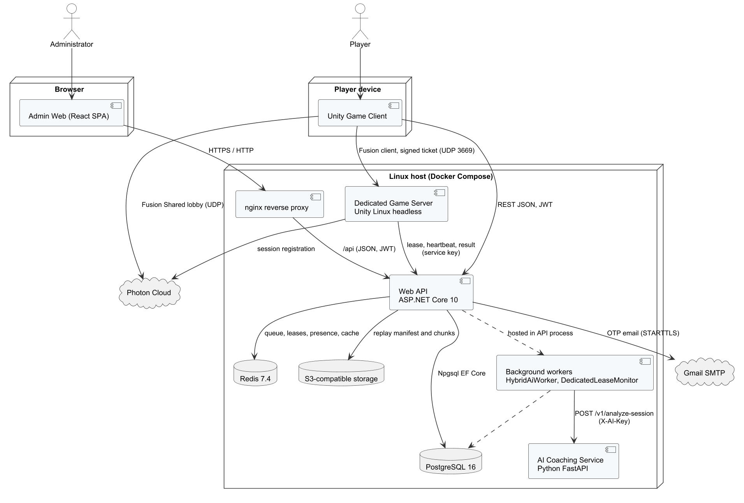
Figure 1. System architecture (component view)
Table 1. Architecture components
Component | Technology | Responsibility
Unity game client | Unity 6000.6.2f1, C#, uGUI, Input System | Scenes and UI, local physics and rules for training and bot matches, Photon Fusion client, offline training store, REST client (ApiClient) to the Web API
Dedicated game server | Unity Linux headless build, Photon Fusion 2.1.3 (server mode) | Authoritative simulation of online matches; validates signed tickets; sends heartbeats, telemetry, replay and result to the Web API
Web API | ASP.NET Core (.NET 10), layered API → Services → Repositories → Entities | REST endpoints, JWT authentication, business rules, transactions through IUnitOfWork and Npgsql EF Core
Background workers | Hosted services in the Web API | HybridAiWorker (analysis jobs), DedicatedLeaseMonitor (expired leases), ModerationExpiryWorker (expired suspensions), AnalyticsProjectionWorker (daily aggregates), PasswordRecoveryMailQueue (e-mail sending)
AI coaching service | Python 3.12, FastAPI, scikit-learn | Rule engine for technique errors, summary and drill recommendations, gated tier model; internal API protected by an API key
Admin web application | React 18, TypeScript 5, Vite 5, React Query, Axios | Administration screens served by nginx; calls the Web API with the administrator's JWT
PostgreSQL 16 | Relational database | 51 tables: accounts, profiles, content, matches, economy, moderation, telemetry and coaching
Redis 7.4 | In-memory store | Matchmaking queue and search state, dedicated-server lease, presence, leaderboard cache (15 s)
Object storage | S3-compatible container | Replay manifests and compressed chunks
Photon Cloud | External service | Fusion session lookup and relay for clients and the dedicated server
Gmail SMTP | External service | Delivery of verification and password-reset e-mails

Online matches support two authority modes recorded in GameMatches.AuthorityMode. In dedicated mode, enabled by the configuration flag DedicatedServer:Enabled (true on staging), the dedicated server runs the simulation and is the only authority for points, faults and the result. In shared mode, kept for local development without a server, the room host runs the simulation through Photon Fusion shared mode. The staging deployment has one dedicated-server container, so one authoritative match runs at a time; the API reports the slot as busy and the client waits (Report 3, MSG36). Scaling to more matches requires more server containers and is outside release 1.0.

Deployment
Figure 2 shows the staging deployment on the host tad-min.io.vn (Ubuntu 24.04, Docker Engine). GitHub Actions validates each push to main, publishes images to Docker Hub and deploys them over SSH with deploy.sh, which pulls images by digest and restarts the Docker Compose stack. Only the ports listed in Table 2 are reachable from the Internet.
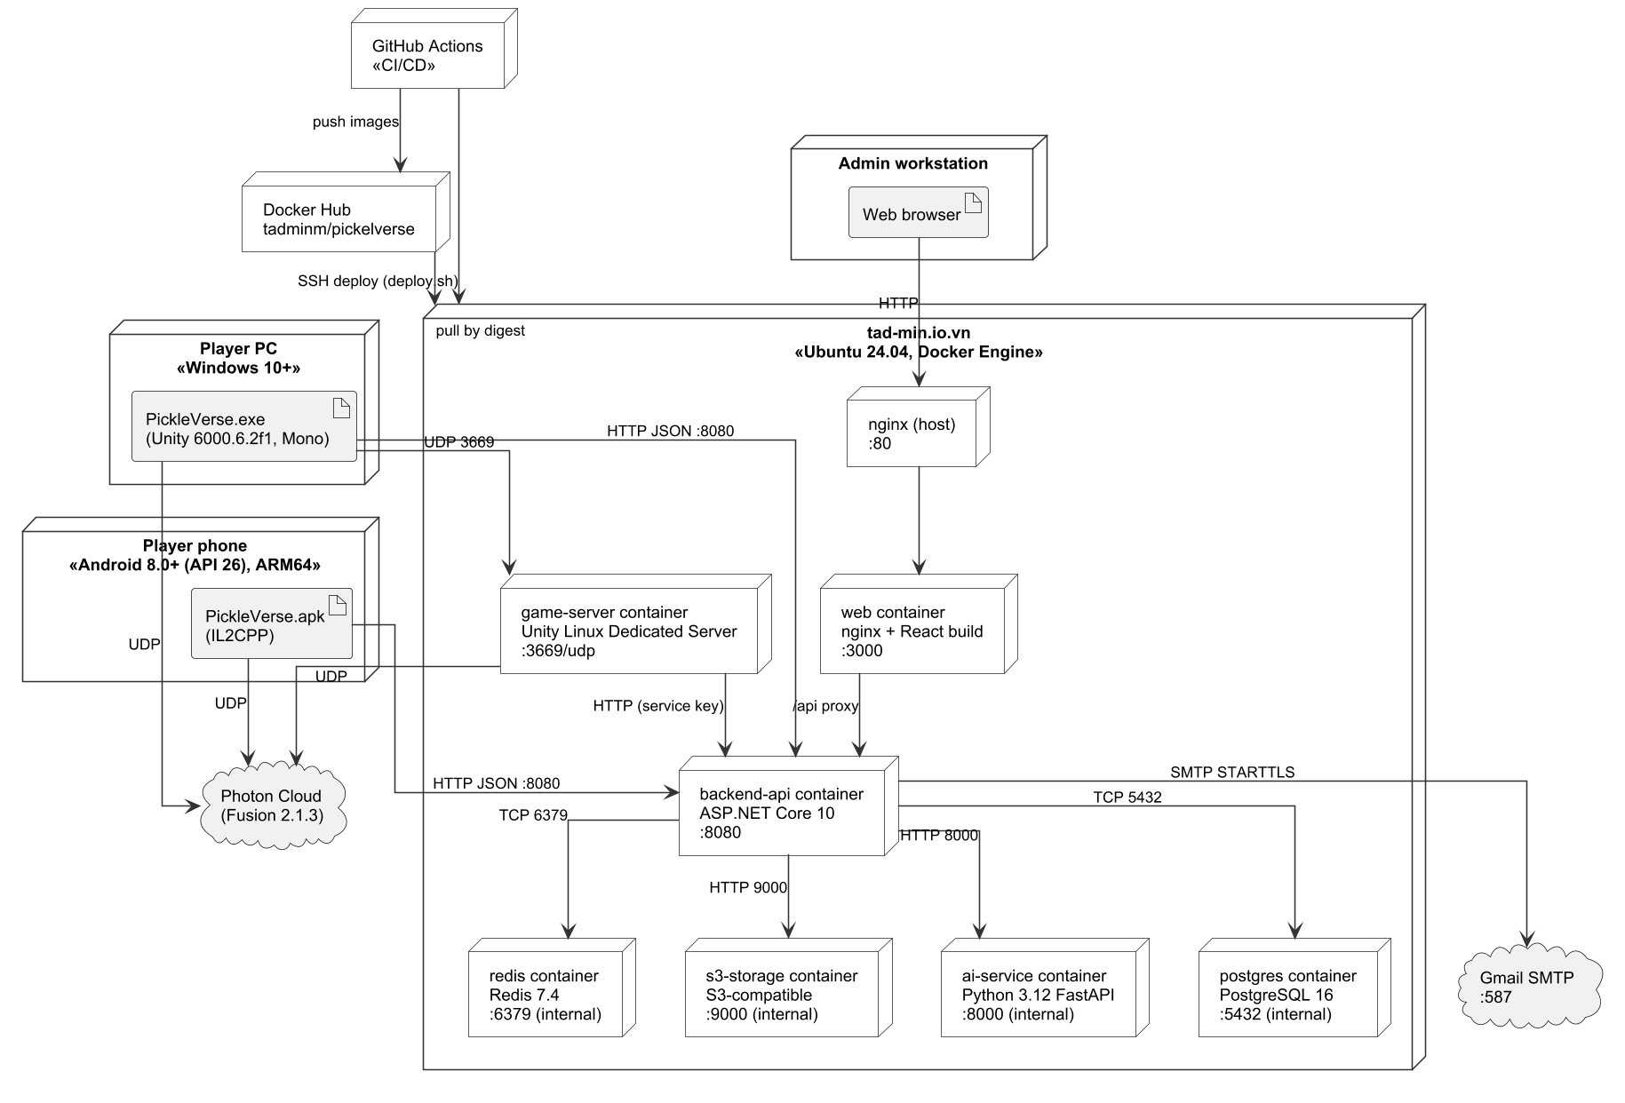
Figure 2. Deployment diagram of the staging environment
Table 2. Deployment nodes
Node / container | Image or artifact | Port | Notes
Host nginx | Ubuntu package | 80/tcp | Reverse proxy to the web container; TLS termination is planned for production (port 443)
web | tadminm/pickelverse:web-<release> | 3000/tcp (internal) | nginx serving the React build; proxies /api to backend-api
backend-api | tadminm/pickelverse:api-<release> | 8080/tcp | Web API and background workers
game-server | tadminm/pickelverse:server-<release> | 3669/udp | Unity dedicated server; limited to 2 CPUs and 2 GB RAM
ai-service | tadminm/pickelverse:ai-<release> | 8000/tcp (internal) | FastAPI coaching service, reachable only from backend-api
postgres | PostgreSQL 16 (pinned digest) | 5432/tcp (internal) | Volume for data; schema and seed from src/Database.sql
redis | Redis 7.4 (pinned digest) | 6379/tcp (internal) | Coordination data; no persistence required
s3-storage | S3-compatible server (pinned digest) | 9000/tcp (internal) | Bucket pickleverse for replays
Player PC / phone | PickleVerse.exe (Windows, Mono) / PickleVerse.apk (Android 8.0+, IL2CPP, ARM64) | – | Connects to the API, Photon Cloud and the game server

1.2 Package Diagram
The three code bases are organised in layers. Dependencies point only downwards: a package may use the packages below it but never the reverse. Figures 3 to 5 show the packages of the Web API, the Unity client and the admin web with the AI service.

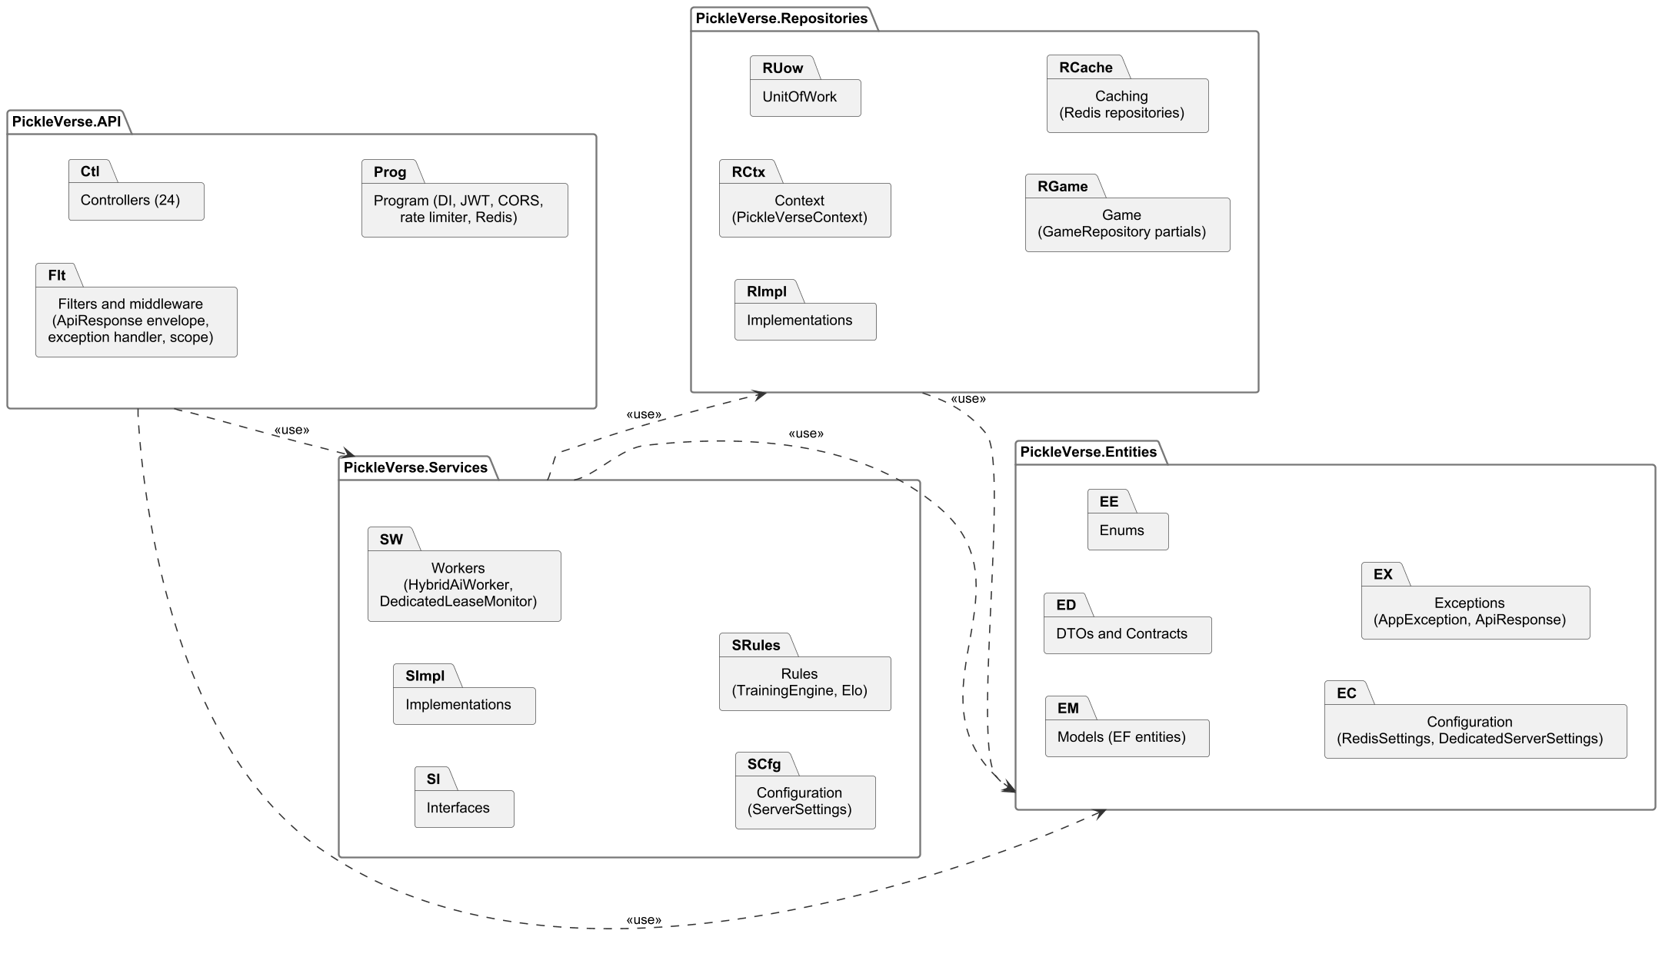
Figure 3. Package diagram of the Web API solution

Table 3. Web API package descriptions
No | Package | Description
01 | PickleVerse.API | Entry point: 24 controllers, Program.cs (dependency injection, JWT, CORS, rate limiter, Redis), filters that wrap responses in ApiResponse<T>, the global exception handler that maps service exceptions to HTTP status codes
02 | PickleVerse.Services | Business logic: service interfaces (Interfaces) and implementations (Implementations), background workers, typed settings (ServerSettings) and pure rule classes (TrainingEngine, ProgressionEngine, EloPolicy)
03 | PickleVerse.Repositories | Data access: PickleVerseContext (Npgsql EF Core mapping of the 51 tables), IUnitOfWork, repositories, GameRepository partial classes for match and progress persistence, Redis repositories for queues, leases and caches
04 | PickleVerse.Entities | Shared model: EF entity classes, DTOs and contracts, enums, configuration models (RedisSettings, DedicatedServerSettings) and exception/response types (AppException, ApiResponse)

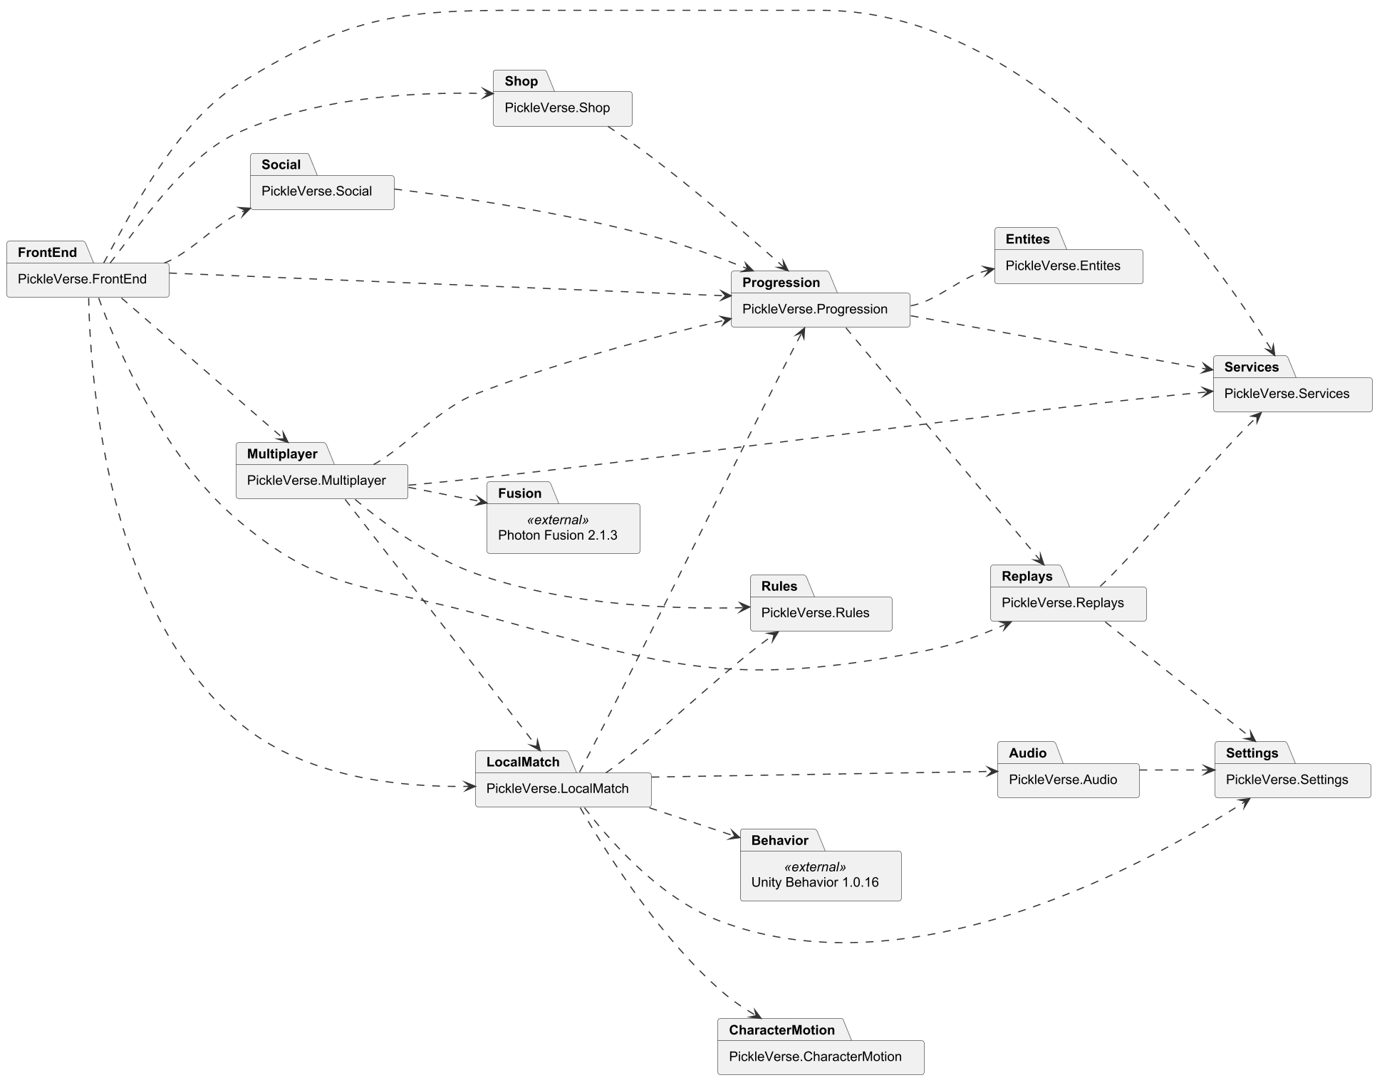
Figure 4. Package diagram of the Unity client (assembly definitions)
Table 4. Unity client package descriptions
No | Package | Description
01 | PickleVerse.FrontEnd | Menus and screens: login, loading, menu, mode selection, settings entry, overlays, history and missions popups
02 | PickleVerse.Multiplayer | Online flow: MultiplayerApp, PhotonSession, room state, NetworkMatch and NetworkPlayer, dedicated-server client and reconnection
03 | PickleVerse.LocalMatch | Local gameplay: BotMatch, MatchActor, ball flight, paddle contact, shot input, LocalBot and BhTreeBot, training and tutorial directors
04 | PickleVerse.Rules | Engine-independent rules shared by local and online play (scoring, faults, court geometry)
05 | PickleVerse.Progression | ProgressionRuntime, training engine on the client, offline training store, wallet and profile cache
06 | PickleVerse.Services | ApiClient, AccountService and backend settings
07 | PickleVerse.Entites | Data contracts shared by client assemblies (room models, DTOs); the name keeps the original spelling of the assembly
08 | PickleVerse.Shop | Shop and collection scenes
09 | PickleVerse.Social | Friends, blocking and leaderboard UI
10 | PickleVerse.Replays | Replay recording, upload and the replay viewer
11 | PickleVerse.Settings | Settings scene: audio, graphics, key binding and touch layout
12 | PickleVerse.Audio | Music player and sound effects policy
13 | PickleVerse.CharacterMotion | Character animation controller and movement blending

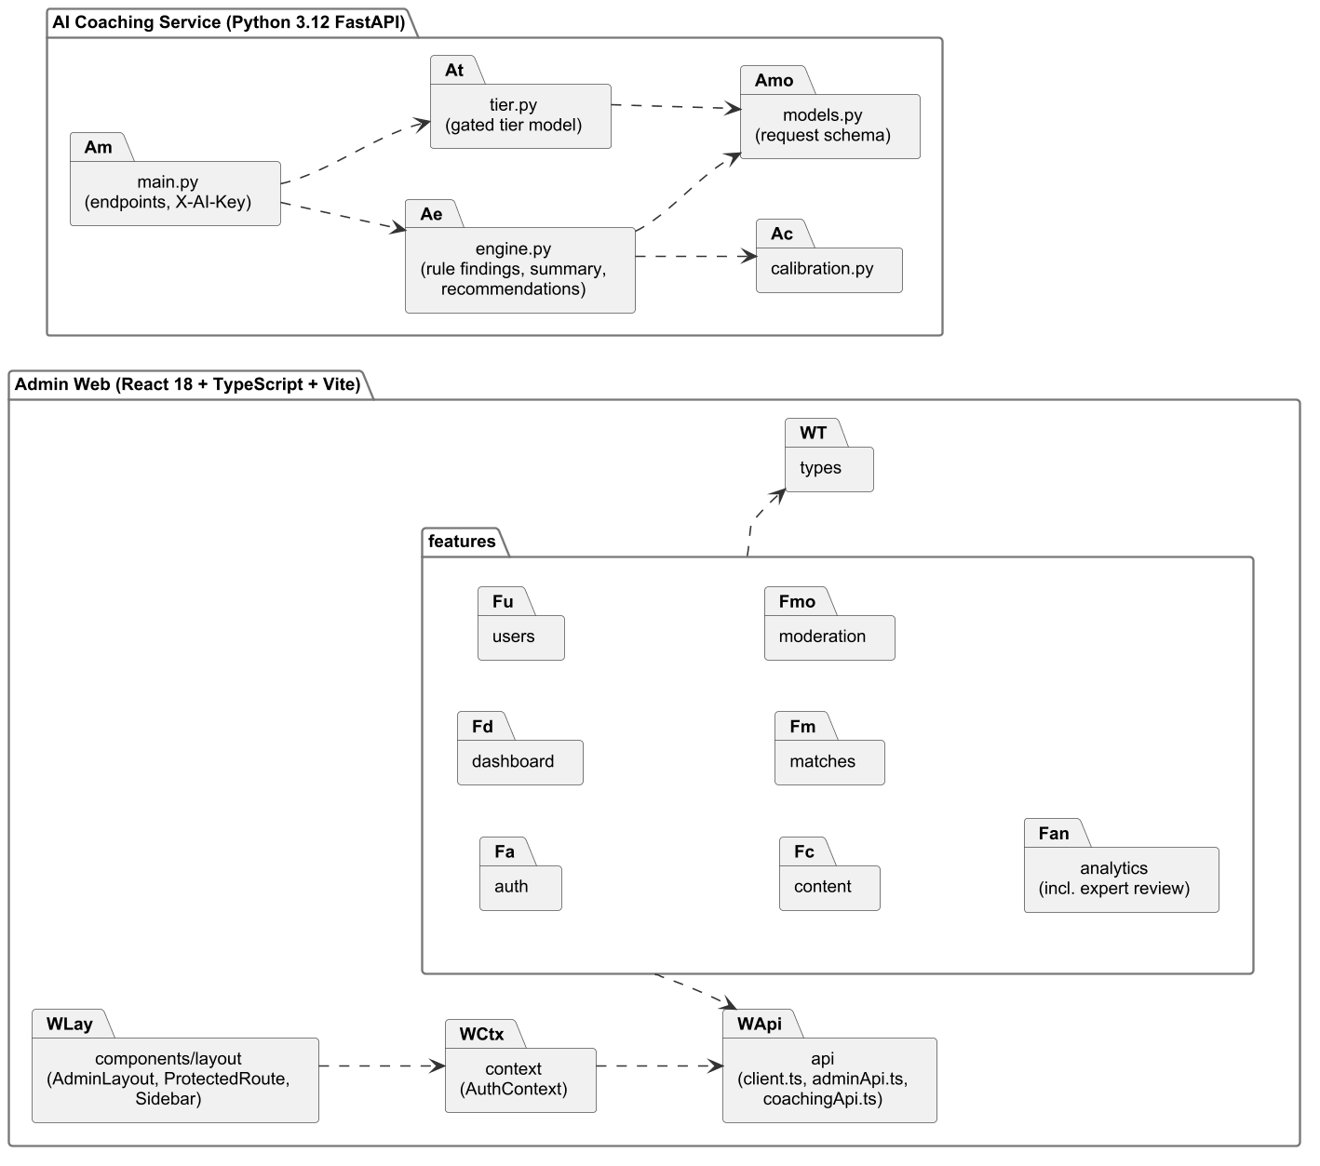
Figure 5. Package diagram of the admin web application and the AI coaching service
Table 5. Admin web and AI service package descriptions
No | Package | Description
01 | features (admin web) | One folder per area: auth, dashboard, users, content, matches, moderation, analytics (including expert review); each holds its pages
02 | api | Axios client with the JWT interceptor (client.ts) and typed API modules (adminApi.ts, coachingApi.ts)
03 | context | AuthContext: stores the session and exposes sign-in and sign-out
04 | components/layout | AdminLayout, Sidebar and ProtectedRoute, which redirects users without the Admin role to the login page
05 | main.py (AI service) | FastAPI application, request validation and the X-AI-Key check
06 | engine.py | Rule-based findings for 15 error codes, summary and at most three recommendations
07 | tier.py | Gated tier model: 8 features, minimum confidence 0.65, minimum 20 opportunities
08 | calibration.py / models.py | Threshold calibration against expert labels; request and response schemas

1.3 Technology Stack
Table 6. Technology stack
Layer | Technology and version | Purpose
Game client | Unity 6000.6.2f1, C#, uGUI, Input System, Unity Behavior 1.0.16, Photon Fusion 2.1.3 | Gameplay, UI, bot behaviour graph, networking
Game server | Unity 6000.6.2f1 Linux dedicated server build | Authoritative online matches
Web API | ASP.NET Core on .NET 10, Npgsql EF Core 10, StackExchange.Redis 3.4, BCrypt.Net-Next 4.2, MailKit 4.17, AWSSDK.S3 4.0, JwtBearer 10 | REST API, persistence, caching, password hashing, e-mail
AI service | Python 3.12, FastAPI, Pydantic, scikit-learn | Coaching analysis and tier model
Admin web | React 18, TypeScript 5, Vite 5, TanStack React Query 5, Axios 1.6, Recharts 2, Tailwind CSS 3 | Administration UI
Data | PostgreSQL 16, Redis 7.4, S3-compatible storage | Persistence, coordination, replays
DevOps | Docker, Docker Compose, GitHub Actions, Docker Hub, nginx, Ubuntu 24.04 | Build, delivery and hosting

1.4 Architecture Decisions
Table 7 records the main decisions that differ from the registered proposal, the alternatives considered and their consequences. Report 1 (LI-08) refers to this table.
Table 7. Architecture decisions
# | Decision | Alternatives | Reason | Consequence
1 | ASP.NET Core Web API (.NET 10) | Spring Boot; FastAPI | The team writes C# for Unity; sharing the language reduces context switching and lets DTOs be checked against the Unity client in IntegrationChecks | The AI service stays in Python; two runtimes on the server
2 | Photon Fusion 2 with a dedicated server | Netcode for GameObjects with Relay (prototype 07–21/10/2026); Mirror | The NGO prototype showed unstable relayed connections; Fusion provides lag compensation, input authority and a server mode | Dependency on Photon Cloud and its CCU plan (Report 2, risk 4)
3 | Custom fixed-step ball simulation (120 Hz) | Unity PhysX rigidbody | Deterministic, engine-independent flight and bounce that the server and replays can reproduce exactly | Collision with paddle and net is implemented by the team (sphere sweep against a contact box)
4 | uGUI for the game interface | UI Toolkit | Existing art assets and world-space panels were built with uGUI; better support for runtime animation | Two UI systems are not mixed; layout code is in C#
5 | Server-authoritative results and rewards | Client-reported results | Prevents cheating on Elo, currency and missions | Bot matches are reported by the client; only Elo-neutral practice uses this path except Ranked Bot, whose result is validated against the server-created match
6 | Single schema file (src/Database.sql) without migrations during development | EF Core migrations | The schema changed often; one reviewed file is the single source for schema and seed data | Database resets are allowed only on the development instance (AGENTS.md)
7 | Gated AI tier model with rule fallback | Always show the model output | Too little labelled real data; a wrong tier would mislead beginners | The tier is hidden until the acceptance criteria of NFR-06 are met

2. Database Design
The logical database design is derived directly from src/Database.sql (51 tables, 366 columns, 71 foreign keys). To keep the diagrams readable the schema is divided into seven subject areas (Figures 6 to 12). Each diagram uses crow's-foot notation: * marks NOT NULL columns, «PK» and «FK» mark keys, and tables drawn without columns belong to another area and are shown only for their relationships. Table names follow the PascalCase convention of the EF model; the AI tables (ai*) and ratingledger use lower case because they were created for the Python service and the rating ledger and are mapped explicitly in PickleVerseContext.
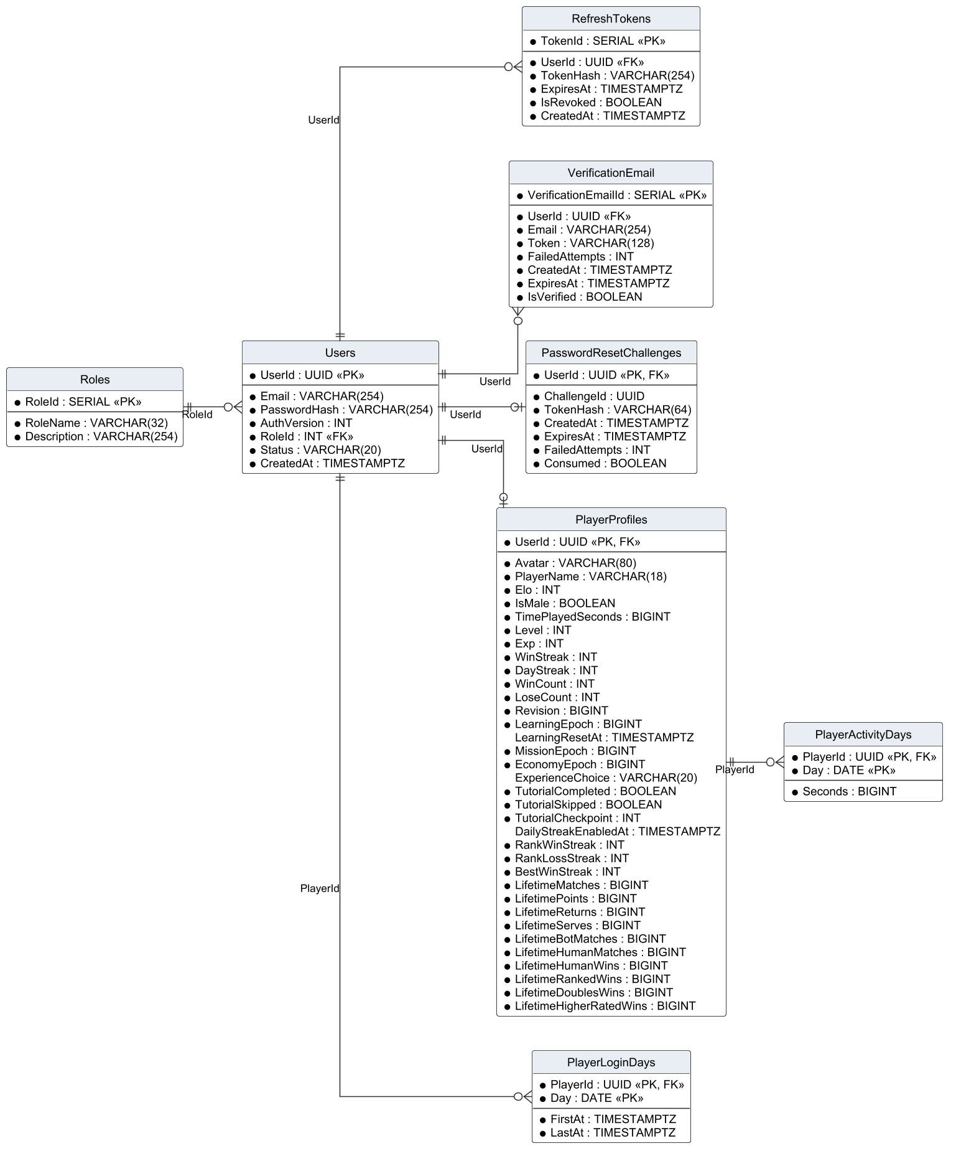
Figure 6. Logical ERD – accounts and profiles
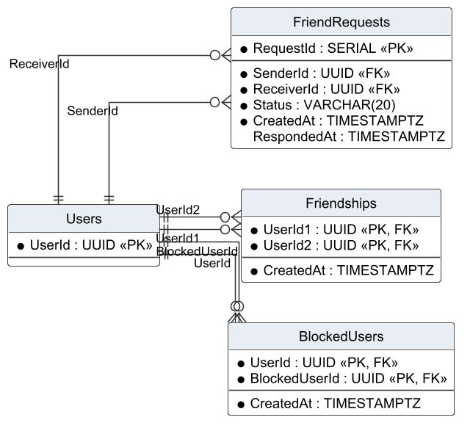
Figure 7. Logical ERD – friends and blocking
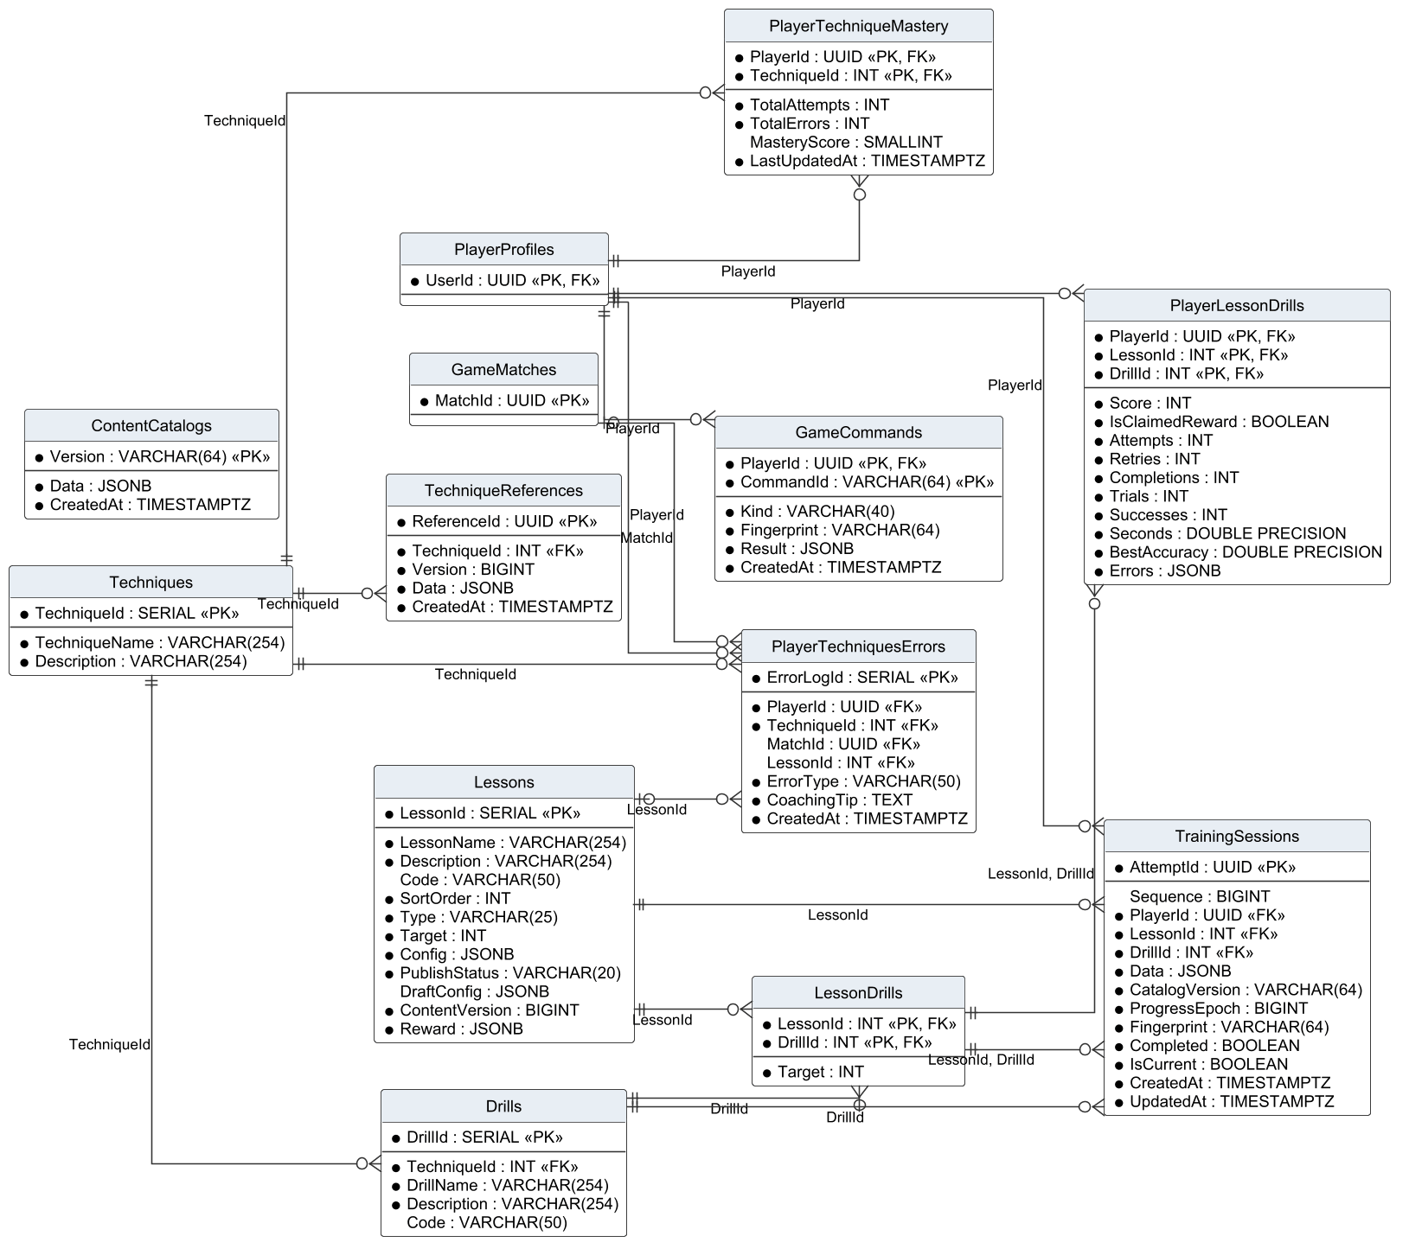
Figure 8. Logical ERD – techniques, lessons and training
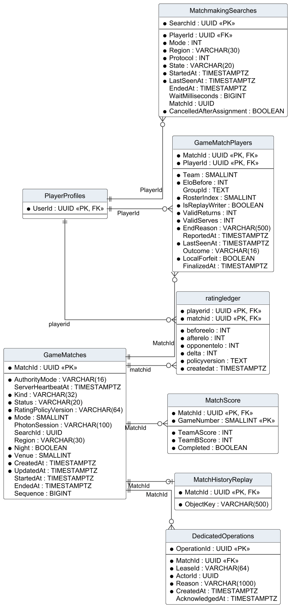
Figure 9. Logical ERD – matches, ratings, replays and matchmaking
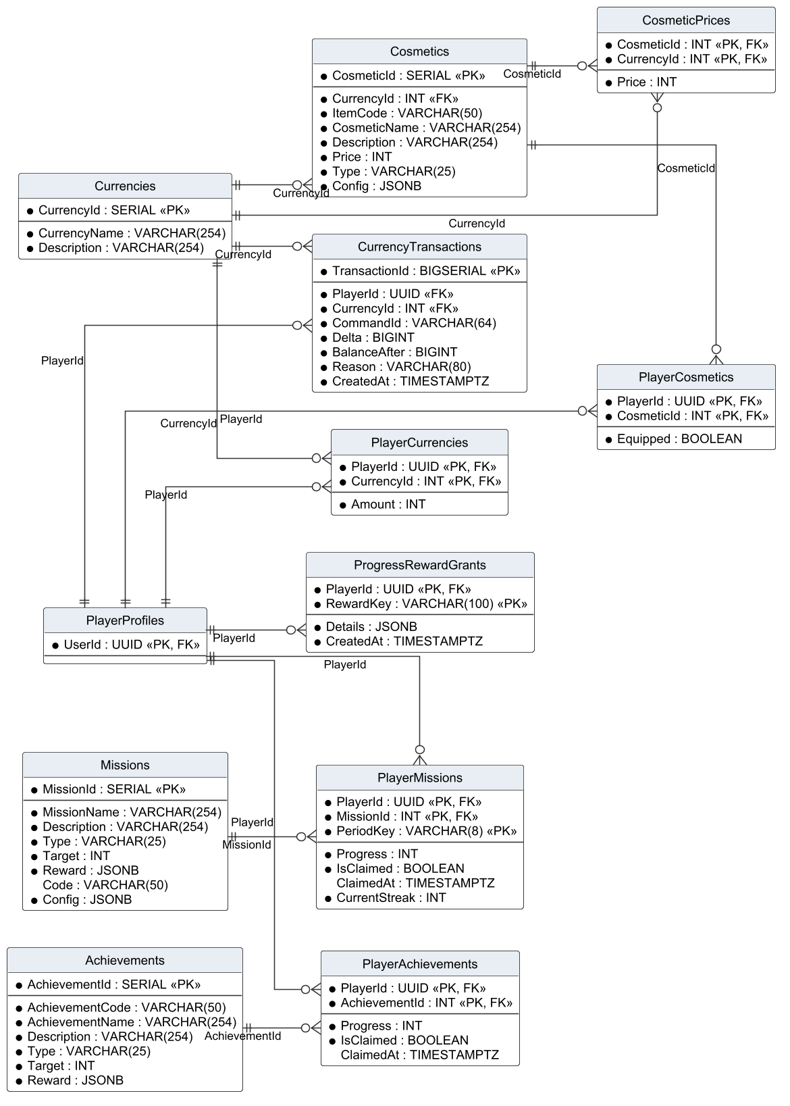
Figure 10. Logical ERD – currencies, cosmetics, missions and achievements
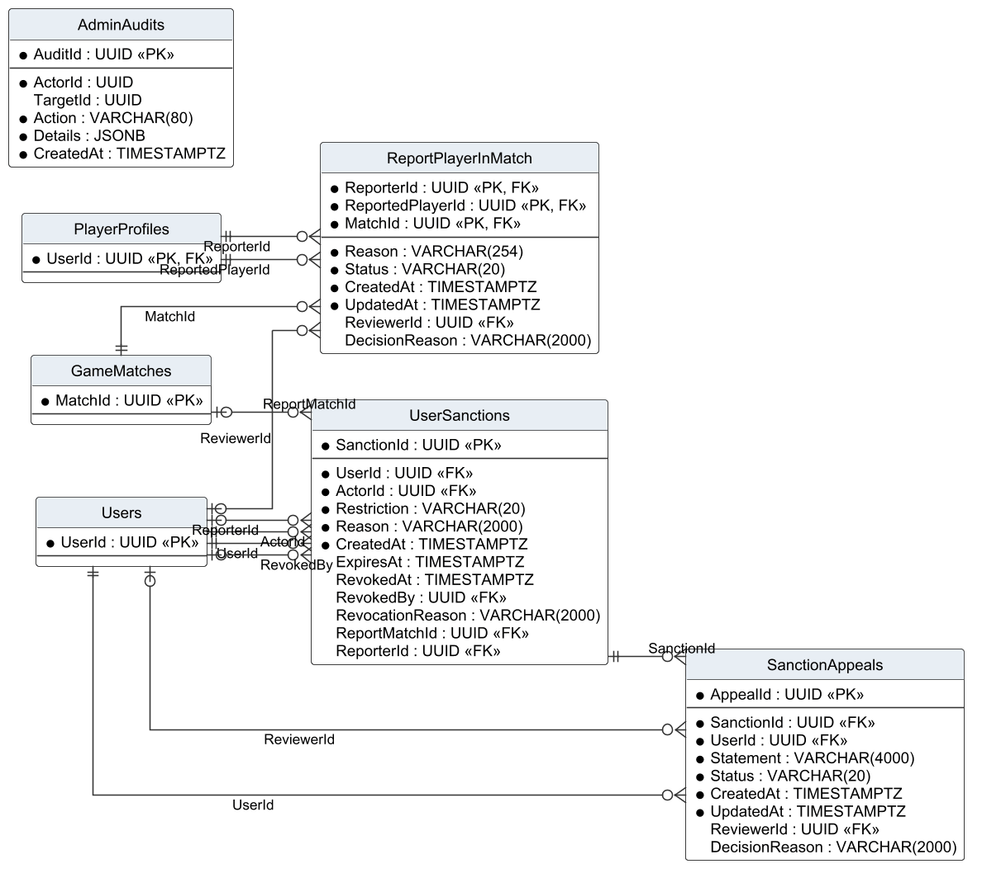
Figure 11. Logical ERD – reports, sanctions, appeals and audit
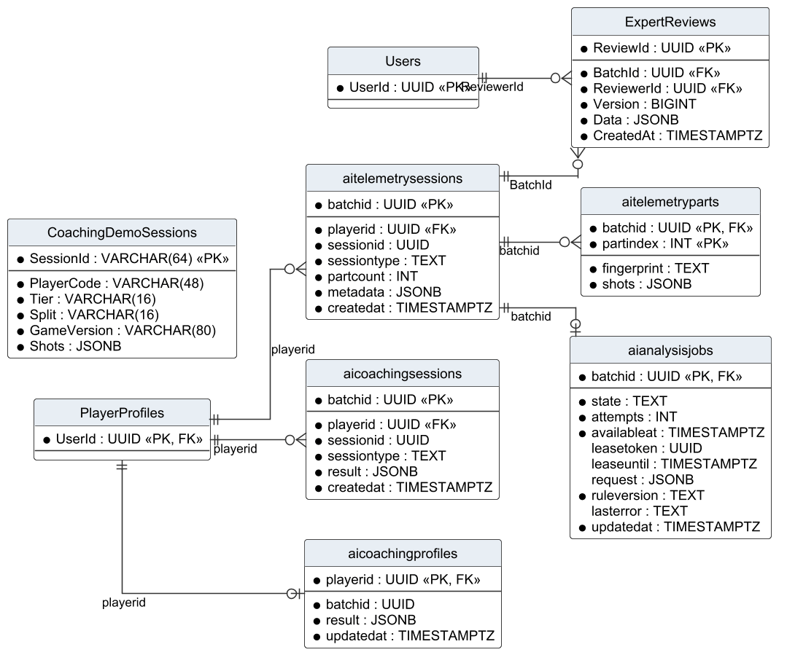
Figure 12. Logical ERD – telemetry, coaching and expert review
Table Descriptions
Table 8. Table descriptions (51 tables)
No | Table | Description
01 | Roles | Role catalogue (Player, Admin).  - Primary keys: RoleId  - Foreign keys: none
02 | Users | Account: e-mail, BCrypt password hash, role, status (ACTIVE, SUSPENDED, BANNED), e-mail verification flag and auth version used to revoke tokens.  - Primary keys: UserId  - Foreign keys: RoleId → Roles
03 | RefreshTokens | Refresh tokens stored as SHA-256 hashes with expiry and revocation time.  - Primary keys: TokenId  - Foreign keys: UserId → Users
04 | VerificationEmail | E-mail verification codes (HMAC of the code), expiry, attempts and resend time.  - Primary keys: VerificationEmailId  - Foreign keys: UserId → Users
05 | PasswordResetChallenges | The current password-reset challenge of an account (one per user).  - Primary keys: UserId  - Foreign keys: UserId → Users
06 | PlayerProfiles | Game profile of an account: display name, character, onboarding choice, level, XP, Elo, wins, losses, streaks, statistics and equipped items.  - Primary keys: UserId  - Foreign keys: UserId → Users
07 | FriendRequests | Friend requests with status PENDING, ACCEPTED or DECLINED.  - Primary keys: RequestId  - Foreign keys: SenderId → Users; ReceiverId → Users
08 | Friendships | Accepted friendships stored once per pair (UserId1 < UserId2).  - Primary keys: UserId1, UserId2  - Foreign keys: UserId1 → Users; UserId2 → Users
09 | BlockedUsers | Blocks from one user to another.  - Primary keys: UserId, BlockedUserId  - Foreign keys: UserId → Users; BlockedUserId → Users
10 | GameMatches | Matches of every kind with mode, kind, authority mode, status (PREPARING, PLAYING, FINISHED, CANCELLED), rating policy and timestamps.  - Primary keys: MatchId  - Foreign keys: none
11 | PlayerLoginDays | Days (Vietnam time) on which a player signed in; used for retention.  - Primary keys: PlayerId, Day  - Foreign keys: PlayerId → Users
12 | PlayerActivityDays | Days on which a player was active, with active seconds.  - Primary keys: PlayerId, Day  - Foreign keys: PlayerId → PlayerProfiles
13 | MatchmakingSearches | Durable log of ranked searches with status SEARCHING, MATCHED, BOT, CANCELLED or TIMEOUT.  - Primary keys: SearchId  - Foreign keys: PlayerId → PlayerProfiles
14 | ReportPlayerInMatch | Player reports, one per reporter, reported player and match, with status and decision.  - Primary keys: ReporterId, ReportedPlayerId, MatchId  - Foreign keys: ReviewerId → Users; ReporterId → PlayerProfiles; ReportedPlayerId → PlayerProfiles; MatchId → GameMatches
15 | UserSanctions | Suspensions and bans with actor, reason, expiry and revocation data.  - Primary keys: SanctionId  - Foreign keys: UserId → Users; ActorId → Users; RevokedBy → Users; ReportMatchId → GameMatches; ReporterId → Users
16 | SanctionAppeals | Appeals, at most one per sanction, with statement, status and decision.  - Primary keys: AppealId  - Foreign keys: SanctionId → UserSanctions; UserId → Users; ReviewerId → Users
17 | MatchHistoryReplay | Object-storage key of the replay manifest of a match.  - Primary keys: MatchId  - Foreign keys: MatchId → GameMatches
18 | Currencies | Currency catalogue (TOKENPAD, ELITE TOKEN).  - Primary keys: CurrencyId  - Foreign keys: none
19 | PlayerCurrencies | Wallet balance of a player per currency.  - Primary keys: PlayerId, CurrencyId  - Foreign keys: PlayerId → PlayerProfiles; CurrencyId → Currencies
20 | Cosmetics | Cosmetic items with code, type, default price and currency, and display configuration.  - Primary keys: CosmeticId  - Foreign keys: CurrencyId → Currencies
21 | PlayerCosmetics | Items owned by a player and the equipped flag.  - Primary keys: PlayerId, CosmeticId  - Foreign keys: PlayerId → PlayerProfiles; CosmeticId → Cosmetics
22 | Achievements | Achievement definitions with type, target and reward.  - Primary keys: AchievementId  - Foreign keys: none
23 | PlayerAchievements | Achievement progress and claim time of a player.  - Primary keys: PlayerId, AchievementId  - Foreign keys: PlayerId → PlayerProfiles; AchievementId → Achievements
24 | Missions | Daily and weekly mission definitions with target and reward.  - Primary keys: MissionId  - Foreign keys: none
25 | PlayerMissions | Mission progress of a player in one period (PeriodKey) and the claim time.  - Primary keys: PlayerId, MissionId, PeriodKey  - Foreign keys: PlayerId → PlayerProfiles; MissionId → Missions
26 | Techniques | Techniques taught by the curriculum.  - Primary keys: TechniqueId  - Foreign keys: none
27 | TechniqueReferences | Versioned reference values used to judge a technique.  - Primary keys: ReferenceId  - Foreign keys: TechniqueId → Techniques
28 | Lessons | Lessons with code, group, order, target, reward (JSONB), configuration (JSONB), prerequisite and status (DRAFT, PUBLISHED, UNPUBLISHED).  - Primary keys: LessonId  - Foreign keys: none
29 | Drills | Drills that practise one technique.  - Primary keys: DrillId  - Foreign keys: TechniqueId → Techniques
30 | LessonDrills | Drills of a lesson with their target (many-to-many).  - Primary keys: LessonId, DrillId  - Foreign keys: LessonId → Lessons; DrillId → Drills
31 | PlayerTechniqueMastery | Mastery score of a player per technique.  - Primary keys: PlayerId, TechniqueId  - Foreign keys: PlayerId → PlayerProfiles; TechniqueId → Techniques
32 | PlayerTechniquesErrors | Technique errors detected for a player in a lesson or match.  - Primary keys: ErrorLogId  - Foreign keys: PlayerId → PlayerProfiles; TechniqueId → Techniques; MatchId → GameMatches; LessonId → Lessons
33 | PlayerLessonDrills | Best result of a player per lesson drill: stars, accuracy, timing, attempts and first-pass time.  - Primary keys: PlayerId, LessonId, DrillId  - Foreign keys: PlayerId → PlayerProfiles; LessonId, DrillId → LessonDrills
34 | CosmeticPrices | Prices of an item in each accepted currency.  - Primary keys: CosmeticId, CurrencyId  - Foreign keys: CosmeticId → Cosmetics; CurrencyId → Currencies
35 | GameCommands | Idempotency log of client commands (purchase, claim, sync) per player and command ID.  - Primary keys: PlayerId, CommandId  - Foreign keys: PlayerId → PlayerProfiles
36 | TrainingSessions | Each training attempt with lesson, drill, shots, hits, timing, stars and receipt status.  - Primary keys: AttemptId  - Foreign keys: PlayerId → PlayerProfiles; LessonId → Lessons; DrillId → Drills; LessonId, DrillId → LessonDrills
37 | MatchScore | Score of each game of a match (weak entity identified by match and game number).  - Primary keys: MatchId, GameNumber  - Foreign keys: MatchId → GameMatches
38 | GameMatchPlayers | Participants of a match with team, slot, character, bot flag, Elo input and outcome.  - Primary keys: MatchId, PlayerId  - Foreign keys: MatchId → GameMatches; PlayerId → PlayerProfiles
39 | CurrencyTransactions | Ledger of every currency change with reason and reference.  - Primary keys: TransactionId  - Foreign keys: PlayerId → PlayerProfiles; CurrencyId → Currencies
40 | ratingledger | Elo before, delta and after for one player in one ranked match.  - Primary keys: playerid, matchid  - Foreign keys: playerid → PlayerProfiles; matchid → GameMatches
41 | aitelemetrysessions | Telemetry batch of a drill or match with source, mode and status.  - Primary keys: batchid  - Foreign keys: playerid → PlayerProfiles
42 | ExpertReviews | Expert labels (level, errors, data group) for a telemetry batch.  - Primary keys: ReviewId  - Foreign keys: BatchId → aitelemetrysessions; ReviewerId → Users
43 | CoachingDemoSessions | Simulated demonstration sessions kept apart from real player data.  - Primary keys: SessionId  - Foreign keys: none
44 | aitelemetryparts | Compressed parts of a telemetry batch.  - Primary keys: batchid, partindex  - Foreign keys: batchid → aitelemetrysessions
45 | aianalysisjobs | Analysis job of a batch with status pending, processing, completed or failed, attempts and error.  - Primary keys: batchid  - Foreign keys: batchid → aitelemetrysessions
46 | aicoachingsessions | Coaching result of a batch: findings, summary and recommendations.  - Primary keys: batchid  - Foreign keys: playerid → PlayerProfiles
47 | aicoachingprofiles | Aggregated coaching profile of a player.  - Primary keys: playerid  - Foreign keys: playerid → PlayerProfiles
48 | ContentCatalogs | Published versions of the content catalogue sent to clients.  - Primary keys: Version  - Foreign keys: none
49 | ProgressRewardGrants | Log of one-time progression rewards (for example THOT, GEMSTONE) per player.  - Primary keys: PlayerId, RewardKey  - Foreign keys: PlayerId → PlayerProfiles
50 | DedicatedOperations | Operations on dedicated matches (stop requests and their acknowledgement).  - Primary keys: OperationId  - Foreign keys: MatchId → GameMatches
51 | AdminAudits | Audit trail of administrative actions with actor, action, target and data.  - Primary keys: AuditId  - Foreign keys: none

2.1 Data Dictionary of the Core Tables
The core tables of the account, match, training and moderation domains are listed column by column. Types are PostgreSQL types; * marks NOT NULL.
Table 9. Data dictionary – Users
Column | Type | Null | Key | Notes
UserId | UUID | * | PK
Email | VARCHAR(254) | *
PasswordHash | VARCHAR(254) | *
AuthVersion | INT | *
RoleId | INT | * | FK → Roles
Status | VARCHAR(20) | * |  | ACTIVE, SUSPENDED, BANNED
CreatedAt | TIMESTAMPTZ | *

Table 10. Data dictionary – PlayerProfiles
Column | Type | Null | Key | Notes
UserId | UUID | * | PK, FK → Users
Avatar | VARCHAR(80) | *
PlayerName | VARCHAR(18) | *
Elo | INT | *
IsMale | BOOLEAN | *
TimePlayedSeconds | BIGINT | *
Level | INT | *
Exp | INT | *
WinStreak | INT | *
DayStreak | INT | *
WinCount | INT | *
LoseCount | INT | *
Revision | BIGINT | *
LearningEpoch | BIGINT | *
LearningResetAt | TIMESTAMPTZ
MissionEpoch | BIGINT | *
EconomyEpoch | BIGINT | *
ExperienceChoice | VARCHAR(20)
TutorialCompleted | BOOLEAN | *
TutorialSkipped | BOOLEAN | *
TutorialCheckpoint | INT | *
DailyStreakEnabledAt | TIMESTAMPTZ
RankWinStreak | INT | *
RankLossStreak | INT | *
BestWinStreak | INT | *
LifetimeMatches | BIGINT | *
LifetimePoints | BIGINT | *
LifetimeReturns | BIGINT | *
LifetimeServes | BIGINT | *
LifetimeBotMatches | BIGINT | *
LifetimeHumanMatches | BIGINT | *
LifetimeHumanWins | BIGINT | *
LifetimeRankedWins | BIGINT | *
LifetimeDoublesWins | BIGINT | *
LifetimeHigherRatedWins | BIGINT | *

Table 11. Data dictionary – GameMatches
Column | Type | Null | Key | Notes
AuthorityMode | VARCHAR(16) | * |  | shared or dedicated
ServerHeartbeatAt | TIMESTAMPTZ
MatchId | UUID | * | PK
Kind | VARCHAR(32) | *
Status | VARCHAR(20) | * |  | PREPARING, PLAYING, FINISHED, CANCELLED
RatingPolicyVersion | VARCHAR(64) | *
Mode | SMALLINT | *
PhotonSession | VARCHAR(100)
SearchId | UUID
Region | VARCHAR(30)
Night | BOOLEAN | *
Venue | SMALLINT | *
CreatedAt | TIMESTAMPTZ | *
UpdatedAt | TIMESTAMPTZ | *
StartedAt | TIMESTAMPTZ
EndedAt | TIMESTAMPTZ
Sequence | BIGINT

Table 12. Data dictionary – GameMatchPlayers
Column | Type | Null | Key | Notes
MatchId | UUID | * | PK, FK → GameMatches
PlayerId | UUID | * | PK, FK → PlayerProfiles
Team | SMALLINT | *
EloBefore | INT | *
GroupId | TEXT
RosterIndex | SMALLINT | *
IsReplayWriter | BOOLEAN | *
ValidReturns | INT | *
ValidServes | INT | *
EndReason | VARCHAR(500) | *
ReportedAt | TIMESTAMPTZ
LastSeenAt | TIMESTAMPTZ | *
Outcome | VARCHAR(16)
LocalForfeit | BOOLEAN | *
FinalizedAt | TIMESTAMPTZ

Table 13. Data dictionary – MatchScore
Column | Type | Null | Key | Notes
MatchId | UUID | * | PK, FK → GameMatches
GameNumber | SMALLINT | * | PK
TeamAScore | INT | *
TeamBScore | INT | *
Completed | BOOLEAN | *

Table 14. Data dictionary – ratingledger
Column | Type | Null | Key | Notes
playerid | UUID | * | PK, FK → PlayerProfiles
matchid | UUID | * | PK, FK → GameMatches
beforeelo | INT | *
afterelo | INT | *
opponentelo | INT | *
delta | INT | *
policyversion | TEXT | *
createdat | TIMESTAMPTZ | *

Table 15. Data dictionary – Lessons
Column | Type | Null | Key | Notes
LessonId | SERIAL | * | PK
LessonName | VARCHAR(254) | *
Description | VARCHAR(254) | *
Code | VARCHAR(50)
SortOrder | INT | *
Type | VARCHAR(25) | *
Target | INT | *
Config | JSONB | *
PublishStatus | VARCHAR(20) | *
DraftConfig | JSONB
ContentVersion | BIGINT | *
Reward | JSONB | *

Table 16. Data dictionary – TrainingSessions
Column | Type | Null | Key | Notes
AttemptId | UUID | * | PK
Sequence | BIGINT
PlayerId | UUID | * | FK → PlayerProfiles
LessonId | INT | * | FK → LessonDrills
DrillId | INT | * | FK → LessonDrills
Data | JSONB | *
CatalogVersion | VARCHAR(64) | *
ProgressEpoch | BIGINT | *
Fingerprint | VARCHAR(64) | *
Completed | BOOLEAN | *
IsCurrent | BOOLEAN | *
CreatedAt | TIMESTAMPTZ | *
UpdatedAt | TIMESTAMPTZ | *

Table 17. Data dictionary – UserSanctions
Column | Type | Null | Key | Notes
SanctionId | UUID | * | PK
UserId | UUID | * | FK → Users
ActorId | UUID | * | FK → Users
Restriction | VARCHAR(20) | * |  | BANNED or SUSPENDED; SUSPENDED requires ExpiresAt
Reason | VARCHAR(2000) | *
CreatedAt | TIMESTAMPTZ | *
ExpiresAt | TIMESTAMPTZ
RevokedAt | TIMESTAMPTZ
RevokedBy | UUID |  | FK → Users
RevocationReason | VARCHAR(2000)
ReportMatchId | UUID |  | FK → GameMatches
ReporterId | UUID |  | FK → Users

Table 18. Data dictionary – SanctionAppeals
Column | Type | Null | Key | Notes
AppealId | UUID | * | PK
SanctionId | UUID | * | FK → UserSanctions | UNIQUE: one appeal per sanction
UserId | UUID | * | FK → Users
Statement | VARCHAR(4000) | *
Status | VARCHAR(20) | * |  | PENDING, CHECKING, ACCEPTED, DECLINED
CreatedAt | TIMESTAMPTZ | *
UpdatedAt | TIMESTAMPTZ | *
ReviewerId | UUID |  | FK → Users
DecisionReason | VARCHAR(2000)

2.2 Design Notes
• Team game totals are not stored in GameMatches; they are derived from the completed MatchScore rows, which avoids inconsistent copies (AGENTS.md).
• GameMatchPlayers keeps only facts that belong to the participant in that match, including the fixed Elo input needed before a rating ledger row exists; names and cosmetics are joined from the profile tables.
• PlayerProfiles is wide (35 columns) because it is the hot read model of the menu; statistics that change together are kept in one row to avoid joins on every screen.
• TrainingSessions references Lessons, Drills and the composite LessonDrills key: the composite key guarantees that the drill belongs to the lesson, and the single keys keep historical attempts when a lesson is re-configured.
• Lessons.Reward and Lessons.Config are JSONB because each lesson type has different parameters; the API validates them before saving.
• AdminAudits stores the actor ID without a foreign key so that audit records survive the deletion of an administrator account.
• CoachingDemoSessions holds simulated data in its own table so that it can never be mixed with real sessions used for AI evaluation.
• Idempotency: GameCommands, TrainingSessions receipts and the UNIQUE constraints on rewards (ProgressRewardGrants, PlayerMissions period key) make retried requests safe.

3. Detailed Design
Each subsection gives the class diagram of one feature group, the specification of its classes and the sequence diagrams of its main functions. Client classes (Unity) and server classes (Web API) are drawn in the same diagram only when the diagram shows their interaction; the boundary is the HTTP API, marked as a dependency to the controller.

3.1 Account and Authentication
This feature group implements FR-01 to FR-05. The Unity AccountScreen calls AccountService, which uses ApiClient to reach AuthController. AuthService performs the rules of BR-01 to BR-05 through IUnitOfWork and sends e-mails through IEmailSender.

3.1.1 Class Diagram
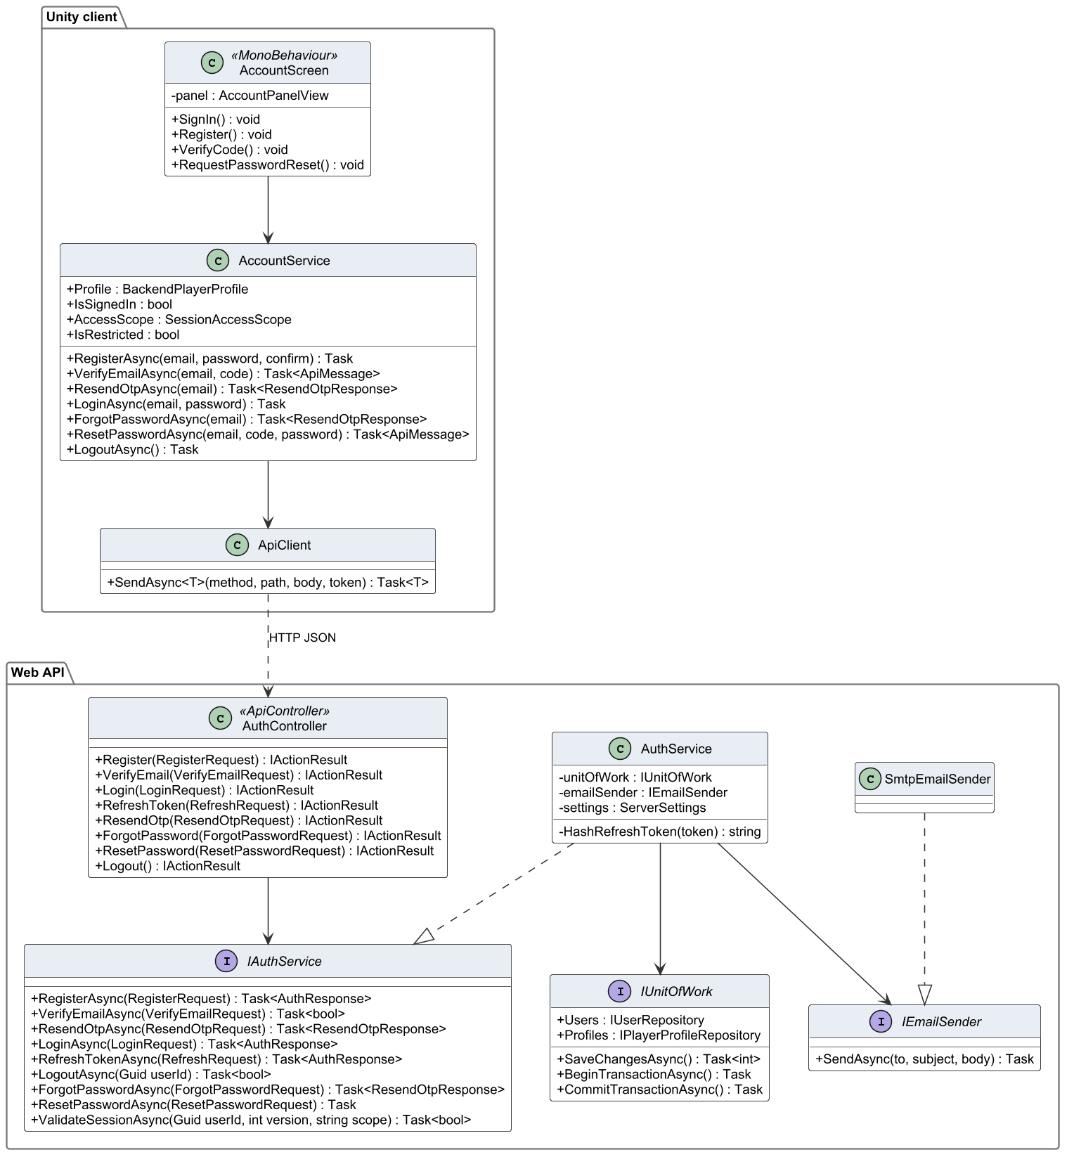
Figure 13. Class diagram – account and authentication

3.1.2 Class Specifications
Table 19. Class specifications – account and authentication
Class | Responsibility | Main attributes | Main operations
AccountScreen  «MonoBehaviour» | Login, register, verification and password-reset pages of the Login scene; client-side validation | - panel : AccountPanelView | + SignIn() : void  + Register() : void  + VerifyCode() : void  + RequestPasswordReset() : void
AccountService | Client facade for authentication; keeps the session, scope and profile and refreshes tokens | + Profile : BackendPlayerProfile  + IsSignedIn : bool  + AccessScope : SessionAccessScope  + IsRestricted : bool | + RegisterAsync(email, password, confirm) : Task  + VerifyEmailAsync(email, code) : Task<ApiMessage>  + ResendOtpAsync(email) : Task<ResendOtpResponse>  + LoginAsync(email, password) : Task  + ForgotPasswordAsync(email) : Task<ResendOtpResponse>  + ResetPasswordAsync(email, code, password) : Task<ApiMessage>  + LogoutAsync() : Task
ApiClient | Sends HTTP requests with the bearer token and unwraps the ApiResponse envelope | – | + SendAsync<T>(method, path, body, token) : Task<T>
AuthController  «ApiController» | REST endpoints /api/Auth/*; rate-limited | – | + Register(RegisterRequest) : IActionResult  + VerifyEmail(VerifyEmailRequest) : IActionResult  + Login(LoginRequest) : IActionResult  + RefreshToken(RefreshRequest) : IActionResult  + ResendOtp(ResendOtpRequest) : IActionResult  + ForgotPassword(ForgotPasswordRequest) : IActionResult  + ResetPassword(ResetPasswordRequest) : IActionResult  + Logout() : IActionResult
IAuthService  «interface» | Contract of the authentication use cases | – | + RegisterAsync(RegisterRequest) : Task<AuthResponse>  + VerifyEmailAsync(VerifyEmailRequest) : Task<bool>  + ResendOtpAsync(ResendOtpRequest) : Task<ResendOtpResponse>  + LoginAsync(LoginRequest) : Task<AuthResponse>  + RefreshTokenAsync(RefreshRequest) : Task<AuthResponse>  + LogoutAsync(Guid userId) : Task<bool>  + ForgotPasswordAsync(ForgotPasswordRequest) : Task<ResendOtpResponse>  + ResetPasswordAsync(ResetPasswordRequest) : Task  + ValidateSessionAsync(Guid userId, int version, string scope) : Task<bool>
AuthService | Registration, OTP, sign-in, token issue and rotation, password reset, session validation | - unitOfWork : IUnitOfWork  - emailSender : IEmailSender  - settings : ServerSettings | - HashRefreshToken(token) : string
IEmailSender  «interface» | Abstraction for sending e-mail | – | + SendAsync(to, subject, body) : Task
SmtpEmailSender | Sends e-mail through Gmail SMTP with STARTTLS | – | –
IUnitOfWork  «interface» | Gives services access to repositories and one shared transaction | + Users : IUserRepository  + Profiles : IPlayerProfileRepository | + SaveChangesAsync() : Task<int>  + BeginTransactionAsync() : Task  + CommitTransactionAsync() : Task

3.1.3 Register and verify e-mail
The visitor registers; the service hashes the password, stores the HMAC of a six-digit code and queues the e-mail. The alternative fragments show a confirmation mismatch, a registered e-mail, a valid code and an invalid or expired code.
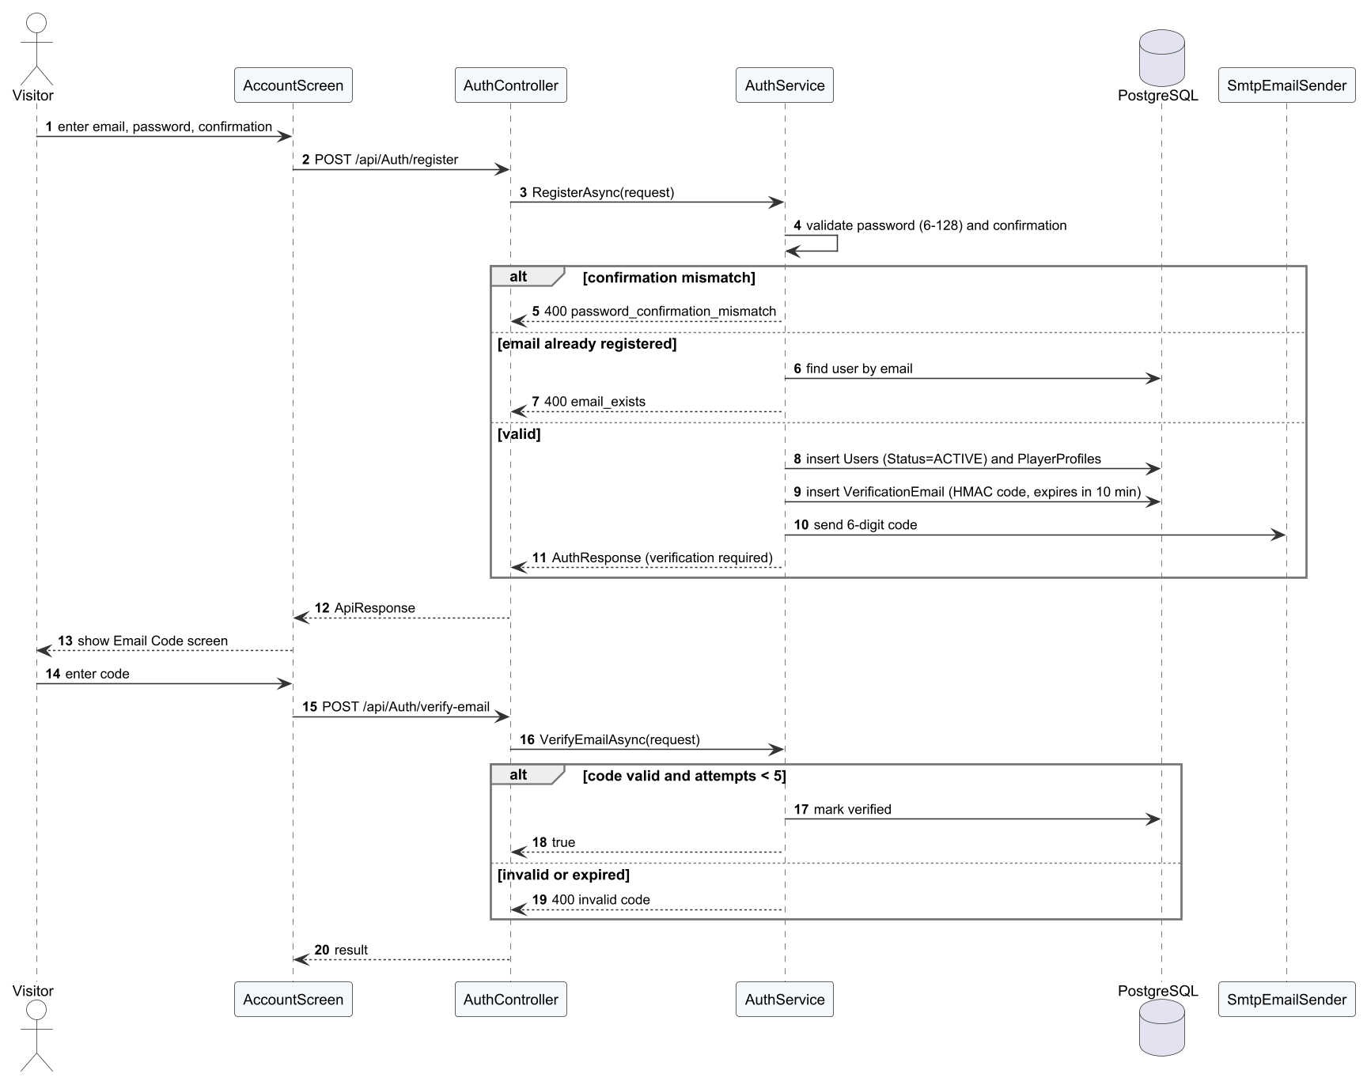
Figure 14. Sequence diagram – Register and verify e-mail

3.1.4 Sign in
The service checks the password hash and the account state. A wrong password, an unverified e-mail and a restricted account return different results; an active account receives the JWT and refresh token, after which the client loads the profile.
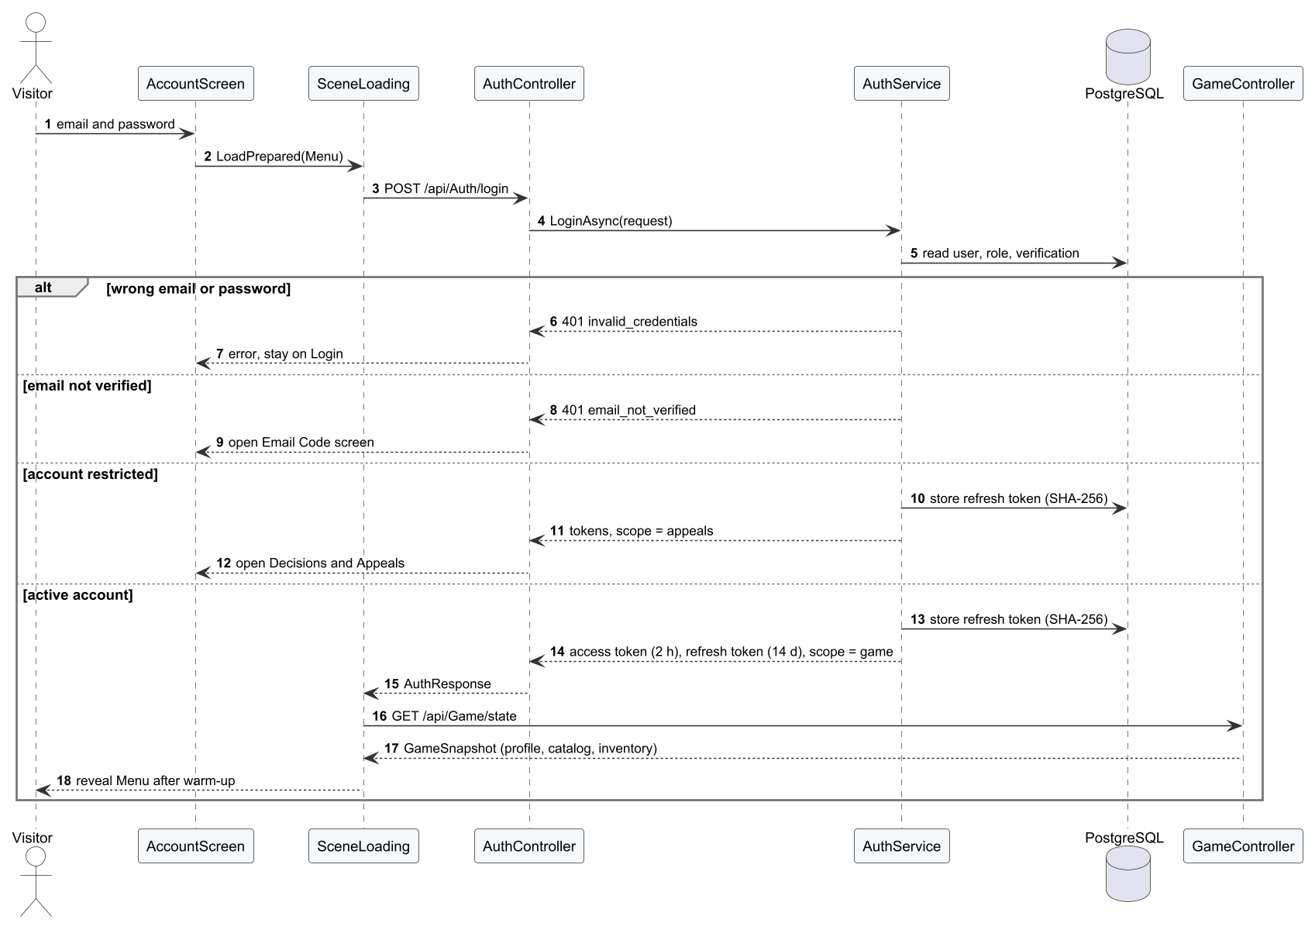
Figure 15. Sequence diagram – Sign in

3.1.5 Reset password
The reset request always returns the same message; the mail queue sends the code only for a verified account. A valid code changes the hash and revokes every refresh token.

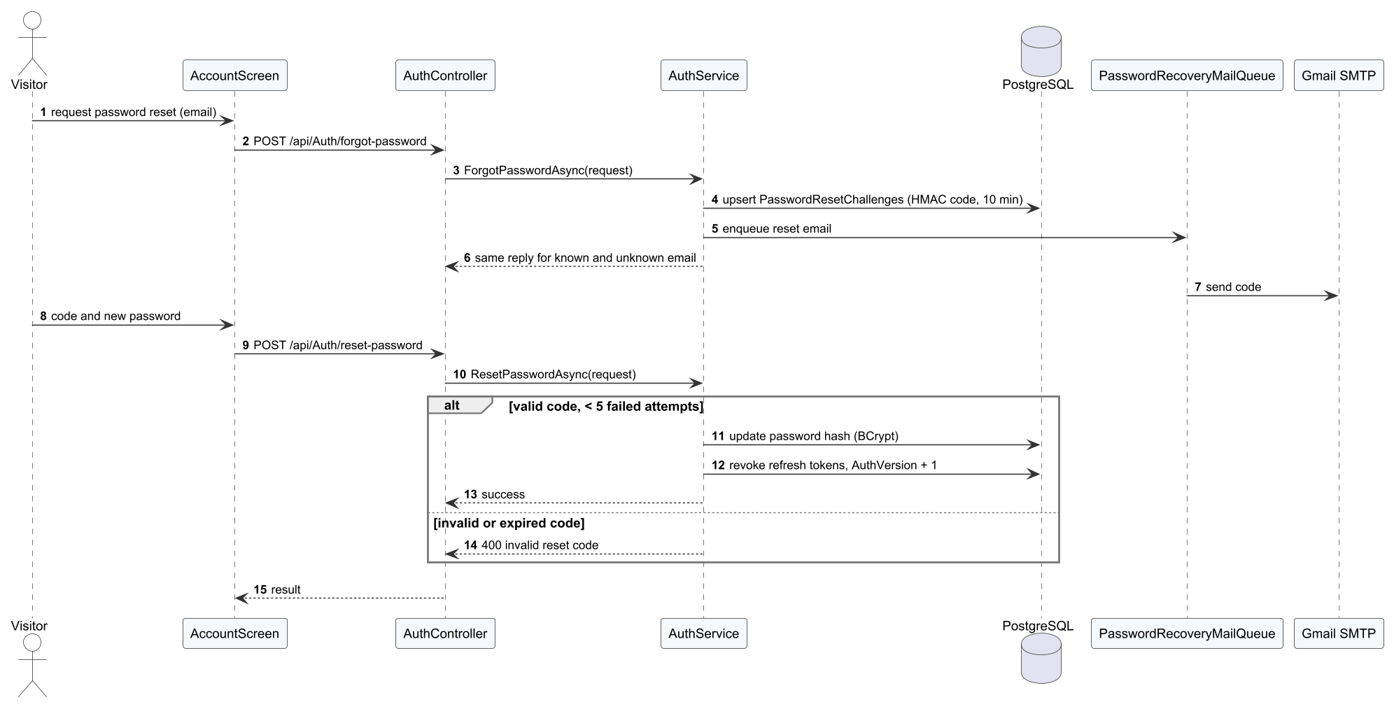
Figure 16. Sequence diagram – Reset password

3.2 Gameplay Core and Ball Physics
The gameplay core implements FR-11 to FR-13. BotMatch drives the match phases. Each MatchActor reads its intent from ShotInput (player) or a bot. PaddleContact accepts the hit, ShotTrajectory computes the launch velocity, BallFlight advances the ball and SinglesRules decides the outcome. The rule and physics classes have no Unity dependencies, so the same code runs in the client, in the dedicated server and in EditMode unit tests.
Table 20. Gameplay and physics parameters
Parameter | Value | Source / meaning
Simulation step | 120 Hz (1/120 s) | BallFlight fixed step, independent of frame rate
Gravity | 9.81 m/s² | Ball flight
Bounce restitution | 0.73 | Vertical speed kept after a bounce
Ball radius | 0.037 m | Line calls use the ball edge
Court half width / half length / kitchen | 3.048 / 6.7056 / 2.1336 m | SinglesRules.Court, official dimensions
Contact window | ±65 ms | PaddleContact; outside the window the swing misses
Perfect contact | ≤ 0.145 m and ±30 ms | Higher speed and accuracy
Serve timer | 10 s | Fault ServeTimeout
Contact delay per shot | serve 0.80 s, dink 0.367 s, drop 0.533 s, smash 0.50 s, volley/reset 0.233 s, drive 0.433 s | ShotIntent.ContactDelay: time from release to the animation's contact frame

3.2.1 Class Diagram
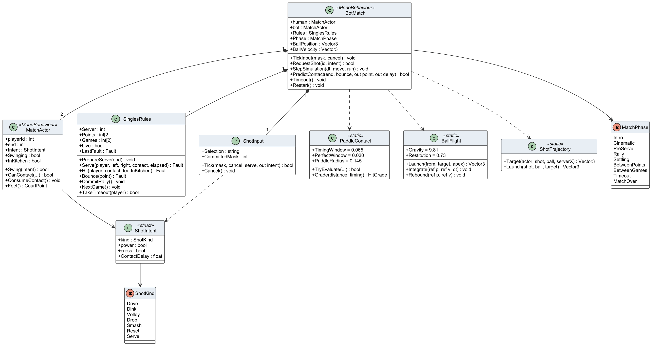
Figure 17. Class diagram – gameplay core (bot match)

3.2.2 Class Specifications
Table 21. Class specifications – gameplay core
Class | Responsibility | Main attributes | Main operations
BotMatch  «MonoBehaviour» | Orchestrates a local singles match: phases, serve, rally, scoring and result | + human : MatchActor  + bot : MatchActor  + Rules : SinglesRules  + Phase : MatchPhase  + BallPosition : Vector3  + BallVelocity : Vector3 | + TickInput(mask, cancel) : void  + RequestShot(id, intent) : bool  + StepSimulation(dt, move, run) : void  + PredictContact(end, bounce, out point, out delay) : bool  + Timeout() : void  + Restart() : void
MatchActor  «MonoBehaviour» | Moves and animates one player and performs hits | + playerId : int  + end : int  + Intent : ShotIntent  + Swinging : bool  + InKitchen : bool | + Swing(intent) : bool  + CanContact(...) : bool  + ConsumeContact() : void  + Feet() : CourtPoint
SinglesRules | Decides faults, points, side-outs, games and match end (BR-10 to BR-15) | + Server : int  + Points : int[2]  + Games : int[2]  + Live : bool  + LastFault : Fault | + PrepareServe(end) : void  + Serve(player, left, right, contact, elapsed) : Fault  + Hit(player, contact, feetInKitchen) : Fault  + Bounce(point) : Fault  + CommitRally() : void  + NextGame() : void  + TakeTimeout(player) : bool
ShotInput | Decodes the J/K/L/U/I key state into one shot intent on the first release | + Selection : string  + CommittedMask : int | + Tick(mask, cancel, serve, out intent) : bool  + Cancel() : void
ShotIntent  «struct» | Requested shot kind with power and cross modifiers | + kind : ShotKind  + power : bool  + cross : bool  + ContactDelay : float | –
ShotKind  «enum» | Seven shot kinds of the local game | Drive  Dink  Volley  Drop  Smash  Reset  Serve | –
PaddleContact  «static» | Checks the contact window (±65 ms) and the contact quality (Perfect, Good) | + TimingWindow = 0.065  + PerfectWindow = 0.030  + PaddleRadius = 0.145 | + TryEvaluate(...) : bool  + Grade(distance, timing) : HitGrade
BallFlight  «static» | Fixed-step ball flight: gravity, drag-free arc and bounce with restitution 0.73 | + Gravity = 9.81  + Restitution = 0.73 | + Launch(from, target, apex) : Vector3  + Integrate(ref p, ref v, dt) : void  + Rebound(ref p, ref v) : void
ShotTrajectory  «static» | Computes launch velocity for a target point and flight time | – | + Target(actor, shot, ball, serverX) : Vector3  + Launch(shot, ball, target) : Vector3
MatchPhase  «enum» | Phases of a match (Intro, PreServe, Rally, Settling, BetweenPoints, BetweenGames, Timeout, MatchOver, Cinematic) | Intro  Cinematic  PreServe  Rally  Settling  BetweenPoints  BetweenGames  Timeout  MatchOver | –

3.3 Training and Offline Synchronisation
Training implements FR-06 to FR-10. TrainingDirector runs a drill locally with the gameplay core and evaluates it with TrainingEngine. Online, the attempt is sent at once; offline, OfflineTrainingStore keeps it until the device reconnects. On the server OnlineGameService re-evaluates the attempt with the same engine and returns a receipt.

3.3.1 Class Diagram
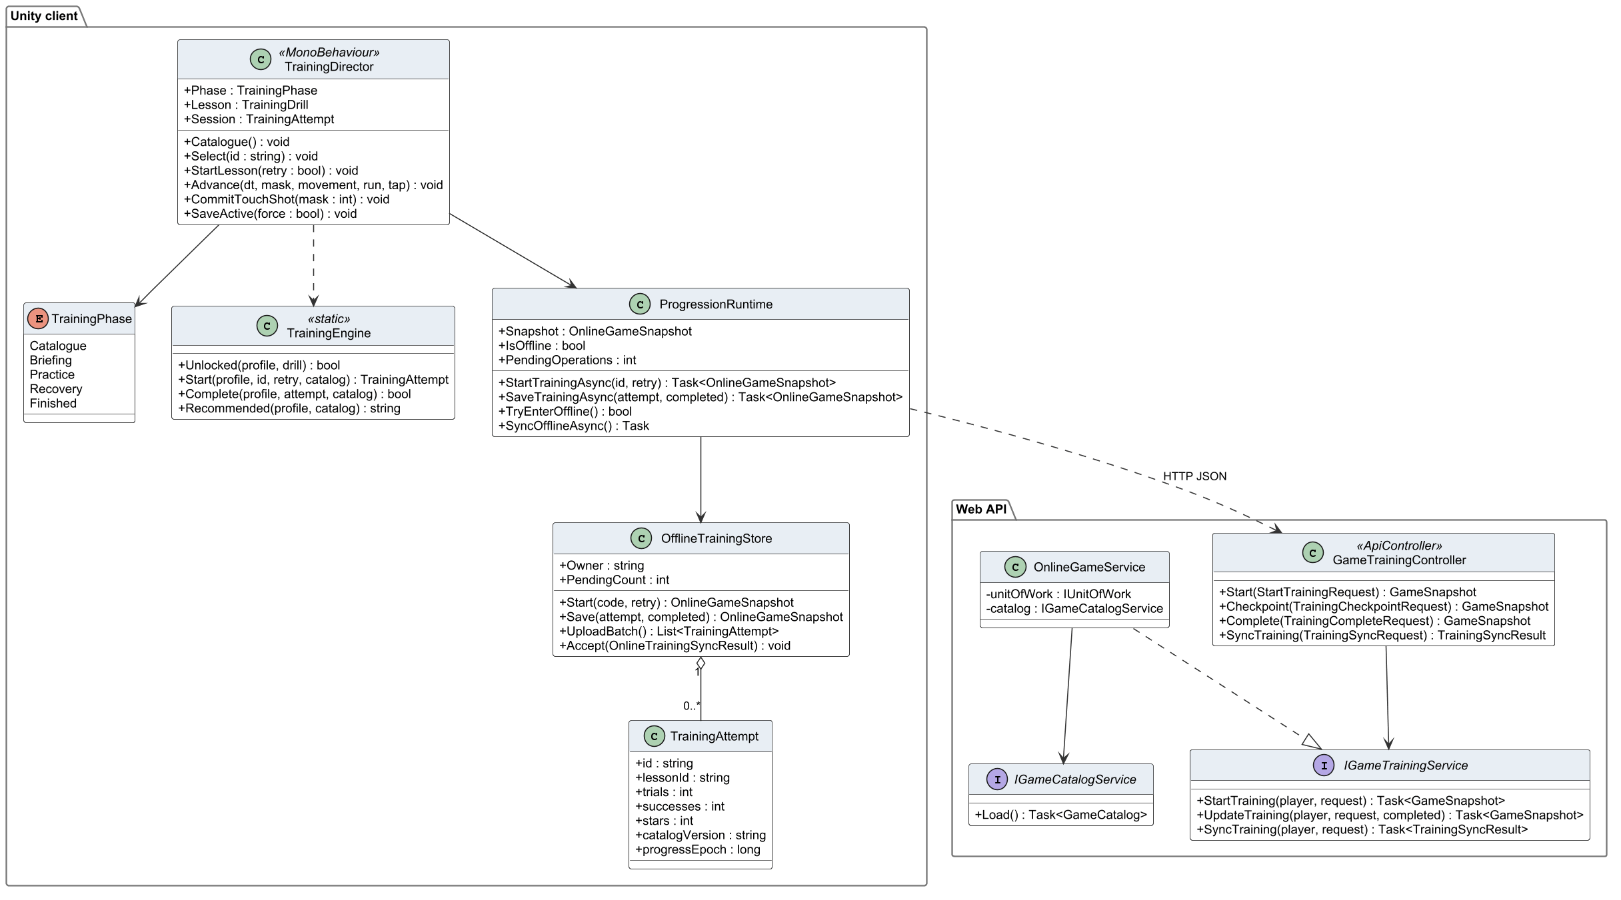
Figure 18. Class diagram – training and synchronisation

3.3.2 Class Specifications
Table 22. Class specifications – training
Class | Responsibility | Main attributes | Main operations
TrainingDirector  «MonoBehaviour» | Runs a drill in the Training scene: briefing, shots, feedback and result popup | + Phase : TrainingPhase  + Lesson : TrainingDrill  + Session : TrainingAttempt | + Catalogue() : void  + Select(id : string) : void  + StartLesson(retry : bool) : void  + Advance(dt, mask, movement, run, tap) : void  + CommitTouchShot(mask : int) : void  + SaveActive(force : bool) : void
TrainingPhase  «enum» | Phases of the training screen | Catalogue  Briefing  Practice  Recovery  Finished | –
TrainingEngine  «static» | Pure rules for drill evaluation: hits, timing and stars (BR-18) | – | + Unlocked(profile, drill) : bool  + Start(profile, id, retry, catalog) : TrainingAttempt  + Complete(profile, attempt, catalog) : bool  + Recommended(profile, catalog) : string
ProgressionRuntime | Client-side cache of profile, wallet, catalogue and the synchronisation queue | + Snapshot : OnlineGameSnapshot  + IsOffline : bool  + PendingOperations : int | + StartTrainingAsync(id, retry) : Task<OnlineGameSnapshot>  + SaveTrainingAsync(attempt, completed) : Task<OnlineGameSnapshot>  + TryEnterOffline() : bool  + SyncOfflineAsync() : Task
OfflineTrainingStore | Durable local queue of offline attempts with request IDs | + Owner : string  + PendingCount : int | + Start(code, retry) : OnlineGameSnapshot  + Save(attempt, completed) : OnlineGameSnapshot  + UploadBatch() : List<TrainingAttempt>  + Accept(OnlineTrainingSyncResult) : void
TrainingAttempt | Data of one drill attempt sent to the server | + id : string  + lessonId : string  + trials : int  + successes : int  + stars : int  + catalogVersion : string  + progressEpoch : long | –
GameTrainingController  «ApiController» | REST endpoints for starting, completing and synchronising training | – | + Start(StartTrainingRequest) : GameSnapshot  + Checkpoint(TrainingCheckpointRequest) : GameSnapshot  + Complete(TrainingCompleteRequest) : GameSnapshot  + SyncTraining(TrainingSyncRequest) : TrainingSyncResult
IGameTrainingService  «interface» | Contract of the training use cases | – | + StartTraining(player, request) : Task<GameSnapshot>  + UpdateTraining(player, request, completed) : Task<GameSnapshot>  + SyncTraining(player, request) : Task<TrainingSyncResult>
OnlineGameService | Server implementation of training, match settlement, matchmaking and economy use cases | - unitOfWork : IUnitOfWork  - catalog : IGameCatalogService | –
IGameCatalogService  «interface» | Provides the published content catalogue and its version | – | + Load() : Task<GameCatalog>

3.3.3 Practise a drill online
The server first checks that the lesson is published and unlocked, then records each trial; at the end it applies stars and the first-pass reward in one transaction.
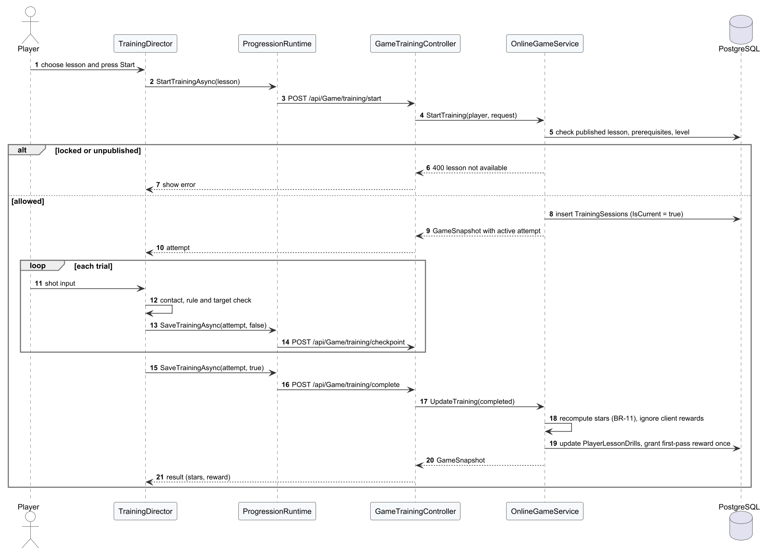
Figure 19. Sequence diagram – Practise a drill online

3.3.4 Synchronise offline attempts
Each queued attempt is sent with its request ID. A new and valid attempt is applied, an already applied one is answered DUPLICATE, and a stale or invalid one is REJECTED.

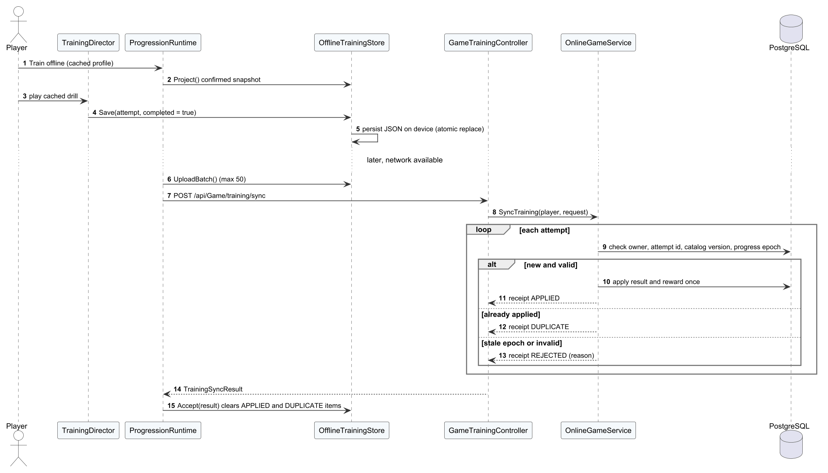
Figure 20. Sequence diagram – Synchronise offline attempts

3.4 Bot AI
The bot design implements FR-13 and BR-31. LocalBot provides three fixed levels. BhTreeBot executes a Unity Behavior graph whose decisions (position, shot choice, aggression, deliberate errors) are parameterised by BotPolicy and a BotTierProfile selected from the opponent's Elo. The IAdaptiveBotContext interface hides whether the bot plays locally or on the dedicated server, so the same bot is used for practice and for the ranked bot fallback.
Table 23. Bot parameters
Parameter | Value | Source / meaning
Fixed levels | Easy, Medium, Hard | LocalBot: fixed reaction and accuracy
Adaptive tiers | Elo < 500 beginner; < 2000 intermediate; ≥ 2000 advanced | BotPolicy tier selection
Ranked bot Elo | own + 120 (own − 100 after 5 losses) | EloPolicy.BotElo (BR-26)
Ranked bot accuracy | min(100, 25 + (Elo − 100) / 120) % | EloPolicy.BotAccuracy

3.4.1 Class Diagram
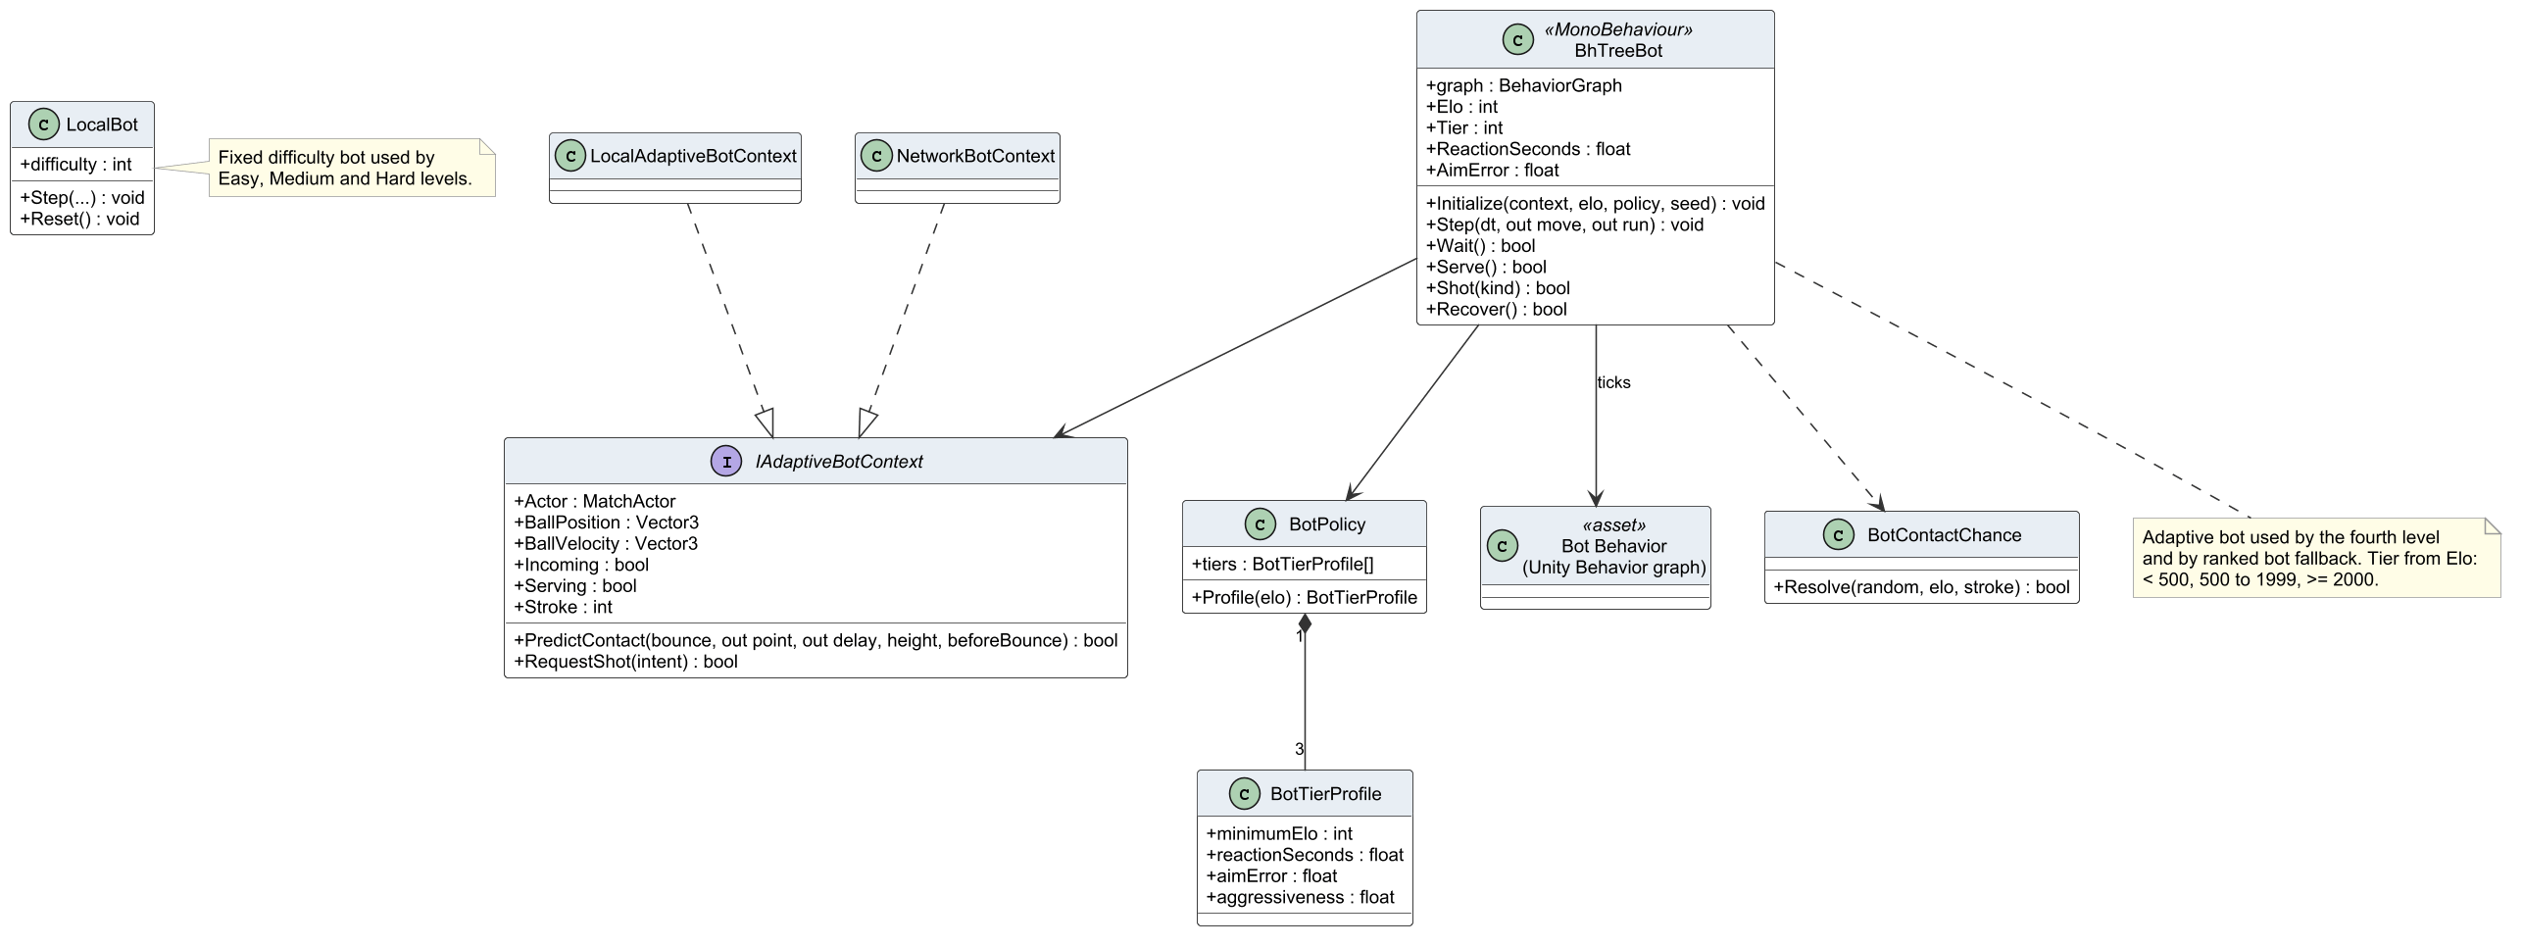
Figure 21. Class diagram – bots

3.4.2 Class Specifications
Table 24. Class specifications – bot AI
Class | Responsibility | Main attributes | Main operations
IAdaptiveBotContext  «interface» | Information the bot needs about ball, court and opponent, independent of local or network play | + Actor : MatchActor  + BallPosition : Vector3  + BallVelocity : Vector3  + Incoming : bool  + Serving : bool  + Stroke : int | + PredictContact(bounce, out point, out delay, height, beforeBounce) : bool  + RequestShot(intent) : bool
LocalAdaptiveBotContext | Bot context for a local bot match | – | –
NetworkBotContext | Bot context for a ranked bot on the dedicated server | – | –
BhTreeBot  «MonoBehaviour» | Adaptive bot driven by the Unity Behavior graph; tier chosen from Elo | + graph : BehaviorGraph  + Elo : int  + Tier : int  + ReactionSeconds : float  + AimError : float | + Initialize(context, elo, policy, seed) : void  + Step(dt, out move, out run) : void  + Wait() : bool  + Serve() : bool  + Shot(kind) : bool  + Recover() : bool
BotPolicy | Maps a tier to reaction time, accuracy, aggression and error rate | + tiers : BotTierProfile[] | + Profile(elo) : BotTierProfile
BotTierProfile | Parameter set of one bot tier | + minimumElo : int  + reactionSeconds : float  + aimError : float  + aggressiveness : float | –
LocalBot | Fixed-level bot (Easy, Medium, Hard) with deterministic settings | + difficulty : int | + Step(...) : void  + Reset() : void
Bot Behavior (Unity Behavior graph)  «asset» | Behaviour tree asset: position, choose shot, hit, recover | – | –
BotContactChance | Probability that the bot reaches and returns a ball | – | + Resolve(random, elo, stroke) : bool

3.4.3 Play a bot match
The loop fragment repeats rallies until one side wins two games; at the end the client reports the result to GameMatchesController, which settles rewards.
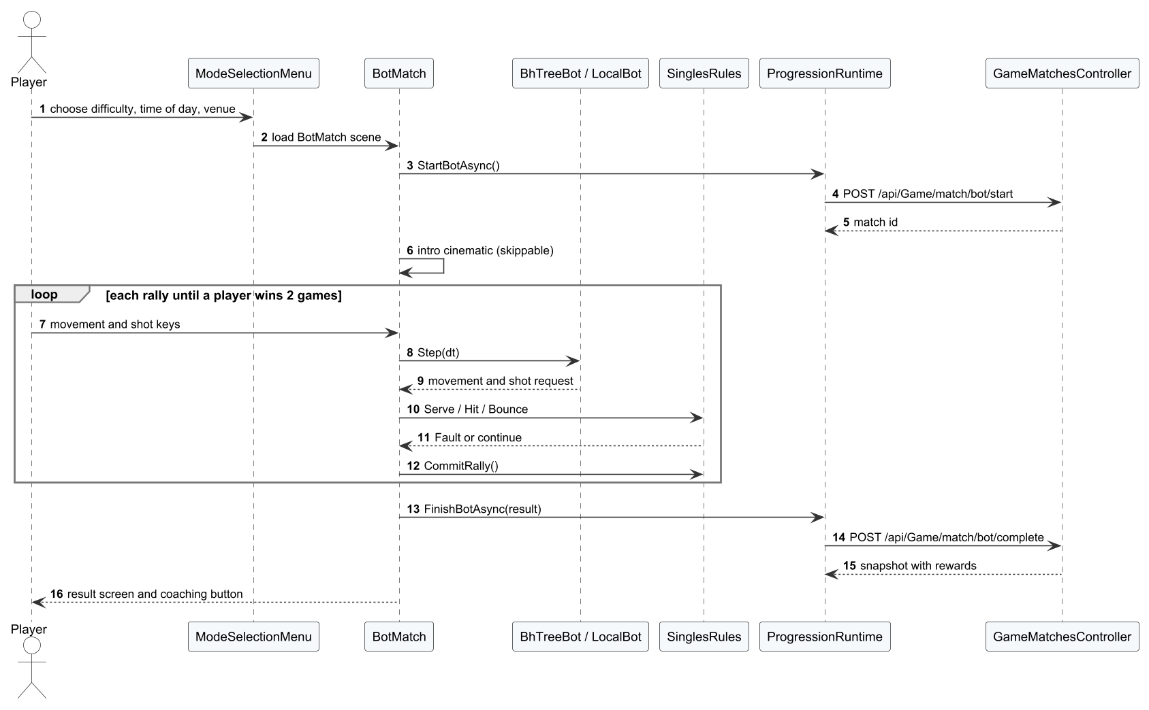
Figure 22. Sequence diagram – Play a bot match

3.5 Online Matchmaking and Netcode
Online play implements FR-14 to FR-18. MultiplayerApp is a state machine over FlowState. PhotonSession connects to Fusion; NetworkMatch and NetworkPlayer replicate state from the authority. Clients send only input (32-input history per tick) and render remote objects with snapshot interpolation; the protocol version (18) must match between client and server or the connection is refused.

3.5.1 Class Diagram
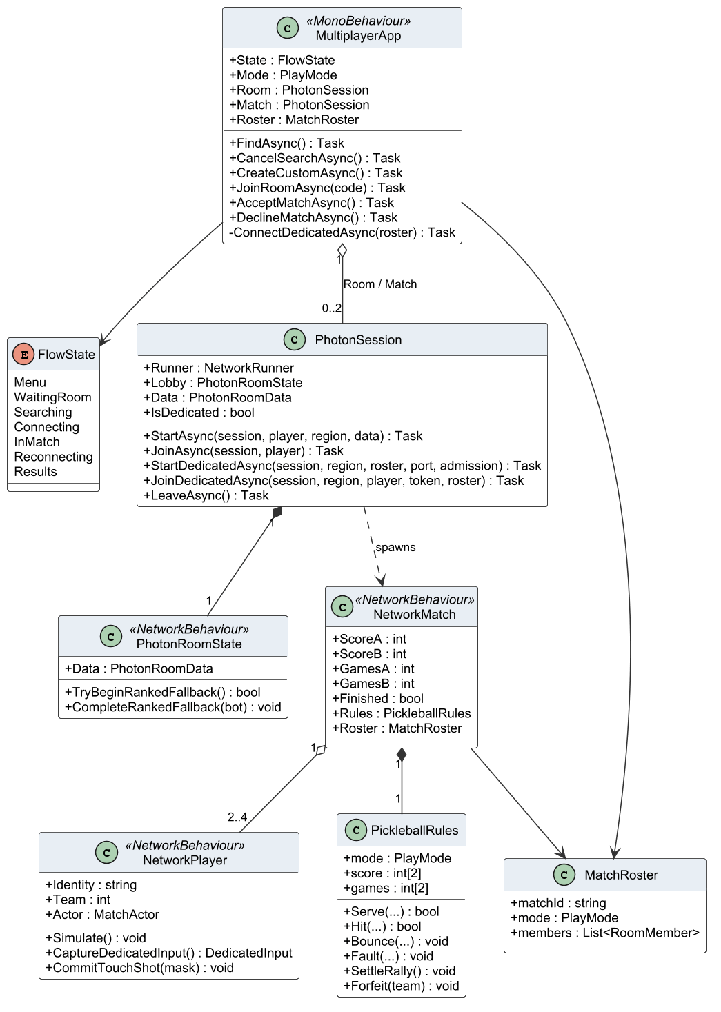
Figure 23. Class diagram – online client

3.5.2 Class Specifications
Table 25. Class specifications – online play
Class | Responsibility | Main attributes | Main operations
MultiplayerApp  «MonoBehaviour» | Online flow controller: lobby, search, ready check, loading, match, reconnection and results | + State : FlowState  + Mode : PlayMode  + Room : PhotonSession  + Match : PhotonSession  + Roster : MatchRoster | + FindAsync() : Task  + CancelSearchAsync() : Task  + CreateCustomAsync() : Task  + JoinRoomAsync(code) : Task  + AcceptMatchAsync() : Task  + DeclineMatchAsync() : Task  - ConnectDedicatedAsync(roster) : Task
FlowState  «enum» | States of the online flow (Menu, WaitingRoom, Delay, Searching, Connecting, InMatch, Reconnecting, Results) | Menu  WaitingRoom  Searching  Connecting  InMatch  Reconnecting  Results | –
PhotonSession | Starts and joins Fusion sessions in shared or client mode and handles disconnects | + Runner : NetworkRunner  + Lobby : PhotonRoomState  + Data : PhotonRoomData  + IsDedicated : bool | + StartAsync(session, player, region, data) : Task  + JoinAsync(session, player) : Task  + StartDedicatedAsync(session, region, roster, port, admission) : Task  + JoinDedicatedAsync(session, region, player, token, roster) : Task  + LeaveAsync() : Task
PhotonRoomState  «NetworkBehaviour» | Networked room state: roster, phase and host | + Data : PhotonRoomData | + TryBeginRankedFallback() : bool  + CompleteRankedFallback(bot) : void
NetworkMatch  «NetworkBehaviour» | Networked match state replicated from the authority: score, phase and ball | + ScoreA : int  + ScoreB : int  + GamesA : int  + GamesB : int  + Finished : bool  + Rules : PickleballRules  + Roster : MatchRoster | –
NetworkPlayer  «NetworkBehaviour» | Networked player: input, position and animation | + Identity : string  + Team : int  + Actor : MatchActor | + Simulate() : void  + CaptureDedicatedInput() : DedicatedInput  + CommitTouchShot(mask) : void
PickleballRules | Rules engine used by the network match (singles and doubles) | + mode : PlayMode  + score : int[2]  + games : int[2] | + Serve(...) : bool  + Hit(...) : bool  + Bounce(...) : void  + Fault(...) : void  + SettleRally() : void  + Forfeit(team) : void
MatchRoster | Teams, slots, bot flags and mode of a match | + matchId : string  + mode : PlayMode  + members : List<RoomMember> | –

3.5.3 Class Diagram – dedicated server coordination
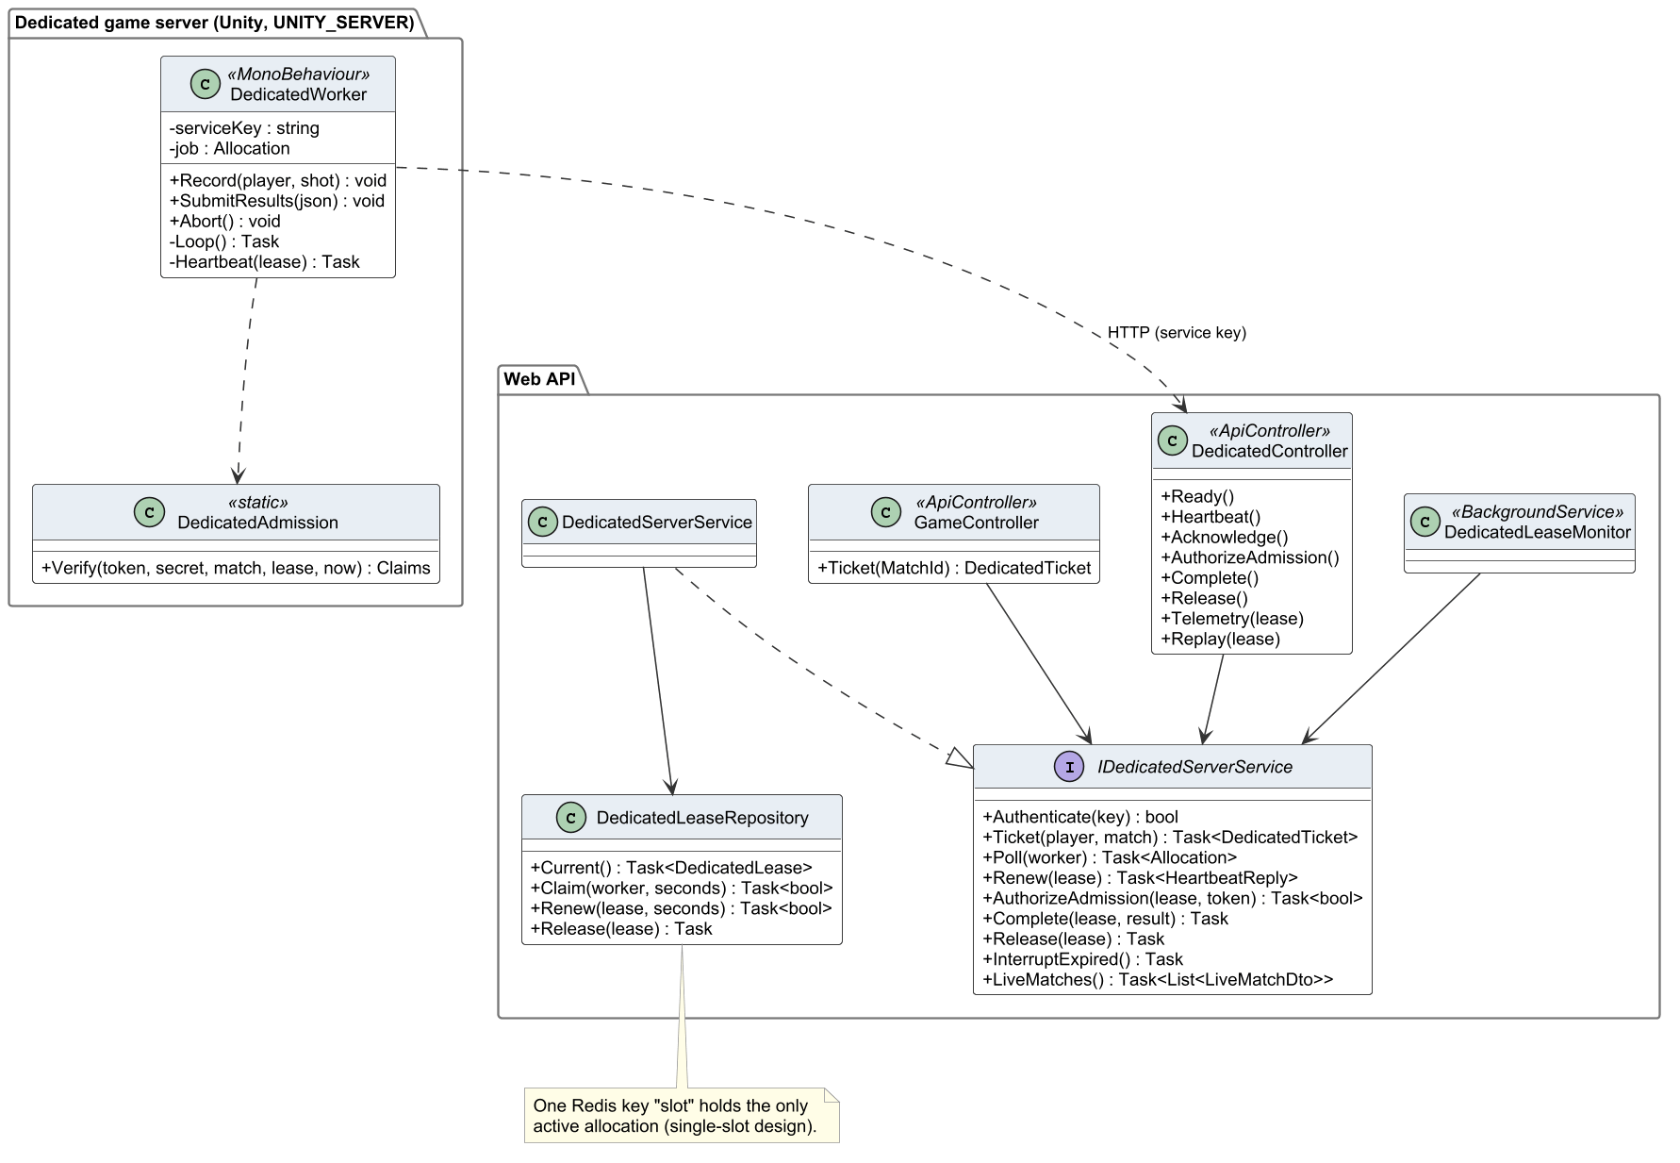
Figure 24. Class diagram – dedicated server coordination
Table 26. Class specifications – dedicated server
Class | Responsibility | Main attributes | Main operations
DedicatedWorker  «MonoBehaviour» | Main loop of the dedicated server: lease, admission, heartbeats, telemetry, replay and result | - serviceKey : string  - job : Allocation | + Record(player, shot) : void  + SubmitResults(json) : void  + Abort() : void  - Loop() : Task  - Heartbeat(lease) : Task
DedicatedAdmission  «static» | Validates HMAC tickets and admits players to the session | – | + Verify(token, secret, match, lease, now) : Claims
DedicatedController  «ApiController» | REST endpoints used by clients (ticket) and by the server (lease, heartbeat, result) | – | + Ready()  + Heartbeat()  + Acknowledge()  + AuthorizeAdmission()  + Complete()  + Release()  + Telemetry(lease)  + Replay(lease)
GameController  «ApiController» | REST endpoints for profile, wallet, catalogue, purchase and claims | – | + Ticket(MatchId) : DedicatedTicket
IDedicatedServerService  «interface» | Contract of dedicated-server coordination | – | + Authenticate(key) : bool  + Ticket(player, match) : Task<DedicatedTicket>  + Poll(worker) : Task<Allocation>  + Renew(lease) : Task<HeartbeatReply>  + AuthorizeAdmission(lease, token) : Task<bool>  + Complete(lease, result) : Task  + Release(lease) : Task  + InterruptExpired() : Task  + LiveMatches() : Task<List<LiveMatchDto>>
DedicatedServerService | Allocates the slot, signs tickets, records heartbeats and settles results | – | –
DedicatedLeaseRepository | Redis lease of the single server slot with expiry | – | + Current() : Task<DedicatedLease>  + Claim(worker, seconds) : Task<bool>  + Renew(lease, seconds) : Task<bool>  + Release(lease) : Task
DedicatedLeaseMonitor  «BackgroundService» | Background worker that releases expired leases and interrupts orphan matches | – | –

3.5.4 Find a ranked match
The client polls the search. The alternatives show a human opponent found, the bot fallback after 180 seconds, all players accepting, and a decline or timeout that closes the offer.
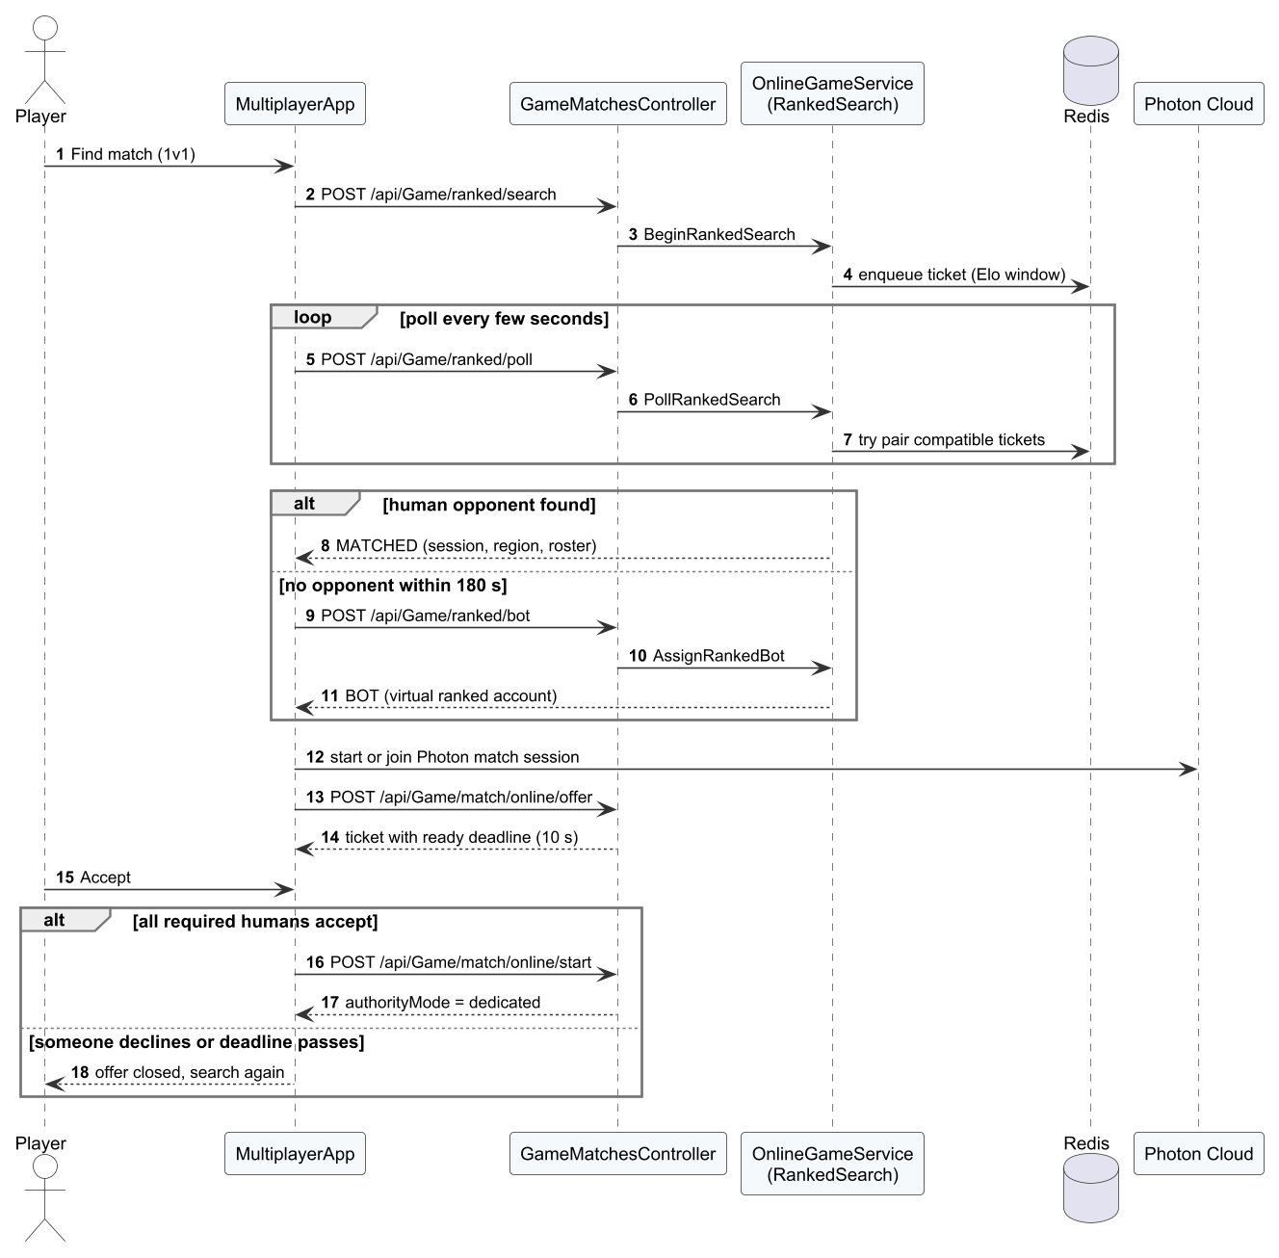
Figure 25. Sequence diagram – Find a ranked match

3.5.5 Invite a friend to a room
The invitation is rejected when the friend is not in the lobby, is blocked or the room is full; otherwise the friend polls and accepts it.
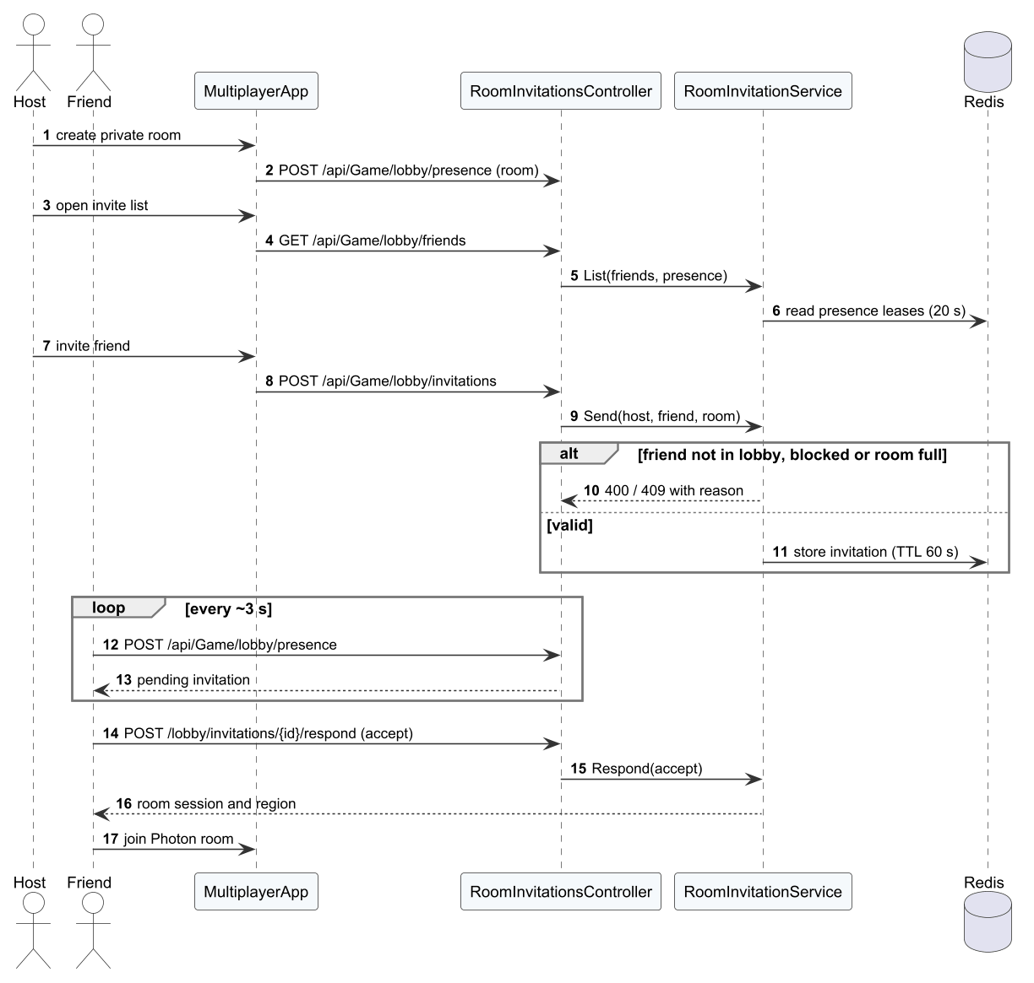
Figure 26. Sequence diagram – Invite a friend to a room

3.5.6 Allocate the dedicated server and play
When the slot is busy the client waits. When the slot is reserved the API signs tickets; the client polls every 500 ms until the server is ready; during play the server sends heartbeats and at the end the result.
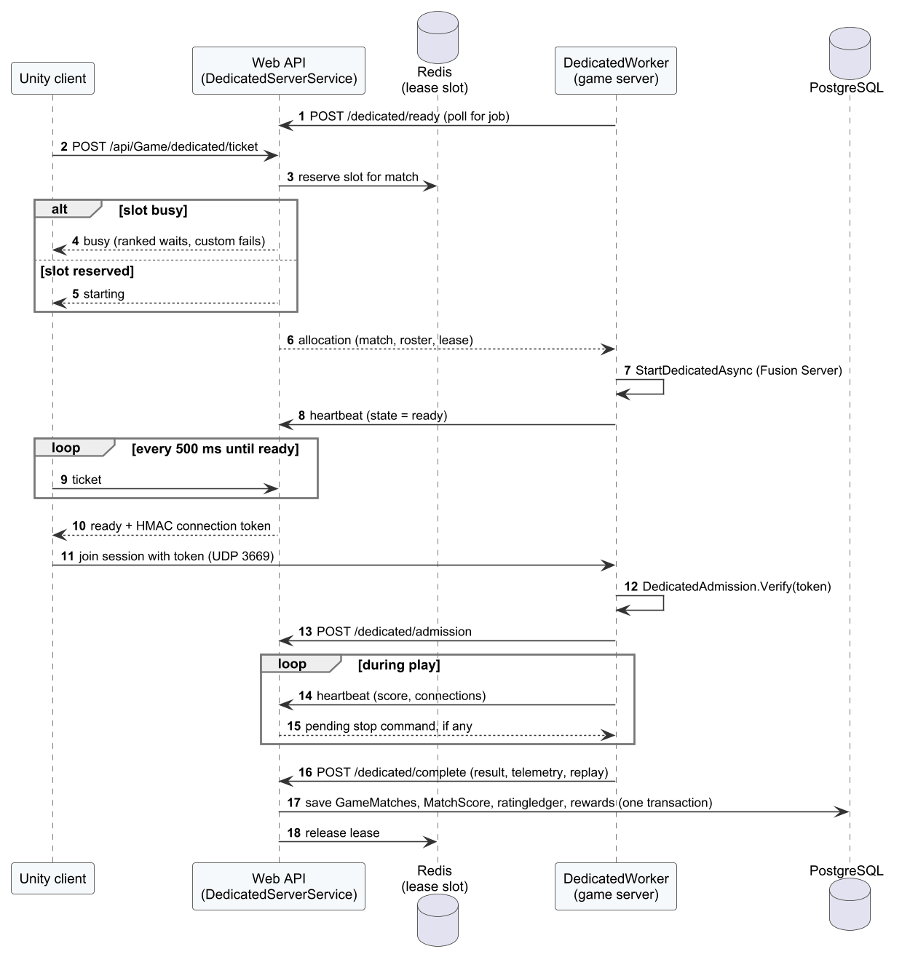
Figure 27. Sequence diagram – Allocate the dedicated server and play

3.6 AI Coaching
AI coaching implements FR-19 and NFR-05/NFR-06. Telemetry is uploaded by CoachingRuntime (drills and bot matches) or DedicatedWorker (online matches). HybridCoachingService stores it and creates an analysis job; HybridAiWorker calls the FastAPI service, which runs the rule engine and, when approved, the tier model.
Table 27. AI coaching parameters
Parameter | Value | Source / meaning
Model features | 8 | mean_abs_timing, late_rate, early_rate, kitchen_rate, momentum_rate, target_rate, recovery_rate, input_error_rate
Tiers | beginner, intermediate, advanced | tier.py
Minimum confidence / opportunities | 0.65 / 20 | Below these values no tier is returned
Finding acceptance | precision ≥ 0.80, recall ≥ 0.70 | calibration.py, NFR-06
Model approval | real data, ≥ 10 holdout players per tier, macro-F1 ≥ 0.70 and ≥ baseline + 0.05 | train.py
Recommendations | at most 3 | engine.py

3.6.1 Class Diagram
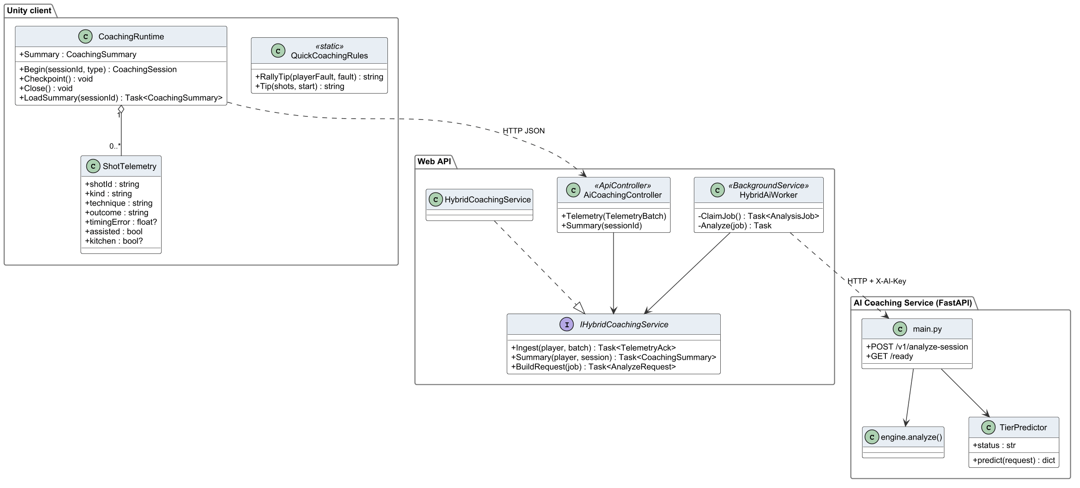
Figure 28. Class diagram – AI coaching

3.6.2 Class Specifications
Table 28. Class specifications – AI coaching
Class | Responsibility | Main attributes | Main operations
QuickCoachingRules  «static» | Client-side quick tip shown when offline or before the AI result arrives | – | + RallyTip(playerFault, fault) : string  + Tip(shots, start) : string
CoachingRuntime | Uploads telemetry, polls the analysis job and shows the coaching popup | + Summary : CoachingSummary | + Begin(sessionId, type) : CoachingSession  + Checkpoint() : void  + Close() : void  + LoadSummary(sessionId) : Task<CoachingSummary>
ShotTelemetry | Per-shot record: timing, contact, landing, position and errors | + shotId : string  + kind : string  + technique : string  + outcome : string  + timingError : float?  + assisted : bool  + kitchen : bool? | –
AiCoachingController  «ApiController» | REST endpoints for telemetry upload and coaching results | – | + Telemetry(TelemetryBatch)  + Summary(sessionId)
IHybridCoachingService  «interface» | Contract of telemetry ingestion and coaching retrieval | – | + Ingest(player, batch) : Task<TelemetryAck>  + Summary(player, session) : Task<CoachingSummary>  + BuildRequest(job) : Task<AnalyzeRequest>
HybridCoachingService | Stores telemetry, creates analysis jobs and returns results | – | –
HybridAiWorker  «BackgroundService» | Sends pending jobs to the AI service with retries and stores the result | – | - ClaimJob() : Task<AnalysisJob>  - Analyze(job) : Task
main.py | FastAPI entry point: /v1/analyze-session and health | + POST /v1/analyze-session  + GET /ready | –
engine.analyze() | Rule-based analysis producing findings, summary and recommendations | – | –
TierPredictor | Loads the approved model and predicts the tier with a confidence threshold | + status : str | + predict(request) : dict

3.6.3 Analyse a session
The worker marks the job processing and calls the service; on success the result is stored and the job completed, on failure the job is retried and finally marked failed.

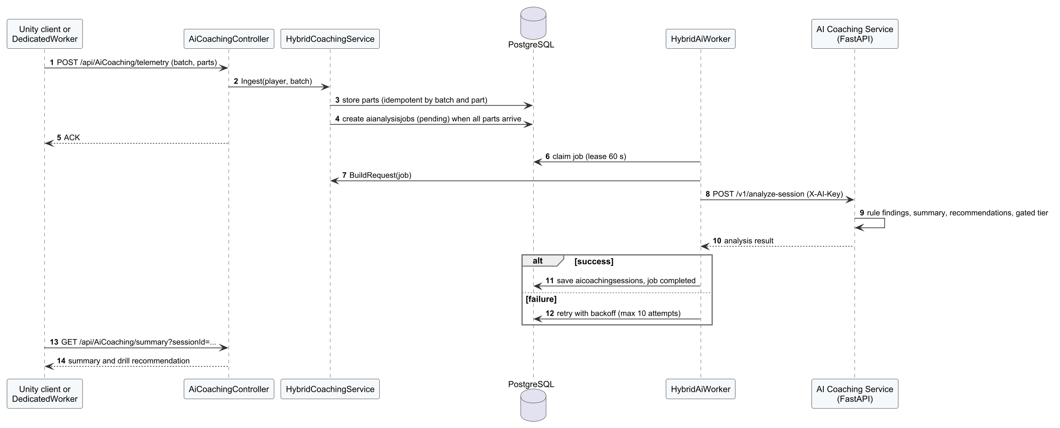
Figure 29. Sequence diagram – Analyse a session

3.7 Progress, Economy, Social and Replays
This group implements FR-20 to FR-26. The client screens share ProgressionRuntime. On the server, OnlineGameService settles rewards and purchases, OnlineSocialService manages friends and the leaderboard, and IMatchReplayService stores replays; GameRepository performs the EF Core queries and row locks inside the unit of work.

3.7.1 Class Diagram
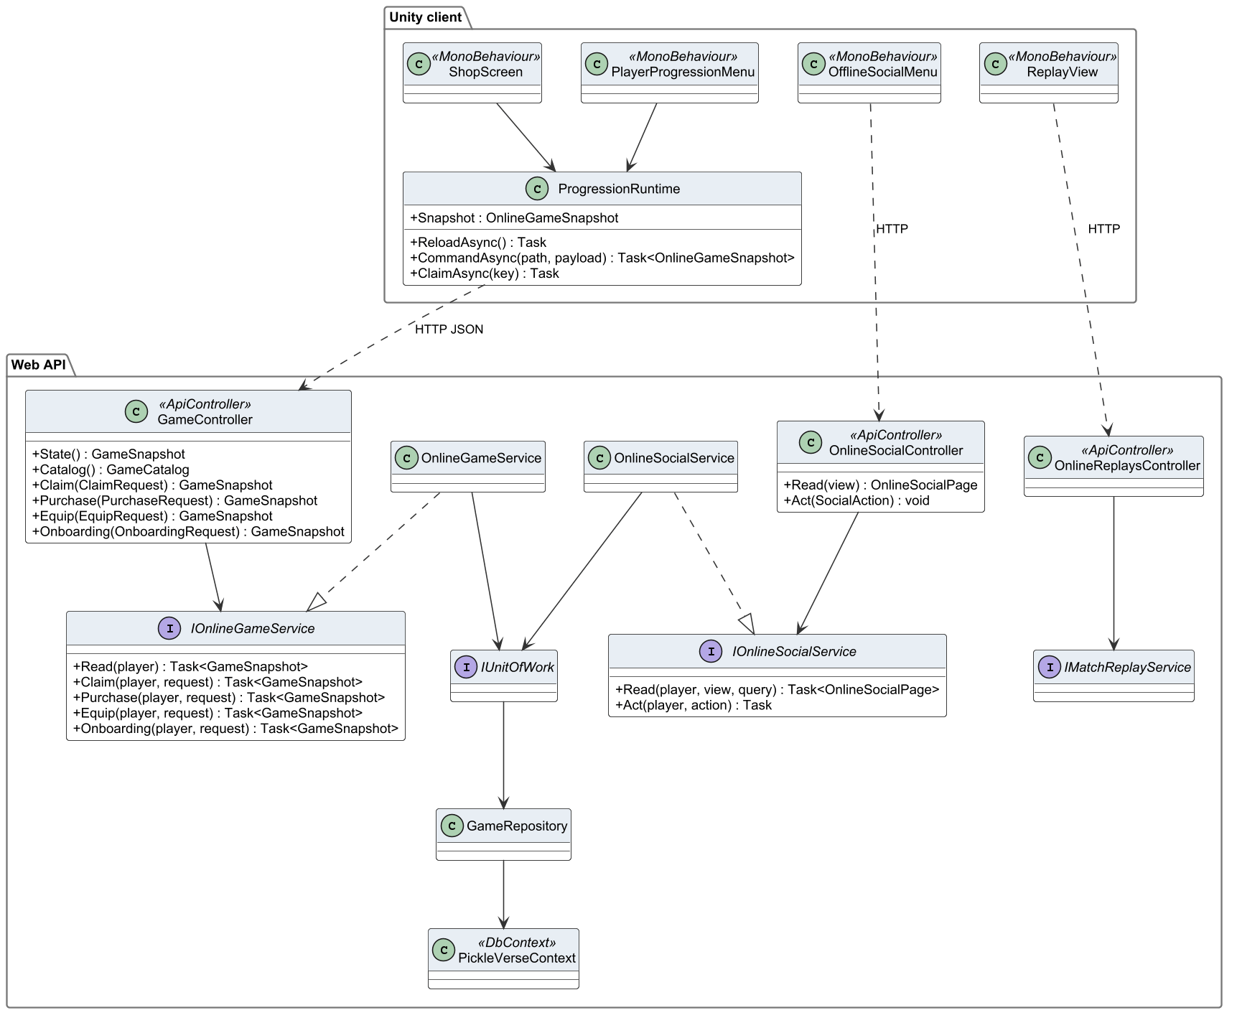
Figure 30. Class diagram – progress, economy, social and replays

3.7.2 Class Specifications
Table 29. Class specifications – progress, economy and social
Class | Responsibility | Main attributes | Main operations
ProgressionRuntime | Client-side cache of profile, wallet, catalogue and the synchronisation queue | + Snapshot : OnlineGameSnapshot | + ReloadAsync() : Task  + CommandAsync(path, payload) : Task<OnlineGameSnapshot>  + ClaimAsync(key) : Task
PlayerProgressionMenu  «MonoBehaviour» | Progress, missions and history popups | – | –
OfflineSocialMenu  «MonoBehaviour» | Friends and leaderboard drawer | – | –
ShopScreen  «MonoBehaviour» | Shop scene: list, preview and purchase | – | –
ReplayView  «MonoBehaviour» | Replay viewer: download and playback controls | – | –
GameController  «ApiController» | REST endpoints for profile, wallet, catalogue, purchase and claims | – | + State() : GameSnapshot  + Catalog() : GameCatalog  + Claim(ClaimRequest) : GameSnapshot  + Purchase(PurchaseRequest) : GameSnapshot  + Equip(EquipRequest) : GameSnapshot  + Onboarding(OnboardingRequest) : GameSnapshot
OnlineSocialController  «ApiController» | REST endpoints for friends, blocking and leaderboard | – | + Read(view) : OnlineSocialPage  + Act(SocialAction) : void
OnlineReplaysController  «ApiController» | REST endpoints for replay upload and download | – | –
IOnlineGameService  «interface» | Contract of progression, economy and match use cases | – | + Read(player) : Task<GameSnapshot>  + Claim(player, request) : Task<GameSnapshot>  + Purchase(player, request) : Task<GameSnapshot>  + Equip(player, request) : Task<GameSnapshot>  + Onboarding(player, request) : Task<GameSnapshot>
IOnlineSocialService  «interface» | Contract of social use cases | – | + Read(player, view, query) : Task<OnlineSocialPage>  + Act(player, action) : Task
IMatchReplayService  «interface» | Contract of replay storage | – | –
OnlineGameService | Server implementation of training, match settlement, matchmaking and economy use cases | – | –
OnlineSocialService | Friend requests, friendships, blocks and leaderboard cache | – | –
IUnitOfWork  «interface» | Gives services access to repositories and one shared transaction | – | –
GameRepository | EF Core queries and locks for matches, progression and economy | – | –
PickleVerseContext  «DbContext» | EF Core DbContext mapping the 51 tables | – | –

3.7.3 Purchase a cosmetic
The command ID makes the purchase idempotent: an already processed request returns the stored receipt; otherwise ownership and balance are checked and the debit, ledger entry and ownership are written in one transaction.
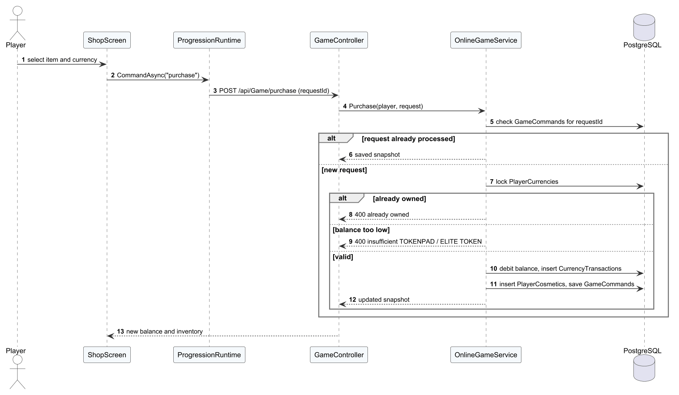
Figure 31. Sequence diagram – Purchase a cosmetic

3.8 Administration and Moderation
Administration implements FR-27 to FR-33. Every admin controller requires the Admin role; services write an AdminAudits record in the same transaction as the change.

3.8.1 Class Diagram
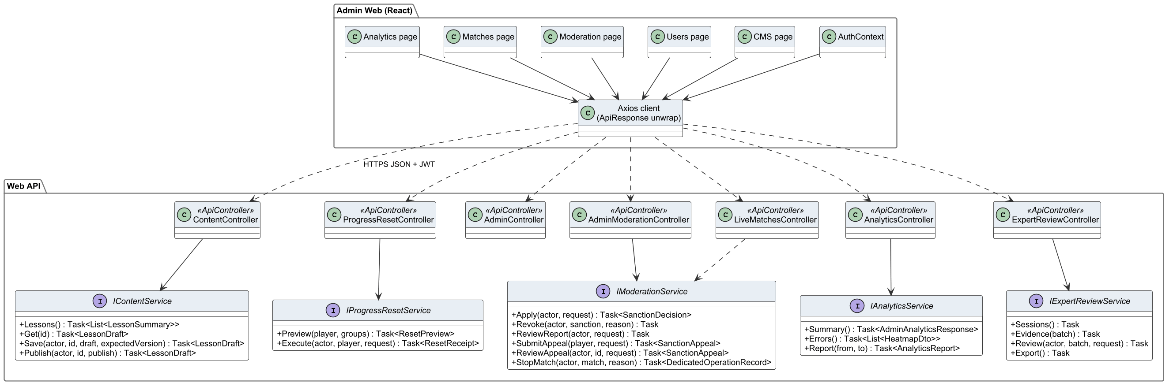
Figure 32. Class diagram – administration web and admin API

3.8.2 Class Specifications
Table 30. Class specifications – administration
Class | Responsibility | Main attributes | Main operations
AuthContext | Admin web session state and role check | – | –
CMS page | Lesson, drill, item and mission forms | – | –
Users page | Account search and actions | – | –
Moderation page | Reports, sanctions and appeals | – | –
Matches page | Live matches and stop dialog | – | –
Analytics page | Charts for the selected date range | – | –
Axios client (ApiResponse unwrap) | HTTP client that adds the JWT and unwraps the ApiResponse envelope | – | –
ContentController  «ApiController» | Admin endpoints for lessons and catalogue | – | –
ProgressResetController  «ApiController» | Admin endpoints for reset preview and execution | – | –
AdminController  «ApiController» | Admin endpoints for users, roles, sanctions and e-mail activation | – | –
AdminModerationController  «ApiController» | Admin endpoints for reports, appeals and match stop | – | –
LiveMatchesController  «ApiController» | Admin endpoints for live and finished matches | – | –
AnalyticsController  «ApiController» | Admin endpoints for analytics summary and error heat map | – | –
ExpertReviewController  «ApiController» | Admin endpoints for expert labelling and dataset export | – | –
IContentService  «interface» | Contract of content management | – | + Lessons() : Task<List<LessonSummary>>  + Get(id) : Task<LessonDraft>  + Save(actor, id, draft, expectedVersion) : Task<LessonDraft>  + Publish(actor, id, publish) : Task<LessonDraft>
IProgressResetService  «interface» | Contract of progress reset | – | + Preview(player, groups) : Task<ResetPreview>  + Execute(actor, player, request) : Task<ResetReceipt>
IModerationService  «interface» | Contract of moderation use cases | – | + Apply(actor, request) : Task<SanctionDecision>  + Revoke(actor, sanction, reason) : Task  + ReviewReport(actor, request) : Task  + SubmitAppeal(player, request) : Task<SanctionAppeal>  + ReviewAppeal(actor, id, request) : Task<SanctionAppeal>  + StopMatch(actor, match, reason) : Task<DedicatedOperationRecord>
IAnalyticsService  «interface» | Contract of analytics queries | – | + Summary() : Task<AdminAnalyticsResponse>  + Errors() : Task<List<HeatmapDto>>  + Report(from, to) : Task<AnalyticsReport>
IExpertReviewService  «interface» | Contract of expert review and export | – | + Sessions() : Task  + Evidence(batch) : Task  + Review(actor, batch, request) : Task  + Export() : Task

3.8.3 Report, sanction and appeal
A player reports; the administrator accepts the report and applies a sanction; the restricted player appeals; the administrator accepts or declines the appeal.
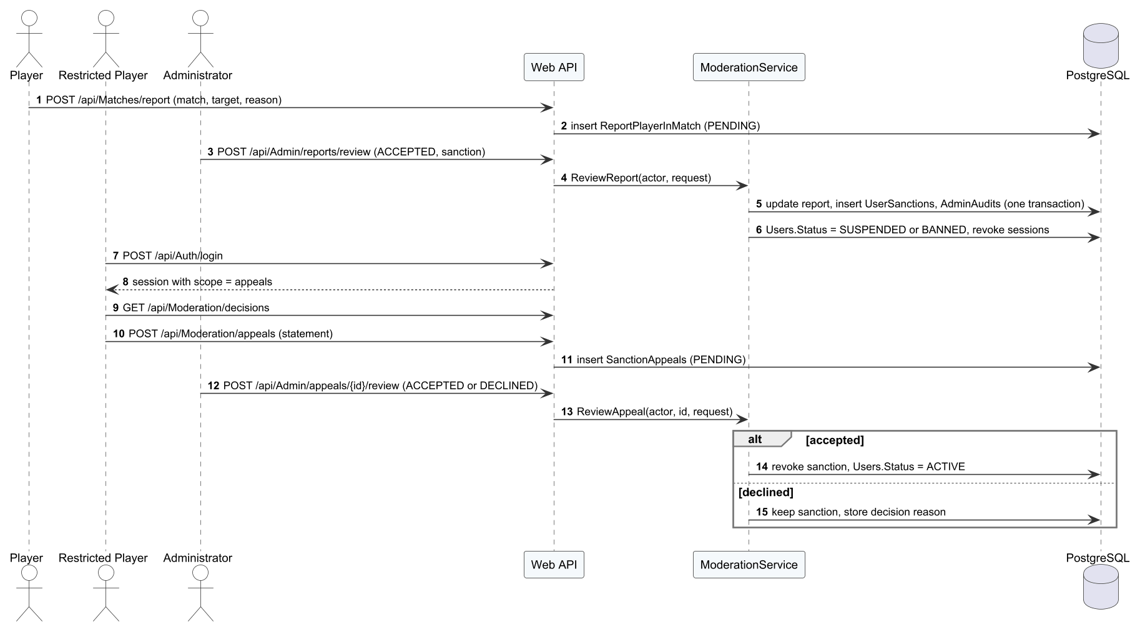
Figure 33. Sequence diagram – Report, sanction and appeal

3.8.4 Reset player progress
The dialog previews the impact; execution is refused when the revision changed after the preview.
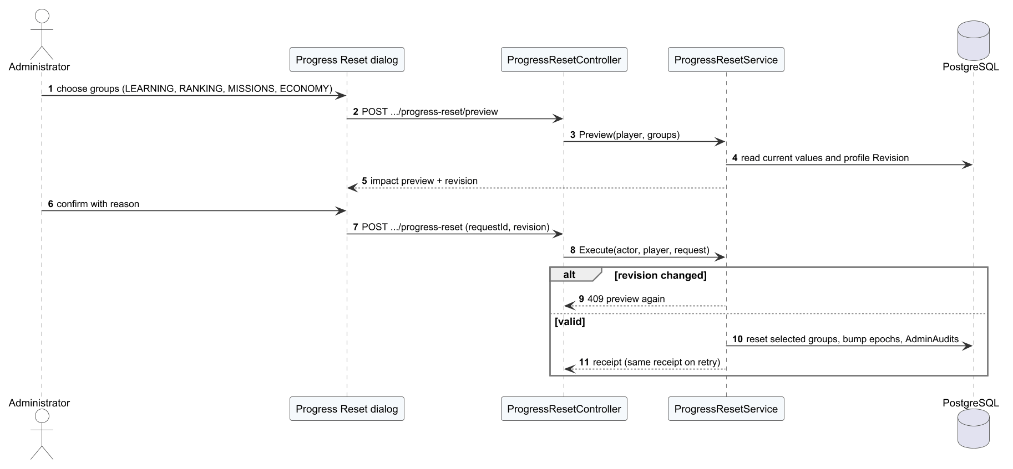
Figure 34. Sequence diagram – Reset player progress

3.8.5 Publish a lesson
Publishing is refused when the expected version changed; otherwise the lesson becomes PUBLISHED and a new catalogue version is produced.
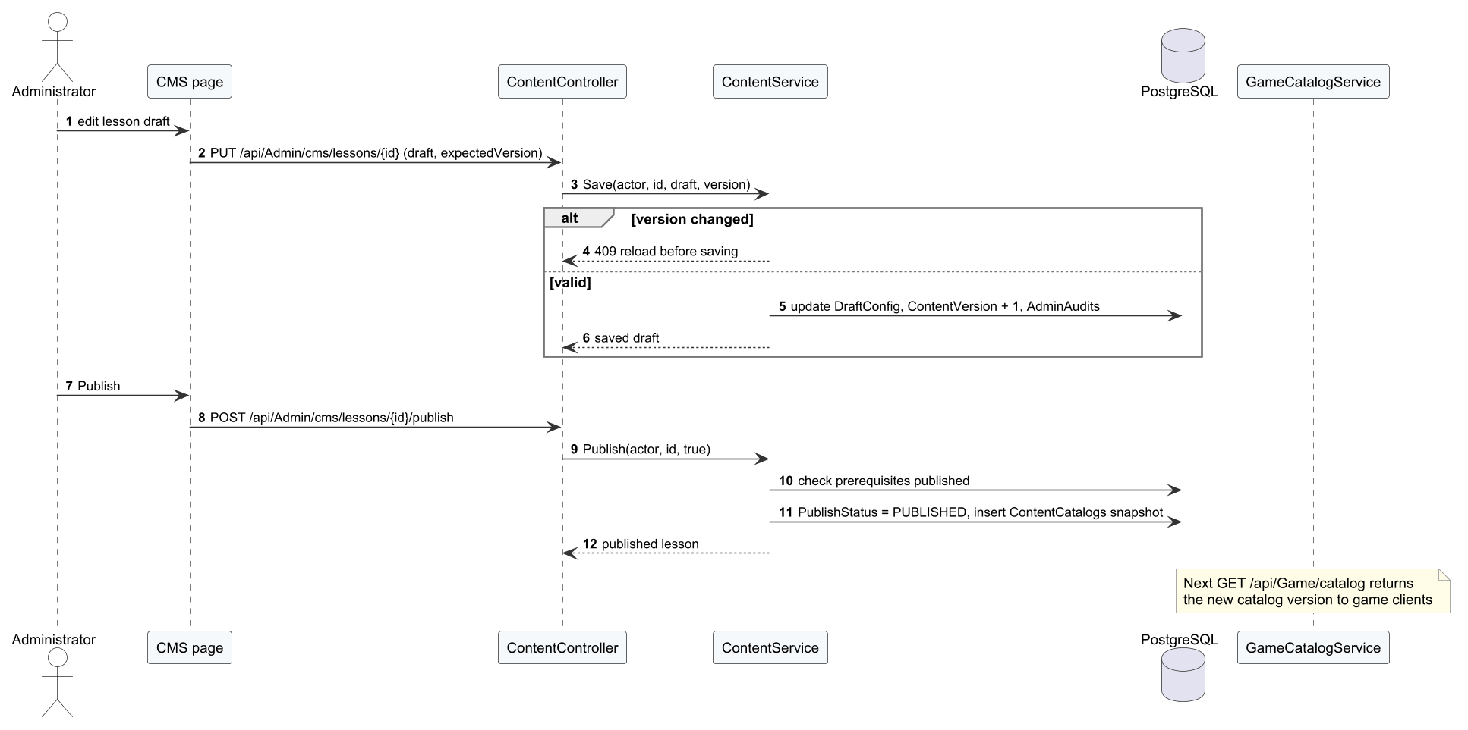
Figure 35. Sequence diagram – Publish a lesson

3.8.6 Stop a live match
The stop request is stored as a dedicated operation; the server reads it with the next heartbeat, ends the match as interrupted and acknowledges.
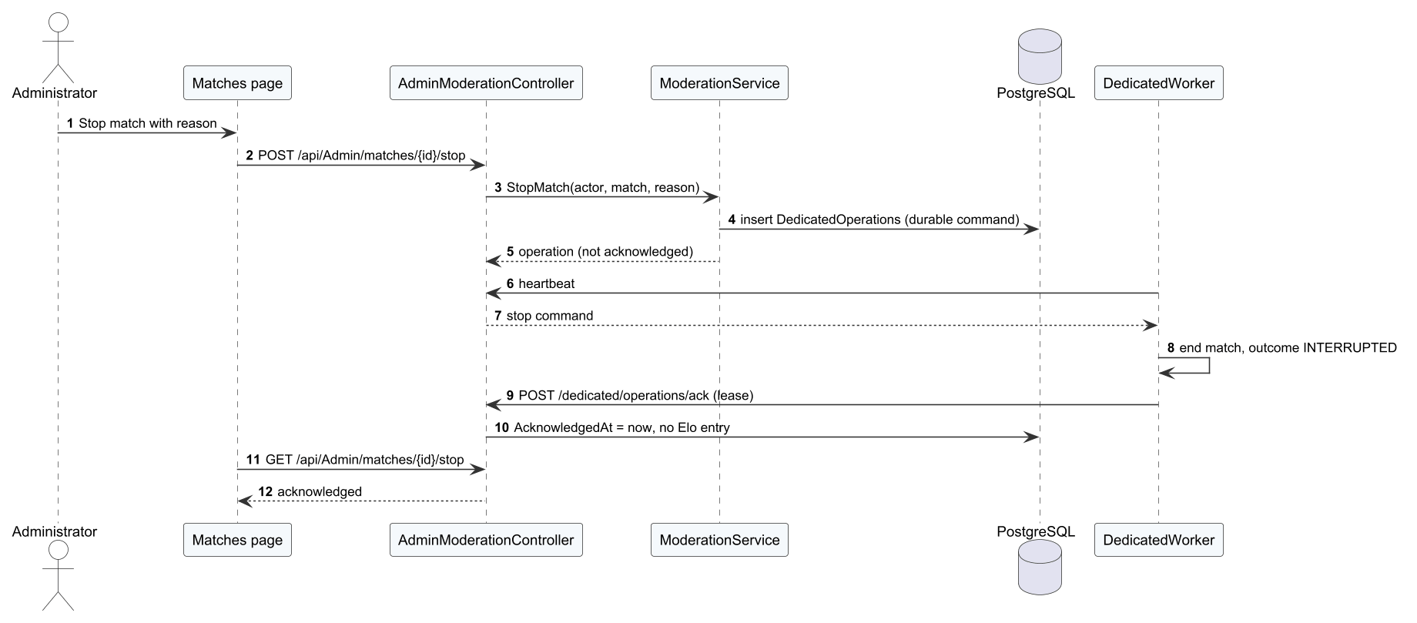
Figure 36. Sequence diagram – Stop a live match

3.9 API Design
The Web API exposes 122 REST endpoints in 24 controllers. Table below lists the conventions, and the full list of endpoints with their access level follows.
Table 31. API conventions
Item | Design
Base path and format | /api/<Controller>/...; JSON (UTF-8); enum values serialised as strings
Envelope | Success: ApiResponse<T> {success: true, message, data}. Error: ApiResponse {success: false, message, code, errors}
Status codes | 400 validation, 401 missing or expired token, 403 role or scope not allowed, 404 not found, 409 conflict or stale version, 429 rate limit, 503 dependency unavailable, 500 internal (no details)
Authentication | Bearer JWT (HS256) with claims sub/NameIdentifier, email, role (Player, Admin or Restricted), access_scope (game or appeals) and auth_version; refresh tokens rotate
Rate limiting | Policy auth: 20 requests per minute per IP on authentication endpoints; rejection returns 429 with Retry-After: 60
Idempotency | Commands carry a request/command ID stored in GameCommands or receipts
Service calls | Dedicated server: service key header and HMAC-signed tickets; AI service: X-AI-Key header
Documentation | OpenAPI document generated at runtime with the ApiResponse schema

Table 32. Web API endpoints (122)
Controller | Method | Route | Action | Access
Achievements | GET | /api/Achievements | GetMyAchievements | Player
Achievements | POST | /api/Achievements/{achievementId}/claim | ClaimReward | Player
Admin | POST | /api/Admin/cms/cosmetics | CreateCosmetic | Admin
Admin | POST | /api/Admin/cms/drills | CreateDrill | Admin
Admin | POST | /api/Admin/cms/lessons | CreateLesson | Admin
Admin | POST | /api/Admin/cms/missions | CreateMission | Admin
Admin | GET | /api/Admin/matches/recent | GetRecentMatches | Admin
Admin | GET | /api/Admin/reports | GetReports | Admin
Admin | POST | /api/Admin/reports/review | ReviewReport | Admin
Admin | GET | /api/Admin/users | GetUsers | Admin
Admin | POST | /api/Admin/users/assign-role | AssignRole | Admin
Admin | POST | /api/Admin/users/ban | BanUser | Admin
Admin | POST | /api/Admin/users/{playerId}/reset-elo | ResetPlayerElo | Admin
Admin | POST | /api/Admin/users/{userId}/unban | UnbanUser | Admin
Admin | POST | /api/Admin/users/{userId}/verify-email | ManualVerifyUserEmail | Admin
AiCoaching | POST | /api/AiCoaching/log-error | LogTechniqueError | Player
AiCoaching | GET | /api/AiCoaching/mastery | GetMastery | Player
AiCoaching | GET | /api/AiCoaching/recommendation | GetRecommendation | Player
AiCoaching | GET | /api/AiCoaching/summary | Summary | Player
AiCoaching | POST | /api/AiCoaching/telemetry | Telemetry | Player
Analytics | GET | /?/error-heatmap | Errors | Player
Analytics | GET | /?/report | Report | Player
Analytics | GET | /?/summary | Summary | Player
AppActivity | POST | /api/Game/activity/checkpoint | Activity | Player
AppActivity | POST | /api/Game/activity/open | OpenActivity | Player
Auth | POST | /api/Auth/forgot-password | ForgotPassword | Anonymous
Auth | POST | /api/Auth/login | Login | Anonymous
Auth | POST | /api/Auth/logout | Logout | Player
Auth | POST | /api/Auth/refresh-token | RefreshToken | Anonymous
Auth | POST | /api/Auth/register | Register | Anonymous
Auth | POST | /api/Auth/resend-otp | ResendOtp | Anonymous
Auth | POST | /api/Auth/reset-password | ResetPassword | Anonymous
Auth | POST | /api/Auth/verify-email | VerifyEmail | Anonymous
Content | GET | /? | List | Player
Content | GET | /?/references | References | Player
Content | GET | /?/{id:int} | Get | Player
Content | PUT | /?/{id:int} | Save | Player
Content | POST | /?/{id:int}/publish | Publish | Player
Content | POST | /?/{id:int}/references | Create | Player
Content | POST | /?/{id:int}/unpublish | Unpublish | Player
Dedicated | POST | /api/Game/dedicated/admission | AuthorizeAdmission | Player
Dedicated | POST | /api/Game/dedicated/complete | Complete | Player
Dedicated | POST | /api/Game/dedicated/heartbeat | Heartbeat | Player
Dedicated | POST | /api/Game/dedicated/operations/ack | Acknowledge | Player
Dedicated | POST | /api/Game/dedicated/ready | Ready | Player
Dedicated | POST | /api/Game/dedicated/release | Release | Player
Dedicated | POST | /api/Game/dedicated/{lease}/replay | Replay | Player
Dedicated | POST | /api/Game/dedicated/{lease}/replay/chunks/{index:int} | Chunk | Player
Dedicated | POST | /api/Game/dedicated/{lease}/telemetry | Telemetry | Player
Economy | POST | /api/Economy/buy | BuyCosmetic | Player
Economy | GET | /api/Economy/currencies | GetCurrencies | Player
Economy | POST | /api/Economy/equip | EquipCosmetic | Player
Economy | GET | /api/Economy/my-inventory | GetMyCosmetics | Player
Economy | GET | /api/Economy/shop | GetShopItems | Player
ExpertReview | GET | /?/demo-sessions | DemoSessions | Player
ExpertReview | GET | /?/demo-sessions/{sessionId} | DemoEvidence | Player
ExpertReview | GET | /?/sessions | Sessions | Player
ExpertReview | GET | /?/sessions/{batch:guid} | Evidence | Player
ExpertReview | POST | /?/sessions/{batch:guid}/review | Review | Player
Friends | GET | /api/Friends | GetFriends | Player
Friends | POST | /api/Friends/block/{targetUserId} | BlockUser | Player
Friends | POST | /api/Friends/request | SendFriendRequest | Player
Friends | POST | /api/Friends/respond | RespondFriendRequest | Player
Friends | DELETE | /api/Friends/{friendId} | RemoveFriend | Player
Game | GET | /api/Game/catalog | Catalog | Player
Game | POST | /api/Game/claim | Claim | Player
Game | POST | /api/Game/equip | Equip | Player
Game | POST | /api/Game/onboarding | Onboarding | Player
Game | POST | /api/Game/purchase | Purchase | Player
Game | GET | /api/Game/state | State | Player
Game | POST | /api/Game/tutorial | Tutorial | Player
GameMatches | POST | /api/Game/match/bot/complete | FinishBot | Player
GameMatches | POST | /api/Game/match/bot/start | StartBot | Player
GameMatches | POST | /api/Game/match/online/heartbeat | HeartbeatOnline | Player
GameMatches | POST | /api/Game/match/online/leave | LeaveOnline | Player
GameMatches | POST | /api/Game/match/online/offer | OfferOnline | Player
GameMatches | POST | /api/Game/match/online/prepare | PrepareOnline | Player
GameMatches | POST | /api/Game/match/online/report | ReportOnline | Player
GameMatches | POST | /api/Game/match/online/start | StartOnline | Player
GameMatches | POST | /api/Game/ranked/bot | Bot | Player
GameMatches | POST | /api/Game/ranked/cancel | CancelSearch | Player
GameMatches | POST | /api/Game/ranked/poll | Poll | Player
GameMatches | POST | /api/Game/ranked/room-ready | PublishRoom | Player
GameMatches | POST | /api/Game/ranked/search | Search | Player
GameTraining | POST | /api/Game/training/checkpoint | Checkpoint | Player
GameTraining | POST | /api/Game/training/complete | Complete | Player
GameTraining | POST | /api/Game/training/start | Start | Player
GameTraining | POST | /api/Game/training/sync | SyncTraining | Player
Matches | POST | /api/Matches/finish | FinishMatch | Player
Matches | GET | /api/Matches/my-history | GetMyMatchHistory | Player
Matches | POST | /api/Matches/report | ReportPlayer | Player
Missions | GET | /api/Missions | GetMyMissions | Player
Missions | POST | /api/Missions/{missionId}/claim | ClaimReward | Player
Moderation | GET | /?/appeals | Appeals | Player
Moderation | GET | /?/appeals | Appeals | Player
Moderation | POST | /?/appeals | Appeal | Player
Moderation | POST | /?/appeals/{id:guid}/review | Review | Player
Moderation | GET | /?/decisions | Decisions | Player
Moderation | POST | /?/matches/{match:guid}/stop | Stop | Player
Moderation | GET | /?/sanctions | Sanctions | Player
OnlineReplays | GET | /api/Game/replays | List | Player
OnlineReplays | GET | /api/Game/replays/{match:guid} | Read | Player
OnlineReplays | PUT | /api/Game/replays/{match:guid} | Save | Player
OnlineReplays | GET | /api/Game/replays/{match:guid}/chunks/{index:int} | Chunk | Player
OnlineReplays | PUT | /api/Game/replays/{match:guid}/chunks/{index:int} | Upload | Player
OnlineSocial | GET | /api/Game/social | Read | Player
OnlineSocial | POST | /api/Game/social | Act | Player
Profiles | GET | /api/Profiles/leaderboard | GetLeaderboard | Player
Profiles | GET | /api/Profiles/me | GetMyProfile | Player
Profiles | PUT | /api/Profiles/me | UpdateProfile | Player
Profiles | POST | /api/Profiles/sync-time | SyncTime | Player
Profiles | GET | /api/Profiles/{playerId} | GetProfileById | Player
ProgressReset | POST | /? | Reset | Player
ProgressReset | POST | /?/preview | Preview | Player
Replays | POST | /api/Replays/save | SaveReplay | Player
Replays | GET | /api/Replays/{matchId} | GetReplay | Player
RoomInvitations | GET | /api/Game/lobby/friends | Friends | Player
RoomInvitations | POST | /api/Game/lobby/invitations | Send | Player
RoomInvitations | POST | /api/Game/lobby/invitations/{id}/respond | Respond | Player
RoomInvitations | POST | /api/Game/lobby/presence | Presence | Player
Training | GET | /api/Training/lessons | GetLessons | Player
Training | POST | /api/Training/submit-drill | SubmitDrill | Player

3.10 Security Design
Table 33. Security design
Concern | Design
Passwords | BCrypt hash with salt; 6–128 characters; never logged
Tokens | JWT HS256, 2-hour access token; refresh token 14 days stored as SHA-256 hash, rotated on use; auth_version in the token is incremented to revoke all sessions (password reset, ban)
Codes | OTP and reset codes stored as HMAC, 10-minute expiry, 5 attempts, 60-second resend cooldown
Authorisation | Role-based ([Authorize(Roles = "Admin")]) plus access scope: restricted accounts receive scope appeals and can call only moderation endpoints; resource ownership is checked in services (own matches, replays, telemetry)
Transport | HTTPS with TLS 1.2+ in production behind nginx; the staging environment currently uses HTTP and must be switched before release (Report 5 defect list)
Secrets | Read from environment variables and the server .env file. The committed appsettings.json still contains development credentials and Program.cs contains a fallback JWT key; both are tracked as security defects and must be removed and rotated
Abuse protection | Rate limiting on authentication; server-authoritative online results; idempotent commands; validation of telemetry ownership; HMAC tickets bind a player to a match and slot
CORS | AdminWebPolicy allows only the admin web origins; production serves the admin web and API under the same origin through nginx
Data protection | Other players never receive e-mail addresses; audit log for administrative actions; daily database backup
Error handling | GlobalExceptionHandler maps AppException types to status codes and hides internal details of unexpected exceptions

4. Workflows and State Changes

4.1 Activity Diagrams
Each review workflow is owned by one team member, as committed in the Review 2 form BM04 (W01 Trần Nguyễn Hiếu Thuận, W02 Nguyễn Gia Huy, W03 Nguyễn Văn Thành Đạt, W04 Huỳnh Trung Kiên), and is drawn as a UML activity diagram with one swimlane per participant, decisions and exception branches.

W01 – Learn and sync a drill (owner: Trần Nguyễn Hiếu Thuận)
The player signs in or opens offline training; a beginner is sent to the tutorial; the player practises a drill; the attempt is applied online or queued offline and synchronised when the network returns.
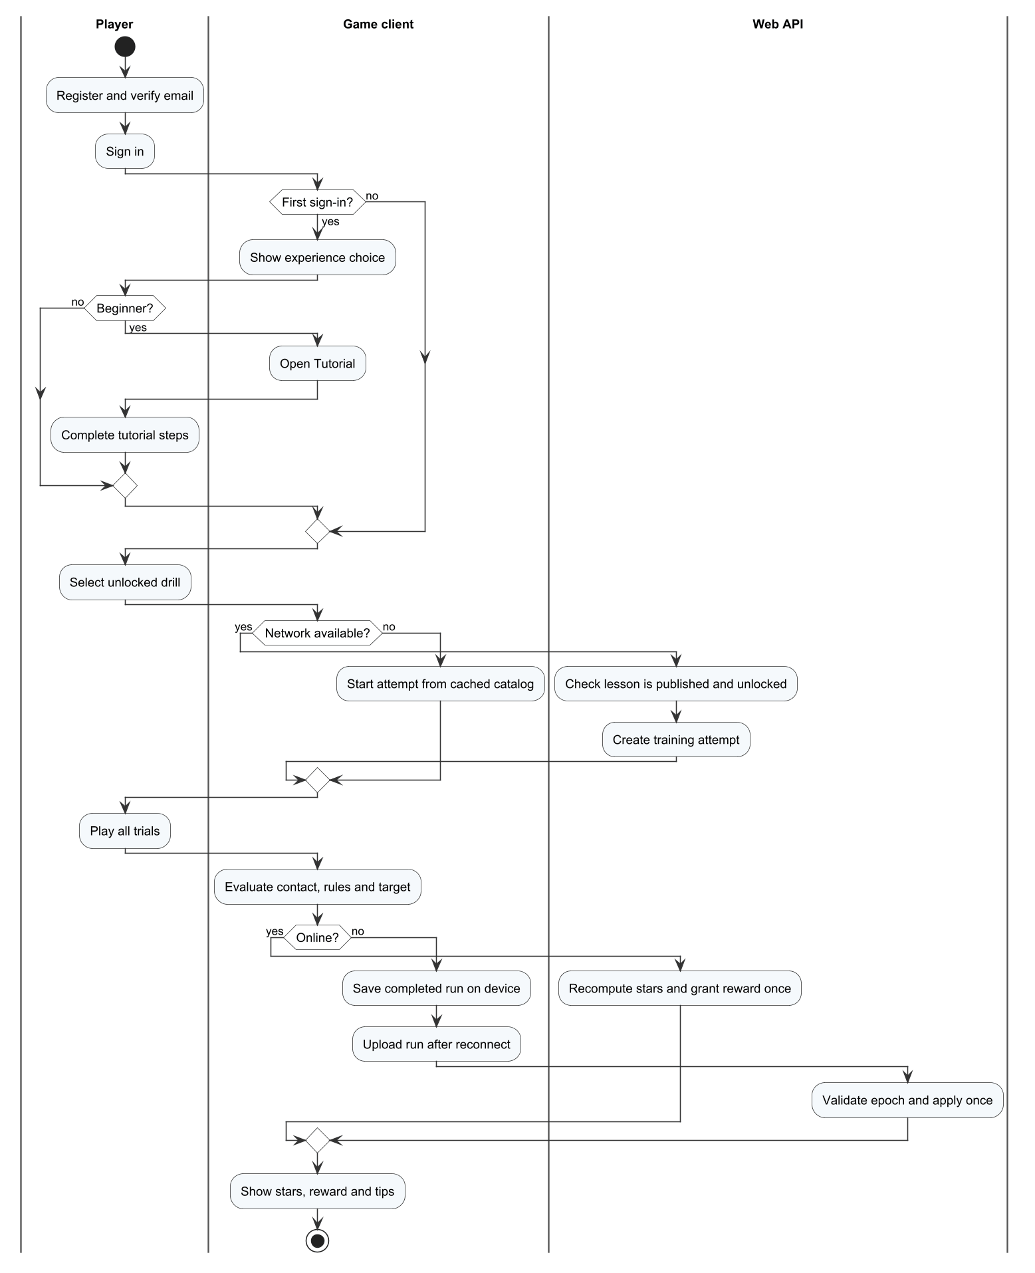
Figure 37. W01 – Learn and sync a drill (owner: Trần Nguyễn Hiếu Thuận)

W02 – Play a bot match and get a tip (owner: Nguyễn Gia Huy)
The player sets up a bot match and plays rallies until a side wins; the API settles the result, the AI service analyses the telemetry and the player reads the tip and opens the recommended drill.
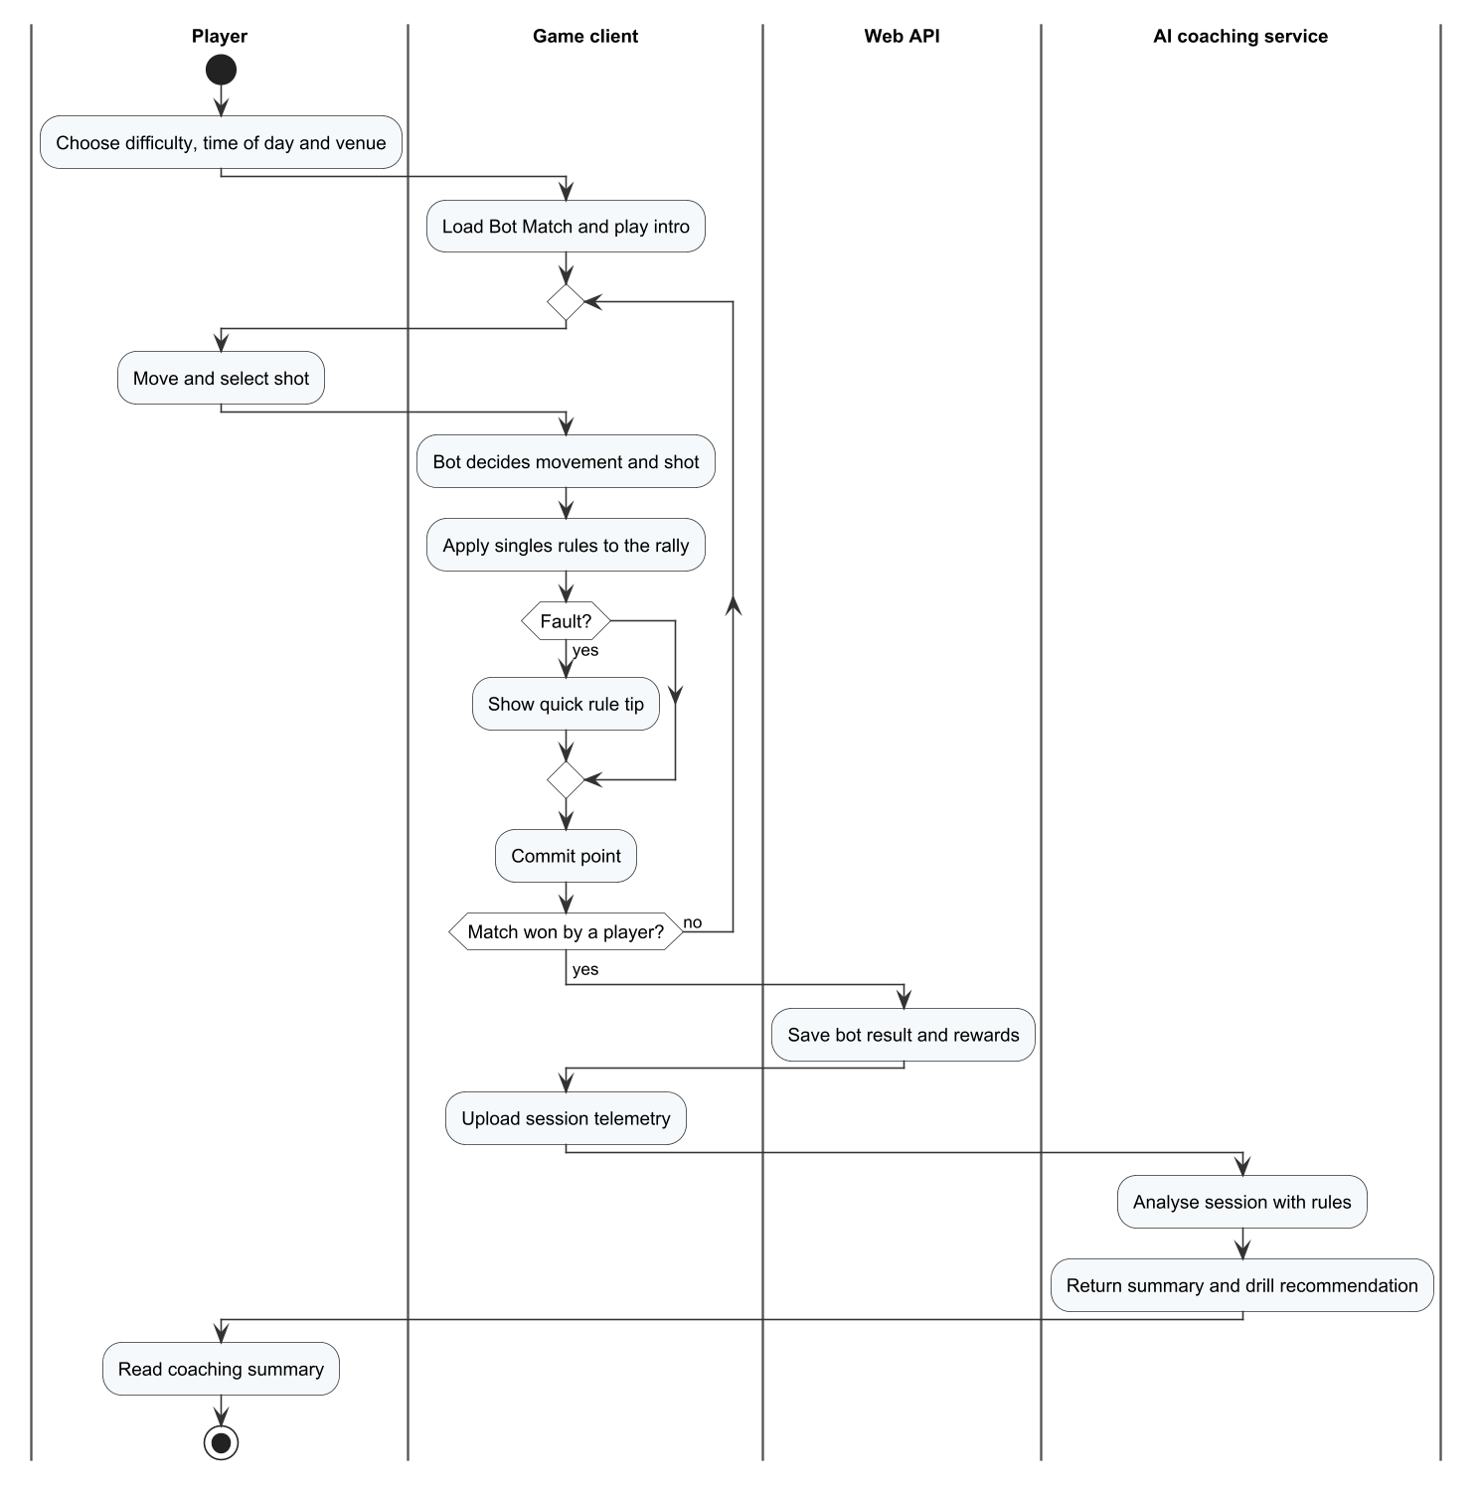
Figure 38. W02 – Play a bot match and get a tip (owner: Nguyễn Gia Huy)

W03 – Find and play an online match (owner: Nguyễn Văn Thành Đạt)
The player either creates a private room or searches a ranked match; the bot fallback applies after 180 seconds; all players must accept; the dedicated server runs the match unless it is stopped or the lease is lost.

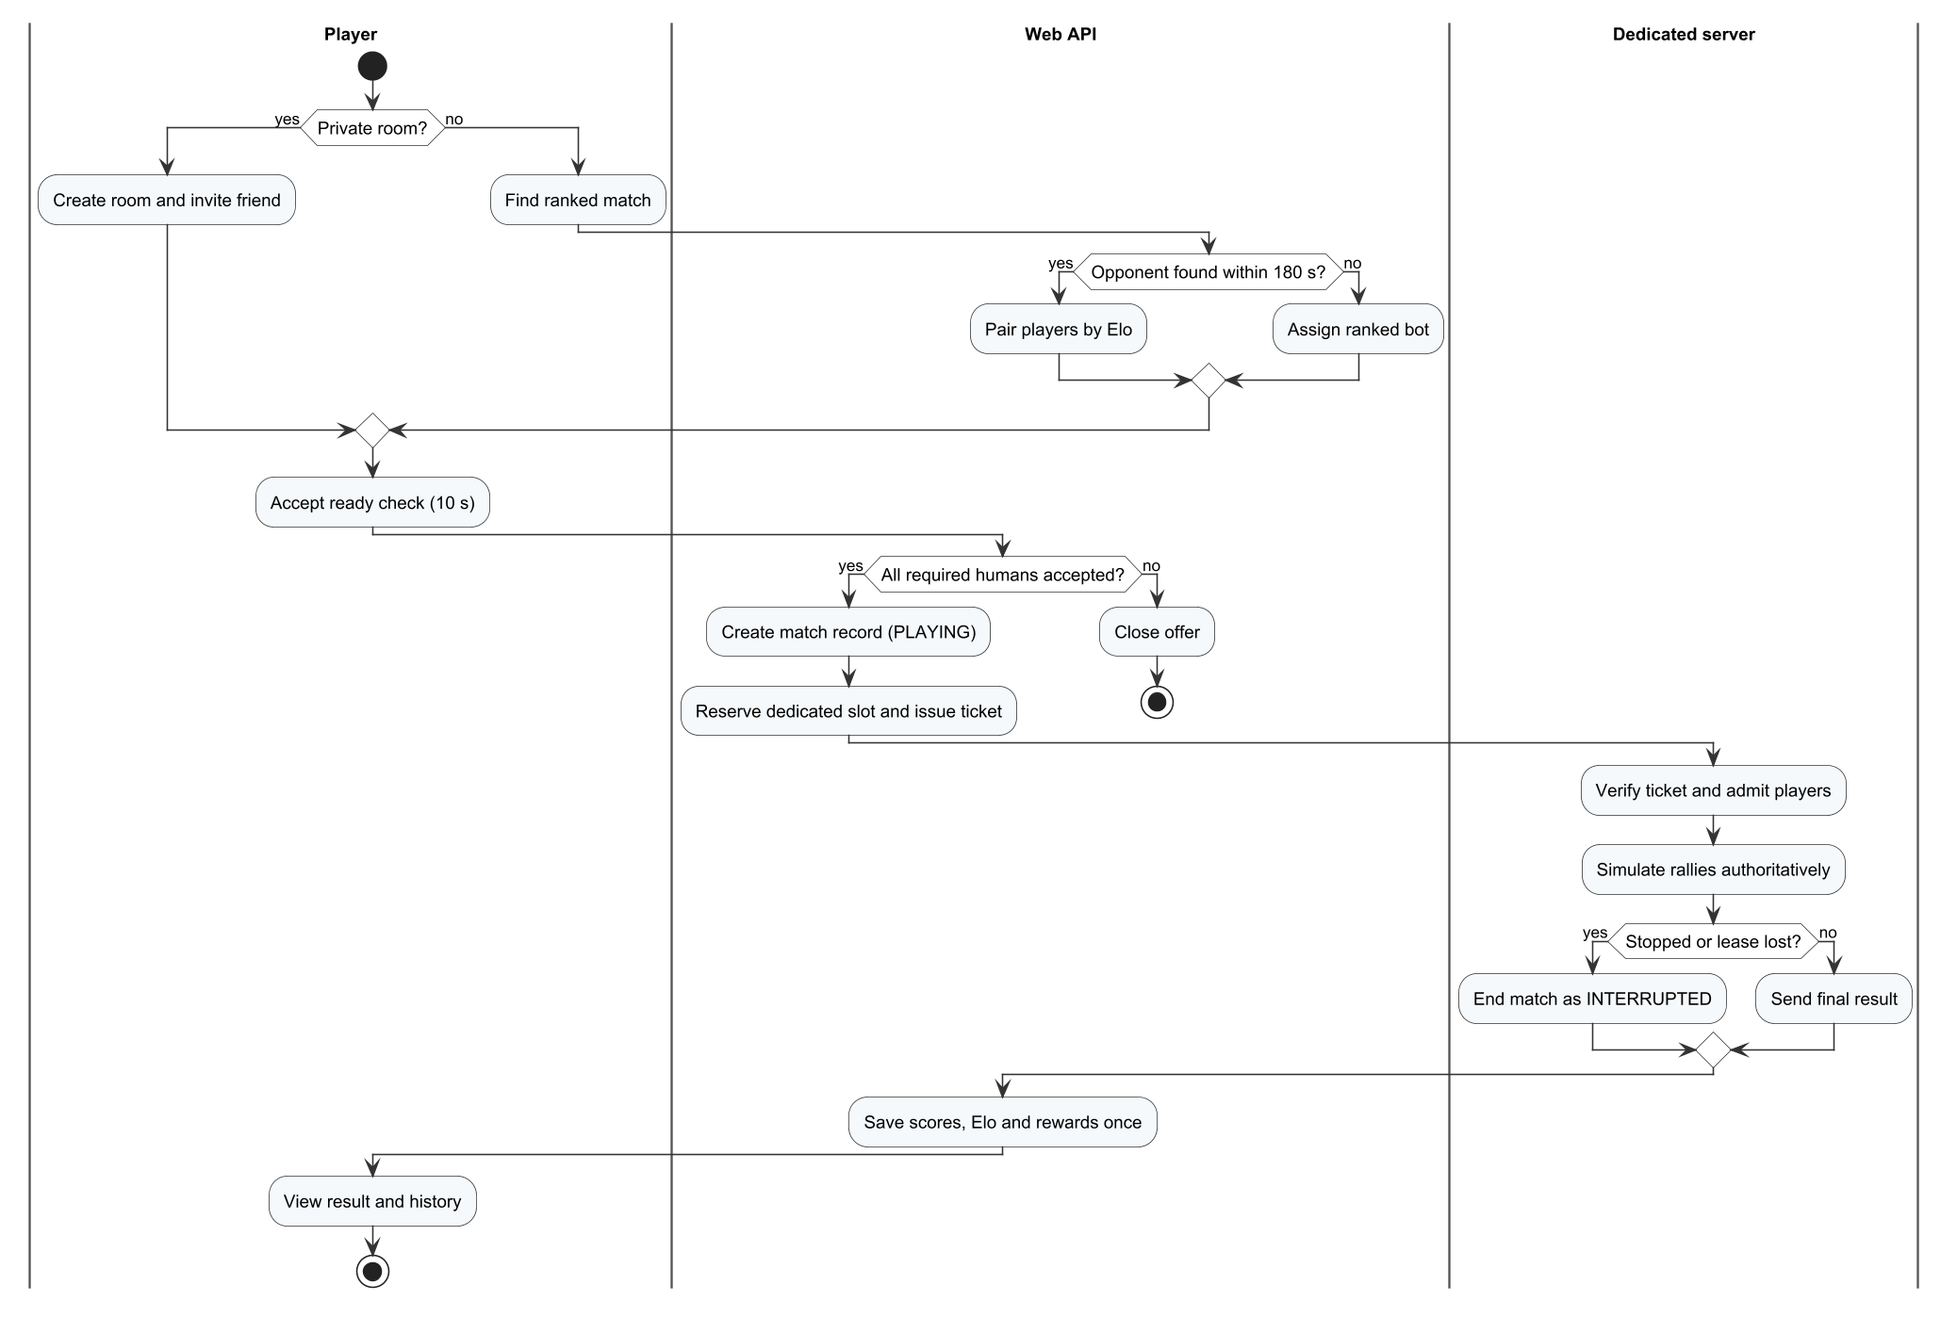
Figure 39. W03 – Find and play an online match (owner: Nguyễn Văn Thành Đạt)

W04 – Report, sanction and appeal (owner: Huỳnh Trung Kiên)
A player reports an opponent; the administrator reviews and may sanction; the restricted player may appeal; the administrator decides the appeal.

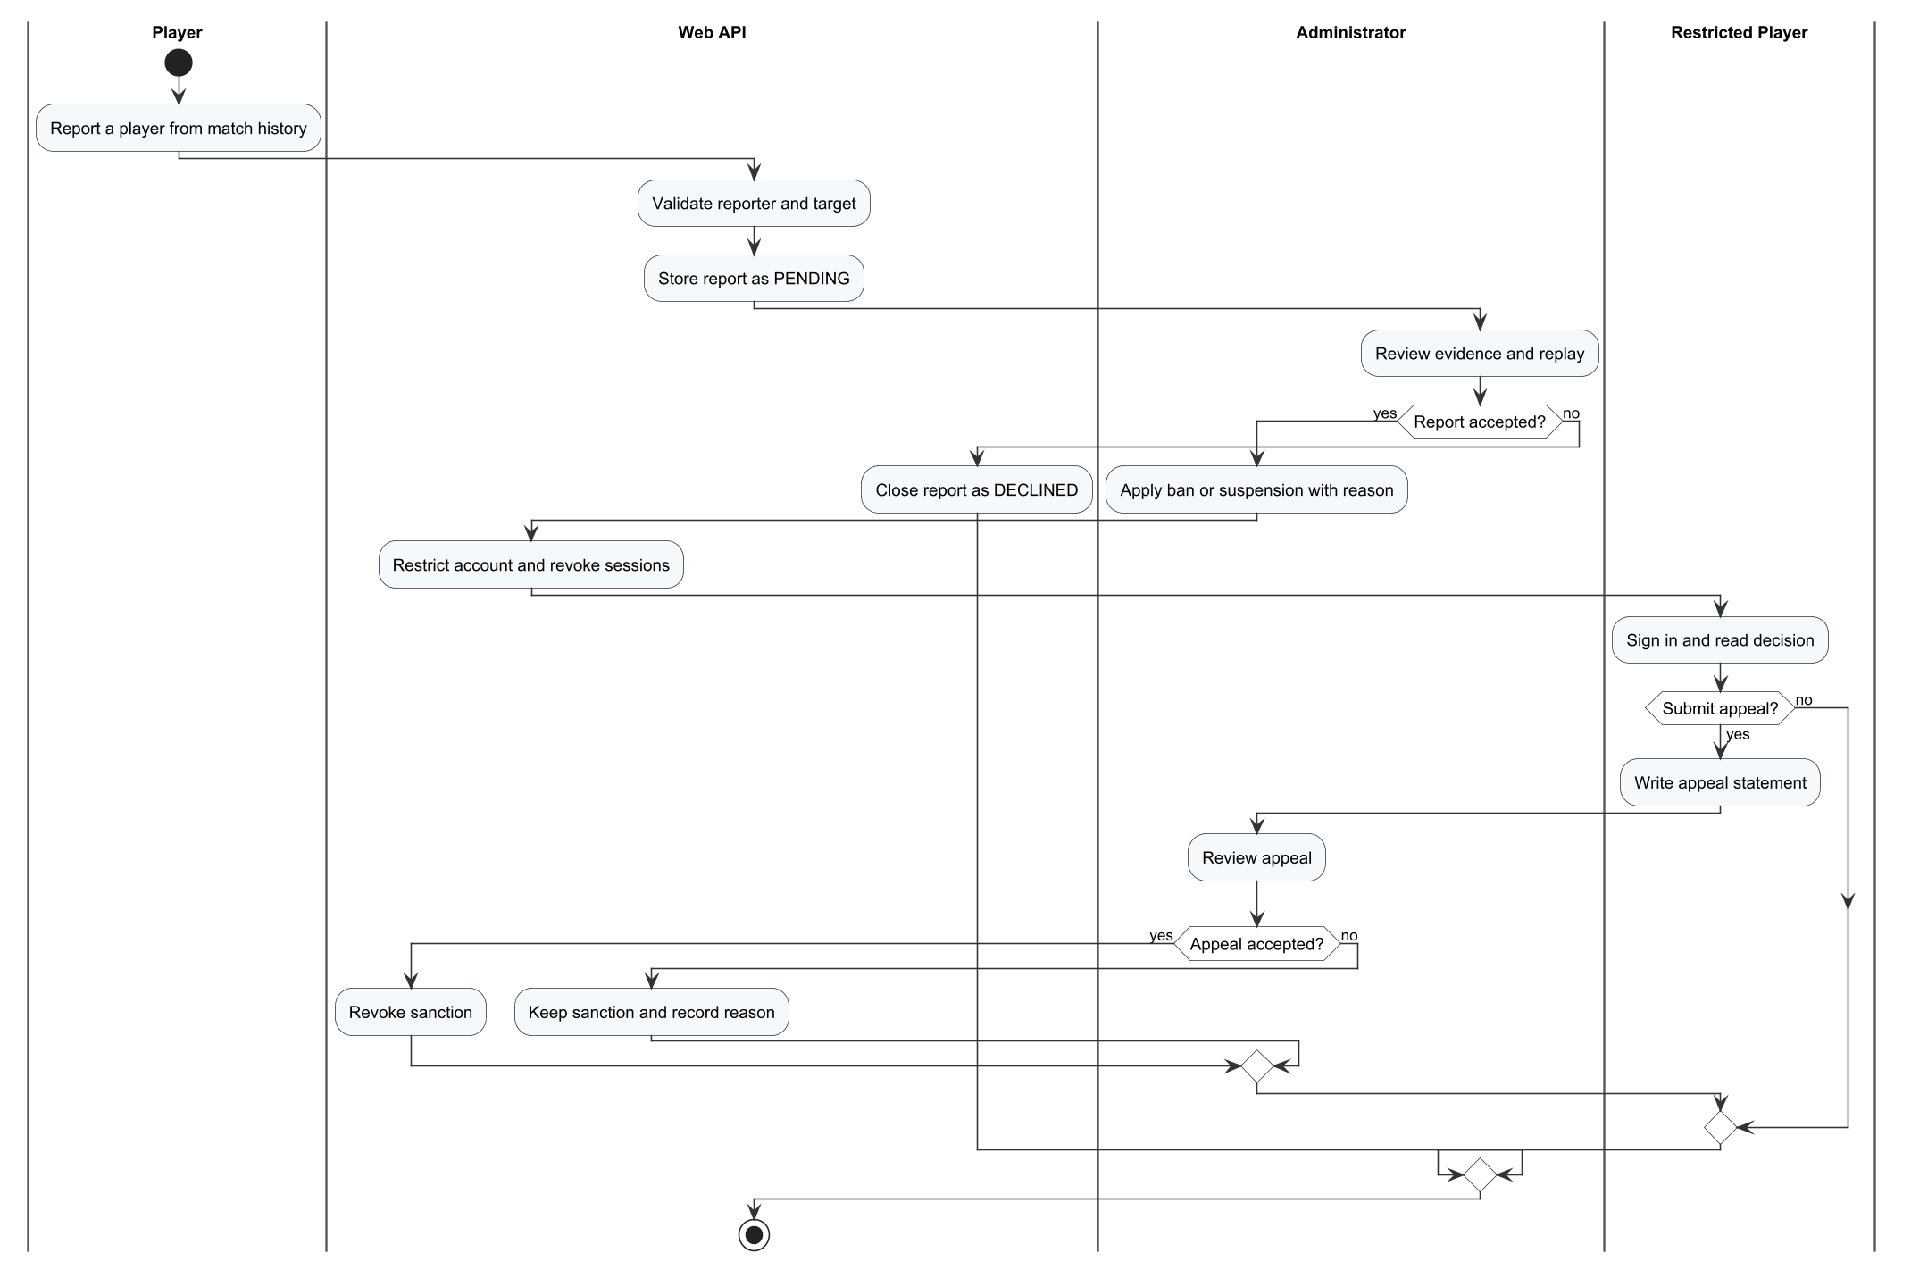
Figure 40. W04 – Report, sanction and appeal (owner: Huỳnh Trung Kiên)

Supporting workflow – publish training content
The administrator edits and publishes a lesson; the API checks the expected version and that prerequisites are published; clients receive the new catalogue version.
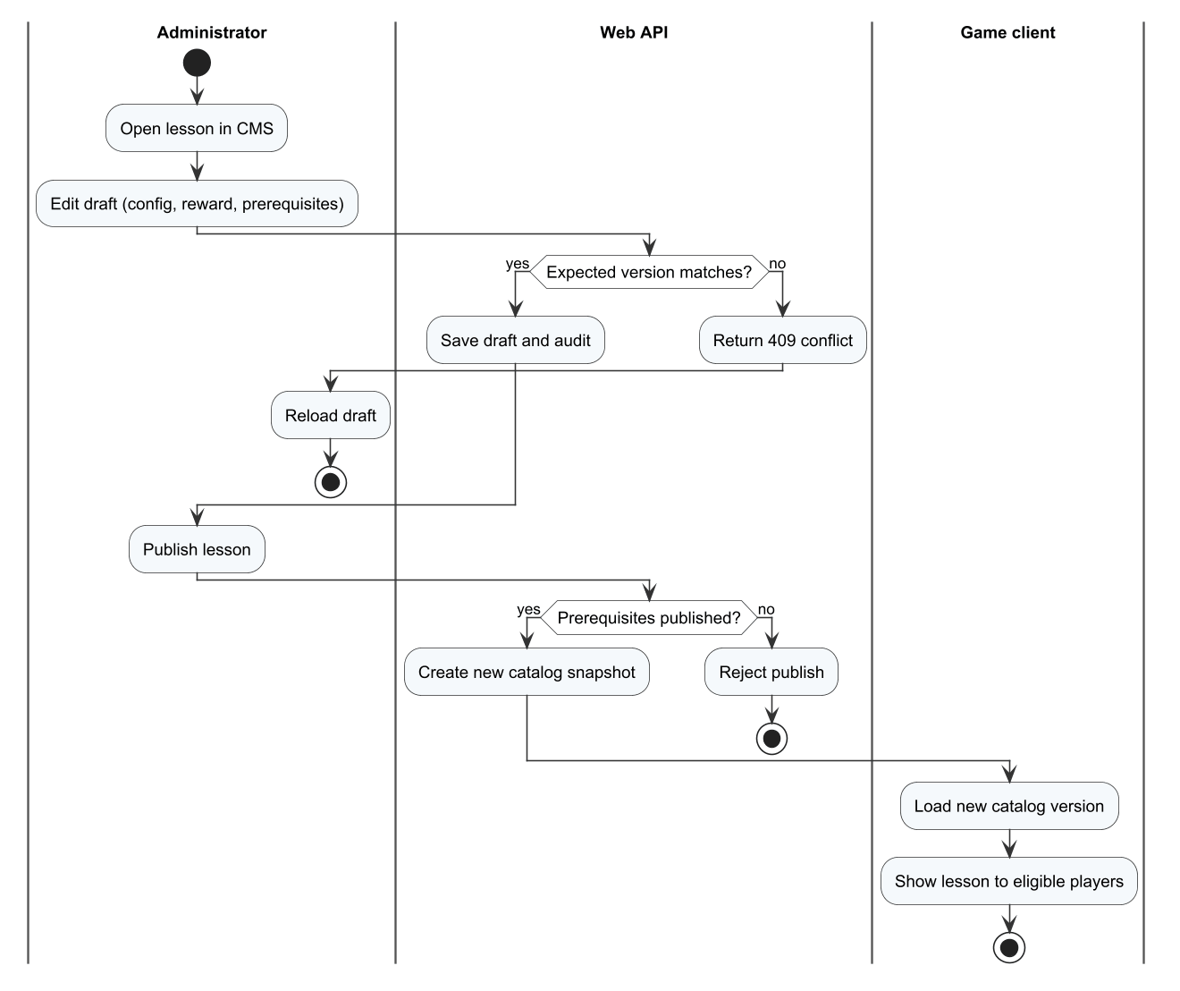
Figure 41. Supporting workflow – publish training content

4.2 State Machine Diagrams
The following state machines specify every entity or runtime object with a life cycle. Each transition is labelled event [guard] / action.

SM-01 Account status
ACTIVE, SUSPENDED and BANNED; suspensions end by expiry or revocation, and an accepted appeal revokes the sanction.
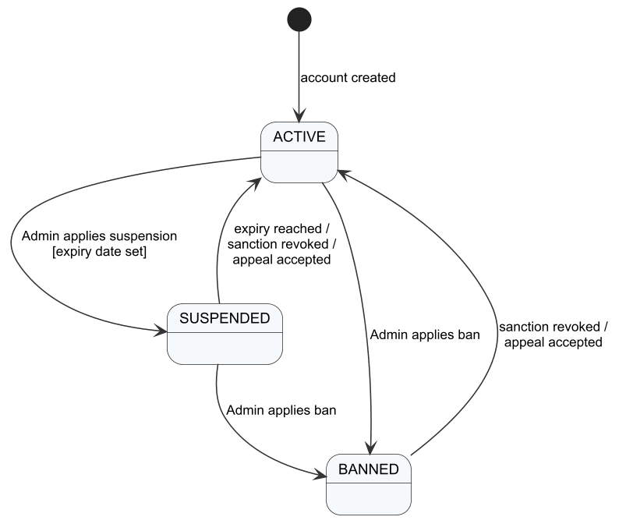
Figure 42. SM-01 Account status

SM-02 E-mail verification code
Pending, verified, expired and locked after 5 wrong attempts; a resend creates a new pending code.
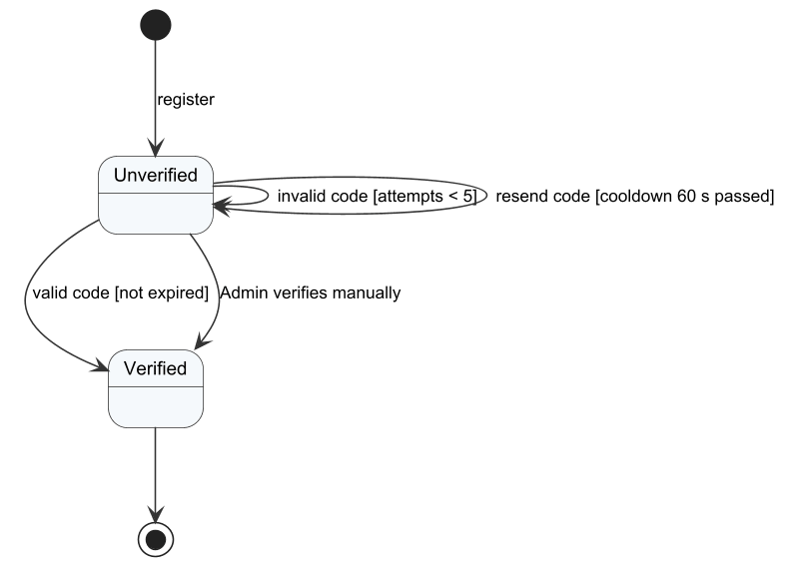
Figure 43. SM-02 E-mail verification code

SM-03 Training attempt and receipt
Briefing, practice, result; the receipt is APPLIED, DUPLICATE or REJECTED.
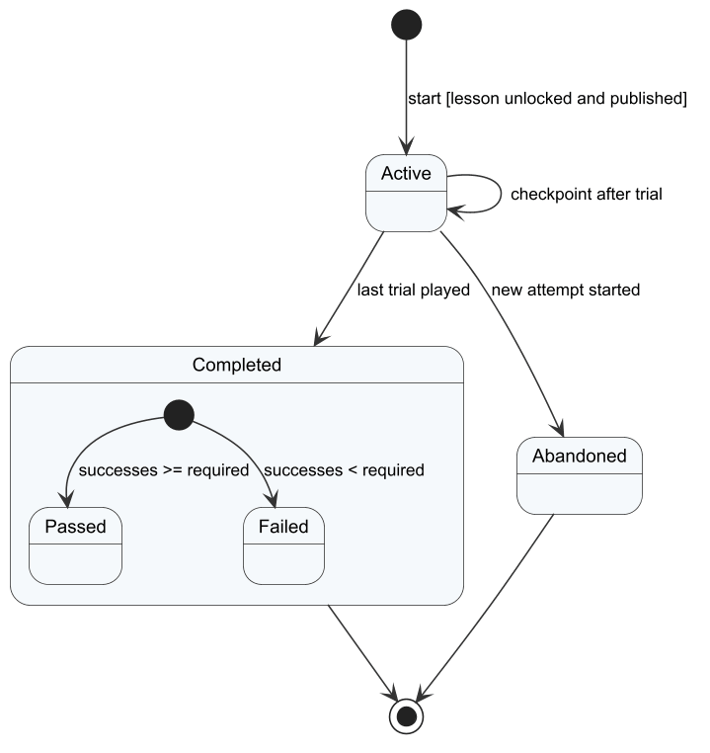
Figure 44. SM-03 Training attempt and receipt

SM-04 Offline queue item
Queued, sending, applied, duplicate or rejected; network failure returns the item to the queue.
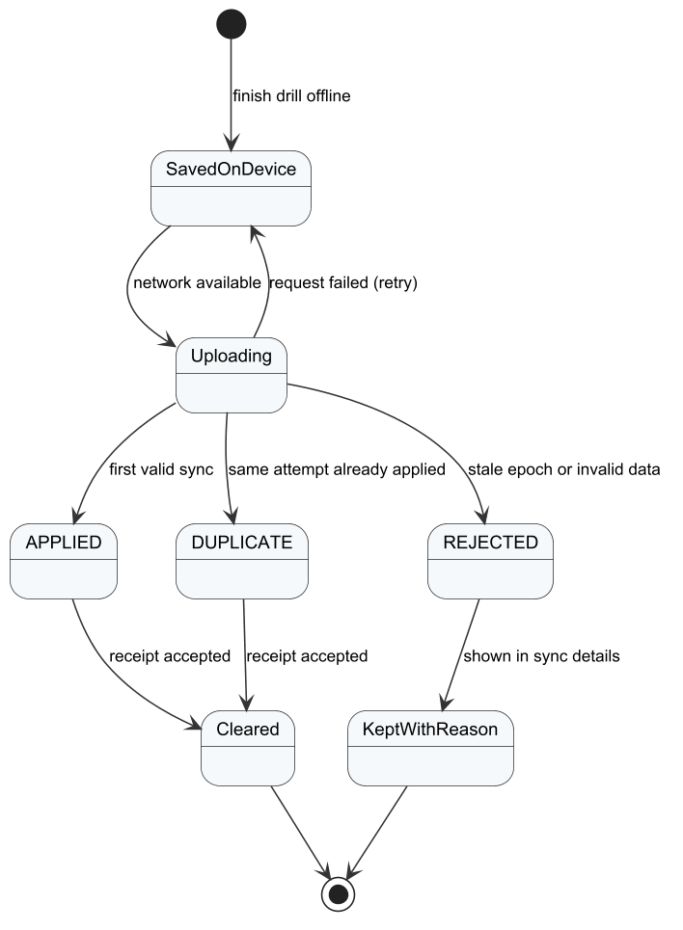
Figure 45. SM-04 Offline queue item

SM-05 Match phase (local match)
Intro, PreServe, Rally, Settling, BetweenPoints, BetweenGames, Timeout, MatchOver and Cinematic.
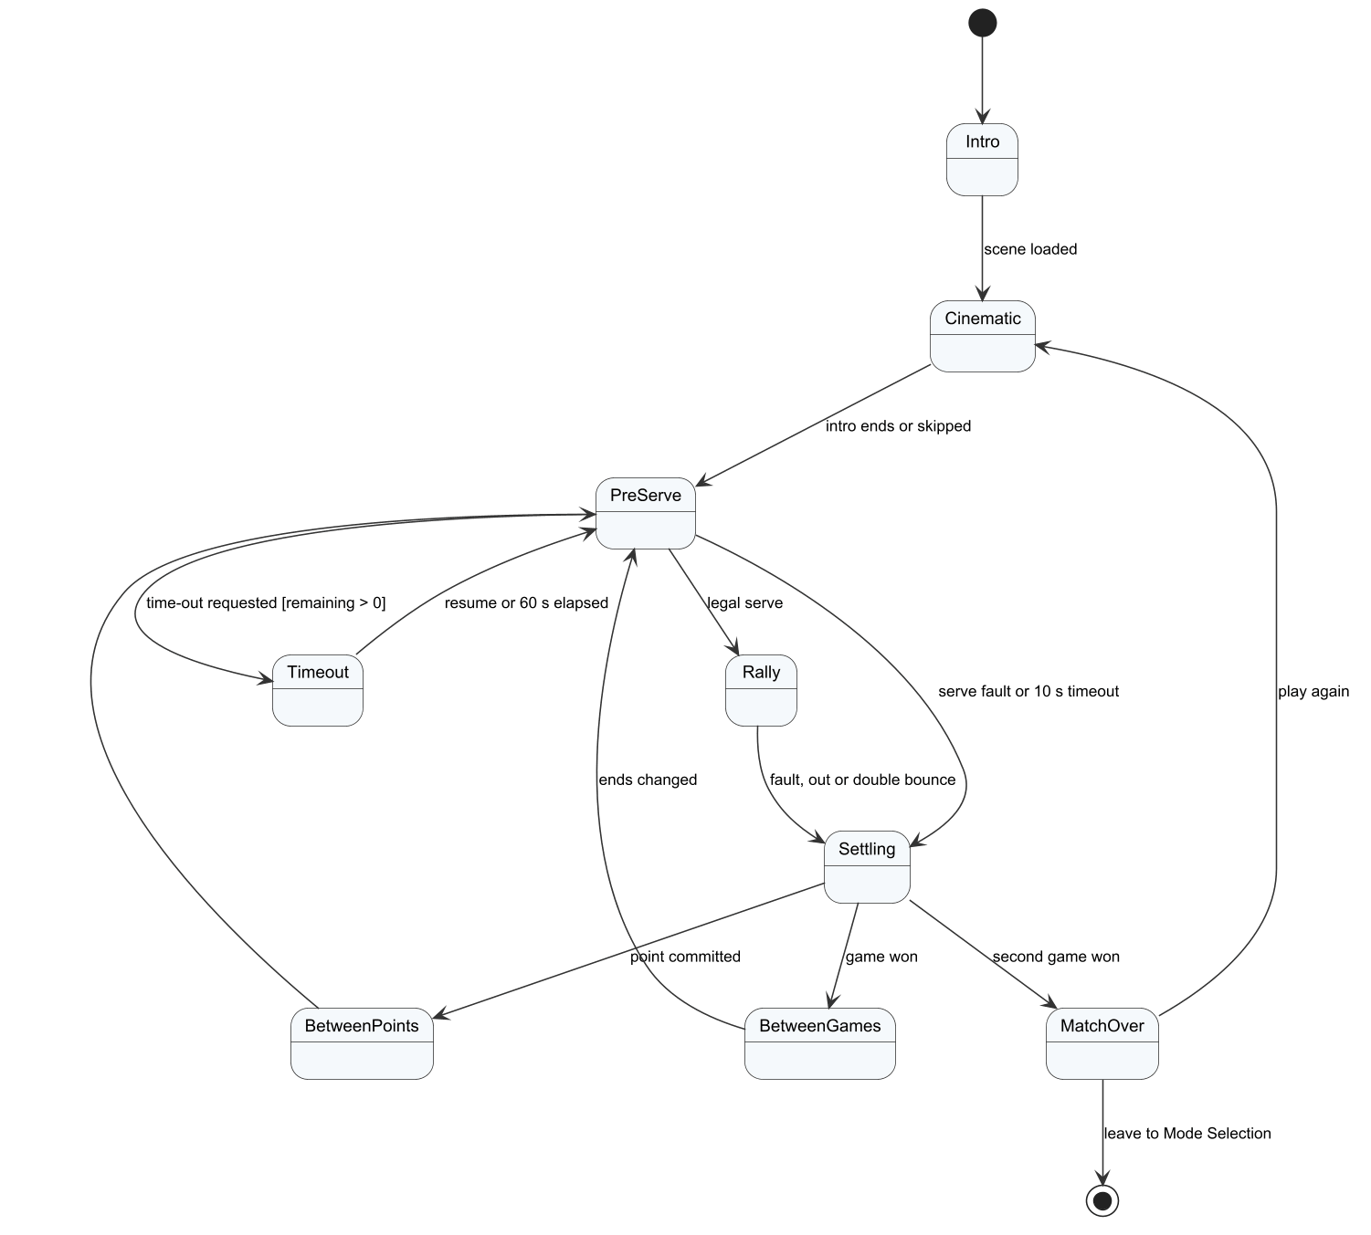
Figure 46. SM-05 Match phase (local match)

SM-06 Matchmaking search
SEARCHING ends in MATCHED, BOT (fallback), CANCELLED or TIMEOUT; a declined offer returns the other player to SEARCHING.
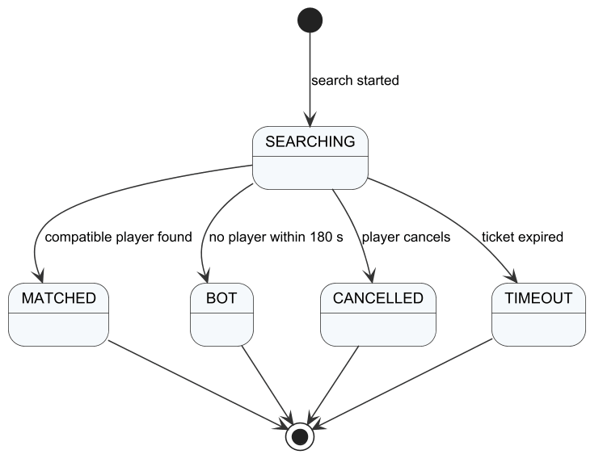
Figure 47. SM-06 Matchmaking search

SM-07 Online room phase
idle, searching, assigning-bot, ready, loading, playing, interrupted, closed and rejected.
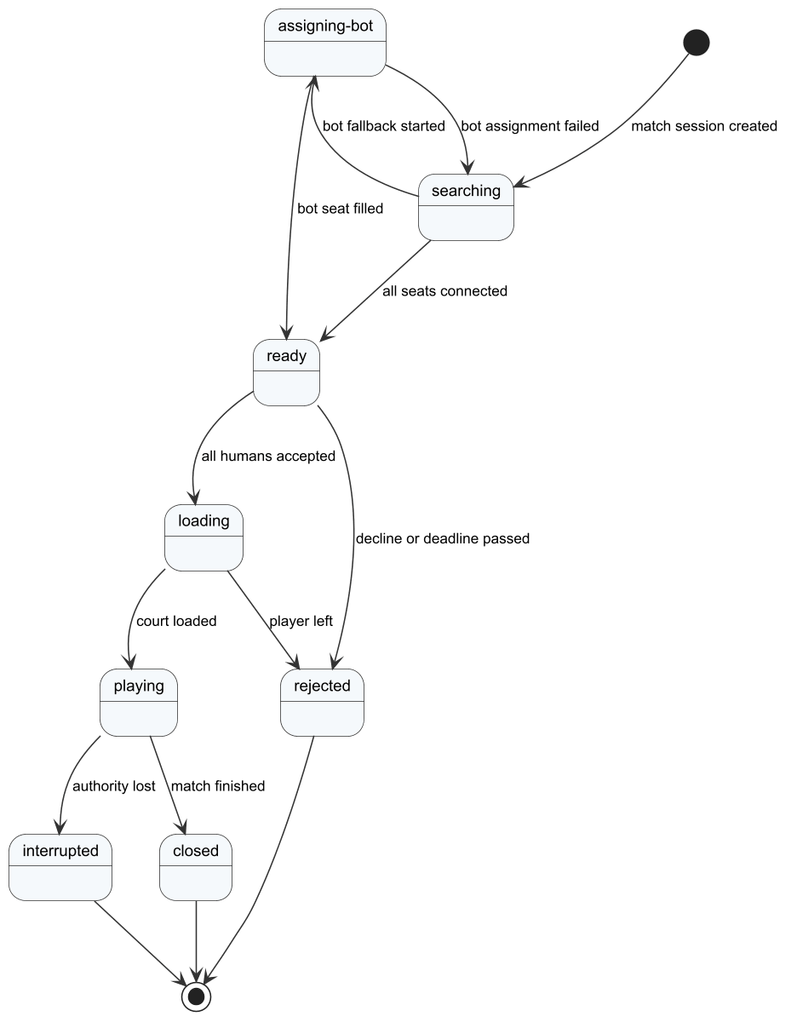
Figure 48. SM-07 Online room phase

SM-08 Game match
PREPARING, PLAYING, FINISHED and CANCELLED; interruption and administrator stop end the match without Elo.
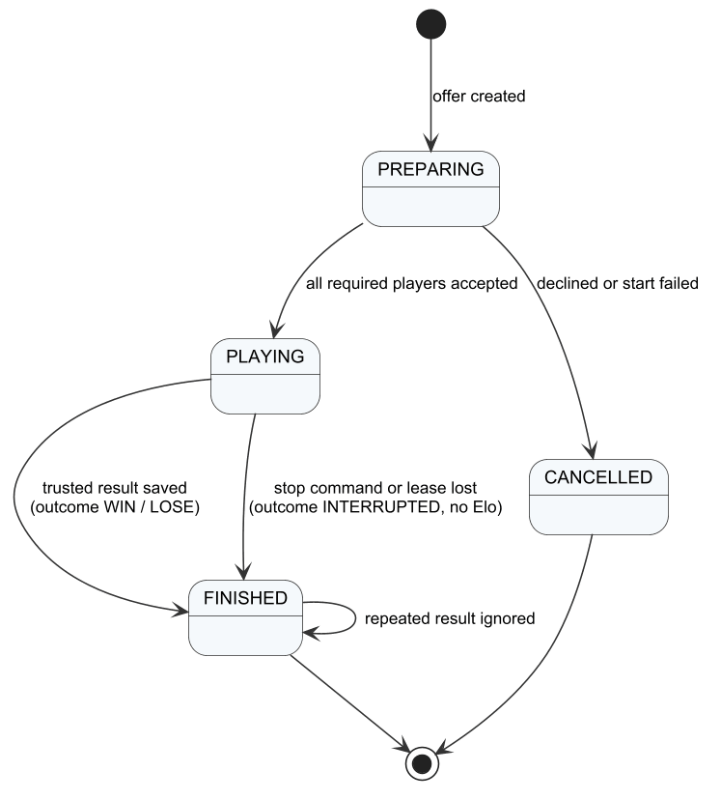
Figure 49. SM-08 Game match

SM-09 Dedicated server lease
queued, starting, ready, finishing, pending and busy; an expired lease releases the slot.
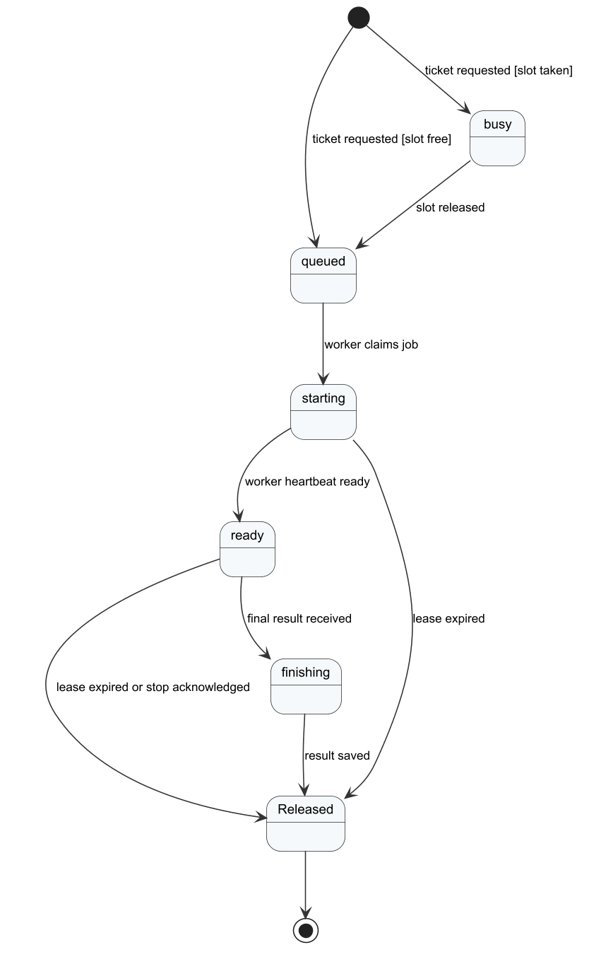
Figure 50. SM-09 Dedicated server lease

SM-10 Lesson publication
DRAFT, PUBLISHED and UNPUBLISHED.
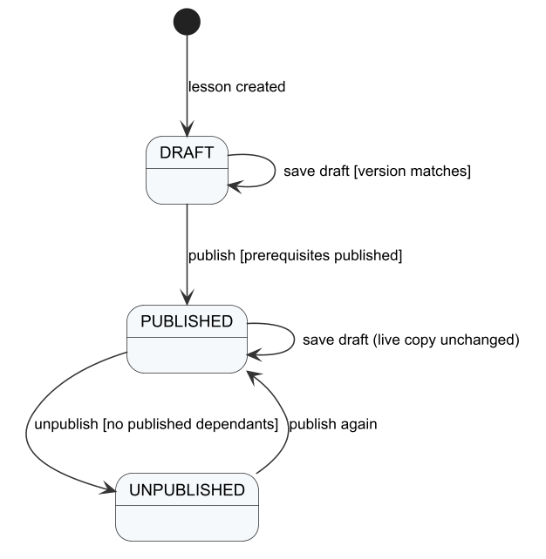
Figure 51. SM-10 Lesson publication

SM-11 Player report
PENDING, CHECKING, ACCEPTED and DECLINED.
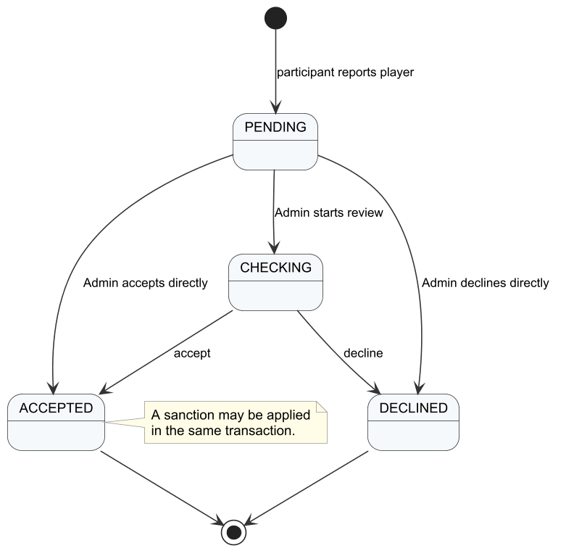
Figure 52. SM-11 Player report

SM-12 Sanction appeal
PENDING, CHECKING, ACCEPTED (sanction revoked) and DECLINED.
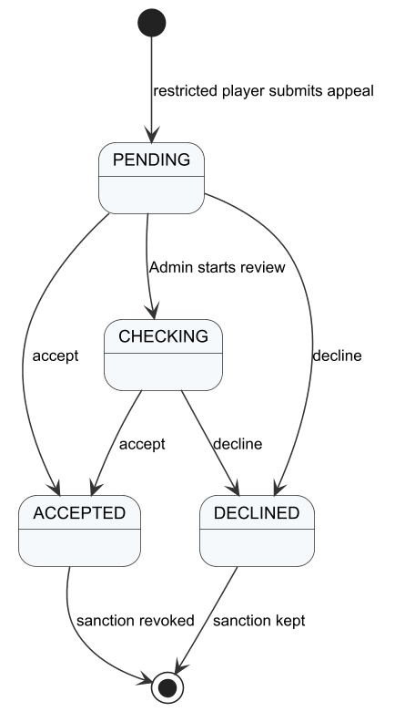
Figure 53. SM-12 Sanction appeal

SM-13 AI analysis job
pending, processing, completed and failed with retries.
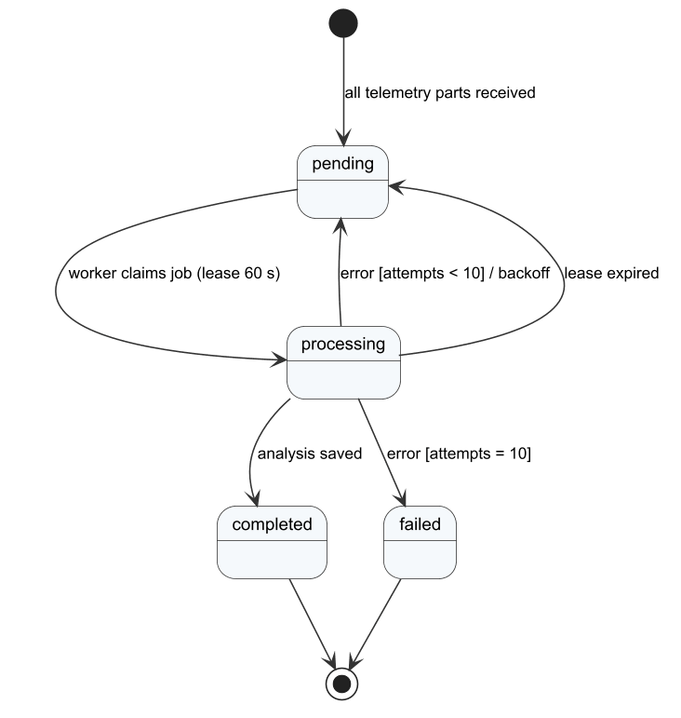
Figure 54. SM-13 AI analysis job

SM-14 Friend request
PENDING, ACCEPTED and DECLINED; blocking removes the friendship.
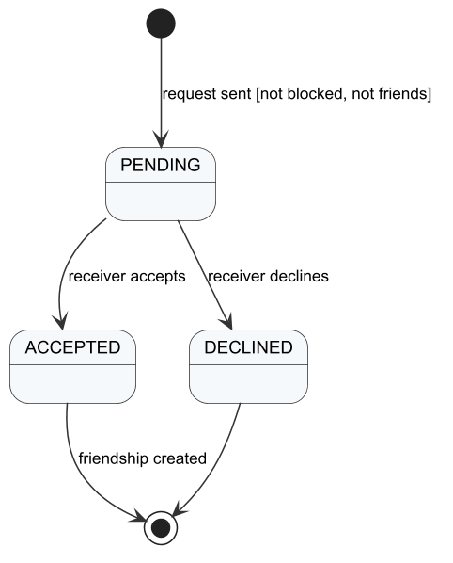
Figure 55. SM-14 Friend request

V. Software Testing Documentation

1. Scope of Testing
The target of test is PickleVerse release 1.0 as specified in Report 3: the ten features FE-01 to FE-10 with their functional requirements FR-01 to FR-33, the business rules BR-01 to BR-51, and the non-functional requirements NFR-01 to NFR-12. Testing covers the Unity game client (Windows build and Unity Editor), the dedicated game server, the Web API with its workers, the AI coaching service and the administration web application deployed on the staging server.
In scope. All screens and non-screen functions of Report 3, the gameplay rules and physics parameters of Report 4 §3.2, online matchmaking and dedicated play, data integrity of rewards and results, role-based access, and the measurable quality attributes NFR-01 to NFR-12.
Out of scope. iOS builds and real-money payment (Report 1, LI-02 and LI-06); load beyond the API capacity target, because the staging deployment has one dedicated-server slot (LI-07); third-party services themselves (Photon Cloud, Gmail SMTP), which are only tested through their integration points; and the tier model's accuracy until enough expert-labelled data exists (NFR-06).
Table 1. Test levels: responsibility, inputs, focus and exit criteria
Level | In charge | Inputs and time | Focus | Acceptance (exit) criteria
Unit | Each module owner; review by Trần Nguyễn Hiếu Thuận | Source code, BR-xx; before every merge | Rules, scoring, Elo, input decoding, economy, offline store, matchmaking policies (Unity EditMode, pytest) | All unit tests pass; every public rule method has at least one normal, abnormal and boundary case
Integration | Nguyễn Văn Thành Đạt | API build, Database.sql seed, PostgreSQL and Redis; each package milestone | API contracts, database writes, dedicated tickets and leases, training sync receipts, role and scope checks | All IntegrationChecks pass on a fresh database; no contract difference between Unity, API and AI service
System | Trần Nguyễn Hiếu Thuận with the feature owners | Staging deployment, test accounts and seed data; Rounds 1–3 (§3.3) | Every FR through the user interface, state transitions, NFR measurements | ≥ 90% of system cases passed, all FRs covered by a passed case, no open Critical/High defect
Acceptance | Huỳnh Trung Kiên with the supervisor | Release candidate, demo scenarios W01–W04 | End-to-end workflows of the four members | All four workflows pass in front of the supervisor

Constraints and assumptions.
• The staging server runs one dedicated-server container, so online cases that need two simultaneous matches cannot be executed.
• The CI pipeline builds the dedicated server with GameCI and a Unity licence but does not yet run the Unity tests; until a test step is added, they are run with the Unity CLI on a team PC and the result file is stored with the commit hash.
• Tests that need several players (rooms, friends, reports) require two or more accounts and devices at the same time.
• A dedicated test mailbox and seed accounts (for example a player at level 24 or with 9 passed lessons) must be added to Database.sql before Round 2.
• The Photon free plan limits concurrent users; group playtests are scheduled so that the limit is not reached.

2. Test Strategy

2.1 Testing Types
Table 2. Testing types
Type | Objective | Technique | Completion criteria
Functional | Verify every FR and BR | Black-box: equivalence partitions and boundary values from BR-xx; decision tables for scoring and Elo | Each FR has ≥ 1 passed case; all Main cases passed
Gameplay rules and physics | Verify serve, faults, scoring, contact timing and bounce | Automated EditMode tests on the engine-independent rule classes; scripted rallies | All rule tests pass; every fault type has a test
User interface and usability | Verify layout, messages and learnability | Checklist per screen against Report 3 §3.1 and the message list; moderated usability test (NFR-01) | No overlapping or truncated elements; NFR-01 met
Integration / API contract | Verify API, database and service contracts | IntegrationChecks console harness on a fresh database; shared JSON fixtures in contracts/ | All checks pass on the release commit
Security | Verify authentication, authorisation and secret handling | Negative API tests with wrong roles and scopes, token expiry, rate limit; secret scan | NFR-09 checklist satisfied; no secret in the repository
Performance and load | Verify NFR-02 to NFR-05 | Unity Profiler on reference devices; Fusion RTT statistics; k6 load test on the API | All measured values within the NFR limits
Network resilience | Verify reconnection and interruption | Disconnect a client for 20 s and 60 s; drop the dedicated server heartbeat | Behaviour matches BR-28 and BR-29
Compatibility | Verify target platforms | Install and smoke test on Windows 10/11 and Android 8+ (ARM64); admin web on Chrome and Edge | NFR-10 met
AI quality | Verify coaching findings and the gated model | Holdout evaluation against expert labels | NFR-06 thresholds met, otherwise the model stays disabled
Exploratory playtest and balance | Find defects that scripted cases miss; tune bot difficulty | Time-boxed sessions with a charter; win rate of players of known level against each bot level | Each session logged; balance targets agreed with the supervisor
Regression | Keep fixed defects fixed | Re-run the automated suites and the cases linked to closed defects in every round | No reopened defect

2.2 Test Levels
Table 3. Test types per level
Type of Tests | Unit | Integration | System | Acceptance
Functional | X | X | X | X
Gameplay rules and physics | X |  | X | X
User interface and usability |  |  | X | X
Integration / API contract |  | X
Security | X | X | X
Performance and load |  | X | X
Network resilience | X |  | X
Compatibility |  |  | X | X
AI quality | X |  | X
Exploratory playtest and balance |  |  | X | X
Regression | X | X | X

2.3 Supporting Tools
Table 4. Supporting tools
Purpose | Tool | Vendor/In-house | Version
Unity unit tests (EditMode, NUnit) | Unity Test Framework | Unity Technologies | 1.8.0
Run tests and capture screens from the command line | Unity CLI with the Pipeline package | Unity Technologies | CLI 1.0.0-beta.17, Pipeline 0.9.0-exp.1
Python unit tests | pytest (with httpx) | Open source | 8.x
API and database integration checks | IntegrationChecks console harness | In-house | main @ 7f8ee32
Manual API calls | Swagger UI | Swashbuckle (open source) | 10.3.1
API load test (NFR-04) | k6 | Grafana Labs (open source) | latest stable, planned
Frame-rate measurement | Unity Profiler | Unity Technologies | 6000.6.2f1
Network statistics | Photon Fusion statistics and dashboard | Exit Games | Fusion 2.1.3
Test case and result management | Microsoft Excel (Report5 workbooks) | Microsoft | Microsoft 365
Continuous integration | GitHub Actions (validate job) | GitHub | Hosted runner

3. Test Plan

3.1 Human Resources
Table 5. Human resources
Worker/Doer | Role | Specific Responsibilities/Comments
Trần Nguyễn Hiếu Thuận | Test lead | Owns the test plan and workbooks; runs system rounds; tracks defects; tests the account, onboarding, offline and social screens (F01, F02, F12, F14); owner of workflow W01
Nguyễn Gia Huy | Tester, gameplay owner | Unit tests of rules, physics, training and bot; playtests and balance sessions; runs the Unity EditMode suite; F03, F05, F11, F13; owner of workflow W02, support for W01 and W03
Nguyễn Văn Thành Đạt | Tester, backend and network owner | IntegrationChecks, API security and load tests, online and dedicated cases (F04, F06–F10); owner of workflow W03, support for W02
Huỳnh Trung Kiên | Tester, leader | Admin web cases (F15–F18), acceptance session with the supervisor, release decision; owner of workflow W04
Mr. Lại Đức Hùng | Supervisor | Witnesses the acceptance scenarios and approves the release criteria

3.2 Test Environment
Table 6. Test environment
Purpose | Tool | Provider | Version
Staging server | Ubuntu with Docker Engine and Docker Compose (API, AI service, dedicated server, PostgreSQL, Redis, S3 storage, web) | Team VPS tad-min.io.vn | Ubuntu 24.04; images of main
Game client under test | Unity Editor and Windows build | Unity Technologies | 6000.6.2f1
Test PC | Windows PC with keyboard and mouse | Team member | Windows 11 Home
Android device | Android phone (ARM64) for NFR-03 and NFR-10 | Team member | Android 8.0 or later (to be recorded in Round 2)
Real-time service | Photon Cloud | Exit Games | Fusion 2.1.3
Database and cache | PostgreSQL, Redis | Docker images (pinned digests) | 16 / 7.4
Admin web browser | Google Chrome, Microsoft Edge | Google, Microsoft | Latest stable

3.3 Test Milestones
Table 7. Test milestones
Milestone Task | Start Date | End Date
Round 1 – automated suites and first system pass on staging | 09/11/2026 | 13/11/2026
Prepare seed accounts, test mailbox and analytics seed | 16/11/2026 | 18/11/2026
Round 2 – all system cases; fix verification of D-01 to D-18 | 16/11/2026 | 27/11/2026
Usability test with 10 students (NFR-01) | 23/11/2026 | 27/11/2026
Load, latency and frame-rate measurements (NFR-02 to NFR-05) | 23/11/2026 | 29/11/2026
Uptime probe for NFR-07 (14 days) | 30/11/2026 | 13/12/2026
Round 3 – regression on the release candidate | 30/11/2026 | 06/12/2026
Acceptance test W01–W04 with the supervisor | 07/12/2026 | 11/12/2026

4. Test Cases
Unit test cases are documented in Report5_Unit Test.xlsx as decision tables (conditions, confirmations, type N/A/B and result for each UTCID) for ten core functions, each mapped to the NUnit test that implements it. Integration, system and acceptance test cases are documented in Report5_Test Report.xlsx, one sheet per feature group, with ID, description, procedure with concrete data, expected result, pre-conditions, three test rounds and a note that names the evidence or the reason why a case is pending.
The number of cases follows the Review 2 formula: 18 committed features × 3 cases (54) + 4 workflows + 42 state transitions (three per state machine SM-01 to SM-14) + 12 NFRs = 112 cases. Five cases are added: two for the expert review tool (FE-10), which is not in the Review 2 feature list, and three for FR-03 to FR-05, which the Review 2 feature F01 did not detail, giving 117 cases.
Table 8. Test cases by sheet and level
Sheet | Scope | Cases | Unit | Integration | System | Acceptance | Automated
FE01 Account | FE-01 Account and onboarding | 6 | 1 | 0 | 5 | 0 | 1
FE02 Training | FE-02 Tutorial, training and offline | 9 | 4 | 0 | 5 | 0 | 4
FE03 Bot | FE-03 Bot practice | 3 | 2 | 0 | 1 | 0 | 2
FE04 Online | FE-04 Online matches | 12 | 8 | 0 | 4 | 0 | 8
FE05 Coaching | FE-05 AI coaching | 3 | 1 | 0 | 2 | 0 | 1
FE06 Progress | FE-06 Progress, rewards and shop | 6 | 4 | 0 | 2 | 0 | 4
FE07 Social | FE-07 History, social and ranking | 6 | 2 | 1 | 3 | 0 | 2
FE08-09 Admin | FE-08/FE-09 Moderation and administration | 12 | 1 | 1 | 10 | 0 | 1
FE10 Expert | FE-10 Expert review | 2 | 0 | 0 | 2 | 0 | 0
Workflows | End-to-end workflows W01–W04 | 4 | 0 | 0 | 0 | 4 | 0
States | State transitions SM-01 to SM-14 | 42 | 11 | 27 | 4 | 0 | 11
NFR | Non-functional requirements | 12 | 0 | 0 | 12 | 0 | 0
Total |  | 117 | 34 | 29 | 50 | 4 | 34

4.1 Requirement Traceability
Table 9. Traceability from functional requirements to test cases
Requirement | Test cases | Cases | Passed | Coverage status
FR-01 | TC-F01-01, TC-F01-03, TC-W01 | 3 | 1 | Covered
FR-02 | TC-F01-01, TC-F01-02 | 2 | 1 | Covered
FR-03 | TC-F01-04 | 1 | 0 | Not yet covered
FR-04 | TC-F01-05 | 1 | 0 | Not yet covered
FR-05 | TC-F01-06 | 1 | 1 | Covered
FR-06 | TC-F02-01, TC-F02-02, TC-W01 | 3 | 1 | Covered
FR-07 | TC-F03-01, TC-F03-03 | 2 | 2 | Covered
FR-08 | TC-F03-01, TC-F03-02, TC-W01 | 3 | 2 | Covered
FR-09 | TC-F14-01, TC-F14-02, TC-F14-03, TC-F06-03, TC-W01 | 5 | 2 | Covered
FR-10 | TC-F11-01 | 1 | 1 | Covered
FR-11 | TC-F02-03 | 1 | 1 | Covered
FR-12 | TC-F05-01, TC-F05-03, TC-F09-02 | 3 | 3 | Covered
FR-13 | TC-F05-01, TC-F05-02, TC-F05-03, TC-W02 | 4 | 4 | Covered
FR-14 | TC-F07-01, TC-F07-02, TC-F07-03, TC-F10-02, TC-W03 | 5 | 4 | Covered
FR-15 | TC-F08-01, TC-F08-02, TC-F08-03 | 3 | 2 | Covered
FR-16 | TC-F09-01, TC-F09-02, TC-W03 | 3 | 2 | Covered
FR-17 | TC-F09-03 | 1 | 0 | Not yet covered
FR-18 | TC-F09-01, TC-F10-01, TC-F10-02, TC-F10-03, TC-W02, TC-W03 | 6 | 5 | Covered
FR-19 | TC-F06-01, TC-F06-02, TC-F06-03, TC-W02 | 4 | 3 | Covered
FR-20 | TC-F04-03 | 1 | 0 | Not yet covered
FR-21 | TC-F13-01, TC-F13-02, TC-F13-03 | 3 | 3 | Covered
FR-22 | TC-F04-01 | 1 | 1 | Covered
FR-23 | TC-F04-02 | 1 | 1 | Covered
FR-24 | TC-F11-02, TC-F11-03 | 2 | 1 | Covered
FR-25 | TC-F12-01, TC-F12-02 | 2 | 1 | Covered
FR-26 | TC-F12-03 | 1 | 1 | Covered
FR-27 | TC-F17-01, TC-W04 | 2 | 0 | Not yet covered
FR-28 | TC-F17-03, TC-W04 | 2 | 0 | Not yet covered
FR-29 | TC-F15-01, TC-F15-02, TC-F15-03 | 3 | 0 | Not yet covered
FR-30 | TC-F17-01, TC-W04 | 2 | 0 | Not yet covered
FR-31 | TC-F16-01, TC-F16-02, TC-F16-03 | 3 | 1 | Covered
FR-32 | TC-F17-02, TC-F18-01, TC-F18-02, TC-F18-03 | 4 | 0 | Not yet covered
FR-33 | TC-X01-01, TC-X01-02 | 2 | 0 | Not yet covered

23 of the 33 functional requirements are covered by at least one passed case after Round 1. NFR-01 to NFR-12 are traced one-to-one to TC-N01 to TC-N12.

5. Test Reports

5.1 Evidence
Table 10. Test evidence
ID | Run | Date | Build / commit | Result | Location
EV-01 | Unity EditMode suite through the Unity CLI (Pipeline test run) | 11/11/2026 | main @ 7f8ee32 | 515 tests, 515 passed, 0 failed, 6.19 s | Doc/Project_report/Report/evidence/editmode_results_20261111.json
EV-02 | Playtest on the staging server (offline training, signed-in menu, bot match, AI coaching, ranked 1v1 with bot fallback) | 10/11/2026 | main @ 82f6a7a client; staging images of 06/11/2026 | See Report5_Test Report.xlsx | screenshots/01–28, evidence/playtest_log_20261110.md
EV-03 | UI check of the register, verification, password-reset screens and the tutorial | 11/11/2026 | main @ 7f8ee32 | See TC-F01-03, TC-F02-01 | screenshots/29–34
EV-04 | Match history of the team test accounts (two ranked 1v1 attempts) | 09/11/2026 | staging | Both interrupted | screenshots/12_history.png
EV-05 | Team-recorded IntegrationChecks on disposable PostgreSQL databases (12 areas) | 06/11/2026 | df5f671 | Reported as passed; logs not in the repository, so not counted | Review3_Evidence.md (file names and SHA-256)

5.2 Unit Test Results
Table 11. Unity EditMode results by assembly (EV-01)
Test assembly | Tests | Passed | Failed
Audio.Tests | 23 | 23 | 0
FrontEnd.Tests | 4 | 4 | 0
HybridBot.Tests | 14 | 14 | 0
LocalMatch.Tests | 157 | 157 | 0
Multiplayer.Tests | 101 | 101 | 0
Progression.Tests | 125 | 125 | 0
Replays.Tests | 16 | 16 | 0
Services.Tests | 31 | 31 | 0
Shop.Tests | 33 | 33 | 0
Social.Tests | 11 | 11 | 0
Total | 515 | 515 | 0

The ten decision tables of Report5_Unit Test.xlsx contain 66 unit test cases (normal, abnormal and boundary), all passed in EV-01. The other automated suites were not executed for this report: the 22 pytest tests of the AI service need FastAPI and scikit-learn, which are not installed on the test PC, and the IntegrationChecks need restored NuGet packages and a PostgreSQL/Redis instance. The team recorded passing IntegrationChecks runs on 06/11/2026 (EV-05), but their logs are not in the repository, so they are not counted here. Both suites run in the GitHub Actions validate job, whose latest result must be attached in Round 2. Code coverage has not been measured yet; the Unity Code Coverage package will be enabled in Round 2.

5.3 System and Integration Test Results
Table 12. Round 1 results by module
Module | Cases | Passed | Failed | Pending
FE-01 Account and onboarding | 6 | 3 | 0 | 3
FE-02 Tutorial, training and offline | 9 | 7 | 0 | 2
FE-03 Bot practice | 3 | 3 | 0 | 0
FE-04 Online matches | 12 | 8 | 2 | 2
FE-05 AI coaching | 3 | 2 | 1 | 0
FE-06 Progress, rewards and shop | 6 | 5 | 0 | 1
FE-07 History, social and ranking | 6 | 4 | 0 | 2
FE-08/FE-09 Moderation and administration | 12 | 1 | 0 | 11
FE-10 Expert review | 2 | 0 | 0 | 2
End-to-end workflows W01–W04 | 4 | 2 | 0 | 2
State transitions SM-01 to SM-14 | 42 | 15 | 0 | 27
Non-functional requirements | 12 | 0 | 0 | 12
Total | 117 | 50 | 3 | 64

Table 13. Release criteria after Round 1
Metric | Value | Target | Status
Test coverage (executed / total) | 45.3% (53 / 117) | 100% before release | Not met
Pass rate of executed cases | 94.3% (50 / 53) | ≥ 90% | Met for executed cases
Test successful coverage (passed / total) | 42.7% | ≥ 90% | Not met
Automated cases | 29.1% (34 / 117) | ≥ 50%, run in CI | Not met
Functional requirements covered by a passed case | 23 / 33 | 33 / 33 | Not met
Open Critical / High defects | 0 / 3 (D-09, D-17, D-18) | 0 / 0 | Not met

5.4 Defects
Table 14. Defects found in Round 1 (all Open)
ID | Summary | Type | Severity | Found by | Owner
D-01 | Offline banner overlaps the titles of Progress, the training HUD and the lesson list | UI | Low | TC-F14-01 | Thuận
D-02 | Offline: the analysis area stays at "Đang phân tích…" forever | Functional | Medium | TC-F06-03 | Đạt
D-03 | Key-hint box of the training HUD covers the player character | UI | Low | TC-F03-01 | Huy
D-04 | "Quyết định & Khiếu nại" button overlaps the PLAY button and the profile panel | UI | Medium | TC-F01-02 | Thuận
D-05 | Fourth bot difficulty shows the technical name "BhTree" | UI text | Low | TC-F05-01 | Huy
D-06 | Bot card says "Không cần kết nối mạng" but bot matches are disabled offline | UI text | Low | TC-F14-01 | Thuận
D-07 | Male/female choice is not applied in bot match, training and tutorial (always the female character) | Functional | Medium | TC-F05-01 | Huy
D-08 | New players start at Elo 100 while the admin reset-Elo default is 2000 | Business rule | Medium | TC-F10-01 | Đạt
D-09 | Ranked 1v1 between two humans ended "Gián đoạn" twice, without replay | Functional | High | TC-F09-01 | Đạt
D-10 | "Xem phân tích" button on the match result is oversized and covers the centre of the screen | UI | Low | TC-F05-01 | Thuận
D-11 | Coaching popup mixes session-wide (2/86) and per-technique (1/16) figures | Usability | Low | TC-F06-01 | Đạt
D-12 | Elite Token has no earning source, so GEMSTONE can only be granted at level 25 | Requirement | Medium | TC-F04-01 | Kiên
D-13 | Hard bot is beaten 2–0 by the auto-player with short rallies; balance not validated | Balance | Medium | TC-F05-01 | Huy
D-14 | After a normal ranked result the lobby shows "Mất kết nối Photon." | UI message | Low | TC-W03 | Đạt
D-15 | Ranked bot offered about 160 s after the search started instead of 180 s | Functional | Low | TC-F07-01 | Đạt
D-16 | Sync-UnityTests.ps1 fails to parse in Windows PowerShell 5.1 (UTF-8 file without BOM) | Tooling | Medium | Unit test run | Thuận
D-17 | Development credentials committed in appsettings.json and a fallback JWT key in Program.cs | Security | High | TC-N09 | Đạt
D-18 | Staging API and admin web are served over HTTP instead of HTTPS | Security | High | TC-N09 | Đạt

Round 1 found 18 defects: 3 High, 7 Medium and 8 Low. Severity follows Report 3 NFR-08: Critical means loss of player data or inability to sign in or play; High means a main workflow or a security requirement fails; Medium means a requirement is partly wrong or a rule is inconsistent; Low means a cosmetic or wording problem. The defect life cycle (Open → Fixed → Verified → Closed) is tracked in PickleVerse_Project_Tracking.xlsx.

5.5 Analysis and Next Actions
• Engine-level quality is good. All 515 EditMode tests pass, and every system case that could be executed for the single-player features (training, bot match, coaching, progress screens) passed, apart from the offline analysis status (D-02).
• Online play between humans is the main risk. The only human-versus-human ranked attempts (EV-04) were interrupted (D-09), which also blocks the reconnection, report and appeal cases. Reproducing D-09 with server logs is the first task of Round 2 (owner: Đạt, by 18/11/2026).
• Security requirements are not yet met because of committed credentials and HTTP on staging (D-17, D-18). Both must be fixed before the acceptance test.
• Coverage is limited by test data, not by tooling. 62 cases are pending mainly because seed accounts, a test mailbox and a second player were not available. These will be added to Database.sql before Round 2 (owner: Thuận, by 18/11/2026).
• Automation is below the 50% target and not in CI. 34 of 117 cases are automated. The EditMode suite will be added to the CI pipeline as a GameCI unity-test-runner step that reuses the licence secrets already used to build the dedicated server, and the pytest and IntegrationChecks results of the validate job will be linked to their test case IDs.

VI. Release Package & User Guides

1. Deliverable Package
Table 1 lists the items of the release package of PickleVerse 1.0. Source code and documents are versioned in the Git repository https://github.com/Tad-Min/PickleVerse; this package corresponds to the commit main @ 7f8ee32 (10/11/2026) for the software and to the v1.1 documents of 11/11/2026. The final release will be tagged v1.0 at milestone M08.
Table 1. Deliverable package of PickleVerse 1.0
No. | Deliverable Item | Description
1 | Project Schedule / Tracking | Doc/Project_report/Report/PickleVerse_Project_Schedule.xml (MS Project XML: 82 tasks, 4 resources, 61 assignments, % complete as of 11/11/2026) and PickleVerse_Project_Tracking.xlsx (sheets WBS, Backlog, Issues, Defects, Q&A)
2 | Project Backlog | Sheet Backlog of the tracking workbook: 14 product and iteration backlog items for Iterations 5 and 6 with priority, owner, estimate and status
3 | Source Codes | Unity client and dedicated server: My project/ (Unity 6000.6.2f1, 13 runtime assemblies); Web API: src/Backend (ASP.NET Core .NET 10, 4 projects); AI coaching service: src/AiService (Python 3.12, FastAPI); admin web: src/Frontend (React 18, TypeScript, Vite); tests: src/Testing; deployment: deploy/, docker-compose*.yml, .github/workflows/dockerhub.yml
4 | Database Script(s) | src/Database.sql – single script with the schema (51 tables, 71 foreign keys) and seed data (roles, currencies, 15 lessons, 12 techniques, 3 paddles, 17 missions, 10 achievements, 10 ranked bot accounts) executed in one transaction
5 | Final Report Document | Report7_Final Project Report.docx, which consolidates Reports 1–6; the individual Reports 1–6 (.docx) and their PDF exports in Doc/Project_report/Report/pdf
6 | Test Cases Document | Report5_Test Documentation.docx, Report5_Test Report.xlsx (117 cases with Round 1 results) and Report5_Unit Test.xlsx (10 functions, 66 decision-table cases); evidence files in Doc/Project_report/Report/evidence
7 | Defects List | Sheet Defects of the tracking workbook (18 defects with severity, owner and status); also listed in the Test Report workbook
8 | Issues List | Sheet Issues of the tracking workbook (10 issues with priority, owner, open and close dates)
9 | Slide | Defense presentation – prepared for milestone M10 (Week 15, 14–20/12/2026)
10 | Server images | Docker Hub repository tadminm/pickelverse with four digest-locked images per release: api-<release>, ai-<release>, server-<release> (Unity Linux dedicated server) and web-<release>
11 | Game client builds | Windows 64-bit build (PickleVerse.exe, Mono) and Android build (PickleVerse.apk, IL2CPP, ARM64) produced from the Unity project for the release; the scene list and settings are defined in My project/ProjectSettings
12 | Design sources | PlantUML sources and rendered diagrams (Doc/Project_report/Report/diagrams), the editable draw.io file PickleVerse_UseCase_ConceptualERD.drawio and the report build scripts (Doc/Project_report/Report/build)

2. Installation Guides

2.1 System Requirements
Table 2. System requirements
Component | Requirement
Player PC | Windows 10 or 11, 64-bit; DirectX 11 graphics card; recommended Intel Core i5 (10th generation) or equivalent, GTX 1650 or equivalent, 16 GB RAM (reference device of NFR-03); keyboard and mouse; broadband Internet for online features; outbound UDP allowed for Photon and port 3669
Player phone | Android 8.0 (API level 26) or later, ARM64 processor; touch screen; Wi-Fi or 4G connection for online features
Administrator | Latest Google Chrome or Microsoft Edge on a desktop screen of at least 1366 × 768; an account with the Admin role
Server host | Linux amd64 (Ubuntu 24.04 used for staging) with Docker Engine and Docker Compose v2 that supports up --wait-timeout; recommended 4 vCPU and 8 GB RAM; the game-server container is limited to 2 CPUs and 2 GB RAM by default; open ports 80/tcp (admin web), 8080/tcp (Web API) and 3669/udp (dedicated game server)
External services | Photon Cloud application for Fusion 2.1.3 (App ID in the Fusion settings of the Unity project); a Gmail account with an app password for SMTP (STARTTLS, port 587)
Developer PC | Unity Hub with Unity 6000.6.2f1 (Windows, Linux Dedicated Server and Android build support); .NET 10 SDK; Python 3.12; Node.js 22 with npm; Docker Desktop; Git; Java 17 only for rendering the report diagrams

2.2 Installation Instruction

2.2.1 Install the game on Windows
1. Copy the Windows release folder (PickleVerse_Windows) to the PC, for example to C:\Games\PickleVerse. The folder contains PickleVerse.exe, PickleVerse_Data and the Unity runtime files; keep them together.
2. Run PickleVerse.exe. When Windows Defender Firewall asks, allow the game on private networks so that UDP traffic to Photon and to the game server is possible.
3. The Login screen opens (Figure 1). The first sign-in needs an Internet connection; afterwards training can also be started offline from the same PC.
Figure 1. First screen after installation – Login

2.2.2 Install the game on Android
1. Copy PickleVerse.apk to the phone or download it from the release location shared by the team.
2. In Settings → Security (or Apps → Special access), allow installing apps from the file manager or browser used to open the APK.
3. Open the APK and select Install. Start PickleVerse from the app drawer; the game runs in landscape mode with touch controls (joystick and shot buttons).

2.2.3 Deploy the server with the CI/CD pipeline (staging and release)
The staging server tad-min.io.vn is deployed automatically. Every push to the main branch runs the GitHub Actions workflow "Build, publish and deploy PickleVerse" (.github/workflows/dockerhub.yml):
1. Validate – builds the .NET solution and runs the IntegrationChecks, runs the FastAPI tests and type-checks the admin web.
2. Build Unity Linux Dedicated Server – builds the dedicated server with GameCI (unity-builder) using the Unity licence stored in the repository secrets.
3. Publish – builds and pushes four digest-locked images (api, ai, server, web) to Docker Hub tadminm/pickelverse and runs a smoke test.
4. Deploy – uploads the release bundle over SSH (deploy/ci/ssh-deploy.sh) and runs deploy/linux/deploy.sh on the host. The script checks the release checksums and the database schema fingerprint, keeps the previous release for rollback and starts the stack with docker-compose.linux.yml.
Before the first deployment the administrator of the host prepares the deployment root and creates the host .env file from deploy/linux/runtime.env.example. The variables are listed in Table 3; secret values are never committed to the repository.
Table 3. Server environment variables (host .env)
Variable | Purpose
POSTGRES_PASSWORD | Password of the PostgreSQL database user
JWT_KEY | Signing key of the access tokens (at least 32 random characters)
SMTP_USERNAME, SMTP_APP_PASSWORD, SMTP_FROM_EMAIL | Gmail account, app password and sender address for OTP e-mails
S3_ACCESS_KEY, S3_SECRET_KEY | Credentials of the S3-compatible replay storage
AI_SERVICE_KEY | Shared key between the Web API worker and the AI coaching service (X-AI-Key)
PKV_GAME_SERVER_KEY | Service key used by the dedicated server to call the Web API
PKV_API_BIND, API_PORT, WEB_BIND, WEB_PORT | Bind address and public ports of the API (8080) and the admin web
POSTGRES_PORT, POSTGRES_MAX_POOL_SIZE, REDIS_PORT, S3_PORT | Internal ports and the database connection pool size
PKV_GAME_CPUS, PKV_GAME_MEMORY | Resource limits of the dedicated game server (default 2 CPUs, 2 GB)
AI_COACHING_CALIBRATION_SHA256 | Hash of the approved coaching calibration file; the service refuses a different file

2.2.4 Initialise the database and create the first administrator
1. On first start, the PostgreSQL container runs src/Database.sql on the empty data volume. It creates all 51 tables and the seed data in one transaction. An existing volume is never re-initialised; use a new volume name to start from an empty database in development.
2. To use an existing PostgreSQL server instead, create an empty database and run psql -v ON_ERROR_STOP=1 -d <database> -f src/Database.sql once.
3. The script creates no administrator account. Register a normal account in the game, verify its e-mail, then grant it the Admin role once with SQL: UPDATE Users SET RoleId = (SELECT RoleId FROM Roles WHERE RoleName = 'Admin') WHERE Email = '<e-mail>';. Further administrators are assigned from the Users page of the admin web (FR-29).
4. Check the deployment: GET http://<host>:8080/health/ready must return HTTP 200; the admin web must open at http://<host>/ and accept the administrator account.

2.2.5 Set up a local development environment
1. Clone the repository and copy .env.example to .env; fill JWT_KEY, the SMTP values and AI_SERVICE_KEY.
2. Start the back-end services with docker compose up -d --build. The development stack exposes PostgreSQL on 127.0.0.1:15432, pgAdmin on 15050, S3 storage on 19000, Redis on 16379 and the Web API on 8080; the AI service is reachable only inside the Docker network.
3. Admin web: in src/Frontend run npm install and npm run dev, then open http://localhost:5173.
4. Unity: open the folder My project with Unity 6000.6.2f1 from Unity Hub. Select Assets/Resources/BackendApiSettings.asset and set Base Url to the API address (http://localhost:8080 for local development; the release build uses http://tad-min.io.vn:8080). Open the scene Assets/Scenes/UI/Login.unity and press Play.
5. Tests: run the Unity EditMode tests in Window → General → Test Runner (or unity command test run --mode editor with the Unity CLI), python -m pytest -q in src/AiService, and dotnet run --project src/Testing/Backend for the integration checks.

3. User Manual

3.1 Overview
PickleVerse has two applications. Players use the game client on Windows or Android to learn the rules, train techniques, play bot and online matches, receive AI coaching and follow their progress. Administrators use the admin web application to manage accounts, training content, matches, moderation, analytics and expert labelling. Figure 2 shows how a player moves between the screens of the game; the four sections that follow describe the four end-to-end workflows committed at Review 2, each owned by one team member.
Figure 2. Screens of the game client and the navigation between them
Table 4. Workflows of the user manual
Workflow | Purpose | Main screens | Owner (BM04)
W01 – Learn and sync a drill | Create an account, learn the rules and practise a drill online or offline | Login, Register, Tutorial, Training Academy, Drill Result | Trần Nguyễn Hiếu Thuận
W02 – Play a bot match and get a tip | Play a singles match against a bot and read the AI coaching | Mode Selection, Bot Match Setup, Bot Match, Match Result, Coaching | Nguyễn Gia Huy
W03 – Find and play an online match | Play ranked singles or a private room with friends on the dedicated server | Online Lobby, Ready Check, Multiplayer Court, History | Nguyễn Văn Thành Đạt
W04 – Moderation and content (administrator) | Handle reports and appeals, manage users, lessons, matches and analytics | Admin web: Dashboard, Users, Moderation, CMS, Matches, Analytics | Huỳnh Trung Kiên

Controls. Table 5 summarises the default controls; all keys can be changed in Settings → Controls.
Table 5. Default controls
Action | PC (keyboard) | Android (touch)
Move / run | W, A, S, D / hold Left Shift | Virtual joystick / run button
Drive (and serve) | J – hold and release | Shot button 1
Dink | K | Shot button 2
Volley | L | Shot button 3
Drop / Smash / Reset | J+K / J+L / K+L | Swipe combination between the shot buttons
Add power / aim cross-court | Hold U / hold I while releasing the shot | Power and cross toggles
Pause, settings / confirm | Esc / Enter | Pause button / tap

The shot is decided when the first shot key is released, so press the key early and release it just before the ball reaches the paddle. A release that is too early or too late produces the feedback "Bạn thả nút hơi sớm/muộn".

3.2 Workflow W01 – Learn and Sync a Drill
Purpose. A new player creates an account, learns the court, rules and controls with the tutorial, then practises the techniques with graded drills. Training also works offline after the first sign-in, and offline results are synchronised once when the game is online again. Figure 3 shows the activity flow.
Figure 3. Workflow W01 – Learn and sync a drill

Step 1 – Register and verify the e-mail
1. On the Login screen select Đăng ký (Register).
2. Enter the e-mail address, a password of at least 6 characters and the same password again, then select TẠO TÀI KHOẢN. Invalid input is shown in red under the form (Figure 5).
3. Open the mailbox (also check the spam folder) and copy the six-digit code. Enter it on the verification page and select XÁC THỰC. If the code does not arrive, select Gửi lại mã xác thực after 60 seconds.
Figure 4. Register screen
Figure 5. Validation message on the Register screen
Figure 6. E-mail verification with the six-digit code

Step 2 – Sign in and choose the experience level
1. Enter the e-mail and password and select ĐĂNG NHẬP. Forgotten passwords are reset with Quên mật khẩu (Figure 7): enter the e-mail, then the code received and a new password.
2. At the first sign-in the game asks "Bạn đã quen với pickleball chưa?". Choose Người mới to start the tutorial or Đã thành thạo to go to the Menu. The choice cannot be changed later.
Figure 7. Forgot password screen

Step 3 – Complete the tutorial
The tutorial has 17 short steps about the court, faults, the two-bounce rule, the non-volley zone and the shot keys. Read each step, select TIẾP TỤC (Enter) to continue, XEM LẠI to replay the demonstration or ĐỂ SAU to leave and finish later from Mode Selection.
Figure 8. Tutorial – step 1 of 17
Figure 9. Tutorial – fault when the ball does not cross the net

Step 4 – Practise a drill
1. From the Menu select CHƠI NGAY → Luyện tập. The academy lists 15 lessons in the groups Basic, Control, Advanced and Doubles; locked lessons open after their prerequisite is passed.
2. Select LUYỆN TẬP on a lesson to read the briefing: target (for example 6 of 8 serves), first-pass reward and the star rules. Select BẮT ĐẦU.
3. Hit the shots shown by the coach panel. After the last shot the result shows the number of successful shots, the accuracy, the mean timing error, the practice time and the most frequent error with a tip. Stars: 1 star when the target is reached, 2 stars at 80%, 3 stars at 90% with timing ≤ 0.16 s.
4. Select LUYỆN LẠI to retry, BÀI TIẾP THEO for the next lesson, or DANH SÁCH BÀI for the catalogue. A failed attempt costs nothing.
Figure 10. Lesson catalogue
Figure 11. Lesson briefing with target and star rules
Figure 12. Drill result

Step 5 – Train offline and synchronise
1. Without a connection, open the game and select Luyện tập ngoại tuyến on the Login screen. This button appears only on a device where the account has signed in before.
2. Practise as in Step 4. The banner "Đang luyện tập ngoại tuyến · n mục chờ đồng bộ" shows how many results wait for synchronisation; bot and online matches and the shop are disabled.
3. When the Internet is available again, select Đăng nhập on the banner. Pending results are sent and applied once; Chi tiết shows rejected items, if any.
Figure 13. Menu in offline training mode
Figure 14. Training progress after practising

3.3 Workflow W02 – Play a Bot Match and Get a Tip
Purpose. The player applies the techniques in a singles match against a computer opponent and receives AI coaching based on the shots of the match. Figure 15 shows the flow.
Figure 15. Workflow W02 – Play a bot match and get a tip

Step 1 – Set up the match
1. In the Menu select CHƠI NGAY → Đấu với bot.
2. Choose the difficulty (Dễ, Vừa, Khó, or the adaptive option that follows your Elo), the time of day (Ban ngày / Ban đêm) and the court (Chuyên nghiệp / Ngoài trời), then select VÀO SÂN.
Figure 16. Mode selection
Figure 17. Bot match setup

Step 2 – Play the match
1. After the introduction, serve within 10 seconds: hold J behind the baseline and release to serve diagonally over the non-volley zone.
2. Let the return and the third shot bounce (two-bounce rule); afterwards volley with L only outside the non-volley zone. Faults appear as a banner, for example "Lỗi • Bóng ra ngoài".
3. A game is won at 11 points with a 2-point lead and the match at two games. Each side can take two time-outs per game from the pause menu (Esc).
Figure 18. Bot match – introduction
Figure 19. Bot match – rally with the score panel

Step 3 – Read the result and the coaching
1. The result shows the winner and the game score. A win gives 100 Tokenpad and 10 XP, a loss 50 Tokenpad and 5 XP; practice bot matches do not change Elo.
2. Select Xem phân tích to open the coaching popup: number of shots, contacts and serves, the main errors and up to three recommended drills. Select Luyện ngay to open the recommended lesson.
3. Open LỊCH SỬ in the Menu to see the match in the history list.
Figure 20. Match result
Figure 21. AI coaching summary with a recommended drill
Figure 22. Match history

3.4 Workflow W03 – Find and Play an Online Match
Purpose. The player plays against other people: a ranked singles match that changes Elo, or a private singles or doubles room with friends. Online matches run on the dedicated server, which decides the score. Figure 23 shows the flow.

Figure 23. Workflow W03 – Find and play an online match

Step 1 – Find a ranked match
1. Select CHƠI NGAY → Đấu online → ĐẤU ĐƠN 1v1, then Tìm trận. The lobby shows "Đang tìm đối thủ trực tuyến…" and the waiting time; Hủy stops the search.
2. When an opponent with a similar Elo is found, accept within 10 seconds. If nobody is found within 180 seconds, a ranked bot is offered instead.
3. If the dedicated server is busy, the lobby shows "Máy chủ đang bận • Đang chờ lượt thi đấu…" and continues automatically when the server is free.
Figure 24. Online lobby – singles
Figure 25. Searching for an opponent

Step 2 – Play with friends in a private room
1. Select Tạo phòng in Mode Selection and choose 1v1 or 2v2. Share the room code with friends, or invite an online friend from the friend list.
2. Friends type the code in Mã phòng and select THAM GIA BẰNG MÃ, or accept the invitation. The host starts the match. Private matches do not change Elo.
Figure 26. Friends drawer used to find and invite friends

Step 3 – Play, reconnect and see the result
1. Play as in a bot match. If the connection drops, the game reconnects automatically for up to 30 seconds and you continue with the server score.
2. If you leave or cannot reconnect in time, the match ends as interrupted and gives no Elo or reward.
3. At the end the result shows the Elo change for ranked matches. The match appears in LỊCH SỬ; from there you can watch the replay or report a player (Tố cáo).
Figure 27. Multiplayer court
Figure 28. Elo leaderboard

3.5 Workflow W04 – Moderation and Content (Administrator)
Purpose. An administrator keeps the community and the training content healthy: handles player reports and appeals, manages accounts and roles, publishes lessons, monitors matches and reads the analytics. Figures 29 and 30 show the moderation and content flows. Every administrative change is recorded in the audit log.

Figure 29. Workflow W04 – Report, sanction and appeal

Figure 30. Workflow W04 – Publish training content

Step 1 – Sign in to the admin web
Open the admin web address (http://tad-min.io.vn on staging), enter the e-mail and password of an Admin account and select Xác thực & Truy cập. Accounts without the Admin role are rejected. The dashboard shows the number of users, today's active players, matches, online time and pending reports.
Figure 31. Admin web login
Figure 32. Admin dashboard

Step 2 – Manage user accounts
1. Open Quản lý người dùng. Search by name, e-mail or ID and filter by status (ACTIVE, SUSPENDED, BANNED).
2. Use the action icons of a row to assign a role, activate an e-mail manually, apply or revoke a sanction (a suspension needs a future expiry date and a reason of 3–2,000 characters) or reset player progress.
3. Progress reset: select the groups LEARNING, RANKING, MISSIONS or ECONOMY, check the preview of the impact and confirm. Reset is refused while the player is searching or playing.
Figure 33. Users page (e-mail addresses hidden in this figure)

Step 3 – Review reports and appeals
1. Open Xử lý vi phạm. Pending reports are listed with the reporter, the reported player, the match and the reason.
2. Open a report, download the match evidence or replay, choose Chấp nhận tố cáo (optionally with a suspension or ban) or Bác tố cáo, write the reason and select Lưu quyết định.
3. In the appeals section, review the statement of a restricted player. Accepting an appeal revokes only the sanction it concerns.
Figure 34. Reports, decisions and appeals

Step 4 – Manage lessons and content
1. Open Nội dung (CMS). The left list shows the 15 lessons with their status and version.
2. Select a lesson to edit the code, name, technique template, group, number of shots, target, rewards, minimum level and target radius, then select Lưu bản nháp.
3. Select Xuất bản bản đã lưu to publish the draft for new attempts, or Gỡ xuất bản to hide the lesson. Attempts already in progress keep their version.
4. Use the other tabs to add a drill, publish a cosmetic item in the shop, or create a daily or weekly mission.
Figure 35. Content management – lesson editor

Step 5 – Monitor matches
Open Giám sát trận đấu. Trận đang hoạt động lists live matches refreshed every 5 seconds with the score and the connection reported by the dedicated server. To stop a live match select Dừng trận có lý do, enter the reason and confirm; the match ends as interrupted without Elo or reward. Lịch sử shows finished matches with kind, games won and end time.
Figure 36. Match monitoring – history

Step 6 – Read analytics and label coaching sessions
1. Open Thống kê & AI Telemetry, choose the date range (Vietnam time, at most 366 days) and select Làm mới. The page shows registrations, daily players, completed matches, active hours, retention, popular lessons with pass rate, the technique-error heat map and matchmaking health.
2. Open Gán nhãn coaching to act as an expert reviewer. Select a synchronised session, inspect the shot-by-shot evidence, set the observed level, the error labels and the data group, then save. Xuất dataset exports the labelled data used to evaluate the AI coaching.
Figure 37. Player and matchmaking analytics
Figure 38. Expert labelling of a training session

3.6 Other Player Functions
Table 6. Other player functions
Function | How to use
Missions and streak | Menu → NHIỆM VỤ: 7 daily and 10 weekly missions; select NHẬN THƯỞNG when a mission is complete and NHẬN THƯỞNG TỔNG for the set bonus. Missions renew at 07:00 Vietnam time; play at least one match per day to keep the streak.
Shop | Menu → CỬA HÀNG: preview a paddle and buy it with Tokenpad or Elite Token (if a price exists in that currency).
Collection | Menu → BỘ SƯU TẬP: owned paddles; select TRANG BỊ to use a paddle in matches.
Friends and leaderboard | Friend drawer on the left of the Menu: search by name or ID, send or answer requests, remove or block players; the Bảng xếp hạng tab ranks players by Elo.
Replay | LỊCH SỬ → replay button of a match: pause, seek and change speed from 0.5× to 2×. Only players of the match can watch it.
Report a player | LỊCH SỬ → Tố cáo on a finished match: choose the player and enter the reason (up to 254 characters).
Decisions and appeals | Menu → Quyết định & Khiếu nại: shows sanctions on the account; a restricted player can send one appeal (at least 10 characters) per sanction.
Settings | Menu → CÀI ĐẶT: Tổng quan (sign out), Âm thanh, Đồ họa, Điều khiển (key binding and touch layout). Select ÁP DỤNG VÀ LƯU to keep the changes.

Figure 39. Missions and daily streak
Figure 40. Shop
Figure 41. Collection
Figure 42. Settings
Figure 43. Settings – key binding

3.7 Troubleshooting
Table 7. Troubleshooting
Message or symptom | Cause | What to do
No verification e-mail | The e-mail is delayed or in the spam folder; SMTP is unavailable | Check the spam folder; select Gửi lại mã xác thực after 60 seconds; if it still fails, ask an administrator to activate the account manually
"Email chưa được xác thực…" | The account was registered but not verified | Open Bạn cần xác thực email? and enter the code
"Email hoặc mật khẩu không chính xác." | Wrong e-mail or password | Check the input or use Quên mật khẩu
"Tài khoản đang bị hạn chế…" | The account is suspended or banned | Read the decision and send an appeal from Quyết định & Khiếu nại
"Không kết nối được Photon…" | No Internet or UDP blocked by a firewall | Check the connection and allow the game in the firewall
"Máy chủ đang bận • Đang chờ lượt thi đấu…" | The dedicated server is running another match | Wait in the lobby; the match starts when the server is free
Offline results not synchronised | The device has not signed in since training offline | Select Đăng nhập on the offline banner; check Chi tiết for rejected items
"Số dư tiền tệ không đủ…" | Not enough Tokenpad or Elite Token | Earn Tokenpad by playing matches, lessons and missions

